EE3122 Analogue Circuit Fundamentals Tutorial 2
Q1. Discuss whether it is possible that the circuits shown below can amplify AC signal. If not, how can we modify the circuit diagram for AC signal amplification?
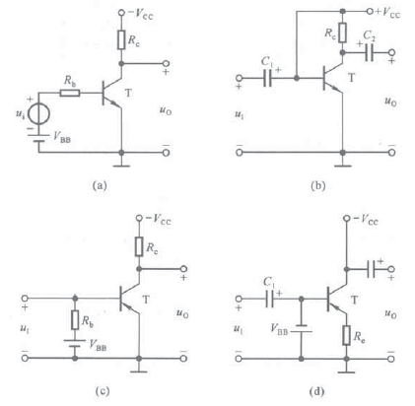
Q2. Given the circuit diagram and the corresponding i-v curve of the transistor, discuss the operation region of the transistor for u_{i}=4V, 8V,12V.
