EE 2000 Logic Circuit Design
Semester A 2021/22
Tutorial 3

- Use a truth table to present (A + B + C +D)’ = A’ B’ C’ D’

Ans:

- Implement the following expression with 2-input NAND gates only:
- ABC + DE
- ABC + D’ + E
Ans:
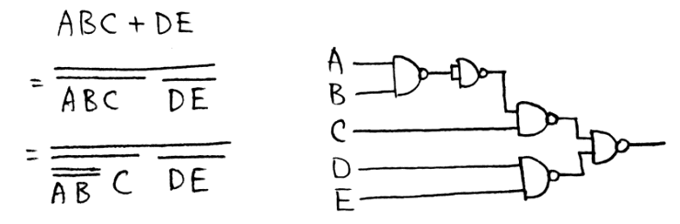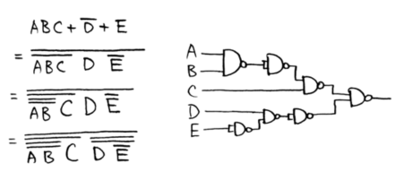

- Given a truth table:
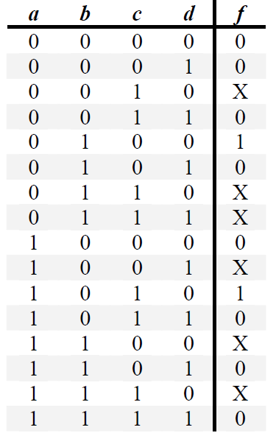 | - Express f as product of maxterms function in numeric form.  - Find its MPS form using K-map.  - From the answer of (b), please design a logic circuit by NAND gates only.

Ans:
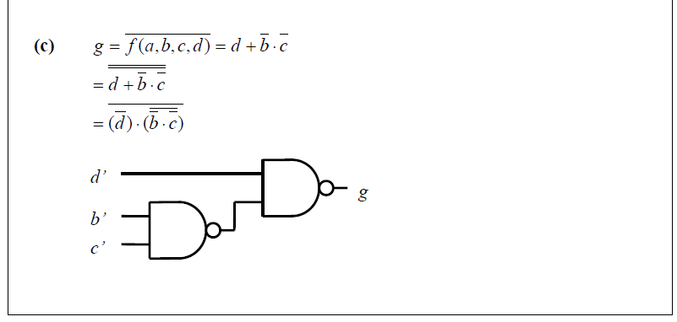

- Design a combinational circuit for a 3-bit Binary-to-Gray code converter.

Ans:

Circuit:
X
Y
Z
A
B
C
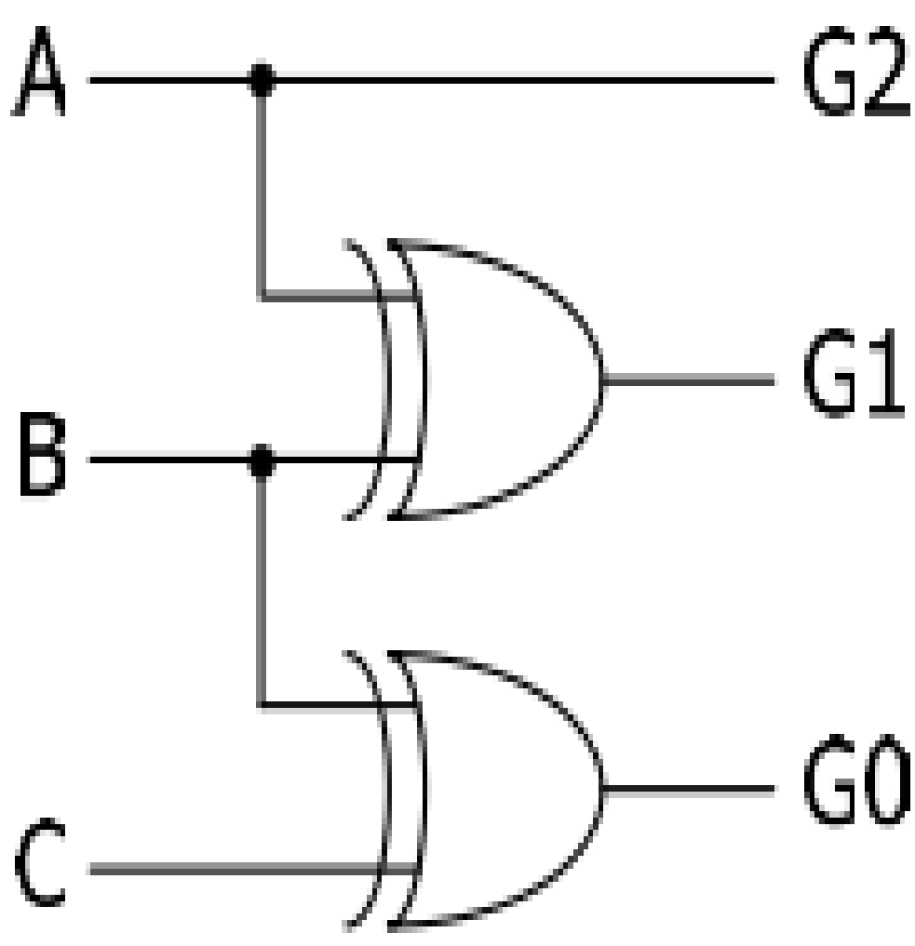

- Joe, Jack, and Jim get together once a week to either go to a movie or go bowling. To decide what to do, they vote and a simple majority wins. Assuming a vote for the movie is represent as a 1, design a NAND gate circuit that automatically computes the decision.
Ans:
Joe / x | Jack / y | Jim / z | Decision / f
0 | 0 | 0 | 0
0 | 0 | 1 | 0
0 | 1 | 0 | 0
0 | 1 | 1 | 1
1 | 0 | 0 | 0
1 | 0 | 1 | 1
1 | 1 | 0 | 1
1 | 1 | 1 | 1

f (x, y, z) = Σ m ( 3, 5, 6, 7) …. By K-map f = xy + xz + yz (Please draw the circuit by own)

