City University of Hong Kong

EE 4101 – Industrial Electronics

Case Report

Case # : _____1____ Group #: ___________ Date: _____11th Nov, 2015____

Leader: ______Tam Chu-kwong______

A) Individual assessment: (The leader is required to put the names of your members into the following table.)

Student name & ID | Comments | Rating (1 – 5)
Tam Chu-kwong
53219921
MA Wai-wai
53649005
Ling Tsz-YAN
53789259

B) Group assessment:
Comment | Rating (1 – 5)

Content
Description | Page
Problem identification | 3
Mind map | 4
Objective of the case | 5
Object 1 | 6-7
Object 2 | 8-9
Object 3 | 10-11
Conclusion | 12

Problem
We are asked to design a 100W AC-powered LED lamp driver.
In this case, the supply voltage to the driver is from 90V to 240V, AC. The supply voltage frequency is between 45Hz to 65Hz. The minimum power factor is 0.98 and the minimum efficiency is 0.92. Since the rating of the LED is 1W, 3V, the driver is required capable to drive 100 LEDs.
The LED lamp current balancing with maximum variation is 2%. The system will work even if only one LED is in operation. Dimming function down to 10%. There is electrical isolation between the supply and LEDs.

Mind map
+
DC/DC design
Fault detection
combination
Series
Connection
Parallel
Loading
V_{out} &I_{out}
V_{out dc} Level Regulate
Changing Duty cycle for error correction
Problem
Boost PFC

Harmonic
Diode Bridge

F_{in} Changing

V_{in} changing
AC/DC

Objective of the case
- AC/DC convertor with low harmonics, high efficient
- DC/DC convertor to convert a high input voltage into a lower output voltage, and step up and smooth the output current.
- Fault detection with automatic finding the fault location with Loading protection

2. Report
- Objective 1 AC/DC convertor with low harmonics, high efficient
Name (ID): _Tam Chu-kwong___ ( 53219921 )
In this part, PFC Boost Rectifier is used. There are there major reasons to adopt the circuit.
- The circuit can give a unity or nearly unity PF which is the task requirement.
- The circuit is practical and easy to install.
- The output voltage is regulated and with a small ripple, with can easily solve.
Since there is a low power output, the Conventional PFC boost rectifier is choose. The advantage of the conventional PFC compared with the bridgeless PFC boost rectifier is simply in control circuit. Moreover, based on research, there is a requirement of MOSEFT R_{DSon} which is lower than 190mΩ if bridgeless PFC boost rectifier is the better choice (Huber, Jang, & Jovanovic, 2008). This will limit the choice of the switch and increase of the production price.
Connection
Basely, there are three parts in the AC/DC converter.  There is a diode bridge connects to the small capacitor and the boost converter. After the converter, there is a loading | 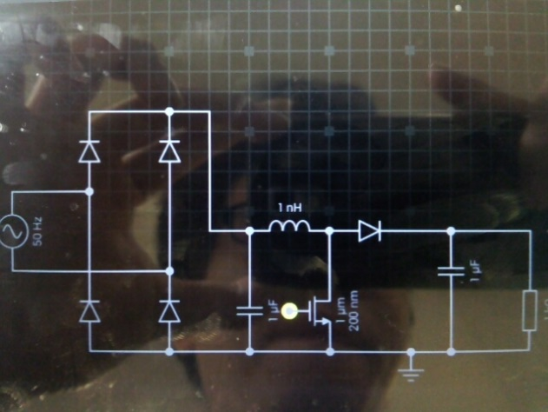

Operation Algorithms
The diode is to rectify the input voltage from V*sin (wt ) to V*|sin(wt)|. At the positive cycle, the diode of the left upper and right lower conduct. Whereas, the diode of the right upper and left lower are conducted at negative cycle.
After the diode bridge, the power will go to boost DC/DC Converter. There are to aims. First is to regulate the output voltage. The other function is to reduce the harmonics. The method is to adjust the Duty cycle according the input voltage.
The formula is DC=1-(V*sin (wt))/Vs. V is the maximum input voltage. Vs is the output direct voltage. Thus, the duty cycle is changed according to the instantaneously input voltage. As the previous diagram, the duty cycle is applied to the gate pin, which is shown in yellow.
The circuit is connected to the square ware signal source to the switch. The circuit can increase the efficiency and response time.  When signal high, Capacitor than is in series with the signal source is chanced up. Then, when the signal low, the capacitor can give a negative voltage to the Gate of the switch. The RC are large enough than can be considered as no voltage drop in voltage low period. | 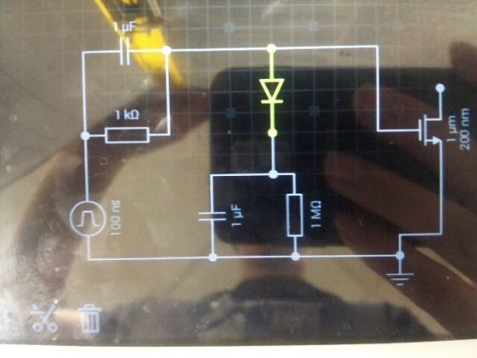
Control System
There are two control mode, Peak Current Mode Control and Hysteresis Current Control. Based on the research result, there may product sub-harmonic at Peak Current Mode Control (Karaarslan & Iskender, 2011). Thus, in order to fulfil the task requirement, Hysteresis Current Control is used.
There are two close loop control.  First, the output voltage is detected and to the I control. Normal, output error detection consists of PI. The resistors are to be choose according to the V_{b} and V_{ref} ratio.  The input signal is connected to two current error amplifier. The lower is for checking the lower bound. If the input current reach the condition, the switch will be turned on. Whereas, the upper current error detector us for checking the upper bound. If the current reaches the condition, the switch will be turned off. Thus, this can reduce the input harmonic and achieve the output voltage regulation. | 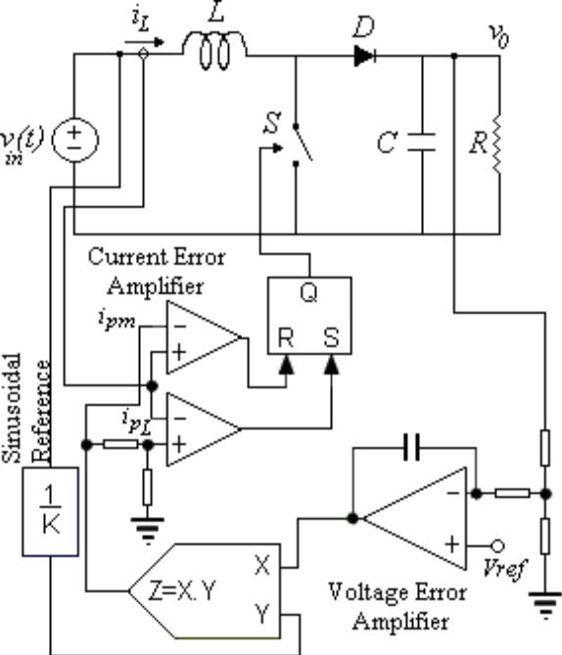
 | (Karaarslan & Iskender, 2011)

Bibliography
Huber, L., Jang, Y., & Jovanovic, M. M. (2008). Performance Evaluation of Bridgeless PFC Bosst Rectifiers. IEEE TRANSACTIONS ON POWER ELECTRONICS, 1381-1390.
Karaarslan, A., & Iskender, I. (2011). the analysus of ac-dc boost pfc converter based on peak and hystreresis currentcontrol techniques. Technical and Physical Problems of Engineering, 100-105.

Objective 2 – DC/DC convertor to convert a high input voltage into a lower output voltage, and step up and smooth the output current

Name (ID): _____MA Wai Wai____ ( 53649005 )

Buck Convertor:
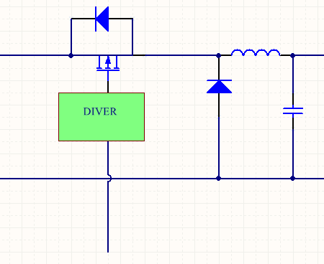

Function:
The DC – DC buck convertor is to distribute power to the output loading. In this case, it provides the require voltage (6V) to the LEDs output.
The buck converter has the filter inductor on the output side, which provides a smooth continuous output current waveform to the load.
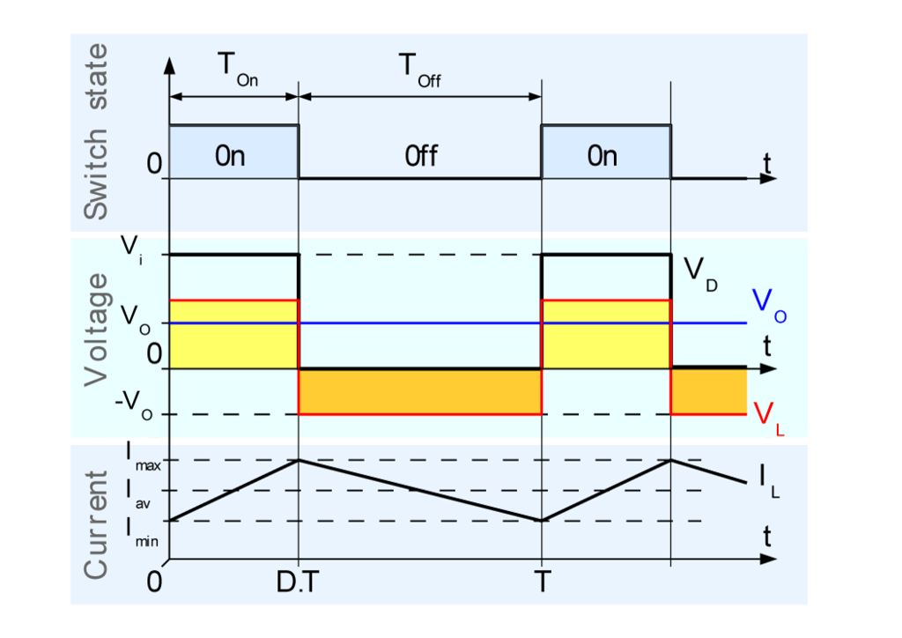

Concept:
When the switch is on, the current will increase. An inductor will produce an opposing voltage VL across the terminals in response to the changing current. During this time, inductor stores energy. If the switch off while the current is still changing, there will always be a voltage drop across the inductor, so the net voltage at the load will always be less than the input voltage.

Mode of Operation:
The buck converter can operate in different modes, continuous conduction mode and discontinuous conduction mode. Our circuit design is parallel 100 LEDs, so that high current is necessary. The components are stressed most when the load current is high. Hence the converter operates in continuous conduction mode.
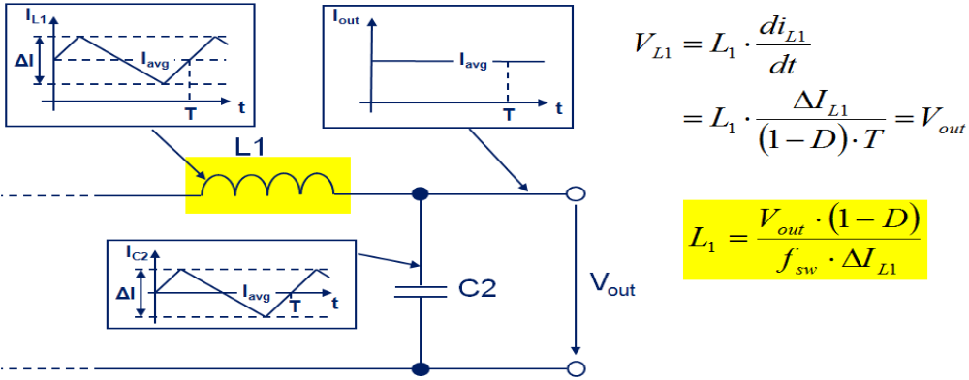
A buck converter operates in continuous conduction mode if the inductor current (IL) never fails to 0 during the commutation cycle (i.e. IL > 0). It shows that the continuous conduction mode is suitable for high current load. In this case 1, our output voltage and output current are fixing. We can control the system by control the duty cycle (D) and inductance (L).
Driver
Error -Amp.
PI
+
Vref
Vout
-
Error Correction:

Three cases of error detection:
Vout > Vref Error > 0 Vcon decrease
Vout < Vref Error < 0 Vcon increase
Vout = Vref Error = 0 Vcon unchanged

According the function above, when the output have an error, it can change the duty cycle automatically, so that the error can be correct.

Objective 3 : Power Factor Correction on LED Driver
Name (ID): ____ Ling Tsz-YAN ( 53789259 )
The device is designed to operate in critical conduction mode and is suitable for flyback as well as buck topologies. Constant on time critical conduction mode operation is particularly suited for isolated flyback LED applications as the control scheme is straightforward and very high efficiency can be achieved even at low power levels. These are important in LED lighting to comply with regulatory requirements and meet overall system luminous efficacy requirements. In critical conduction mode, the switching frequency will vary with line and load and switching losses are low as recovery losses in the output rectifier are negligible since the current goes to zero prior to reactivating the main MOSFET switch.

- Circuit Setting
2.1 Current Regulation to LED
By driving LED light sources with a regulated constant-current power supply the light output variation and lifetime issues resulting from voltage variation and voltage changes can be eliminated. Hence, constant current drivers are generally recommended for powering LED light sources.
In real application, current-limiting devices such as resistors can be an inexpensive alternative to constant-current drivers for restricting current flow. However, there are many trade-offs. First, resistors generate heat and, therefore, waste power. The heat generated by resistors needs to be dissipated.
2.2 Protection to LED
LED light bulbs are vulnerable to overcurrent and short circuit events. They are commonly caused by electrostatic discharge, lightning strikes, inductive or capacitive load switching. It is for these reasons the use of overcurrent protection is mandated by international safety standards. In addition, LEDs are constant current devices. To be compatible with the AC main they require AC-to-DC power conversion. A LED driver is also used to provide a regulated supply of current. The driver maintains constant current regardless of variations in load due to fluctuations in temperature.

- Snubber Circuit Design
Snubbers are used to limit switching transients and help lower EMI. Snubbers are circuits which are placed across semiconductor devices for protection and to improve performance.
Figure 1 shows the relationship between E₁/E₀ and ζ for different values of χ. The key point which this graph makes is that for a given χ (χα1/Cs) there is an optimum value for ζ (ζ_{α}R_{S}) which gives the lowest peak voltage.  A second important point is that the lowest value of peak voltage attainable is determined by the size of Cs. If a lower peak voltage is required, then a larger C_{S} must be used. This means that the power dissipation has to increase as the peak voltage is reduced.  * Peak switch voltage: E₁  Normalized peak switch voltage: E₁/E₀  Initial current factor: χ = (I₀/E₀)Z₀  Damping factor: ζ = P_{S}/2Z₀ | 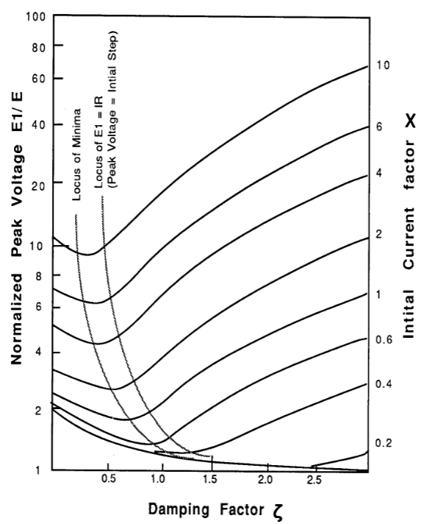

- Error Detection
4.1 Error Voltage Detection
The circuit can be divided into 3 stages. The first stage is the two BiMOS Operational Amplifier with MOSFET connected as voltage follower. The bias current of op-amp is at the scale of pA, therefore the impact on the voltage divider can be neglected. The second stage is another a BiMOS Operational Amplifier with MOSFET, which amplify the voltage difference between two voltage dividers’ output to 100 times. The third stage is the LM139 comparator circuit.
4.2 Error LED Detection
Although LEDs are more robust than incandescent or fluorescent lights, it is possible for LEDs to fail. These failures can be due to mechanical damage, prolonged use, manufacturing defects, and other varied causes.
LED Failure Detector are multipurpose devices that allow current to flow around an LED and support detection and diagnostics of LED failures. When one of LEDs does fail, either as an open or a short, the circuit detects this and immediately switches in a backup LED.

Conclusion
By using the switch, we can achieve the task requirement.
First, the switch is used as output regulation. Meanwhile, it can reduce the harmonics by not using capacitor to regulate the output voltage and changing the Duty cycle according with the input instantaneously voltage.
Second part is to regulate the output voltage by using a bulk converter. This can save energy when doing the power convention.

