CS3402 Tutorial 7:

- Consider the following table scheme, and assume that R1 has 1000 tuples, R2 has 1500 tuples and R3 has 750 tuples.
R1 (A, B, C)
R2 (C, D, E)
R3 (E, F)
- Estimate the size (max and min of tuples) of R1 * R2 * R3 (where * denotes Natural Join).
- There are two ways to perform the Natural Join in (a), which one is more efficient in terms of number of comparison?
  - (R1 * R2) * R3
  - R1 * (R2 * R3)

- A canonical query tree is a tree structure that corresponds to a relational algebra expression or an SQL query directly, without doing any optimization. As such, it is usually not the most efficient way of executing the query.

Consider the relations:

EMPLOYEE(ENAME, SSN, BDATE, ADDRESS, DNUM)
PROJECT(PNAME, PNUMBER, PLOCATION, DNUM)
WORKS_ON(ESSN, PNO, HOURS)

as well as the following SQL query:

SELECT ENAME
FROM EMPLOYEE, WORKS_ON, PROJECT
WHERE PNAME="HeavenRay" AND PNUMBER=PNO
AND ESSN=SSN AND BDATE > 'OCT-11-1966';

- Draw a canonical query tree for the above SQL query.
- Apply the optimization rules to the above query tree and come up with the most optimized query tree.

CS3402 Tutorial 9:

- Answer:
- First, the join order will not affect the result size, i.e., size of ( (R1 * R2) * R3 ) = size of ( R1 * (R2 * R3) )

Let’s estimate the result size by (R1 * R2) * R3
- For table R1 (A, B, C) with 1000 tuples, there are 1000 distinct values in column A, and 1~1000 distinct values in column C
- For table R2 (C, D, E) with 1500 tuples, there are 1500 distinct values in column C, and 1~1500 distinct values in column E

In R1 * R2, the join is on the common column, i.e., column C. Because C is the primary key in R2, one tuple in R1 with a C value will only match to at most one tuple in R2. Therefore, there are 0~1000 tuples of (A, B, C, D, E) in TempR= R1 * R2.

- For table TempR (A, B, C, D, E) with 0~1000 tuples, there are 0~1000 distinct values in column E
- For table R3 (E, F) with 750 tuples, there are 750 distinct values in column E

In TempR * R3, the join is on the common column, i.e., column E, so it will result in 0~1000 tuples of (A, B, C, D, E, F) because one tuple in TempR with an E value will match to at most one tuple in R3.

In conclusion, the size of R1 * R2 * R3 is in the range of 0~1000.

- Efficiency analysis

- For i), in the worst case we need 1000*1500+1000*750 comparisons.
In R1*R2TempR, for each tuple in R1 with a C value, we need to go to R2 to search for its matching tuple, so the number of comparison is 1000*1500. In TempR*R3, for each tuple in TempR with an E value, we need to go to R3 to search for its matching tuple, so the number of comparison is 1000*750.

- For ii), in the worst case we need 1500*750+1000*1500 comparisons.
In R2*R3TempR, for each tuple in R2 with an E value, we need to go to R3 to search for its matching tuple, so the number of comparison is 1500*750.
In R1*TempR, for each tuple in R1 with a C value, we need to go to TempR to search for its matching tuple, the number of comparison is 1000*1500.

In conclusion, (i) is more efficient than (ii) in terms of number of comparison.

- Answer:
- The canonical query tree for the original SQL query is
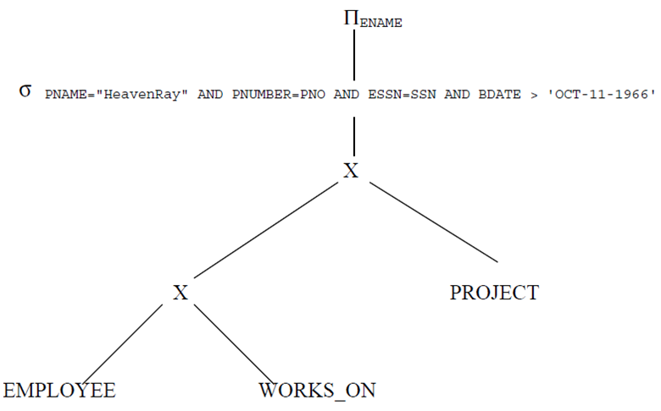

- Applying the optimization rules to come up with the most optimized query tree.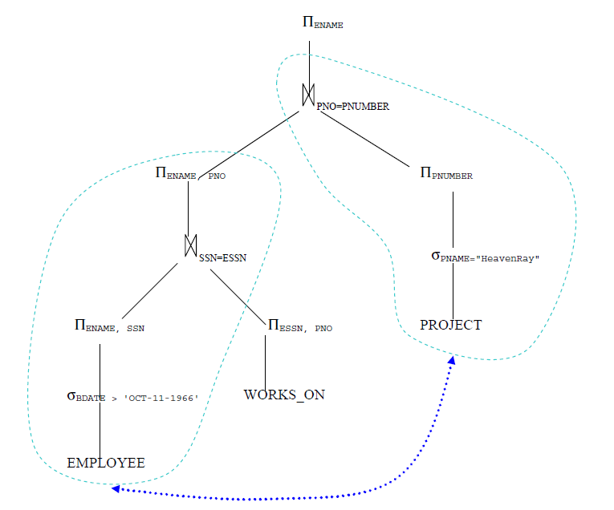
//What if the number of Project with name “HeavenRay” is much smaller than that of Employee whose “BDATE > 'DEC-31-1957'”?
(hint: switch the order of the two sub-trees, as indicated by the blue dash line...)

