EE 2000 Logic Circuit Design
Semester A 2021/22A
Tutorial 2

- Consider a 4-variable Boolean function. Using K-map, list the cells adjacent to cell m₁₃.
Ans:
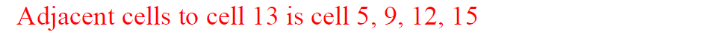

- Plot the following functions on the K-map.
(a) f(x, y, z) = Σ m (0, 1, 3, 5)
(b) f(a, b, c, d) = Σ m (2, 4, 6, 7, 15)
(c) Identify the prime implicants and the essential prime implicants for the answers (a) and (b).
(d) Find the simplest SOP from of the above functions from the K-maps.
(e) Find the simplest POS from of the above functions from the K-maps.

Ans:
(a), (b) and (c):
f(x, y, z) = Σ m (0, 1, 3, 5)
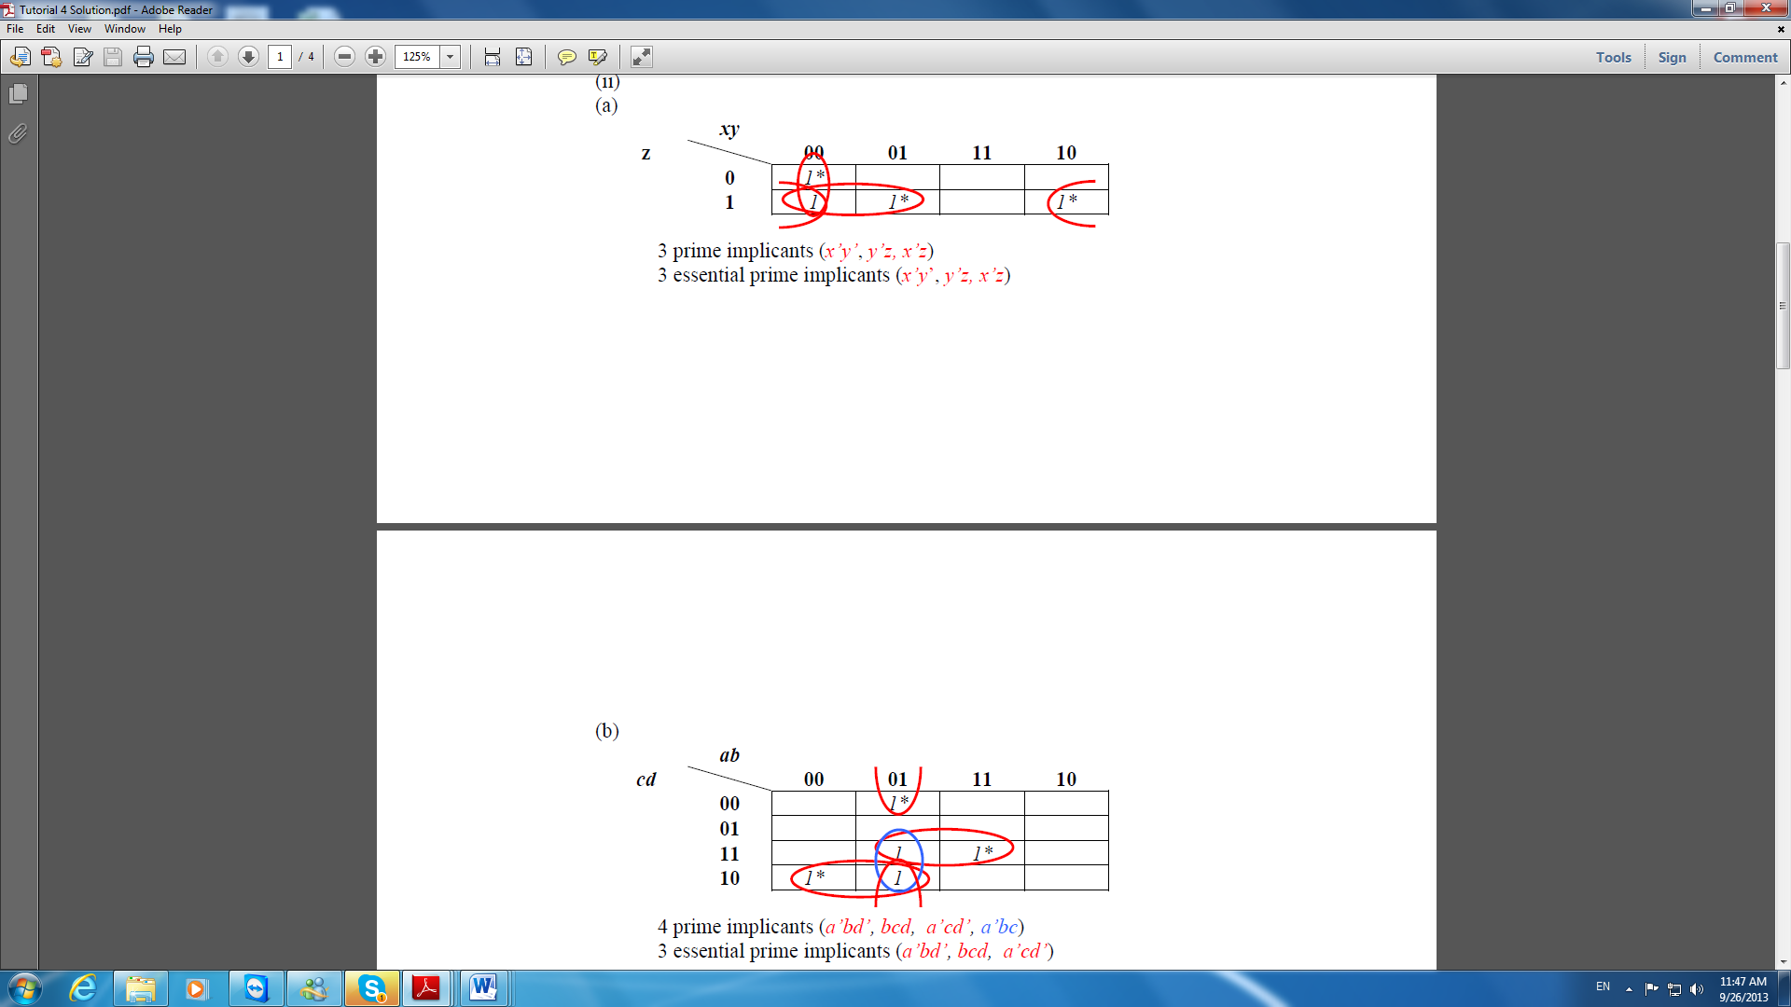
f(a, b, c, d) = Σ m (2, 4, 6, 7, 15)
(d)
f(x, y, z) = x’y’ + y’z + x’z
f(a, b, c, d) = a’bd’ + bcd + a’cd’

(e)
For (a)
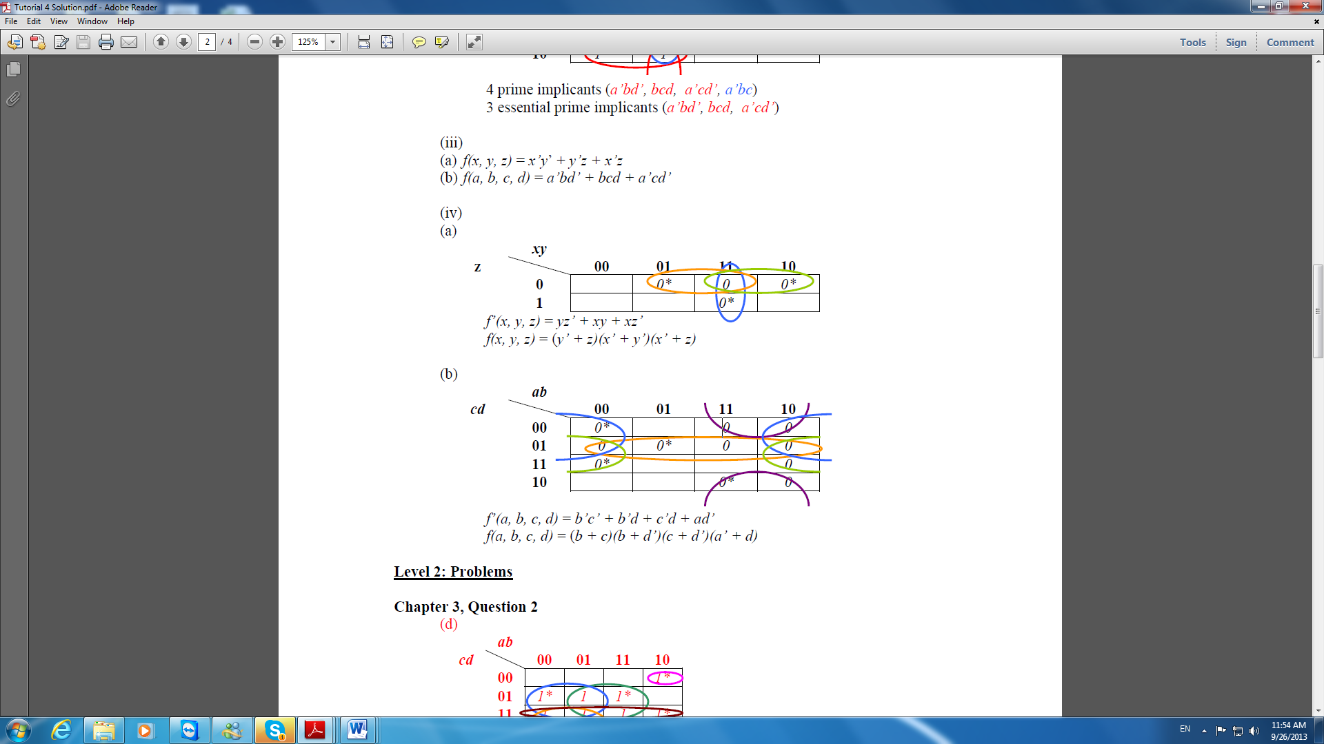

For (b)

- (a) Plot the following function on the K-map.
f(A, B, C, D) = (A’+B’+C+D)(A+B’+C+D)(A+B+C+D’ )(A+B+C’+D’ )(A’+B+C+D’ )(A+B+C’+D)
(b) Convert the standard POS expression in part (a) into
(i) Minimum POS expression.
(ii) Standard SOP expression.
(iii) Minimum SOP expression.

Ans:

- Perform the following number system conversions:

(i) 267 in decimal to Binary, Octal and Hexadecimal
(ii) 731 in Octal to Decimal and Hexadecimal

Ans:
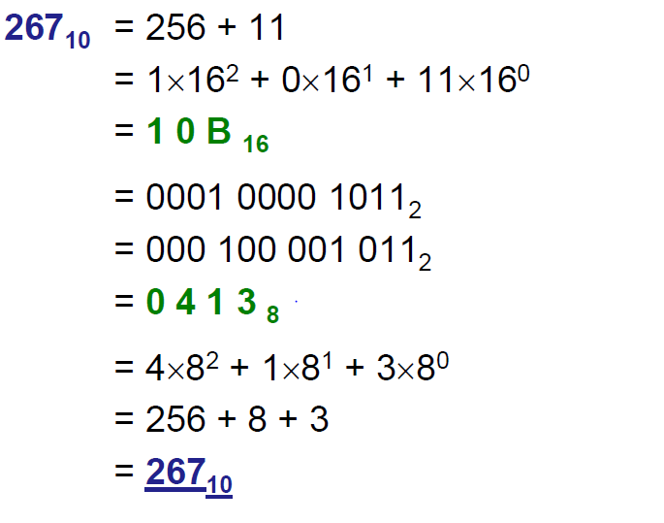

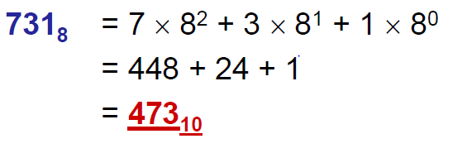
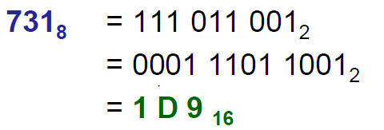

- Perform the following subtraction (267 - 473) in decimal and also after conversion to binary and match the results.

Ans:

