EE3211 Modelling Techniques
Week 8 Assignment Answer

Q1. We use the fixed effects one-way ANOVA model, and employ the F test for one- way ANOVA to compare the mean rate of bone loss among the three groups.

Q2. We have the test statistic
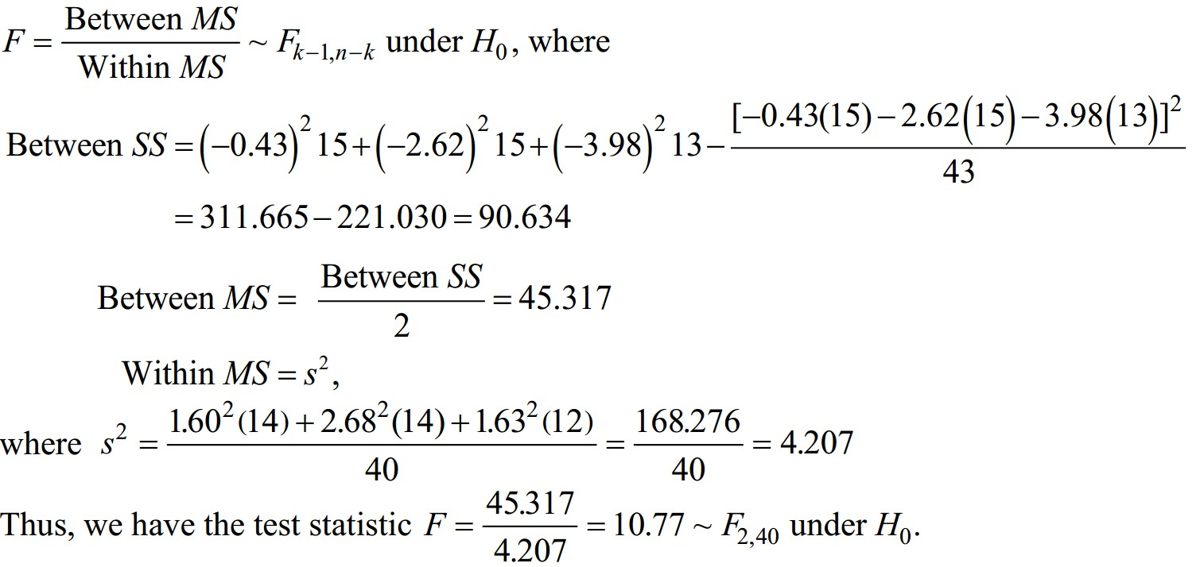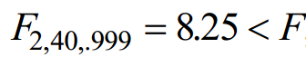
From the table for F distribution, we have
.
Also, using R, we determine that p value can be obtained as shown below.
> pf(10.77,2,40,lower.tail = F)
[1] 0.0001811549

Thus, it follows that p <.001 and there is a significant difference in the mean rate of bone loss among the three groups.

Q3. We first use t tests with critical values based on the LSD procedure as follows

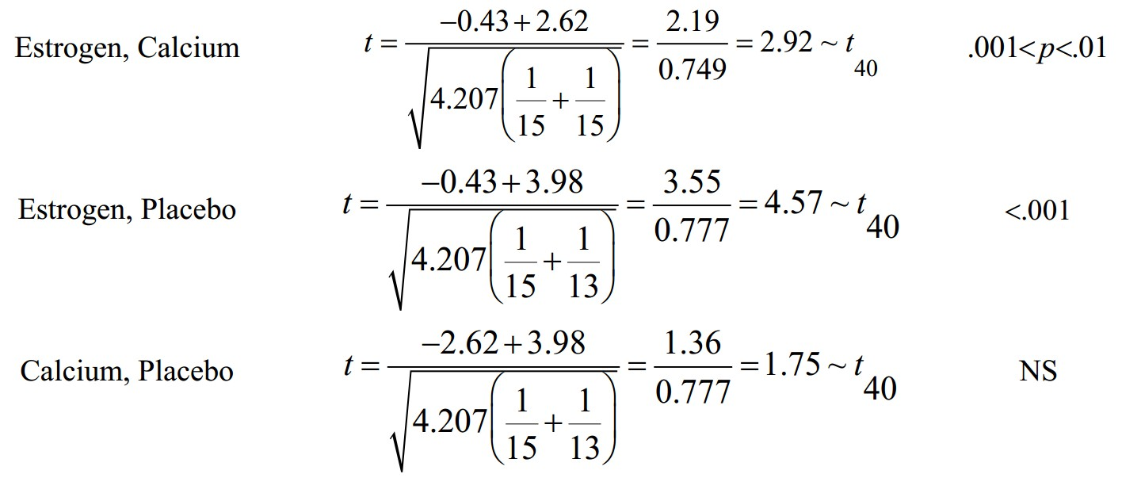
Groups Compared Test Statistic p-value
NS: not significant

Note that there are significant differences between the estrogen group and each of the other two groups, while there is no significant difference between the calcium

and placebo groups. We now use the method of multiple comparisons based on the Bonferroni approach.

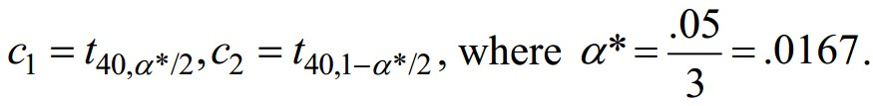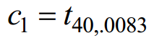Since there are three groups with 40 df, we have 3 two-by-two group comparisons. The critical values are

Thus,

From t distribution table, we have 𝑡40,.99 = 2.423 < 𝑡40,.9917 = |𝑡40,.0083| <
𝑡40,.995 = 2.704.

Thus, 1.75 < |c1| = |𝑡40,.0083| < 2.92 < 4.57, it follows that there are
significant differences in the mean rate of bone loss between the Estrogen Group and each of the Calcium and Placebo groups, respectively, while there is no significant difference between the Calcium and Placebo groups.

Q4. There is not a definite answer to this question. If the comparisons are planned and specified in advance, which they probably were in this case since this was a long- term clinical trial, then t tests based on the LSD approach are appropriate. Fortunately, the results are the same using either approach.

