Tutorial 1
Question 1
Identify whether the following data are Qualitative Data or Quantitative Data.
- The number of pens you have
- The type of OS in your phone
- Your address
- Distance from Kowloon Tong to Sum Shu Po
- The credits you take in this year
- The number of professors in EE1004
- Professors’ names in EE1004
- Movie ratings (good, fair, bad)
- Color preference order (red, blue, green …)
- Weights of your dog
- Amount of money you won in the last poker game
- Number of correct answers on a quiz
- The attitudes that we consider for grant applications
- IQ scores
Show Answer
Items a, e, f, k, and l are quantitative discrete; items d, j, and n are quantitative continuous; items b, c, g, h, i, and m are qualitative.
Question 2
In university, we may face some structured data and unstructured data. Give some two examples for each data type. Briefly explain your answer.
Ans:
Data table of quiz result of student. Have fields
The multimedia files in your phone: file types are different and the data are not organized in rectangular table.
Question 3
Investigate the new world bus App. Use the GPS data in this App to explain the term Veracity.
Ans:
The quality of data.
Discuss what is high quality: Realtime GPS information may not be high quality.
An user is waiting a bus. The realtime GPS information of a coming bus has high quality. But the realtime GPS information of a bus that already passed the bus stop 5 minutes is high quality.
Question 4
In EE1004, students need to submit their lab reports over the Canvas system. Use this scenario to explain the term Variety.
Ans: Different students may submit the reports with different formats, such as WORD, PDF, Text … …
Question 5
- Determine I2, I3, I_{T,} R_{T}
- Using the Ohm’s law and the two Kirchhoff's Law prove that in general
$R_{T}=R_{1}+\frac{R_{2}R_{3}}{R_{2}+R_{3}}$
for resistors’ values and any value of V. Using the Ohm’s law ,
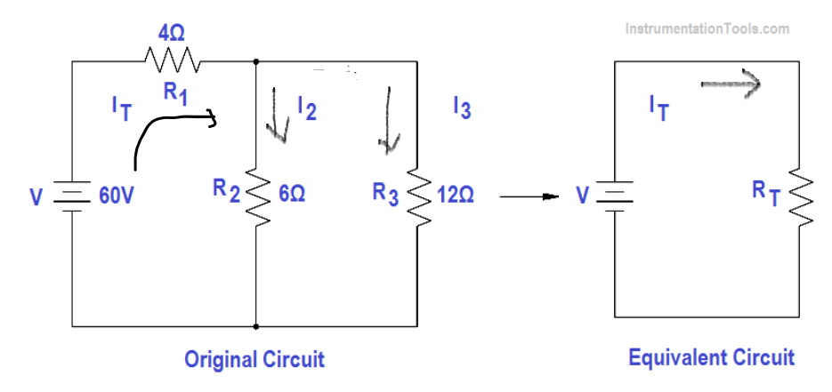

Answer:
(a)
$60=6*i_{2}+4*i_{T}$
$60=12*i_{3}+4*i_{T}$
$0=i_{2}{+i}_{3}-i_{T}$
$=>60=10*i_{2}+4*i_{3}$
$60=4*i_{2}+16*i_{3}$
=>$180=36*i_{2}=>i_{2}=5$
$=>i_{T}=7.5$
$=>i_{3}=2.5$
$=>R_{T}=8$

(b)
Note that $V_{23}=V_{2}=V_{3}$
$i_{T}=i_{2}{+i}_{3}$=> $\frac{V_{23}}{R_{23}}=\frac{V_{2}}{R_{2}}+\frac{V_{3}}{R_{3}}$ =>$R_{23}=\frac{R_{2}R_{3}}{R_{2}+R_{3}}$

$V=V_{1}{+V}_{23}=> i_{T}*R_{T}=i_{T}*R_{1}+i_{T}*R_{23}$ => $R_{T}=R_{1}+\frac{R_{2}R_{3}}{R_{2}+R_{3}}$
Question 6
- Determine $I_{1}$ and $I_{2}$
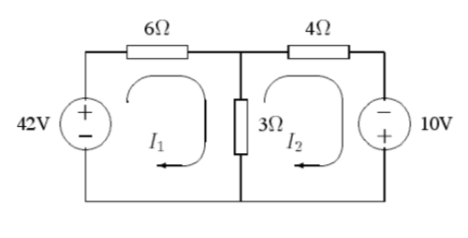
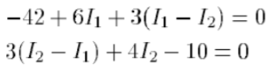
- $I_{1}=6$ and $I_{2}=4$

Question 7
- Draw the graph representing the road system, and write down the number of vertices, the number of edges and the degree of each vertex.
- If some of roads are one-way, what type of graphs we should use to representation the map? Describe your representation method.

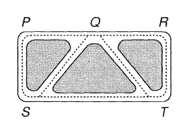j
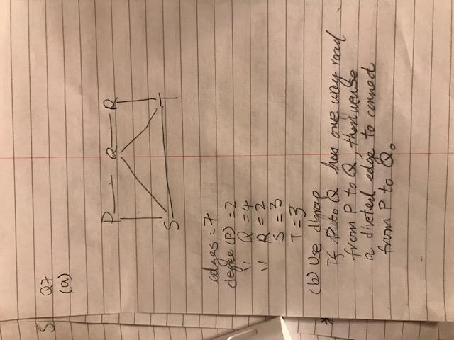

Question 8
Draw a graph with vertices A,. . . ,M that shows the various routes one can take when
tracing the Hampton Court maze. (oh a very large graph. Discuss the concept of your classmates)
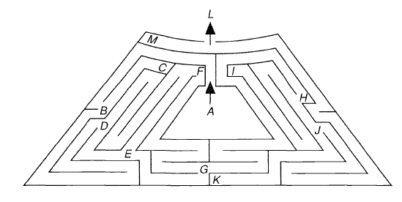

Question 9
John likes Joan, Jean and Jane; Joe likes Jane and Joan; Jean and Joan like each other.
Draw a digraph illustrating these relationships between John, Joan, Jean, Jane and Joe.

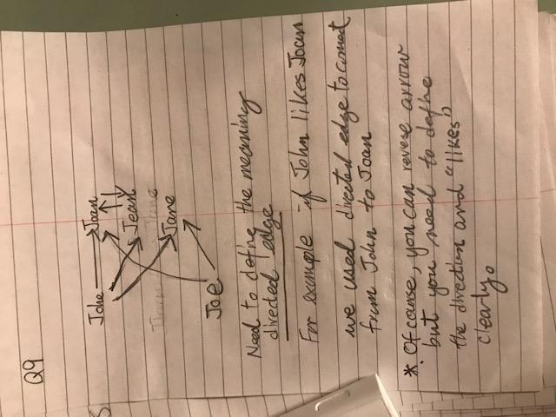

Question 10
Snakes eat frogs and birds eat spiders; birds and spiders both eat insects; frogs eat snails,
spiders and insects. Draw a digraph representing this predatory behaviour.
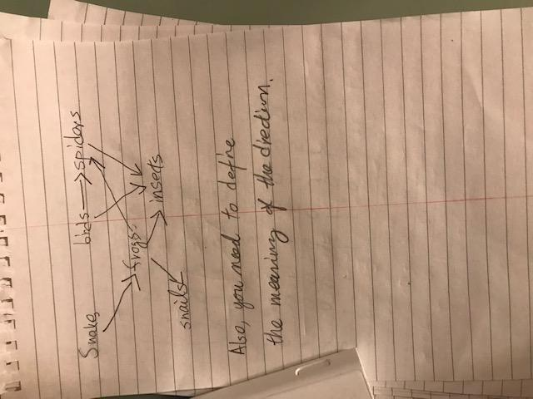

Question 11
Write down the adjacency and incidence arrays of the graph. Note that the numbers in the edges are the edge labels not the weights of the edges
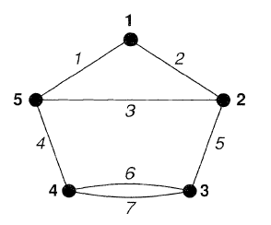

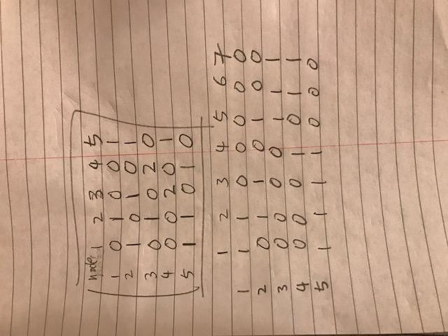
Question 12
Draw the graph whose adjacency array is given by.
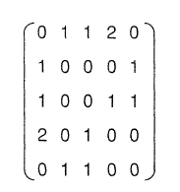
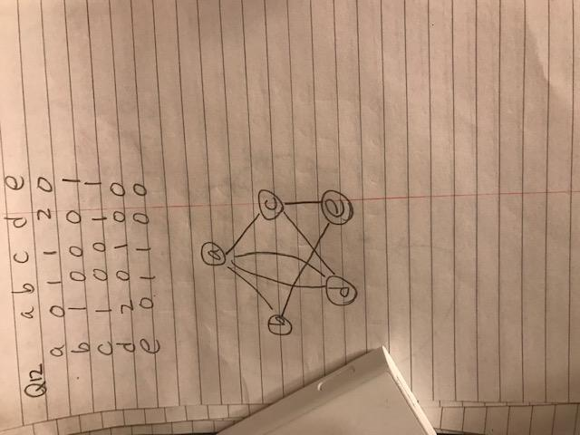

Question 13
Draw the graph whose incidence matrix is given.
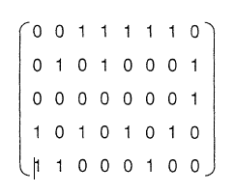
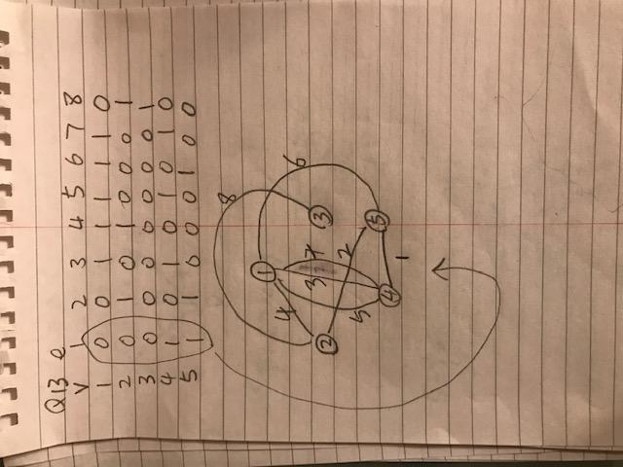

Question 14
Use Dijkstra’s algorithm to find the shortest distance from A to E in the networks below
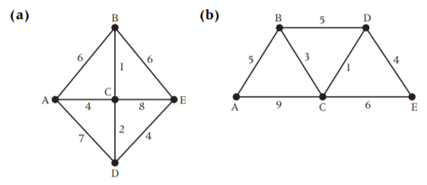

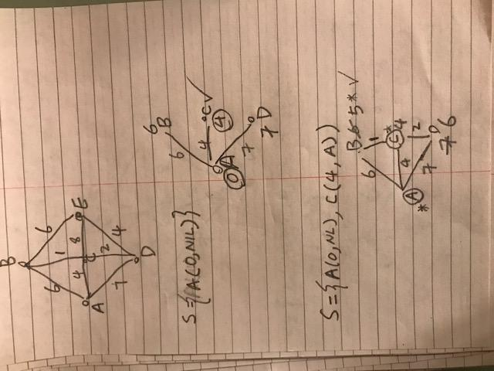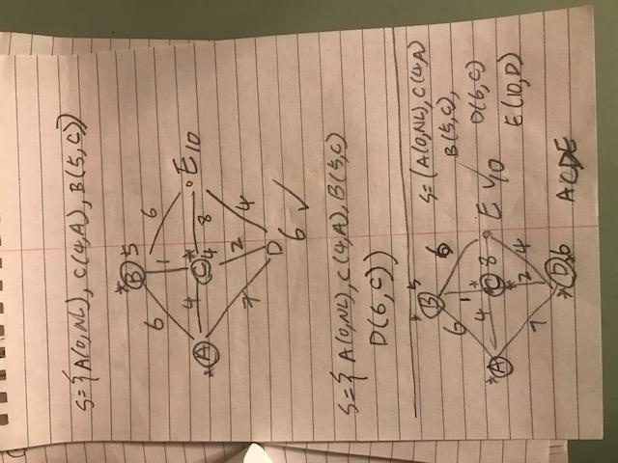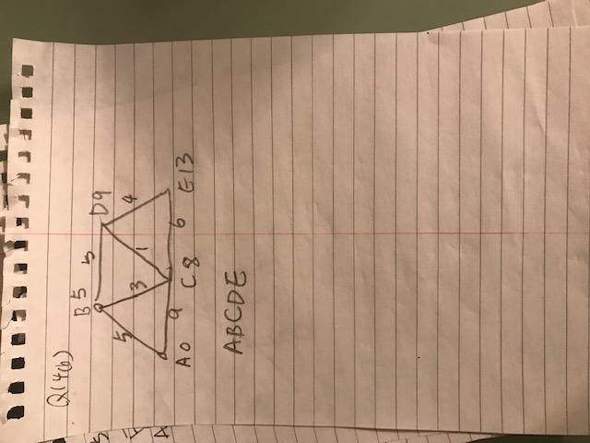

Question 15
The netwjork below has eight vertices and nine edges. Find which of the vertices A, B or C is nearest to vertex H.
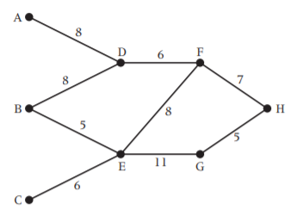
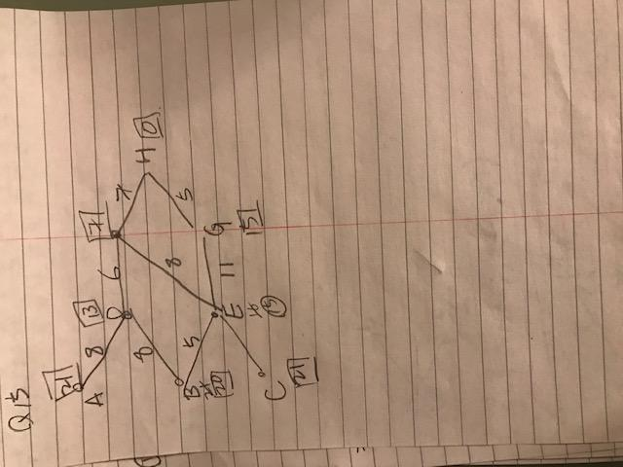
Question 16
Find the shortest path from s to d.
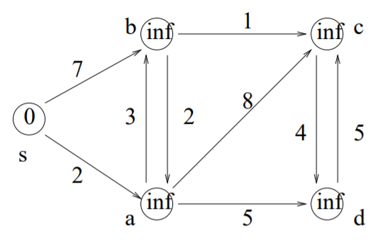
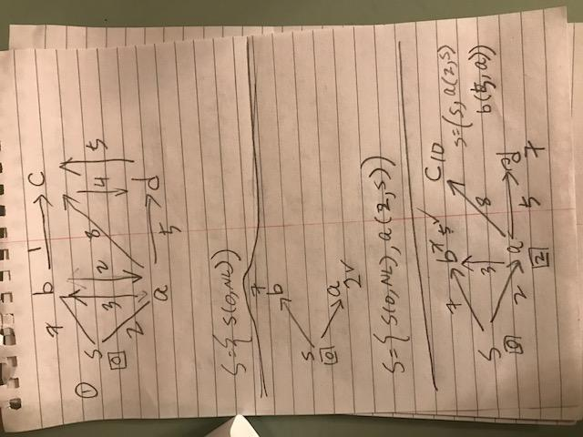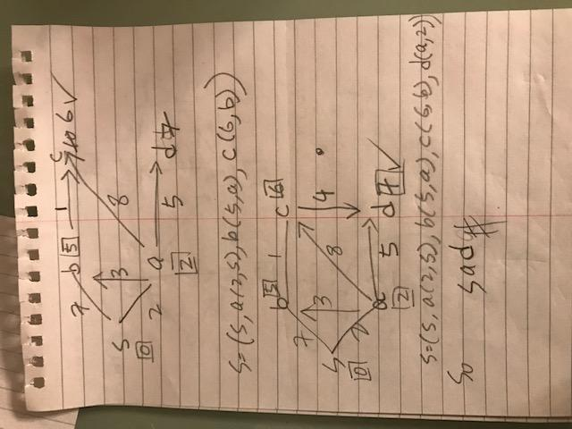

Question 17
Find the shortest path from node 1 to node 6.
