CB2400 Microeconomics

Tick & Learn

Fundamental Economic Issues

1) Which is the most appropriate definition of the study of economics? Economics is the study of
A) the distribution of surplus goods to those in need.
B) affluence in a morally bankrupt world.
C) the choices we make because of scarcity.
D) ways to reduce wants to eliminate the problem of scarcity.

2) During the summer you decide to have a trip to Japan, which precludes you from working at your usual summer job in which you normally earn $6000 for the summer. The trip costs you $4000 that you may use to buy a digital camera. The opportunity cost of having a trip is
A) The $6000 income forgone.
B) The digital camera forgone.
C) The $6000 income or the digital camera forgone depending on your preference.
D) The $6000 income and the digital camera forgone.
E) None of the above.

3) An example of opportunity cost
A) is sweets given up by a person who would never eat them even if he or she could.
B) for a professor of economics is the pleasure that he or she derives from teaching economics.
C) is the Chinese food that you gave up when you chose to eat Italian food.
D) is the grants given by government you pay to attend college.
E) is the price paid for a ticket when you go to the movies.

4) The question “Should movies or compact discs be produced?” is an example of the
A) what question.
B) how question.
C) where question.
D) who question.

5) When a country builds a dam using few machines and a great deal of labor, it is answering the ____ question.
A) “what”
B) “how”
C) “where”
D) “for whom”

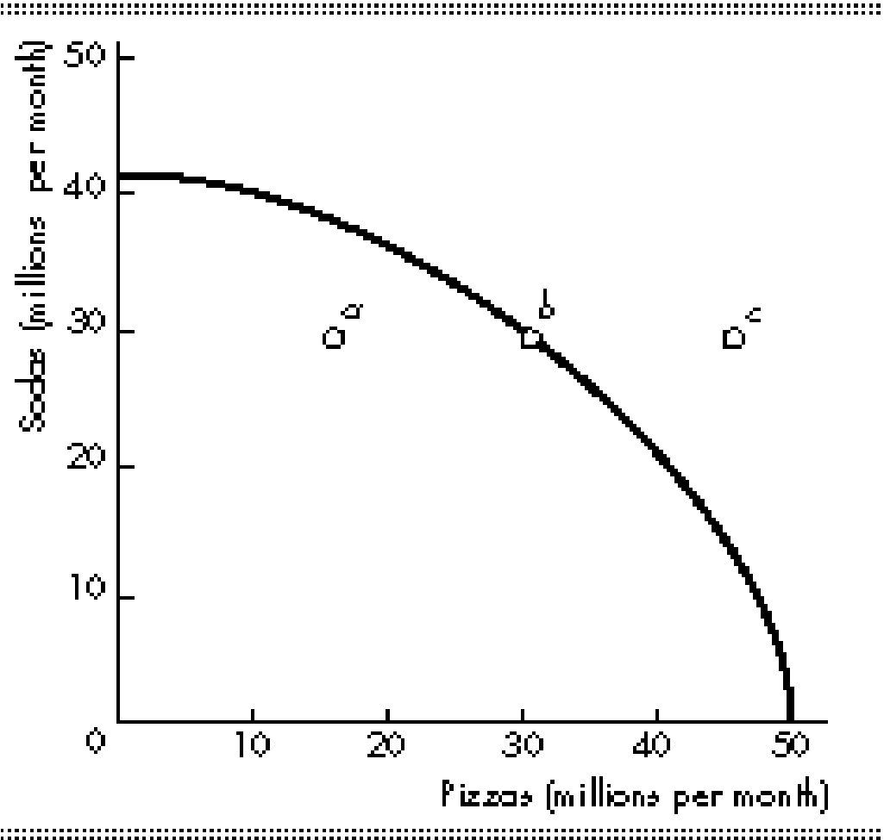

6) In the figure above,
A) moving from point b to point c would require better technology.
B) some resources must be unemployed at point c.
C) opportunity costs are decreasing.
D) point a is efficient.

7) The fact that individual productive resources are NOT equally useful in all activities
A) implies that a production possibilities curve will be bowed outward.
B) implies a linear production curve curve.
C) implies a downward sloping production possibilities curve.
D) the opportunity costs are constant.

