EE3110 Analog Circuit-Laboratory Report



Group:6
Lo Ka Lok (53555897)
Leung Yat Hei (53087631)
Lai Ming Chun (52712399)
Lo Woon Ho(53649496)
Chan ka kin (53943415)
Man Yiu Tak (53085416)

Content
1.Introduction
2.Aims and objectives
3.Principle of operation
4.Circuit design and modification
5.Testing
6.Result
7.Discussion and Conclusion
8.Appendix
9.Reference

Introduction
High-power Light Emitting Diode(LED) are getting more and more common nowadays, as it has a lot of advantages in terms of durability and efficiency compare to the conventional incandescent and fluorescent light. LED is capable of fast switching which suits modulation devices and making visible light communication (VLC) achievable.

In this project, a sound broadcasting system will be built, there are mainly two parts for this system. According to the reference circuit provided in the laboratory guideline, the first part is a simple LED transmitter using Bipolar Junction Transistor(BJT) and the second part is a simple photodiode receiver using both BJT and Junction gate Field-Effect Transistor(JFET). The BJT used in the reference circuit is 2N3904 and the JFET used is 2N5459.

Although the simple sound broadcasting system built using the reference circuit still works, an anlysis on the frequency response and circuit are required in order to improve the performance. DC analysis and small signal ac analysis are implied and conduct testing with different parameters combination, eventually there are some modifications made. In the following of this project report, we will disscuss about objectives, principle of operation, design, testing procedure and finally the results.

Aims and objectives
The purpose of this laboratory is to build a simple transmitter and recceiver circuits by using LED and Photo-diodes.To find out the frequency response of provided circuits by measuring the input and output voltage in different frequency. Suggest reasons to explain the errors in the data. In addition, we have to determine the cut-off frequency, low frequency and high frequency and analyze the voltage gain with corresponding frequency based on the measurement. The original circuits works at 2 centimeters only. In addition, we have to modify the circuit so that the transmission distance can be extended to 1 meter by applying the knowledge.

Principle of operation

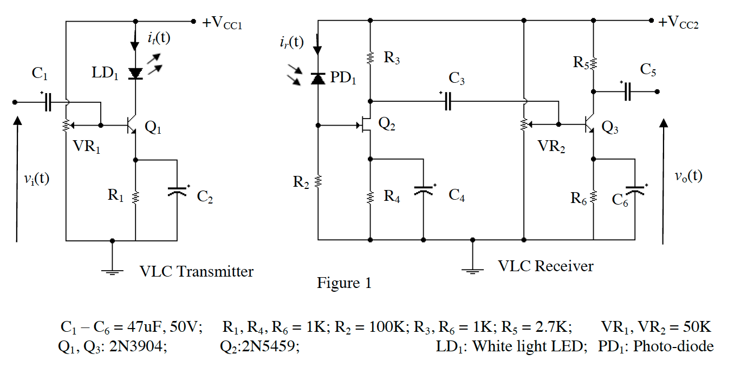

Fig.1 Original circuit of the mini-project

In Fig.1, there are 2 circuits. The first one on the left hand side is the transmitter and the one on the right hand side is the receiver. The signal transmission is using the LED from the transmitter and the photodiode in the receiver to transmits signal.
In the transmitter, there is a bipolar junction transistor, which is a common emitter type. The transistor works as a voltage amplifier, which provided an unstable high gain. Therefore, a resistor needed to place in the emitter pin to reduce and stable the gain. The variable resistor is to control the current into the base pin of the transistor. When it is in AC condition, C1 and C2 will be short circuit and the transistor will work at the active region.
For the receiver part, there is one JFET, which is common source and one bipolar junction transistor,which is common emitter. The signal that received from the photodiode and the value of the R2 form a potential divider and will affect the current into the gate pin. And the potential ratio controls the current from the drain. The output is 180 degree phase shift of the input. C3 is work as coupling capacitor which is use to block the DC signals to the second transistor of the receiver. The bipolar junction transistor of the second stage of the receiver is to amplify amplitude of the signal. C6 is the by-pass capacitor, and R6 is the resistor that control the gain of the amplifier.
To conclude, these three stages of the amplifier works as voltage amplifier. The properties of voltage amplifier, it has a high input impedance and low output impedance also the output signal is out of phase of the input.
Below is the frequency respond of the above cicuit, the data that we got is not quite good, as the frequency respond chart should have a top-flat surface. And we had the curve-top surface. The reason that we had this result is because we did not fix the position of the two breadboard this caused the result has frustruation. As little movement will affect the result from the oscillsope. Therefore, we have got the mistake from -3dB.

Frequency Respond
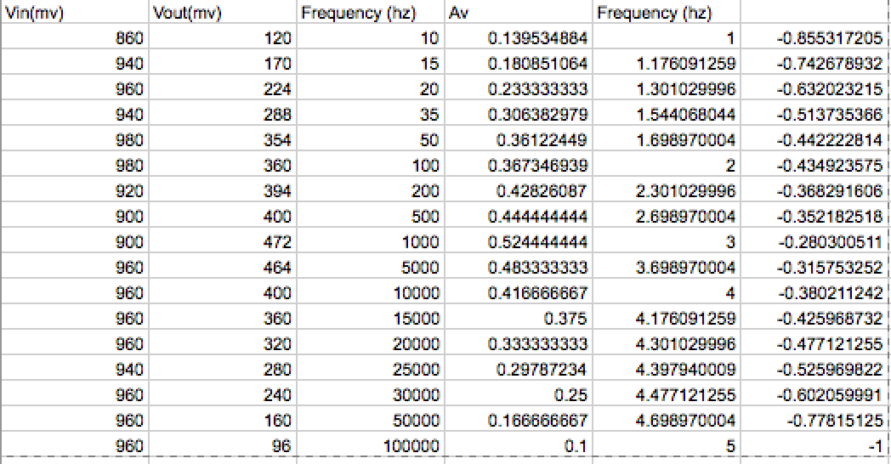
Table. 1

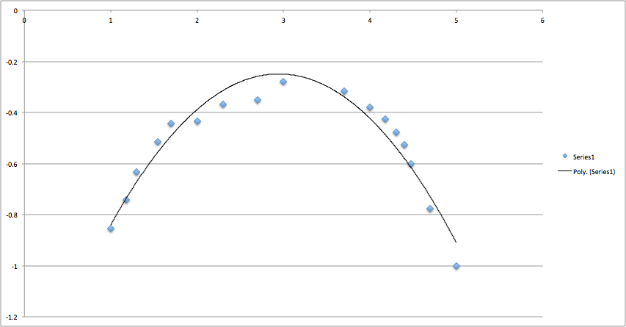
Chart.1

Circuit design and modification

Transmitter part

Voltage supply
The voltage supply, V_{CC} of transmitter was set at 9V. The voltage level is one of the factors to determine the biasing current i_{b}. Here is the illustration:
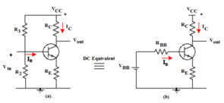
Fig: DC equivalent of self-biased circuit

V_{BB} = (R₂/(R₁+R₂))*V_{CC}
V_{BB} = i_{b*}(R₁//R₂) + V_{BE} + i_{b*}(β+1)

When V_{CC} is getting larger, V_{BB} would increase, causes i_{b} to increase, i_{c} flowing through LED would be larger after the transistor amplification (i_{c} = β*i_{b}). Therefore, the brightness of LED would be stronger. This induces the signal received at the receiver side. Once the voltage level set at too extreme level, the transistor may operate at cut-off or saturation region and most importantly, there would be a potential risk of burning out the LED as its peak forward current is at 100mA . As such, we have decided to set at 9V as the voltage supply to the circuit.

Finding out Q-point
To maximize the brightness of LED and at the same time, to make sure the transistor operates at the linear region, we adjusted with fine tuning on the variable resistor (VR₁) manually for getting the Q-point in order to optimize the operation. The voltage at collector pin to ground should be half of V_{CC}, that is approximated to 4.5V(though we should first calculate the Q-point in order to find out the operating region of the circuit).

Components used
The model of LED (C503B-WAN) and BJT (2N3904) used in our project were based on the one that provided by the lab manual. Their nature of operation were characterized on the data sheet provided.
We decided to use the resistors’ value that were recommended on the lab sheet, as such, there were no modification on the transmitter part by using the lab circuit as our reference.

Receiver part

Voltage supply
Similarly, we have chosen 9V to be the supply voltage in the receiver circuit.

Components used
The model of photodiode and the FET haven’t changed, that is PD204-6C and 2N5459.
The circuit was connected to the speaker to test the sound quality and loudness to verify the voltage gain and filtering of noise signal. The capacitor C₅ was used for noise filtering purpose whereas C₃ was used for blocking d.c signal from FET. The source part at FET and emitter part at BJT were used for determination of cut-off frequency. However, the receiver circuit provided in the lab sheet was not perfect. Here are the illustration:

The circuit was too sensitive to interference from human body, that is when someone is getting closer to it, the voltage gain would be fluctuated. It could be verified by using with a speaker which the sound broadcasted was full of noise and unstable.

To deal with, we decided to replace R₂ from 100kΩ to 300kΩ. Experimental result has shown that the sensitivity to interference was greatly dropped and hence the voltage gain was stabilized. This could be explained when the resistance of R₂ changed both the a.c and d.c biased of the circuit.

Apart from replacing R₂ with a larger resistance value, the emitter circuit at BJT has also been modified. Our group decided to split an individual 1kΩ resistor (R₆) into 2 separate resistors (R_{E1} and R_{E2}, R_{E2} is the one that bypassed by capacitor C₆). Their equivalent resistance were still remain approximately at 1kΩ which R_{E1} was chosen to be 200Ω (actually is 240Ω) and R_{E2} was at 800Ω (actually is 780Ω). The reason for the modification was to suppress the output voltage gain at a.c small signal when R_{E2} was bypassed by the capacitor C₆. The workout is shown as follow:

Before modification:
Voltage gain A_{V} = V_{o}/V_{i} = (-β_{f}*R_{C})/r_{π}
After modification:
A_{V} = (-β_{f}*R_{C})/(r_{π} + R_{E}*(β_{f}+1)) , which the gain is smaller after modification

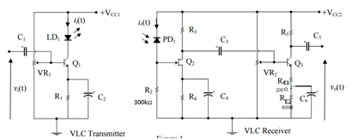
Fig: Modification in receiver circuit

Maintaining the ratio of R_{E1} to R_{E2} in 1:4 was crucial as the resistors together with the capacitor at emitter would affect the frequency response and hence the cut-off frequency of circuit base on the following relationship:

Cut-off frequency = 1/(2π(R_{out}*C_{E})) where

R_{out} = (R_{E} *(r_{e} + R’_{in} / h_{fe})) / (r_{e} + R’_{in} / h_{fe}) + R_{E}

r_{e} = V_{T} / i_{e} (nature of BJT) and R’_{in} = R₃

As the formula suggested, when resistance R_{out} increases, the cut-off frequency would be shifted to the left (becomes smaller). Therefore, when the circuit was tested by using the ratio of 1:1 (500Ω each), 2:3 (400 and 600Ω), 3:7 (300 and 700Ω), the cut-off frequency was still far from expected 15kHz. But as long as choosing the resistors at a ratio of 1:4(200 and 800Ω), the cut-off frequency was then approximate to 14.7kHz which meets the requirement of attenuating the voltage signal to 3dB. This tells that choosing an appropriate resistance value is crucial for the circuit design.

(Transmitter circuit see the Appendix 1)
(Reciver circuit see the Appendix 2)
(1M transmission see the Appendix 3)

Testing
Transmitter testing
For testing our transmitter part, we supply 9V as VCC and provide the 140~200mV Vpp sin wave form signal generator as the signal input connect to Base Pin of the BJT(2N3904). The oscilloscope testing pin was connected to the Connector pin of BJT to check the output signal performance.

Receiver testing
For testing receiver part, we supply 9V as VCC and provide the 140~200mV Vpp form signal generator as the sin wave as the signal input connect to Gain pin of JFET (2N3904). The oscilloscope testing pins were connected to drain pin of JFET and Connector pin of BJT (2N3904) to check the output signal performance.

Cover all Testing (signal generator)
Using Photodiode to receive the signal which transmitted by the LED of transmitter. Both part used 9V as VCC and supply 140~200mV Vpp sin signal to input of transmitter .Then, we connect the oscilloscope testing pin to receiver Connector pin of BJT for check the final output signal performance.In this part will tested different ratio of the RE.

Cover all Testing (play music)
After the testing by signal generator, we used phone as the signal input and connected output pin of receiver to speaker. We try to play music form the phone and check the speaker response.

Result

The result of the Cover all Testing (signal generator) result:
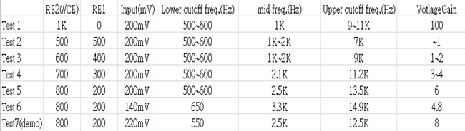

For the result, We found that the RE1(200) and RE2 (800) performed better result for our requirement. The gain also had 6~8 and bandwidth about 500 to 15K Hz. Therefore, we chosen this ratio of our receiver BJT RE.

(The test 6 result see the Appendix 4)
Discusssion and Conclusion:
After doing the experiments, we successfully transfer an audio signal within 1m by using a LED. The method we use is to first amplify the input signal with a BJT (2N3904) using Common Emitter, and then carry this frequency to the LED emitting frequency, and transmit the signal. And then we receive the light source and doing filtering and mainly pick up signal with a FET (2N5459) by acting like a switch, and hence amplifying the signal with a Common emitter again.

Throughout the whole experiment, we found that, in mid-frequency and high frequency, the coupling capacitor in the Common emitter also function differently. (i.e. the coupling cap bypassing the resistor in the emitter pin of the BJT is short in high frequency and remains open in mid-frequency). In ideal case we just want to by-pass the Re with a cap, and make the output impedance with the load resistance (RL) is varying with the RL, hence maximize the output power. But in our experiment, the gain cannot be too high, as the transistor power will be saturated if the gain is too high. So we finally remain an emitter resistor (Re) to reduce the AC gain.

Circuit below with the coupled RE only, in AC equivalent, the gain is too high, hence result in power saturation, the bandwidth becomes infinity long, signal cannot be analyzed.

The Circuit below with the coupled RE and a Re in series, resulted a smaller AC gain, hence, no saturation in this case, and the output bandwidth is limited, and the lower cutoff frequency is 600 Hz and reached a -3dB bandwidth at 14.9k Hz (higher cutoff frequency).
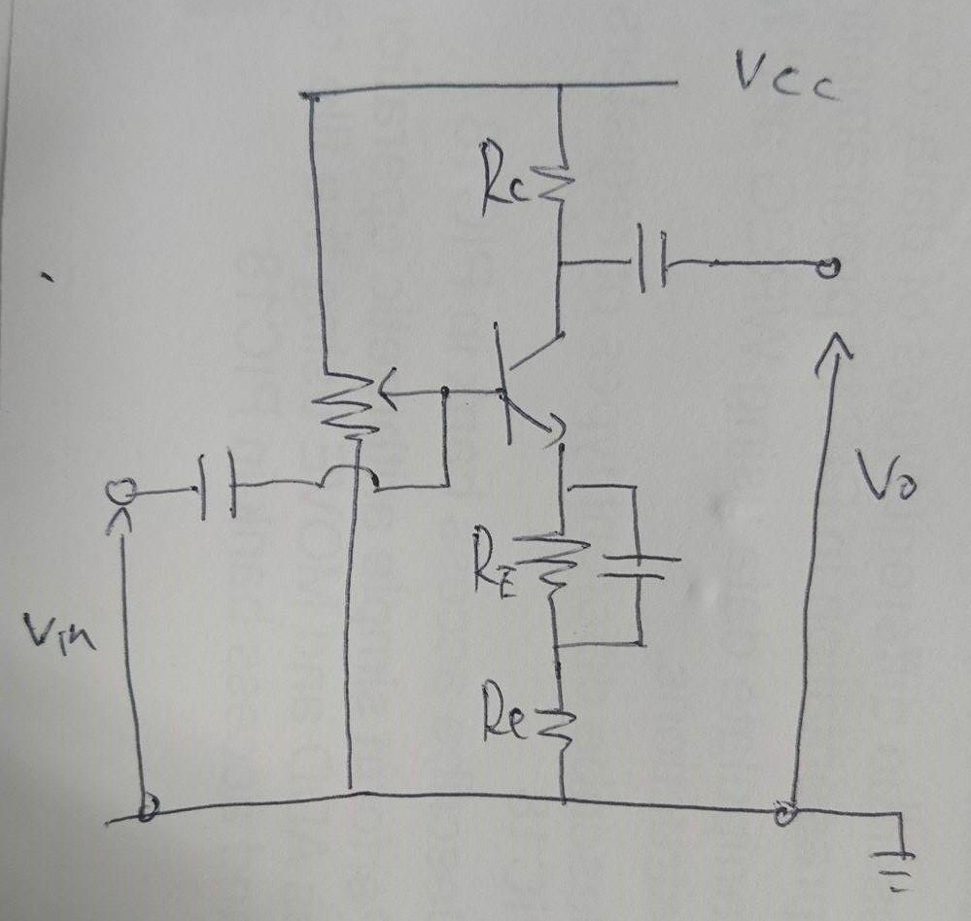
In this lab, we found that to analyze whether we should consider the current gain or the voltage gain is an important part. Because different transmission module, for say the LED, is a current dependent component, and also the RL type is also a consideration, i.e. the Speaker is s current related module, so we should analyze well with the type, if not the system will not function.

Also, the sensitivity of the demodulator is another parameter that matters, it affects the amplifying error in the receiver (i.e. the undesirable signals are also amplified). What’s more is the cut off frequency tuning, to achieve certain bandwidth, the impedance value should be calculated first, then be tuned in practical way.

All in all, different type of amplifier should be chose for different system characteristic.

Appendix1:Transmitter circuit

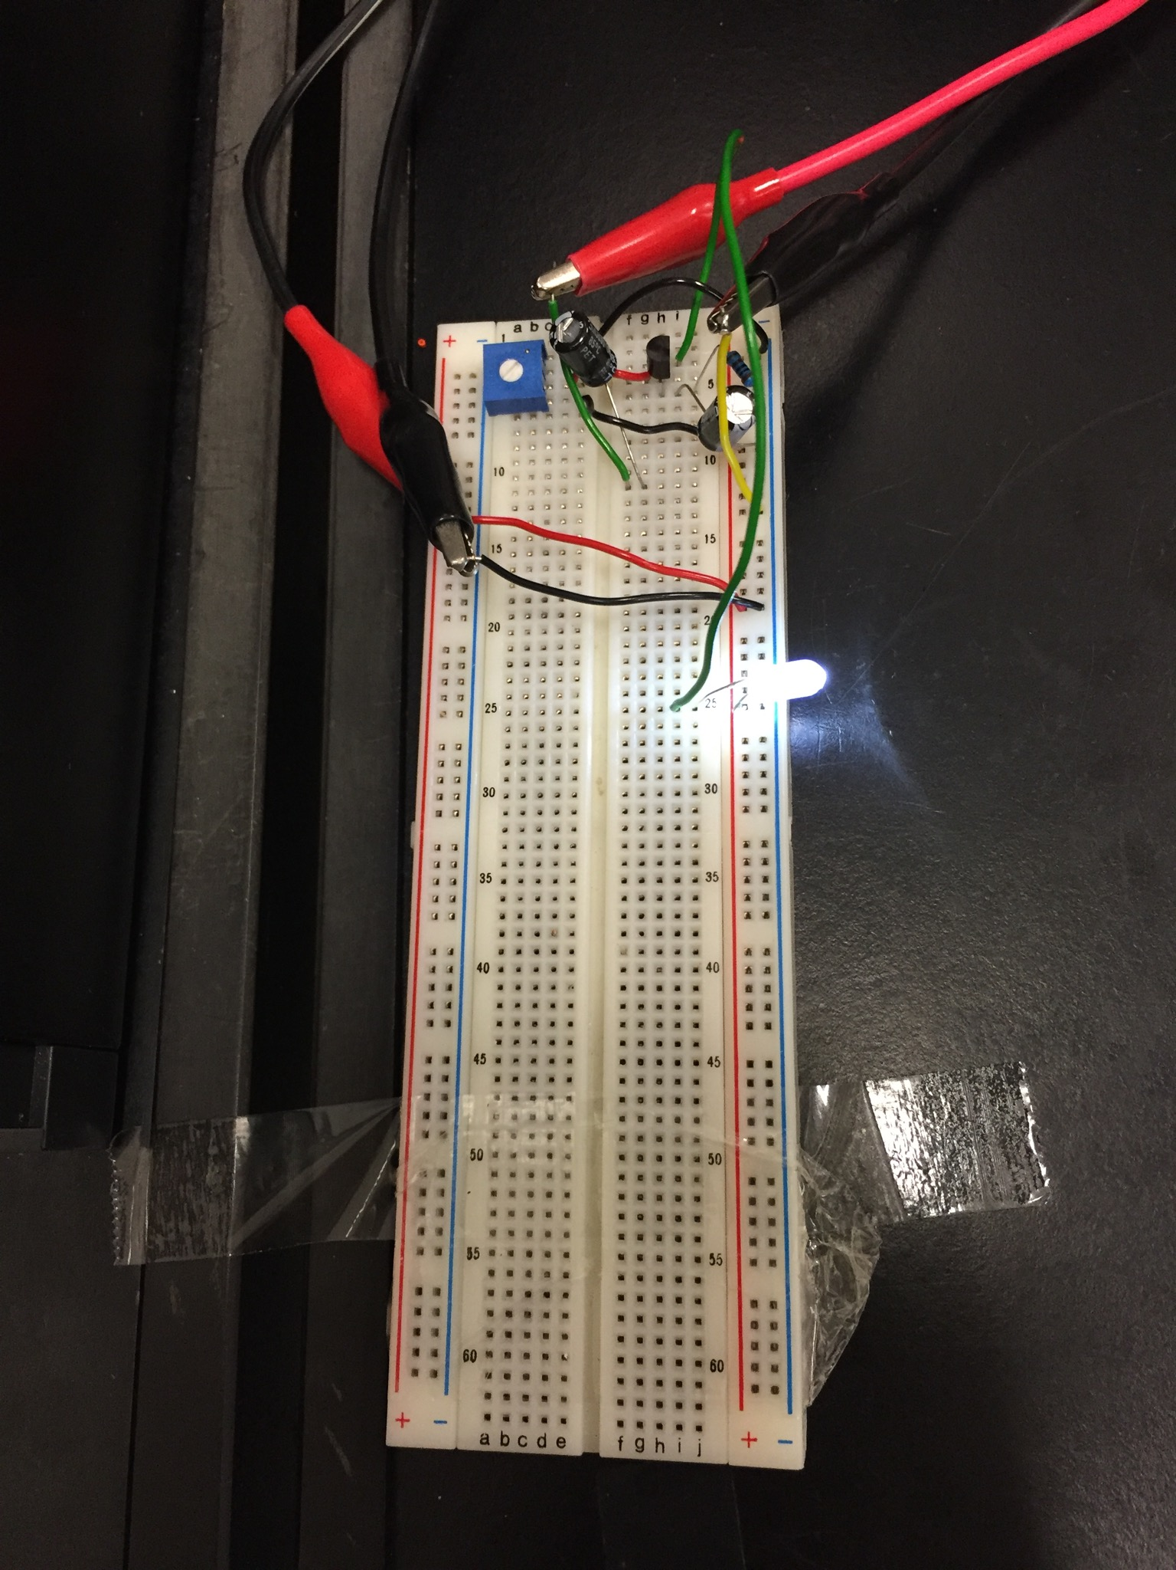
Appendix2:Reciver circuit
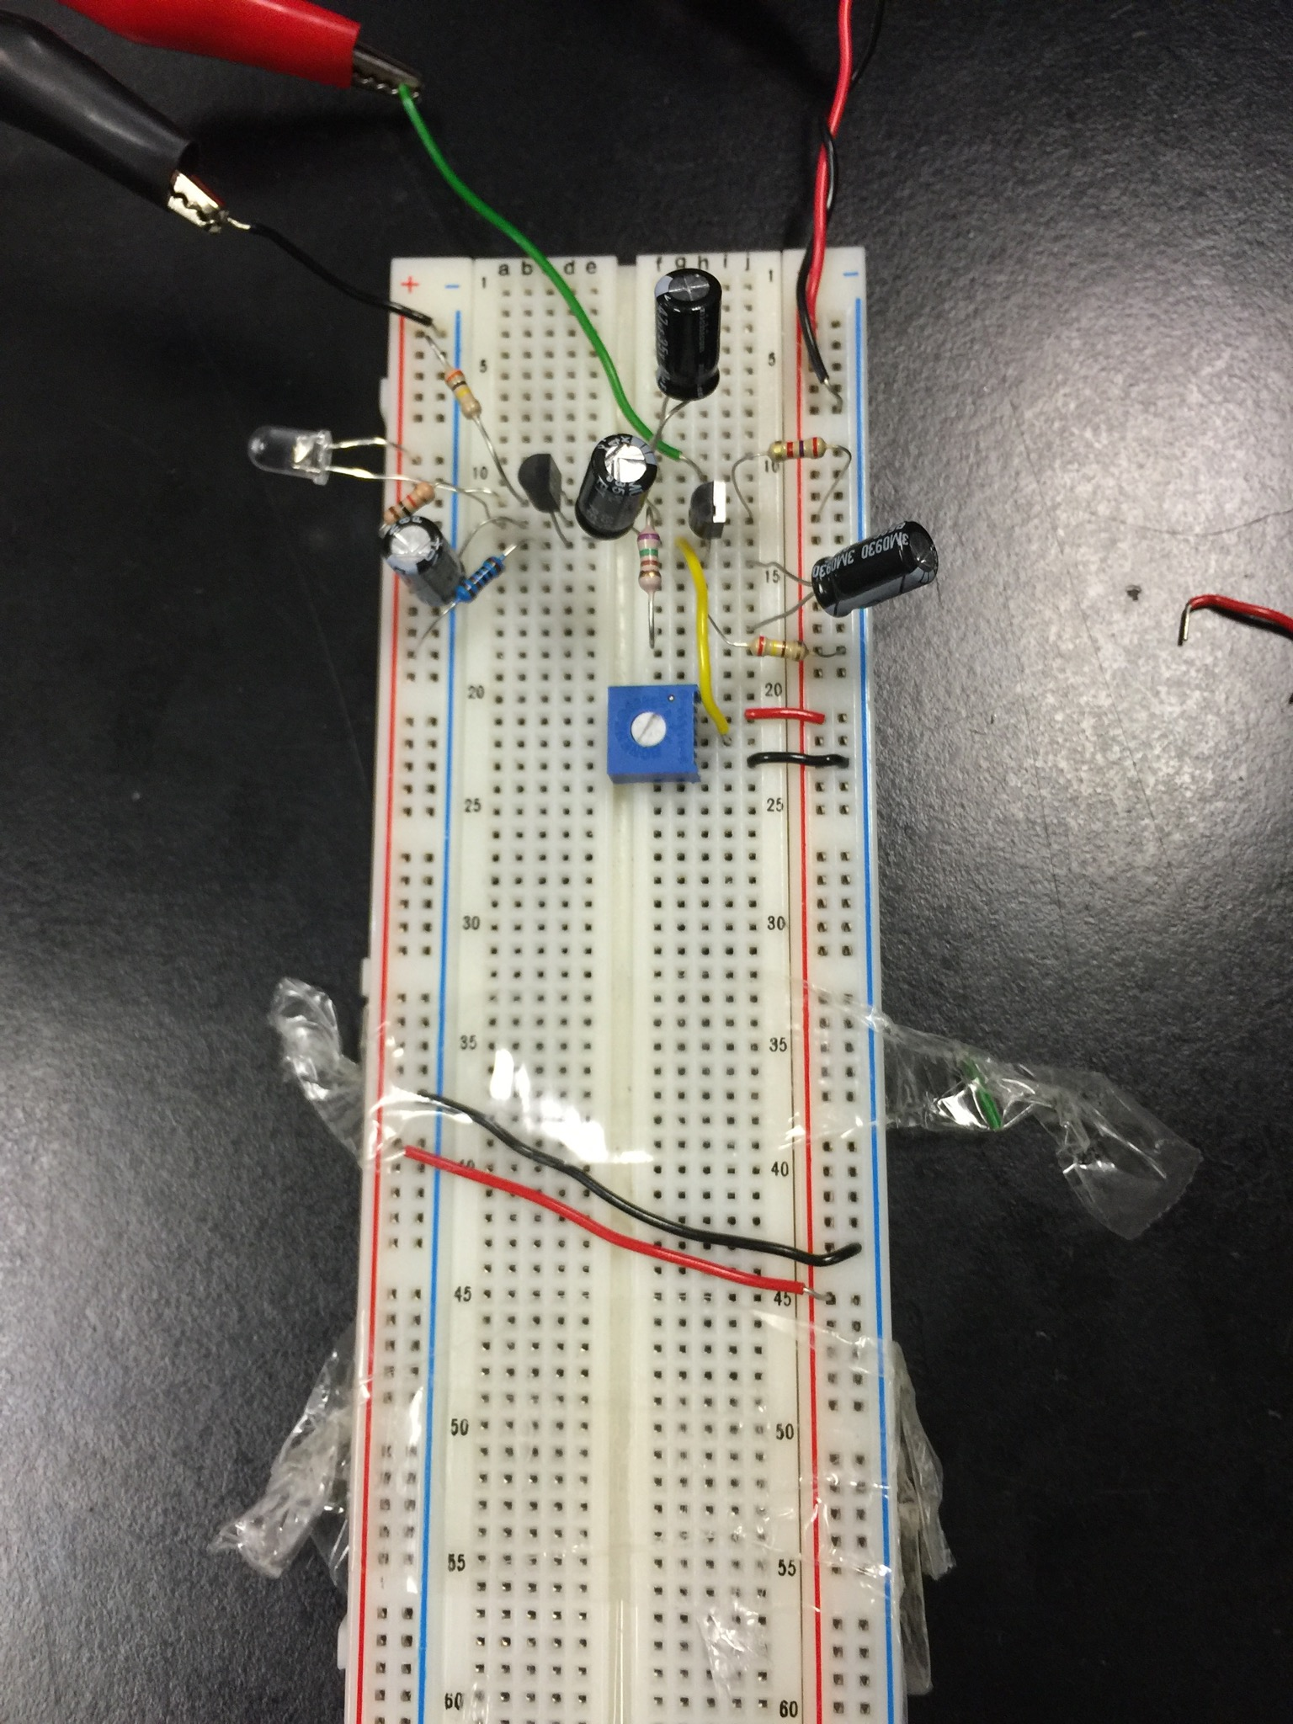

;
Appendix3: 1M transmission
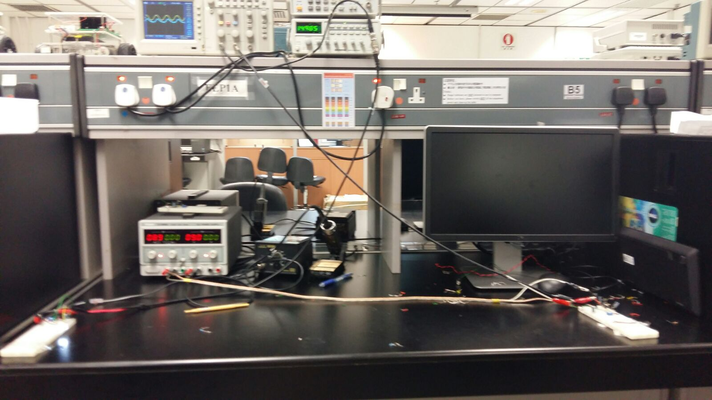
Appendix4:Test 6 result
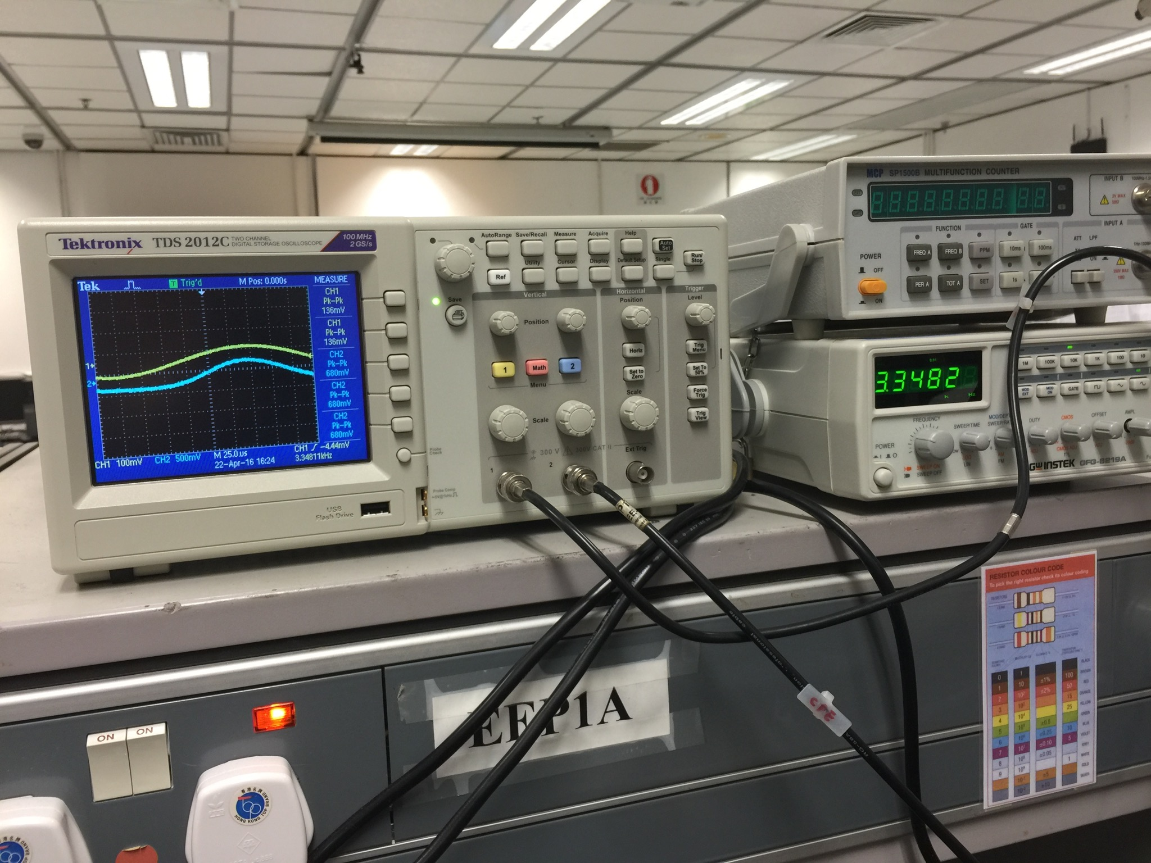
mid frequency

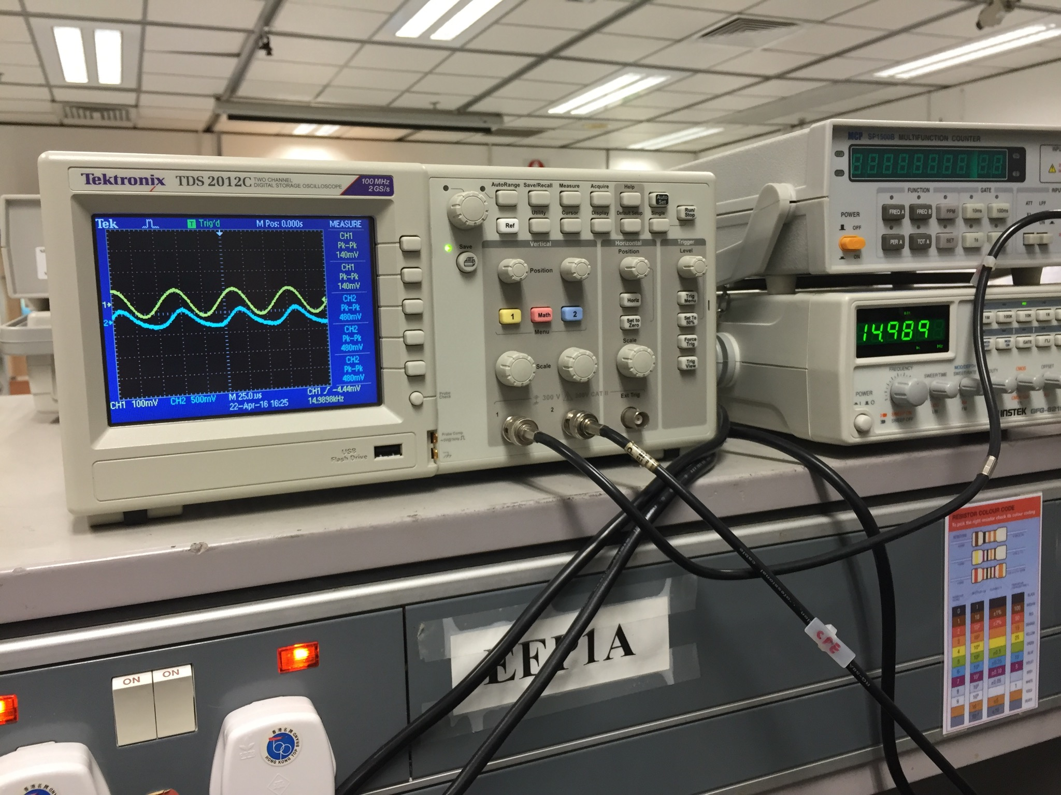
Upper cutoff frequency

