EE3211 Modelling Techniques
Week 6 Assignment

Greene and Touchstone conducted a study to relate birth weight and Estriol level in pregnant women as given in Table-1:
Table: 1 Sample Data from Greene and Touchstone study relating birth weight and estriol.

i | Estriol (mg/24 hr) xi | Birth weight(g/100) yi | i | Estriol (mg/24 hr) xi | Birth weight(g/100) yi
1 | 7 | 25 | 6 | 17 | 32
2 | 9 | 25 | 7 | 25 | 32
3 | 9 | 25 | 8 | 27 | 34
4 | 12 | 27 | 9 | 15 | 34
5 | 14 | 27 | 10 | 15 | 34

Q1. Derive the estimated regression line for the data. (2 points)
Q2. What is the estimated average birth weight if a pregnant woman has an estriol level of 15 mg/24 hr? (2 points)
Q3. If low birth weight is defined as ≤2500 g, for what estriol level would the predicted birth weight be 2500 g? (2 points)
Q4. Fit a linear regression model based on the data using R. (2 points)
Q5.Test for the significance of the regression line derived for the birthweight−estriol data. (2 points)

EE3211 Modelling Techniques
Week 2 Assignment
Name:

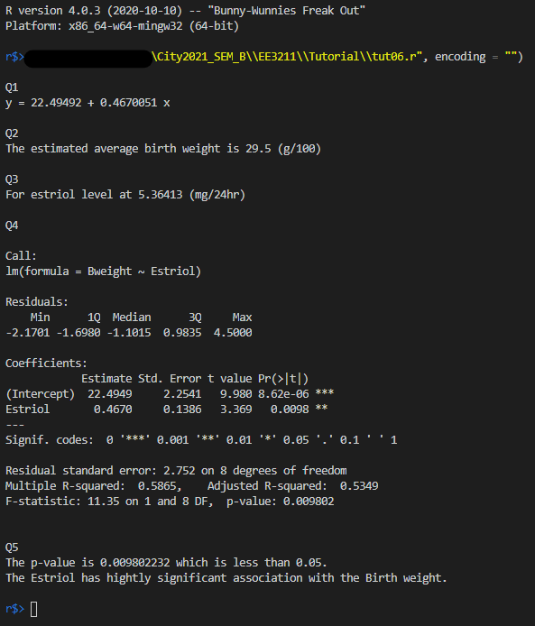

Q4. Plot
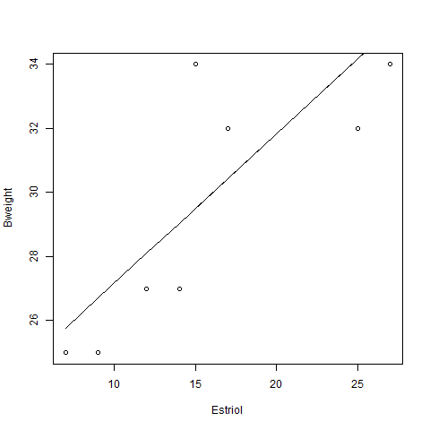

Code:
