EE2004 Microcomputer System
Sem B. 2018-19
In Class Exercise – Timer
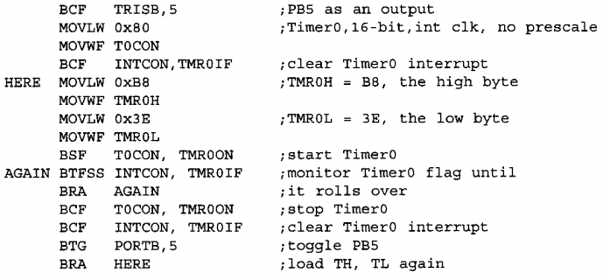
- Find the delay generated by the following codes with Fosc= 10MHZ with no prescaler

Solution
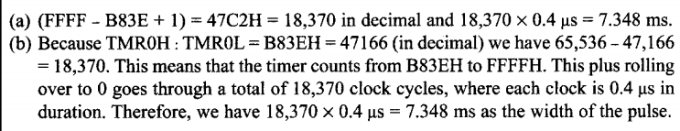

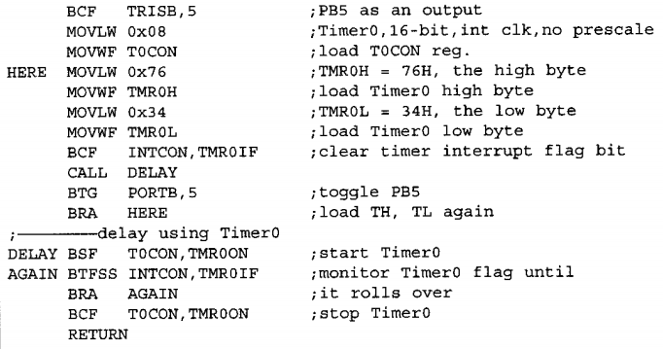
2.

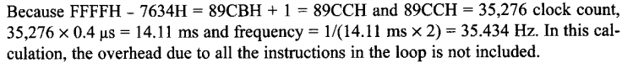

3. Given Fosc = 10 MHz, write a program to generate a square ware with a period of 10 ms on pin PORTB.3 (with the use of a delay sub-routine).
