EE 4215 –Security Technology

Assignment 3 – Due date: April 8, 2019 (Monday) – mid-night Electronic submission only on Canvas

Name: _________ Date: _29/03/19___
Student ID: __________ Mark: _______________

Submission guidelines:

- Please prepare your assignment in “PDF” format.
- For observe the departmental rules for late submission (i.e. 50% deduction per day).

Security Management

- Assume that you are a manager responsible for the security of e-Banking systems in a bank. You heard that Hong Kong Monetary Authority (HKMA) had a guideline called the “Supervision of E-banking”

  - Google for the document, and give the URL showing where the above HKMA guideline for e-Banking can be found.

https://www.hkma.gov.hk/media/eng/doc/key- information/guidelines-and-circular/2004/TM-E-1.pdf

  - Read the HKMA guideline. Briefly describe at least three major technology-related controls relevant to e-banking that you need to consider in your e-Banking infrastructure.

[Hint: you only need to give a brief description (that is, a few lines) summarizing the main points. Please don’t simply copy pages of paragraphs from the HKMA document without understanding. ]

- Authentication of customers
Authenticate the customers with appropriate techniques. For example, ids, passwords, digital certificates or security token generates by hardware etc. Meanwhile, implement security measures to ensure the ids and passwords are safe such that the account is still safe even the user’s pc is corrupted by virus, worm, etc.

- Internet infrastructure and security monitoring
Appropriate detection system should be setup such as the configuration of servers, routers, firewall and DMZ etc. This is to monitor the internet infrastructure and detect and alert for suspected intrusions.

- Application security
Think carefully for what programming language and development tools will be used while developing an e-banking application and hide the error messages which are not supposed to reveal to the outsider. Otherwise, system vulnerabilities may be disclosed.

  - Your e-Banking system is using a Cisco firewall to protect the Internet perimeter and your IT colleagues are familiar with this firewall. Now, to strengthen the security, it is proposed to purchase for another firewall to set up another tier of internal firewall. Your IT colleagues proposed to purchase the same Cisco firewall and use it as an internal firewall. Would you approve this proposal? Why?

I would not approve this proposal. This is because if the same firewall is implemented for both external firewall and internal firewall, they share the same vulnerability. If the hacker can bypass the external firewall, this implies that that hacker is very likely to able to bypass the internal one. Thus, the internal firewall doesn’t serve as a guide to the sensitive data. As a result, the same Cisco firewall should not be used as internal firewall.

Public Key Systems

- Use the Euclidean Algorithm to find the greatest common divisor of 12,345 and 67,890.

gcd(12345, 67890) = gcd(67890, 12345)
= gcd(12345, 6165)
= gcd(6165, 15)
= gcd(15, 0)
The greatest common divisor is 15

- In the RSA cryptosystem, it is possible that M = C, that is the plaintext and the ciphertext are identical. For modulus N = 3127, and encryption exponent e = 17, find a message M that encrypts to itself.

M^e mod N = C

To find a message that encrypts to itself, it has to fulfil:
M^e mod N = M

M^17 mod 3127 = M
Let M = 1
1^17 mod 3127 = 1
M = 1

There are still some other possible solutions such as 235, 295, 530

Technical Tools

- Network packet sniffing.

  - Install Wireshark to your machine. Please show evidence (e.g. screen dump) that you have downloaded and installed this package into your personal computer.

It can be observed that the software is recently downloaded.
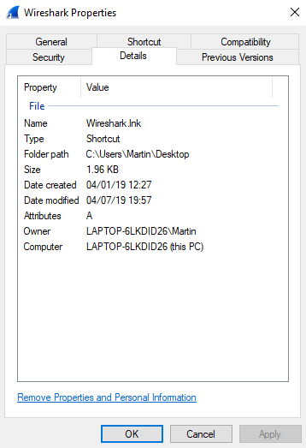
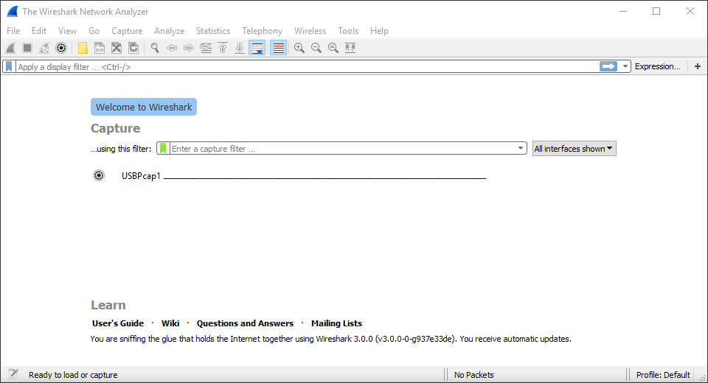

  - Describe the purpose of this program. How do you start capturing the packets, and how do you use filters for just TCP packets?

It is a packet analyzer. It can capture network packets and display the data inside to the user.

To start capturing packets, double click on the desired interface. In the case, wi-fi is chosen. To filter TCP packets, type tcp into the display filter bar
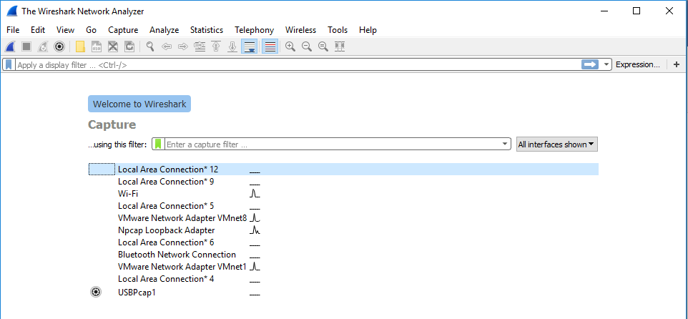
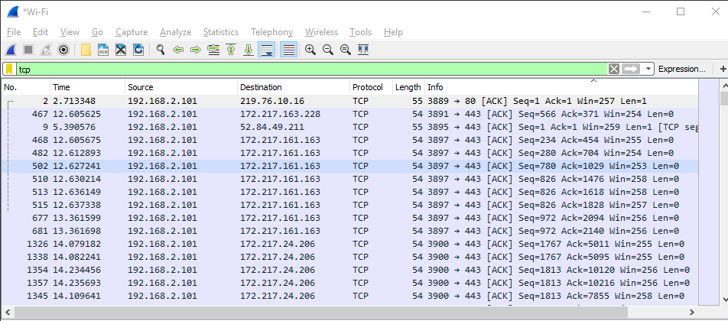

  - Start capturing the packets. While packet collection is still running, attempt to access to your email. Describe:
    - How you access to your email (e.g. using webmail, or pop3, etc)
    - Can your username and password be seen during the sniffing process?
    - During the sniffing process, can you observe other network protocols in addition to the protocol that you used for email access? If so, name two such protocols and briefly explain why they exist.

I access my email via webmail. In this trial, gmail is used.

I enter my password and username of gmail. The username and password cannot be seen since they are protected by TLSv1.2 protocol.

During the process, DNS and TLS are used. As mentioned above, TLS is needed as it helps to encrypt the data during the email access process. This is important since nobody wants their username and password to be intercepted by others. On the other hand, DNS is used since it is a webmail. It needs to translate the URL to IP address, so we can access the webpage.

- Install a mobile banking app to your iOS or Android device (if you don’t have these devices, do this exercise with a web browser connecting to an e-banking site).

  - Name the app or web environment you will use in this exercise.

Hang Seng Bank:
https://www.hangseng.com/zh-hk/e-services/personal-ebanking/hk-personal-ebanking/

Web environment:
Firefox Quantum 66.0.2 (64 bits)

  - Google for “web debugging proxy”. Pick one of such tools (e.g. “Fiddler Web Debugger”, “Burp Suite”, etc) and attempt to use it as a proxy to capture the list of URLs visited by your chosen mobile banking app.

Go to the login name, and arbitrary input values to attempt to login (You don’t really need to login with a valid username / password; a failed login is good enough. But please only try it once)

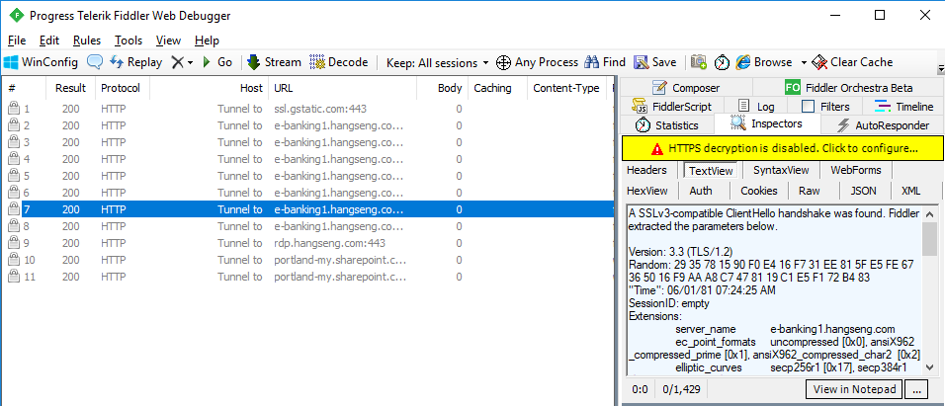
Show the list of URLs that will be involved in the login process. Are all requests to the bank protected by SSL?

The left hand side of the photos show the URL involved and we can see the requests are protected by SSL if we look at right hand side of the photo carefully. It can be seen that TLS is implemented.

  - Display the digital certificate of the HSBC HK website, and elaborate what kind of encryption standards are being used in this certificate.

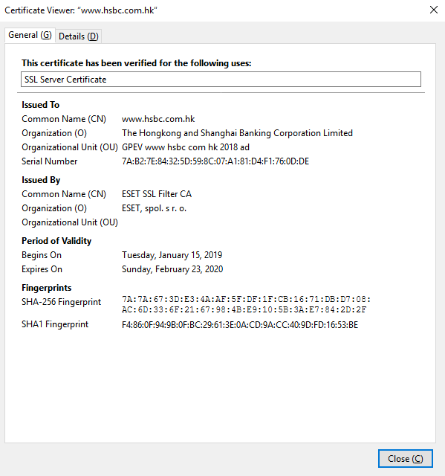
This is the digital certificate of the HSBC HK website

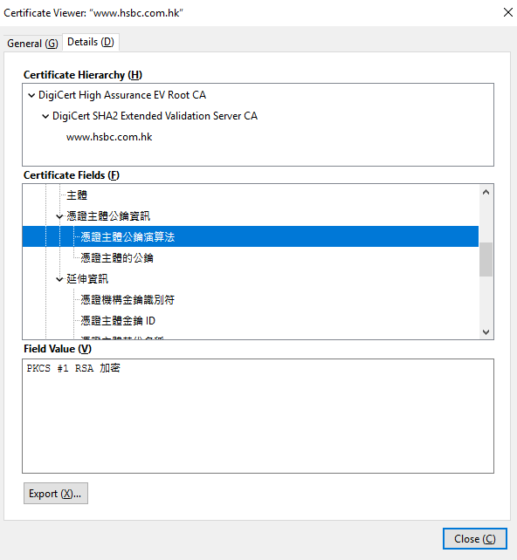
It can be observed that RSA encryption standard is used and the key size is 2048 bits.

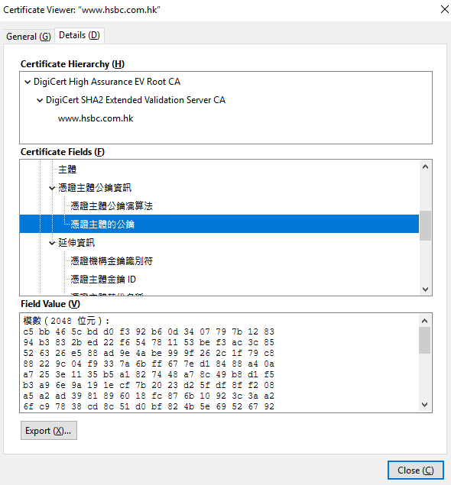

~ END ~

