EE3211 Modelling Techniques
Week 5 Assignment Answer
Q1.
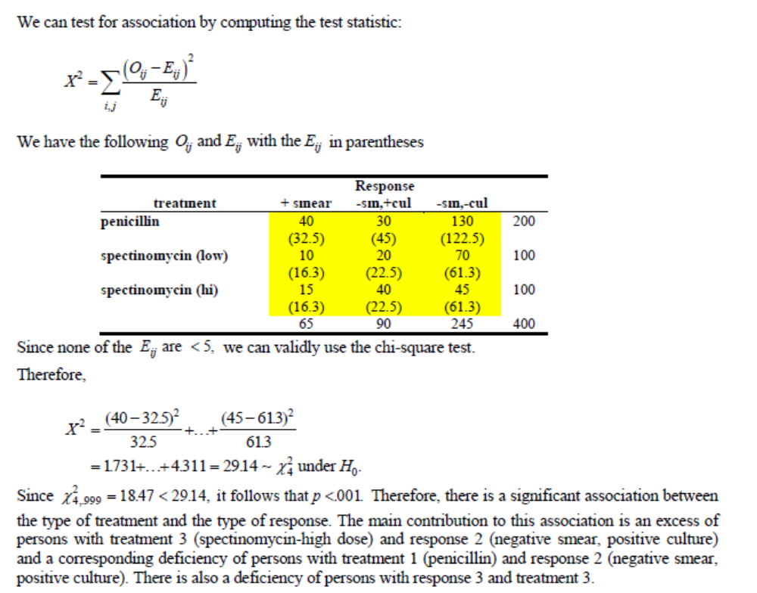
Q2.
