EE 2000 Logic Circuit Design
Semester A 2021/22
Tutorial 9

- Construct a 4 x 16 decoder (with enable input) using five 2 x 4 decoder (with enable input) modules. Show the schematic diagram neatly.

Answer:

- How many selection lines are contained in a multiplexer with 1024 inputs and one output?
Answer: log₂1024 = 10
What is the largest number of data inputs which a multiplexer with k input selection inputs can handle?
Answer: 2^{k}
For the multiplexer circuits shown in the following figure below, what are Y₁(A, B, C) and Y₂(A, B, C) respectively? Please list in standard sum of products form.

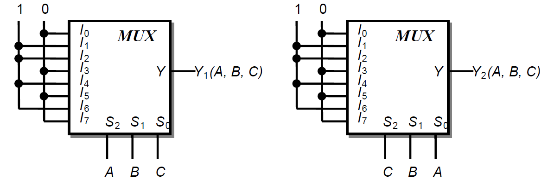

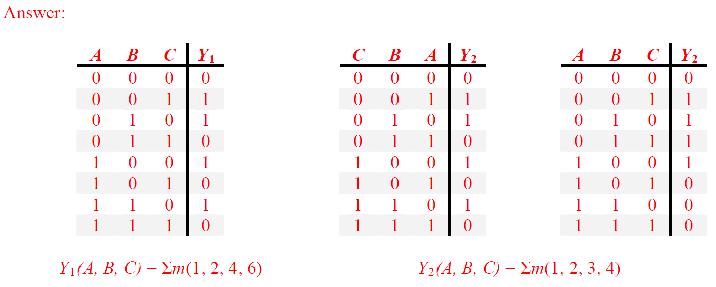

- Implement the function f(a, b, c, d) = Σm (1, 2, 5, 7, 9, 11, 13) using:
(a) A 8-to-1-line multiplexer and a NOT gate only
(b) A 2-to-1-line multiplexer and minimum number of AND, OR, NOT gates
(Hints: Assign variable a as selection input of the MUX, and then express f as a function of b, c, d with the help of K-map)

Answer (a) :

Answer (b) :
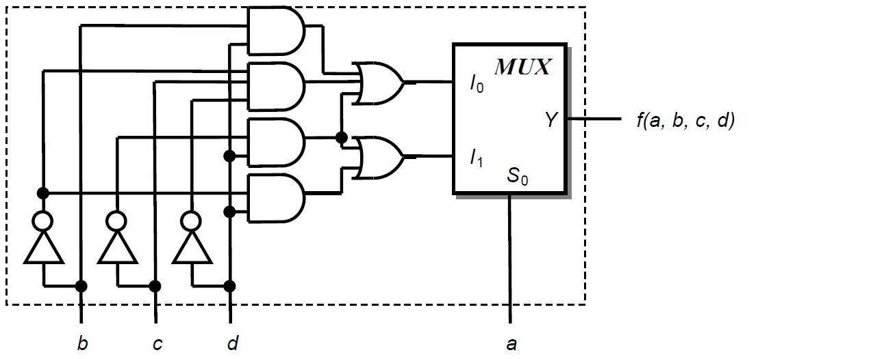

- Draw the PAL diagram for the following truth table.
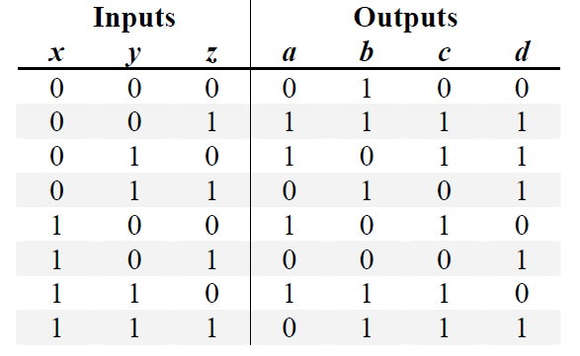

Answer:
- Simplify the output in SOP. Minimum the number of product terms.

- Create the PAL programming table.

