EE2005 Lab Report

Operational Amplifier

Lab Section: L01

Abstract

The objective of the experiments in Lab 5 was to familiarize with the properties and operations of the Operational Amplifier. In task 1, we were required to implement an inverting amplifier on a breadboard by using the LM3558 operational amplifier and resistors. In task 2, we were required to implement a DAC using op amps on a breadboard by using the LM3558 operational amplifier, resistors and the 4-channel SPST switch. In task 3, we were required to implement a comparator using op amps to drive an LED at the output by using the LM3558 operational amplifier, resistors, the 4-channel SPST switch and LEDs. In Conclude, we found out that, we could implement an inverting amplifier, a DAC and a comparator by using the LM358 dual op amp.

- Description of Components
  - LM741 operational amplifier (op amp)

Op amps usually made of resistors, bipolar junction transistor, capacitor, and diodes. The characteristics of an ideal op amp are the following: infinite open loop gain, infinite input resistance and zero output resistance. It can preform methodical operations with external components like addition, subtraction, multiplication division, differentiation and integration.

In this lab, we used the LM741 as our op amp. According to Texas Instruments, LM741 are made of resistors, capacitors and bipolar junction transistor [1]. Fig 1 shows the functional block diagram of LM741. According to Texas Instruments, for LM741, Pin 1 and Pin 5 are the offset null pin used to eliminate the offset voltage and balance the input voltages. Pin 2 is the inverting signal input. Pin 3 is the noninverting signal input. Pin 4 is the negative supply voltage. Pin 6 is the amplified signal output. Pin 7 is the positive supply voltage. Pin 8 has no Connect.

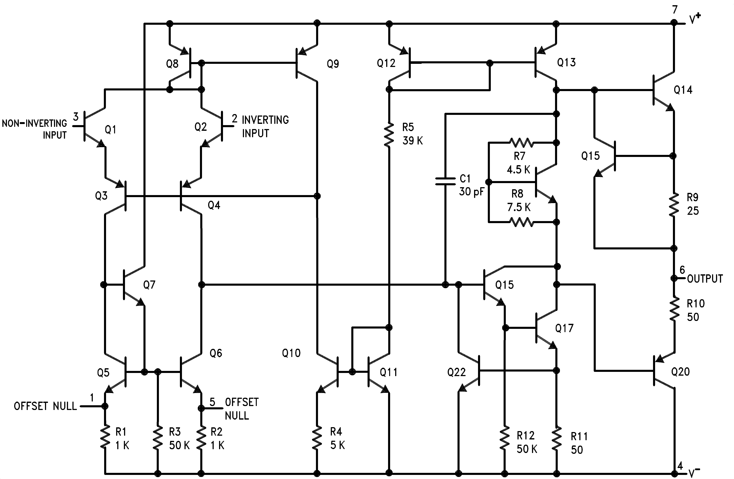
Fig 1: The functional block diagram of LM7413 [1]
  - Resistors

Different resistors are used in this lab, as for controlling the close-loop gain of the circuit. In task 1, one 1kΩ resistor and one 4kΩ resistor are used. In task 2, two 1kΩ resistors, one 2kΩ resistor, one 4kΩ resistor, one 8kΩ resistor are used. Task 3 use the same resistors from task 2 but with one more 270Ω resistor.

  - DIP Switch SPST x 4

DIP Switch SPST x 4 is used in task 2 and task 3, in order to provide us a $2^{4}=16$ different input binary combinations by controlling the resistance of the inverting signal input and the noninverting signal input.

  - LED

A LED is used in task 3, to implement a LED alarm that lights up when the input combination exceeds a minimum set value.

  - Breadboard

Breadboards are used to connect the electronic components. It can let us easily insert any electronic components for prototyping any electronic circuit.

  - Digital multimeter

Digital multimeter are used for measuring the output voltage of the circuit.

  - Power supply

Power supplies are set to $±5V$ as the supply voltages to the operational amplifier. One power supply was used as the input voltage for the operational amplifier. And one power supply was used as the reference voltage for the LED.

- Introduction to the Design of the Circuit
  - Inverting Amplifier

In task 1, we use the op amp as an inverting amplifier, the output of op amp is connected to its input at $V^{-}$ , as shown as Fig 2/3. As it is an inverting amplifier, we can have a close loop gain with $\frac{V_{o}}{V_{i}}=-\frac{R2}{R1}$ by calculating with KCL and nodal voltage analysis.

In this task, we use resistors $R_{1}=1KΩ$ , $R_{2}=4KΩ$ , so the expected closed loop gain of this op amp is 4. We set set the limit on the maximum $V_{out}$ to $5.0V$ and the minimum $V_{out}$ to $-5.0V$ , so we expected the output voltage will be a value between +5V and -5V and the output voltage should not be greater than +5V or smaller than -5V.

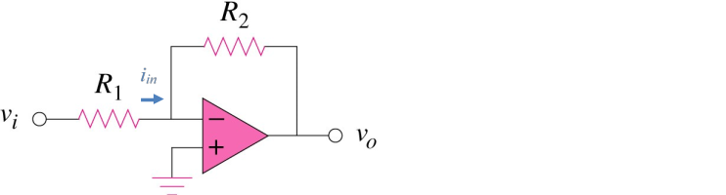
Fig 2: Circuit schematic of an inverting amplifier [2]
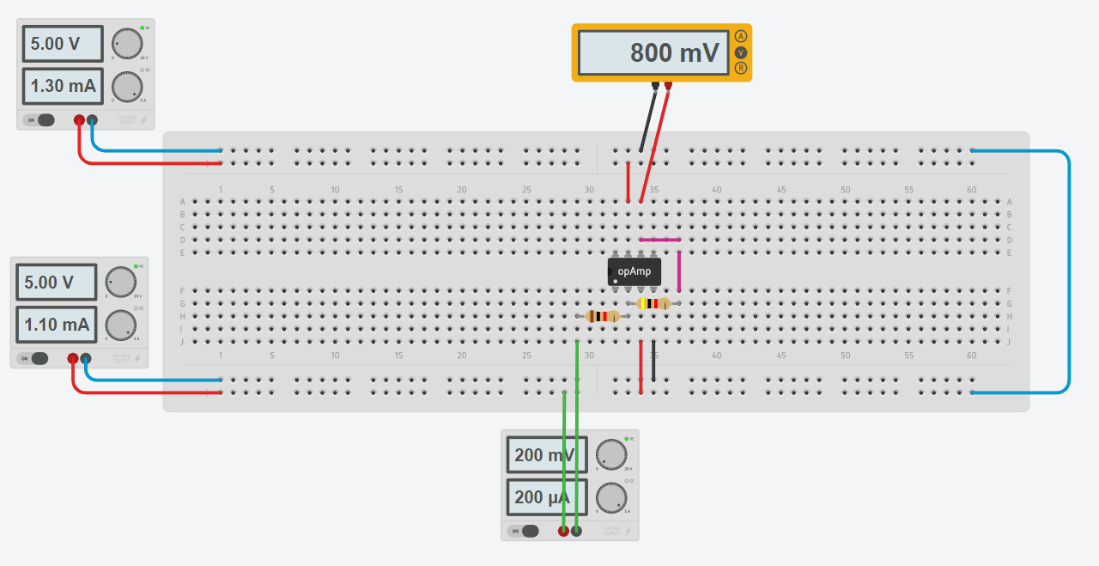
Fig 3: Circuit for task 1

  - DAC

In task 2, circuit is built base on fig 4 and the circuit we build is shown in fig 5. This circuit aims to cover a $2^{4}=16$ 4-bit binary signal into analogue signal by using op amp and resistors. The op amp in this task is used as a summing amplifier, with $-V_{o}=V_{i}\left(\frac{R_{f}}{R_{1}}B_{1}+\frac{R_{f}}{R_{2}}B_{2}+\frac{R_{f}}{R_{3}}B_{3}+\frac{R_{f}}{R_{4}}B_{4}\right)$ and $\left[B_{1} B_{2} B_{3} B_{4}\right]$ is the binary input with 1 is on and 0 is off.

In this task, we used different combination of resistors in order to simulate the result of the DAC. As $V_{i}$ is set to be 1V, the output voltage is expected to be a value between 0V and 2V and the output voltage should not be greater than 2V or smaller than 0V.

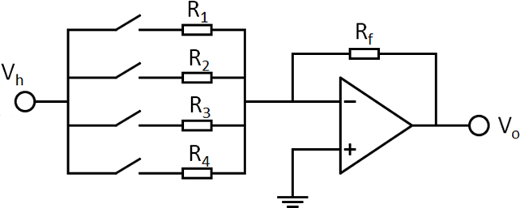
Fig 4: Schematic of DAC for Lab Task 2 [2]

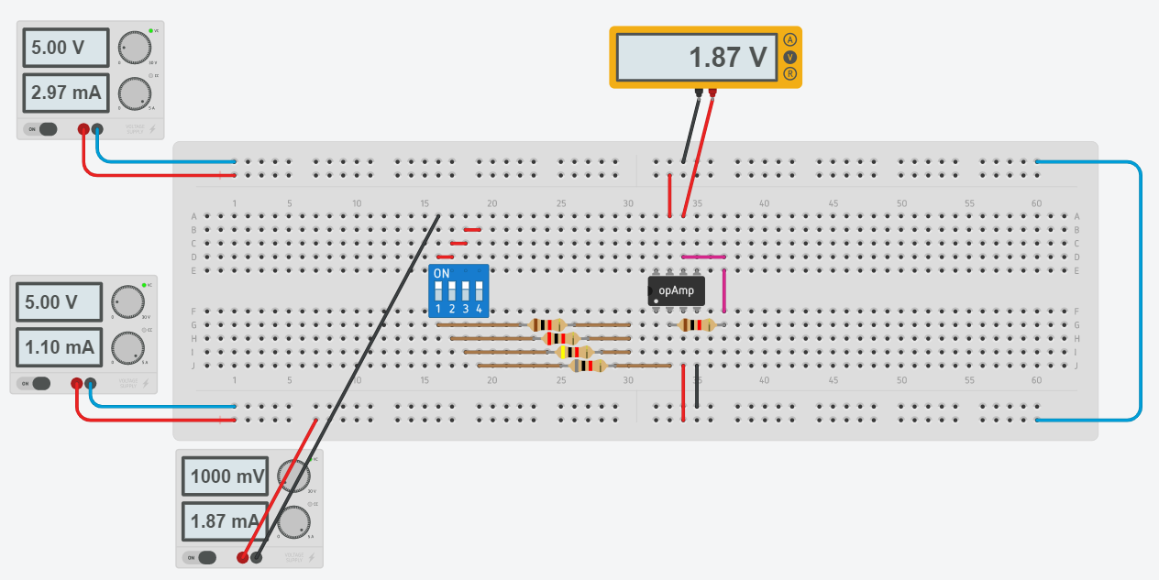
Fig 5: Circuit for task 2
  - Comparator

In task 2, circuit is built base on fig 6 and the circuit we build is shown in fig 7.

This circuit aums to compare the DAC signal the 1V from the power supply, in order to decided whether the LED is turn on or turn off. If the DAC signal is equal or larger than 1V, the LED will turn on, and if the DAC signal is smaller than 1V, the LED will turn off. The op amp in this task is used as a differential amplifier.

We expected to have a result that the LED will turn on when the DAC has the signal of [1 0 0 0] or greater than that.

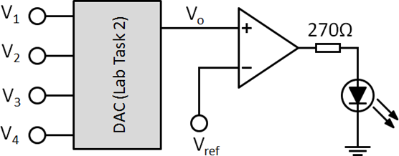
Fig 6: Suggested comparator circuit and LED connection with respect to DAC output (Vo) [2]

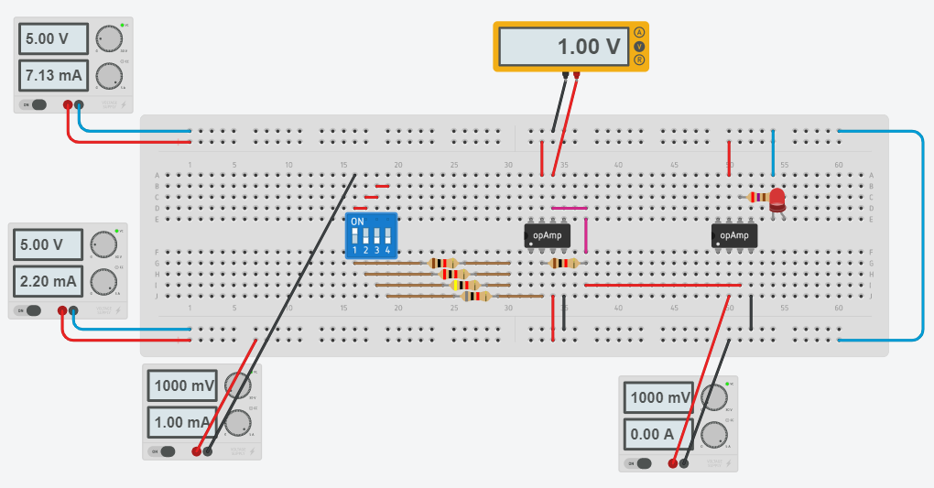
Fig 7: Circuit for task 3

- Results
  - Inverting Amplifier

By measuring, we know that, when $V_{i}=0.2v$ , the input current $i_{in}=199μA$ . Thus, we can calculate that input resistance of the circuit $\frac{V_{i}}{i_{in}}=\frac{0.2V}{199μA}=1.005KΩ$ .

In the graph, $V_{o}$’s minimum is 4.91V and the minimum is -4.91V, and the slope is flat when $V_{o}$ is close to $±5V$ , this is because we set the limit on the maximum $V_{out}$ to $5.0V$ and the minimum $V_{out}$ to $-5.0V$, thus $V_{out}$ cannot be higher than $5.0V$ or lower than $-5.0V$.

In this circuit, $\frac{V_{o}}{V_{I}}=-\frac{R_{2}}{R_{1}}$ , with $V_{o}$ is the output voltage, $V_{i}$ is the input voltage, $R_{2}$ is the source resistance and $R_{1}$ is feedback resistance. The close-loop gain of inverting amplifier circuit is $-\frac{R_{2}}{R_{1}}=-\frac{4KΩ}{1KΩ}=-4$ , which is a negative gain. The slope of the graph is $\frac{V_{o}}{V_{I}}$ , so the slope of the graph shows the amplifier gain by the circuit. If the value of $R_{1}$ is halved while $R_{2}$ remain unchanged, the slope of the $V_{o}$vs $V_{i}$ will be double. If the value of $R_{1}$ is doubled while $R_{2}$ remain unchanged, the slope of the $V_{o}$vs $V_{i}$ will be halved.

The slope of the linear best fit line of $V_{o}$vs $V_{i}$ follows the linear regression $Y=A+Bx$ with $A=0$ and $B=-3.341578$ , so $V_{o}=-3.341578V_{i}$ . The slope of the linear best fit line is around -3.341578 which is similar to the voltage gain we estimated before. Fig 8 shows record of measurements for inverting amplifier with $V_{o}$vs $V_{i}$.

Fig 8: Record of measurements for inverting amplifier with $V_{o}$vs $V_{i}$

  - DAC

The bits of the four-bit DAC are weight with each lesser bit has half the weight of the next hight bit, so choose $R_{1}=R_{f}$ , $R_{2}={2R}_{1}$ , $R_{3}={2R}_{2}$ , $R_{4}={2R}_{3}$ , in order to simulate logic low with all switches are off and logic high with all switches are on. The selected values of resistors for proposed DAC are shown on Table 1.

$$R_{f}$$ | $$R_{1}$$ | $$R_{2}$$ | $$R_{3}$$ | $$R_{4}$$
$$1KΩ$$ | $$1KΩ$$ | $$2KΩ$$ | $$4KΩ$$ | $$8KΩ$$
Table 1: Selected values of resistors for proposed DAC

The digital-to-analogue conversion measurement results are shown on Table 2. From measuring form the table, we can notice that, when the binary combo increased by 1, the measured value of $V_{0}$ will step up by one with 0.125V.

Binary combo | Value in decimal | Measured Vo
0000 | 0 | 0
0001 | 1 | 0.125V
0010 | 2 | 0.250V
0011 | 3 | 0.375V
0100 | 4 | 0.500V
0101 | 5 | 0.625V
0110 | 6 | 0.750V
0111 | 7 | 0.875V
1000 | 8 | 1.00V
1001 | 9 | 1.13V
1010 | 10 | 1.25V
1011 | 11 | 1.37V
1100 | 12 | 1.50V
1101 | 13 | 1.62V
1110 | 14 | 1.75V
1111 | 15 | 1.87V
Table 2: Digital-to-analogue conversion measurement results

In this circuit, $-V_{o}=V_{i}\left(\frac{R_{f}}{R_{1}}B_{1}+\frac{R_{f}}{R_{2}}B_{2}+\frac{R_{f}}{R_{3}}B_{3}+\frac{R_{f}}{R_{4}}B_{4}\right)$ , with $V_{o}$ is the output voltage, $V_{i}$ is the input voltage, $R_{f}$ is the feedback resistance, and $R_{1}, R_{2}, R_{3}, R_{4}$ are the resistance we choose in table 3. In theory, if $B_{i}=0$ the switch is off, if $B_{i}=1$ the switch is on, so when $\left[B_{1} B_{2} B_{3} B_{4}\right]=\left[0 0 0 1\right]$ , $V_{o}=0.125V$ ; $\left[B_{1} B_{2} B_{3} B_{4}\right]=\left[0 0 1 0\right]$ , $V_{o}=0.250V$ ; $\left[B_{1} B_{2} B_{3} B_{4}\right]=\left[0 1 0 0\right]$ , $V_{o}=0.5V$ ; $\left[B_{1} B_{2} B_{3} B_{4}\right]=\left[1 0 0 0\right]$ , $V_{o}=1V$ . The measurement is almost the same as the value we calculated. But we use the difference tolerance value for the resistors, the measuring value of the voltage output will be different.

  - Comparator

In task 3, we sued an op amp as an amplifier n differential amplifier, for comparing the voltage source voltage, to see whether it exceeded the required value, in this case it is $V_{ref}$.

LED alarm will light up when the input combination exceeds a minimum set value, we set this value with $V_{ref}=1V$ . we achieved this by using a comparator which compares the output of the DAC and the $V_{ref}$ . By measuring the result, the LED only light up when the output voltage is equal or greater than 1V, so when the voltage is below 1V, the LED will not turn on. Which means, only if the DAC have a binary signal reached or exceeded 1-0-0-0, the LED will turn on. The LED on-off measurement results are shown on Table 3.

Binary combo | Measured Vo | On / Off
0000 | 0 | Off
0001 | 0.125V | Off
0010 | 0.250V | Off
0011 | 0.375V | Off
0100 | 0.500V | Off
0101 | 0.625V | Off
0110 | 0.750V | Off
0111 | 0.875V | Off
1000 | 1.00V | On
1001 | 1.13V | On
1010 | 1.25V | On
1011 | 1.37V | On
1100 | 1.50V | On
1101 | 1.62V | On
1110 | 1.75V | On
1111 | 1.87V | On
Table 3: LED on-off measurement results

- Discussion

In task 1, comparing the experimental result, we have almost the same value to the theoretical predication since the we did the experiment online. If the tolerance of $R_{1}$ and $R_{2}$ are different, the experimental value will be different from the theoretical predication. As result, the actual output voltage, is affected and the value will be smaller.

In task 2, comparing the experimental result, we have almost the same value to the theoretical predication since the we did the experiment online. If the tolerance of $R_{1}, R_{2}, R_{3}, R_{4}$ and $R_{f}$ are different, the experimental value will be different from the theoretical predication. As result, the actual output voltage, is affected and the value will be smaller.

In task 3, comparing the experimental result, we have almost the same value to the theoretical predication since the we did the experiment online. If the tolerance of $R_{1}, R_{2}, R_{3}, R_{4}, R_{f1}$ and $R_{f2}$ are different, the experimental value will be different from the theoretical predication. As result, the actual output voltage, is affected and the value will be smaller.

- Conclusions
To concluded, in this laboratory, since the we did the experiment online, the value we measured is actually the same as the theoretical predication. But if we use the equipment in the laboratory, the measuring value will be different as the theoretical predication, as there will be internal resistance of the cable and breadboard, the voltage power supply of the amplifier may not be exactually $±5V$ as what we expected. Also, the tolerance of resistors in the laboratory may not be the same as the we use online. It may affect the result of the output voltage. As result, the actual output voltage, is affected and the value will be smaller.

References

[1] | T. Instruments, “LM741 Operational Amplifier datasheet (Rev. D),” 22 2 2020. [Online]. Available: https://www.ti.com/lit/ds/symlink/lm741.pdf. [Accessed 24 11 2020].
[2] | EE2005, “Online Lab 5: Operational Amplifier,” 2020.

