EE 2000 Logic Circuit Design
Semester A 2021/22
Tutorial 8

- An active-LOW SR latch is shown in Fig. 1, sketch the output waveform of Q based on the inputs as shown in Fig. 1. Assume that Q starts LOW.

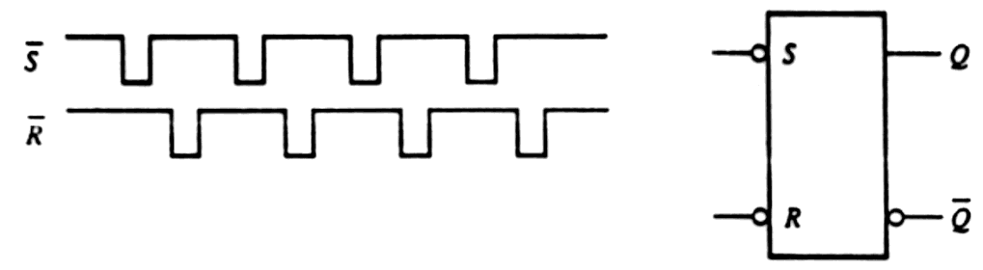
Fig. 1

- Two edge-triggered SR flip-flops are shown in Fig. 2. If the inputs are as shown, sketch the Q output of each flip-flop relative to the clock, and explain the difference between the two. The flip-flops are initially RESET.
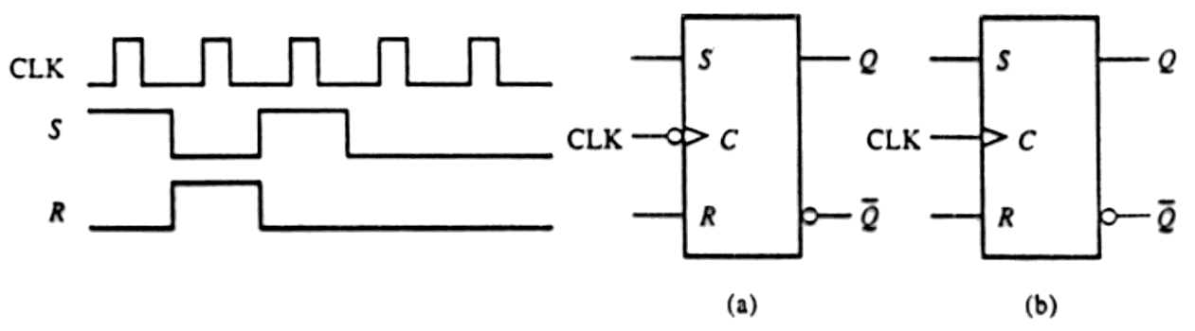
Fig. 2

- The waveforms of Fig. 3 are applied to the inputs of an SN7476 JK flip-flop (negative-edge triggered). Complete the timing diagram by drawing the waveforms of flip-flop output Q.

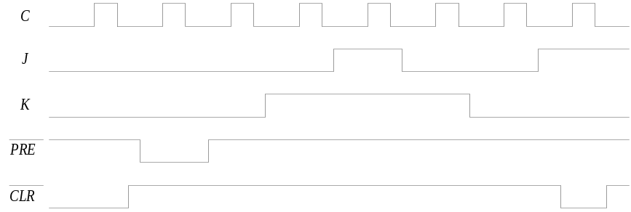
Fig. 3

- The circuit of Fig. 4 contains a D latch, a positive-edge-triggered D flip-flop, and a negative edge-triggered D flip-flop. Complete the timing diagram for the waveform of signals y₁, y₂ and y₃.
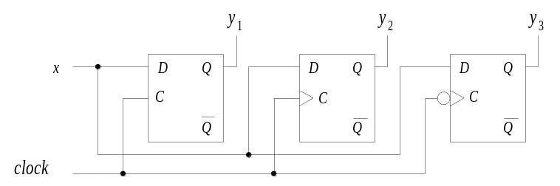

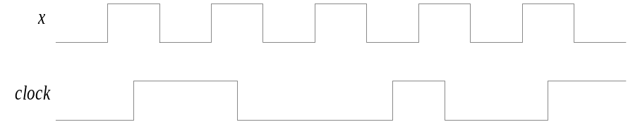
Fig. 4

- The circuit of Fig. 5 contains a negative edge–triggered JK flip-flop and a D flip-flop. Complete the timing diagram of Figure 6-7b by drawing the waveforms of signals Q₁ and Q₂.

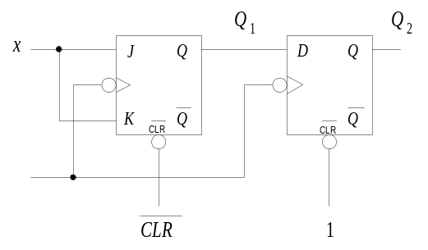

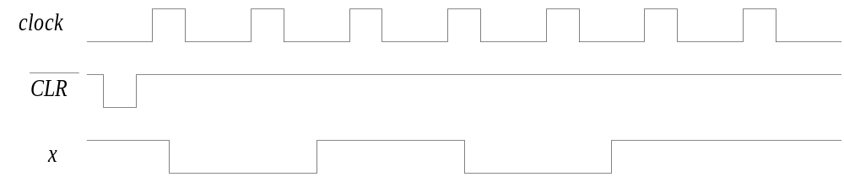

Fig. 5

