EE4215 Security Technology Assignment 4 (Total 65 marks)

Name: Student ID:
Date: 25-04-2019 Mark:

Due date: April 29, 2019 (Monday) – mid-night Electronic submission only on Canvas

Use the contactless smart card system Mifare provided by the Digital Systems Laboratory (P1800) and the software interface manual and the Mifare program EE4215-assignment4-ACR_Reader.exe and Mifare card supplied. Run the program and fill in the answer below:

- Write down the reader Model no. ACR1281U-C1
- Reference No. of Reader : ACS-26 Card No: DS-12
- Press the Initialize button, a screen is display as below:

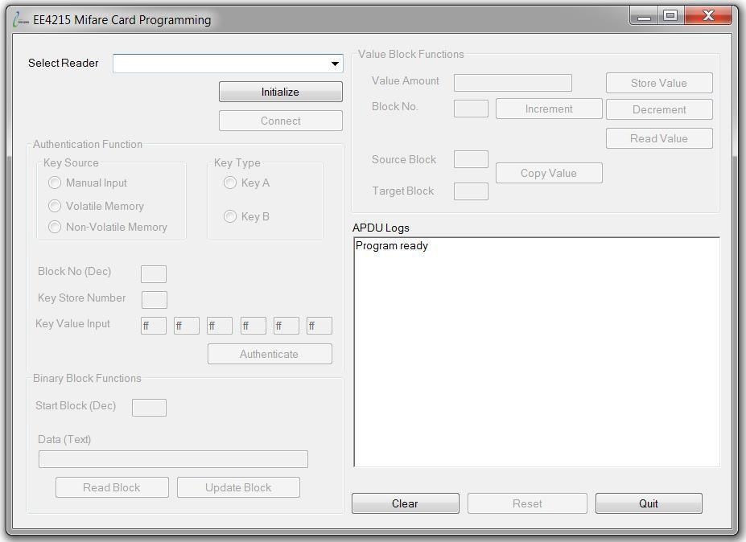

Figure 1: EE4215 Mifare Card Programming

- Place the card on the reader and select the “Connect” button to connect the card reader.
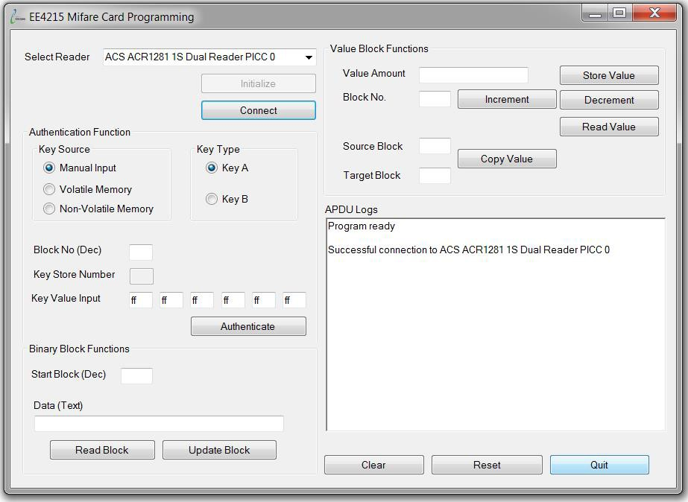

Figure 2: Connect Card Reader

- Ensure response of the APDU logs show the message:
Successful connection to ACS ACR 1281 1S Dual Reader PICC 0 That means the Card Valid.

Part A - Card ID: (10 marks)

* Request Standard |  |  | * Request All

Figure 3: Transaction Flow
* Transfer
Halt
3 Pass Authentication Sector specific
* Restore
Increment
Decrement
Write Block
Read Block
* Select Card
* Anticollision Loop Get Serial Number

The command not implemented by the ACR reader.
*

- Use the default Authentication Function setting: Key Source: Manual Input
Key Type: Key A
Key Value Input: ff ff ff ff ff ff
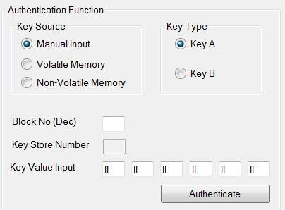
Figure 4: Authentication Function

- Type the Block number(Dec) “0” and Select “Authenticate” and write down the APDU Command FF 86 00 00 05 01 00 00 60 20 and Response
Message 90 00 .

Binary Block Function:

- Type the Start Block number “0” and select “Read Block”, write down the APDU Command FF B0 00 00 10 and Response Message
44 07 7F 29 15 88 04 00 47 C1 1B B4 45 00 19 05 90 00 .

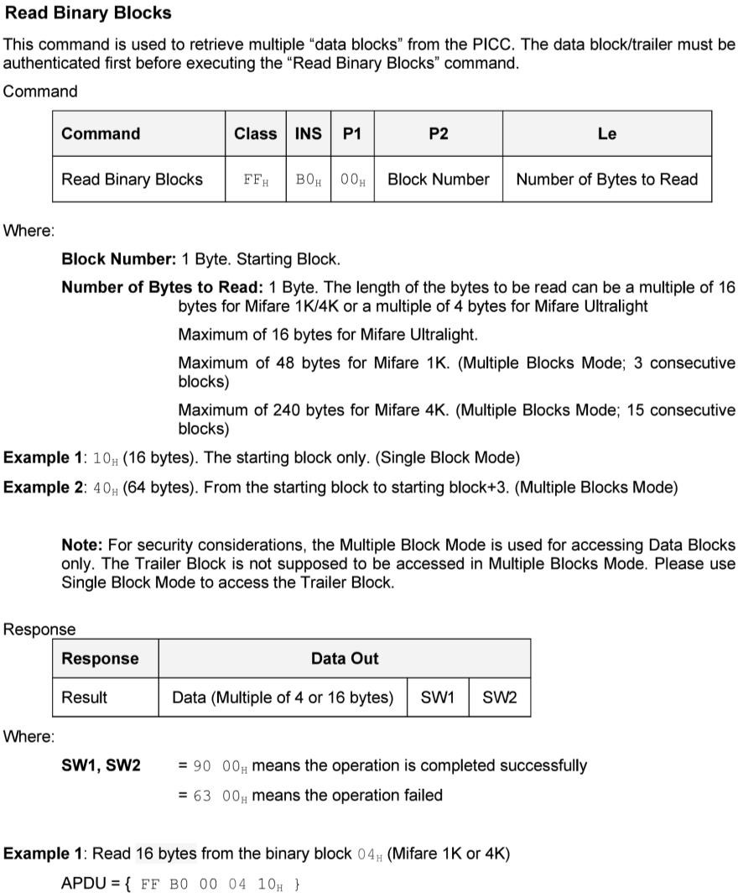

Figure 5: ADPU Format

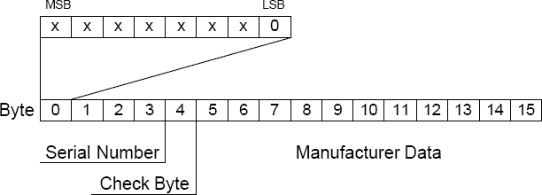
Figure 6: Block 0 Sector 0 Data Format

- Select the part of the data out corresponding to the CardID (byte 0-4)
44 07 7F 29 15 . How many byte is the CardID (Card Serial Number) ? Answer: 4 bytes .
- Read the card ID as 44 07 7F 29 .
- Write the Check byte (byte 4) 15 and
the Manufacturer Data (byte 5-15) 88 04 00 47 C1 1B B4 45 00 19 05 .

- Select “Write” and try to write all “0” to Block by clicking “write” button, explain why the write operation failed It is because the block 0 of sector 0 is write protected which does not allow a write operation .
- Will the card be blocked to operate when error occurred? € Yes No.

Part B - Normal Read and Write Operations: (5 marks)

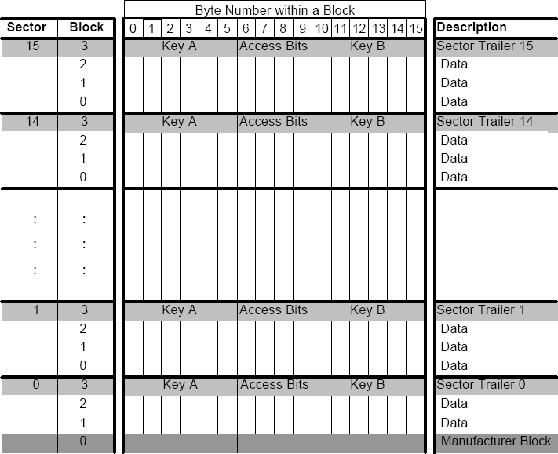

Figure 6: Memory Organization

- Type block no. “1” and select “Read Block”, write down the Response Data out without SW1 and SW2 : 42 04 00 00 BD FB FF FF 42 04 00 00 01 FE 01 FE .
- Type Data(Text) all “1” and select “Update Block”, Write down the Response for the block 1 without SW1 and SW2 :
FF D6 00 01 10 31 31 31 31 31 31 31 31 31 31 31 31 31 31 31 31 .
- Select “Read Block” and write down the Response Data without SW1 and Sw2 as 31 31 31 31 31 31 31 31 31 31 31 31 31 31 31 31 .
- Type block no. “2” and select “Update Block”, with data “1234567890123456”. Write down the Response without SW1 and SW2 :
FF D6 00 02 10 31 32 33 34 35 36 37 38 39 30 31 32 33 34 35 36 .
- Select “Read Block”, write down the Response Data without SW1 and SW2
31 32 33 34 35 36 37 38 39 30 31 32 33 34 35 36 .

Part C- Access Conditions: (10 marks)

Figure 7: Sector Trailer (Block 3)

- Type Block no. “3” and select “Read Block”, write down the Response Data
00 00 00 00 00 00 FF 07 80 69 FF FF FF FF FF FF 90 00 .
- Select the part of data in block 3 which is corresponding to the key A (Byte0-
5) 00 00 00 00 00 00 and key B (Byte10-15) FF FF FF FF FF FF .
- What are the Access Bytes (Byte 6-9)? FF 07 80 69 .
- Given the access conditions in Figures below:
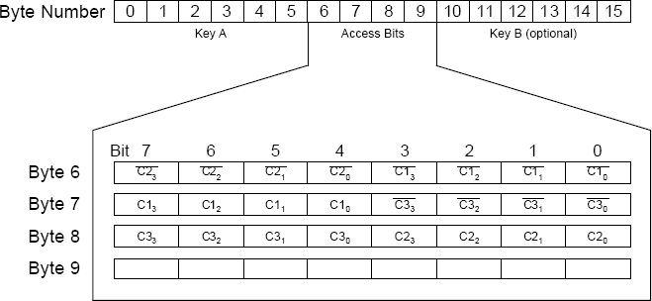
Figure 8: Access Bits

Where CNm is the access bit N in block m and x is the complement of x.

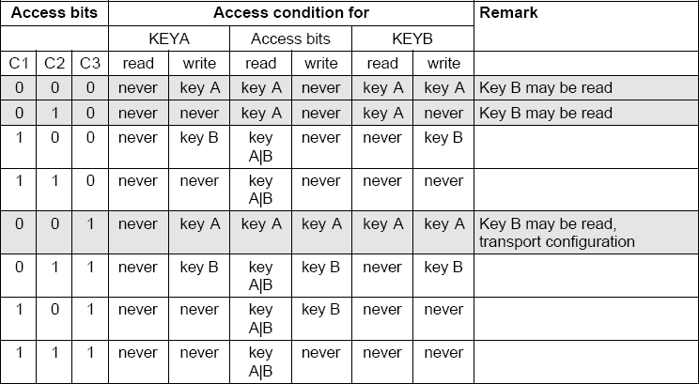

Figure 9: Key Block Access Condition

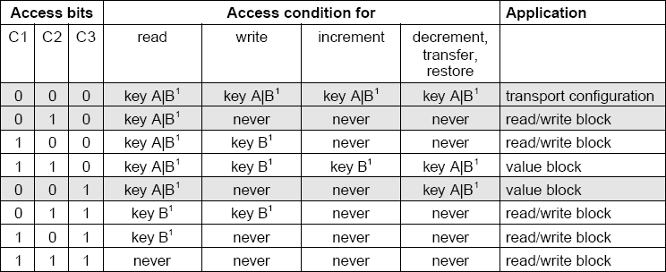

Figure 10: Data Block Access Condition

- Write down the access condition of this sector Block 3 (Key Block): 001 , means Access Read/Write by Key A € Key B € Key A|B.
- Write down the access condition of this sector, Block 0-2 (Data Block):
000 (Block 0/1/2), means read/write access by € Key A € Key B
Key A|B.
- Select “Update Block” again and explain why “block 3” is barred from modification in this exercise,
It is because the 001 access condition does not allow the users to write .
- If “block 3” is allowed to be modified and the original key is used, will the “sector” operation be blocked? € Yes No.

Part D- Value Block: (20 marks)

aa) Type the block no. “1” in Authentication Function and select “Authenticate” to get the data access right. Please do not use the trailer block to store/increment/decrement/copy value.
bb) Type Data(Text) “0000000000000000” and Select “Update Block”. cc) Select “Read Block”, write down the APDU Logs Response Data
30 30 30 30 30 30 30 30 30 30 30 30 30 30 30 30 90 90 .
dd) Type the block no. “1” and Value Amount “0” in Value Block Functions and select “Store Value”, write down the APDU Logs Response Data as
90 00 .
ee) Select “Read Block”, write down the APDU Logs Response Data
00 00 00 00 FF FF FF FF 00 00 00 00 01 FE 01 FE 90 90 .
--- Note that there is a major format difference between reading in steps aa) and cc).
ff) Refer to the value block format below:
Figure 11: Value Block Format

Write down the data of Value (byte 0-3) in step ff) 00 00 00 00 and data of Value (byte 4-7) FF FF FF FF _ and the repeated data of Value (byte 8-11)

00 00 00 00 and data of Adr in byte 12 01 and Adr in byte 13 FE ; and
data of Adr in byte 14 01 and Adr in byte 15 FE . Ensure they are complement.
gg) Change the Value Amount to “1000”, and Select “Store Value”, write down
the APDU Logs Response Data 90 00 . hh) Select “Read Value” and write down the value amount.
1000 .
ii) Type Block no. “1” and select “Read Value” in Value Block Functions, write down the value 00 00 03 E8 and APDU Logs Response Data
00 00 03 E8 90 00 .
jj) Type Block no. “1” and select “Read Block” in Binary Block Function, write down the APDU Logs Response Data
E8 03 00 00 17 FC FF FF E8 03 00 00 01 FE 01 FE 90 00 .
kk) Given 1000 (decimal) is represented by 03E8 in Hexi-decimal form, state where the data E8 (lower byte) can be found in byte 0, 8 of block 1 and the
data 03 (higher byte) can be found in byte 1, 9 of block 1.

ll) Write down the Value (byte 0-3) E8 03 00 00 and Value (byte 4-7)
17 FC FF FF in jj). Check if they are complementary Yes € No.

Part E- Value Block Increment/Decrement Operations: (10 marks)

Value block can be manipulated using increment and decrement operations with values. Increment or decrement values are pre-stored in REGISTERS and the update is completed by a “Transfer” command. The incremental/decrement
REGISTER can be clear using a “Restore” command if the incremental/decrement operation is cancelled by a “revocation” action. Unfortunately, the command not implemented by the ACR reader. The amount of value will be updated directly by using the “Increment” /”Decrement”.

mm) Type Value Amount “100” , Block no. “1” and select “Increment”, write down the APDU Logs Response Data
90 00 .
nn) Select “Read Value”, write down the Value Amount 1100 and APDU Logs Response Data 00 00 04 4C 90 00 .
oo) Check if the amount is increased correctly Yes € No.
pp) Type Value Amount “10” , Block no. “1” and select “Decrement”, write down the APDU Logs Response Data 90 00 .
qq) Select “Read Value”, write down the Value Amount 1090 and APDU Logs Response Data 00 00 04 42 90 00 .
rr) Check if the amount is increased correctly Yes € No.

***END***

