EE2005 Lab Report

Operational Amplifier

Lab Section: L02

Abstract

he purpose of this lab is to familiarize you with the properties and operations of the operational amplifier. Using resistors to control voltage output for desired processes, such as the one in Task 3 where we could represent binary inputs using an LED.

- Description of Components

  - Operational Amplifier (op amp)

The operational amplifier is a circuit element which is designed to perform mathematical operations with external components (addition, subtraction, multiplication, division, differentiation and integration). The circuit element consists of transistors, capacitors, diodes, and resistors.

In the lab we used a 741 op amp. Which has 8 pins. Pin The negative and positive power pins (pin 4 & 7) is used to offset the voltage output to the desired amount that is sent to the respective pins 4 and 7. Pin 2 and 3 are the power supply voltage (input voltage), and pin 6 is the voltage output.

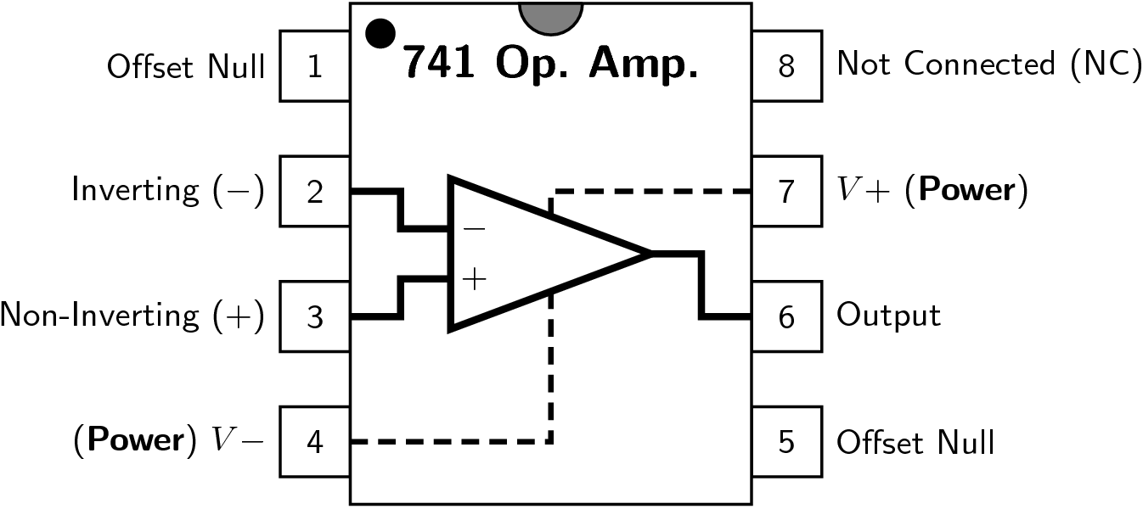

1.2 DIP Switch SPST

DIP Switch is used to provide binary input into the input voltage pins of the amplifier.
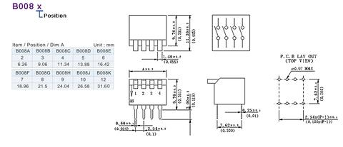

- Analysis of the Circuit

2.1 Inverting Amplifier

In this circuit, unlike the source follower which has an infinite input resistance, this circuit does not, and it depends on the actual connections in the circuit. In this case, any internal resistance from the source would have an affect on the output.

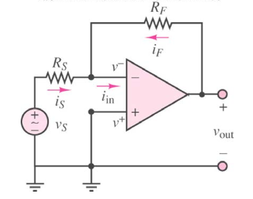

2.2 Digital-to-Analog Converter (DAC)

This is a system that is used to convert digital signal to analog signal. In task 2 and 3, the circuits built can be considered as a DAC. Where the digital inputs are the binary inputs, and the analog signal would be the voltages resulted from digital inputs (switches).

2.3 DAC with Comparator Output

It is a DAC combined with a comparator for practical uses. In task 3, the comparator is used to make sure that the LED is turned off when the voltage output is less than 1 voltage, to simulate the binary input.

- Experimental Results

3.1 Inverting Amplifier

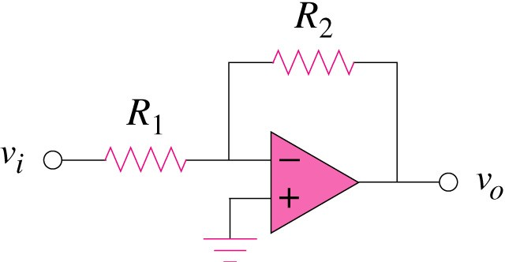
iin
In task 1, we are trying to copy the circuit above. Then record the changes on the voltage output based on differing voltage inputs. In which we found out, there is a hard cap on the bottom and lower limit. Presented from the graph below.

$$R_{1}=2Ω and R_{2}=8Ω$$
I chose these resistors values to limit the voltage output to be $±$5.

And we found out as voltage input increase, voltage output decreases which meant that the inverting amplifier is doing its intended purpose of inverting. And the choice of resistors also will affect the voltage output power as the resistors will affect the input current which correlates with the voltage output power.

Where $v_{0}= -\frac{R_{f}}{R_{s}}*v_{i}$
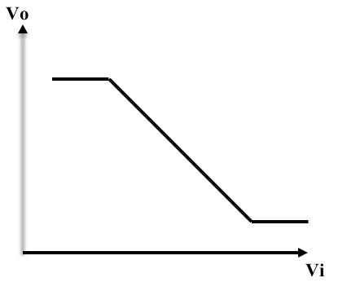
v_{i} | v_{o}
-1.8 | 4.95
-1.6 | 4.95
-1.4 | 4.95
-1.2 | 4.8
-1 | 4
-0.8 | 3.2
-0.6 | 2.4
-0.4 | 1.6
-0.2 | 0.8
0 | 0
0.2 | -0.8
0.4 | -1.6
0.6 | -2.4
0.8 | -3.2
1 | -4
1.2 | -4.8
1.4 | -4.95
1.6 | -4.95
1.8 | -4.95

3.2 Digital-to-Analog Converter (DAC)

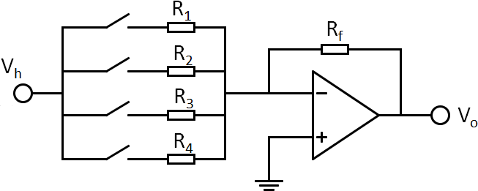
Rf | R1 | R2 | R3 | R4
10k | 10k | 20k | 40k | 80k

$$R_{f}=R_{1} in this case to simplify the process.$$

Binary combo | Value in decimal | Measured Vo
0000 | 0 | 0
0001 | 1 | 125m
0010 | 2 | 250m
0011 | 3 | 375m
0100 | 4 | 500m
0101 | 5 | 625m
0110 | 6 | 750m
0111 | 7 | 875m
1000 | 8 | 1
1001 | 9 | 1.125
1010 | 10 | 1.25
1011 | 11 | 1.375
1100 | 12 | 1.5
1101 | 13 | 1.625
1110 | 14 | 1.75
1111 | 15 | 1.875

Where $$-v_{0}=V_{1}(\frac{R_{f}}{R_{1}} B_{1}+ \frac{R_{f}}{R_{2}} B_{2}+ \frac{R_{f}}{R_{3}} B_{3}+ \frac{R_{f}}{R_{4}}B_{4})$$

In this task we are trying to simulate how different resistors when used in differing combinations can provide basic binary inputs in to the voltage input of the amplifier.

3.3 DAC with Comparator Output

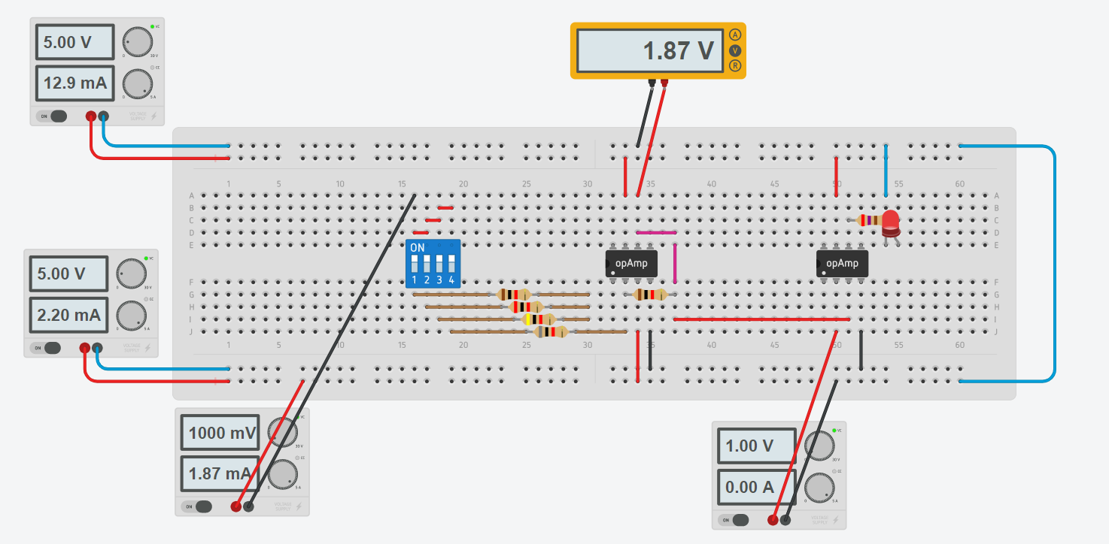

Binary combo | Value in decimal | Measured Vo | Turn on / off
0000 | 0 | 0 | Off
0001 | 1 | 125m | Off
0010 | 2 | 250m | Off
0011 | 3 | 375m | Off
0100 | 4 | 500m | Off
0101 | 5 | 625m | Off
0110 | 6 | 750m | Off
0111 | 7 | 875m | Off
1000 | 8 | 1 | On
1001 | 9 | 1.125 | On
1010 | 10 | 1.25 | On
1011 | 11 | 1.375 | On
1100 | 12 | 1.5 | On
1101 | 13 | 1.625 | On
1110 | 14 | 1.75 | On
1111 | 15 | 1.875 | on

In this circuit, reference voltage is applied onto pin 2 (which is the negative input voltage of the amplifier) in order for the LED to work as intended. By intended, the LED is supposed to turn on when the binary input exceed 1-0-0-0, which is basically when the switch number 1 is toggled on.

- Discussion

In all the tasks, usually there would be a difference in the results between theoretical predicted results and the obtained practical results. But since all of the lab is done online on a website, this difference is negated because online website will also use theoretical methods to obtain the results. But if there is an option to change the tolerance rate of the resistors, this would give a sort of closer result to that of a practical one.

- Conclusions

To conclude, in this laboratory work, using the resistors we could provide differing voltage inputs that can simulate digital inputs such as binary inputs, and in task 3, make use of said inputs for practical use and in the task 3’s case, it is to turn on the LED.

References

