

EE 3070 Design Project

Technical Training 2 Laboratory Manual (Design Modules)

2023/24 Semester A


Equipment List:
- Wifi Router with Internet connection in each laboratory
- PC with Arduino IDE (IDE Download link: http://arduino.cc/en/Main/Software
- Arduino Board (Mega 2560 or Micro)
- Wifi Module ESP8266
- Sensor Modules:
  - Light sensing modules with PGM5539
  - Temperature sensor LM35
  - Pressure sensing modules with RFP-602
  - Ultrasonic ranging module HC-SR04
- Display Module:
  - SPI bus 1.54-inch e-paper GDEW0154T8 (152 x 152) with Waveshare driving board
  - I2C bus Passive OLED (0.96 inch, 128x64 dots)
- RFID System Module
  - PCD (Proximity Coupling Device) with MFRC522 Contactless Reader IC
  - PICC card (Proximity Integrated Circuit Card) with 1K memory
  - PICC tag with 1K memory

Topic Assignments:

Members of project group should discuss and choose the topics that may help to their design. The following must be noticed:

- Each member of a project group is to work on one of the 5 topics. Members within the
same group should work on different topics.
- Each topic contains Basic Tasks and Advanced Tasks. You have to finish the Basic Tasks first. If time left, you proceed to Advanced Tasks.



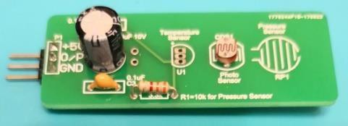
Topic 1: Reading Sensors by Arduino Components list:
  - Arduino: Mega 2560 / Micro
  - Light / pressure sensing module
  - Ultrasonic distance module HC-SR04

Light Sensing Module
Fig. 1.1(a) and Fig. 1.1(b) show a light sensing module and its simplified circuit, respectively. The circuit is to convert the resistance attribute of light sensor (PGM5399) to voltage at o/p pin, which can then be read by an Arduino board.
3.3KΩ Light sensor PGM5539
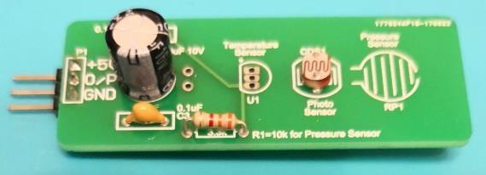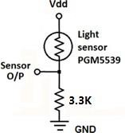
Fig. 1.1: (a) Light sensor module board and (b) the simplified circuit design

Self-Reading  The light sensor can be considered as a resistor for which its value changes according to the light shining onto the sensing surface.  The circuit in right figure is referred as a voltage divider. Current flows from 𝑉𝑑𝑑 to GND and can be calculated by  𝑉𝑑𝑑  𝐼 =  (𝑅 + 𝑅1)  Therefore, using Ohm’s law, the voltage at the Sensor O/P pin (𝑉𝑜) is:  𝑅1  𝑉𝑜 = 𝐼𝑅1 = 𝑉𝑑𝑑 (𝑅 + 𝑅 )  1 | 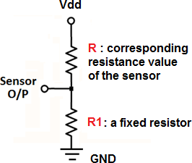
You would find some additional capacitors on the module board. The electrolytic capacitor (e-cap) acts as charge reservoir for voltage source. The ceramic capacitor (with small value) is to resolve issue related to internal impedance (𝐶𝑠 in right figure) of ADC.  electrolytic capacitor ceramic capacitor | 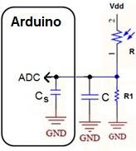

Hardware Connection
Fig. 1.2 shows the wiring which is to read the output from the sensing module by Arduino
5V
O/P GND
sensor
5V
Any Analog pin (eg. A0) GND
Arduino
Figure 1.2 Connection between sensing module and Arduino board

Software Design: Library and functions
We can use analogRead as given in the standard library.

analogRead | Read the value from the specified analog pin.
analogRead | analogRead(pin) | pin: the number of the analog input pin to  read from (eg. A0 to A15 for Mega-2560) Return the value after ADC (as an integer)

The readings can be shown on the screen of a PC/notebook by launching Serial Monitor as given in Arduino IDE. Read Technical Training I Manual to review how to use Serial Monitor.

Self-Reading Materials
You can find the usage of functions and examples:
https://www.arduino.cc/reference/en/language/functions/analog-io/analogread/

Pressure Sensing Module
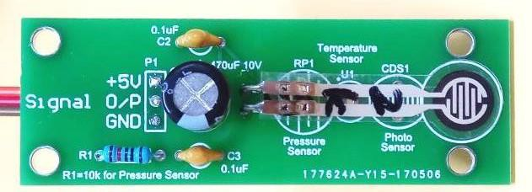
Fig. 1.3 shows a pressure sensing module. The circuitry design is exactly the same as the light sensing module, except the light sensor (PGM5399) is now replaced by a pressure sensor RFP- 602.
RFP-602 is a pressure sensor, when force is applied to the sensing surface, the resistance changes.
Fig. 1.3. Pressure sensing module

You can apply similar programming technique to get the readings from the pressure sensing module.

Ultrasonic Distance Module
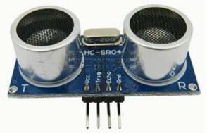
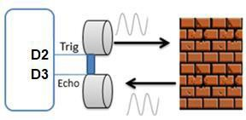
HC-SR04 (see Fig. 1.4) is an ultrasonic ranging module, which measures distances based on echolocation.
Fig. 1.4. (a) Photo of HC-SR04 (b) Measuring distance by HC-SR04 based on echolocation

The usage of this module is described in Fig. 1.5. When a HIGH pulse with width ≥10 μs is sent to Trig pin, the module will work as follows: It first emits out eight 40kHz square wave pulses, and then starts checking whether an echoed signal is received. If yes, the Echo pin will output a square pulse, for which its width equals to the time taken for the emitted wave sent forth and returned back.

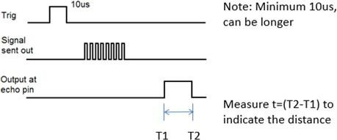
Fig. 1.5. Operational signals in HC-SR04
The distance between the sensor and the object is calculated by
𝐷𝑖𝑠𝑡𝑎𝑛𝑐𝑒 = 𝑡 × 340𝑚𝑠−1 × 0.5
where 𝑡 = (𝑇2 − 𝑇1) is the width of the pulse at echo pin; 340𝑚𝑠−1 is the speed of sound in air; multiplying 0.5 is needed because the wave travelled forth and back.

Hardware Connection
Fig. 1.6 shows the wiring for reading the output from the module.

HC-SR04 Vcc  Trig Echo GND |  | 5V Arduino  Any digital I/O pin (as output) Any digital I/O pin (as input) GND
Figure 1.6 Connection between HC-SR04 and Arduino board

Software Design: Library and functions
We only need to use the standard library in Arduino. Some key functions are given.

pinMode | Configure the specified pin to behave either as an input or an output.
pinMode | pinMode(pin, mode) |  | pin: the number of the pin whose mode you wish to set  mode: INPUT, OUTPUT, or INPUT_PULLUP.
digitalWrite | Write a HIGH or a LOW value to a digital pin.
digitalWrite | digitalWrite(pin, value) |  | pin: the pin number  value: HIGH or LOW
delay | Pause the program for the amount of time (in milliseconds) specified as parameter.
delay | delay(ms) | ms: the number of milliseconds to pause (unsigned long)
pulseIn | Read a pulse on a pin, return the length of the pulse in microseconds. If timeout, returns 0.
pulseIn | pulseIn(pin, value, timeout) | pin: the pin number for reading the pulse.  value: HIGH or LOW.  timeout (optional): maximum time (in ms) to  wait for the pulse to start; default=1000ms.

Self-Reading Materials
To understand more, read the following material.
https://howtomechatronics.com/tutorials/arduino/ultrasonic-sensor-hc-sr04/

Basic Design:
- Design Task 1 Procedures:
- Connect the light sensing module to an Arduino board (5V is applied to the module.)
- Write a program to read the sensor value and output to the Serial Monitor
- Observe the changing of value in Serial Monitor for different light levels

In normal condition, the output value is .
When partially covering the sensor, the output value is . When totally covering the sensor, the output value is .
CHECKPOINT: SHOW THE RESULT AND CIRCUIT TO TUTOR

Design Task 2
Procedures:
- Connect the ultrasonic distance module to Arduino board
- Write a program to read the distance between the sensor and the table surface for every two seconds, and output the values to the Serial Monitor,
- Now, ADD a feature such that the color of a RGB LED changes according to the distance. Define your mapping between the color and the distance.

Describe the mapping between color and the distance
CHECKPOINT: SHOW THE RESULT AND EXPLAIN THE PROGRAM TO TUTOR

Questions to be answered in report:
Q1. Refer to Design Task 1, find the new output value if you connect “5V” pin of the sensor module to 3.3V power bus instead of 5V power bus in the platform board?
Q2. Refer to Design Task 1, find the new output value if you connect “5V” pin and “GND” pin of the sensor module to GND and 5V in the platform board, respectively?
Q3. Observe the value change for different distance (from very close to very far away) in Design Task 2, and comment on the accuracy

Advanced Design: You work on this only after finished tasks in Basic Design
In Design Task 2, the disadvantage of continuously checking the return of the pulse is that we have to wait until there is a pulse, and the Arduino can do nothing while waiting.
To solve this, we can use Interrupt. The Arduino can be triggered by an external event using a digital pin. When event occurs, interrupt will be issued, and the Interrupt Service Routine will be run. (Note: You can refer to the Lecture Notes for Arduino Programming to understand more about Interrupt)
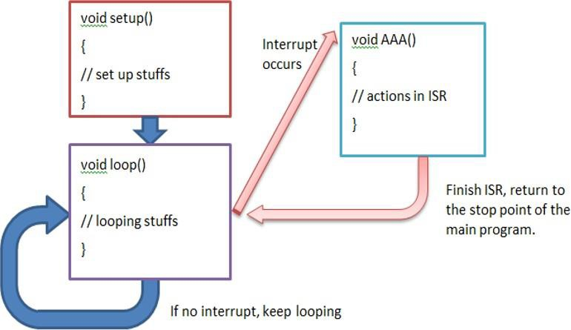
There are several modes to define when the interrupt should be triggered.
- LOW to trigger the interrupt whenever the pin is low,
- CHANGE to trigger the interrupt whenever the pin changes value
- RISING to trigger when the pin goes from low to high,
- FALLING for when the pin goes from high to low.

Advanced Task 1:
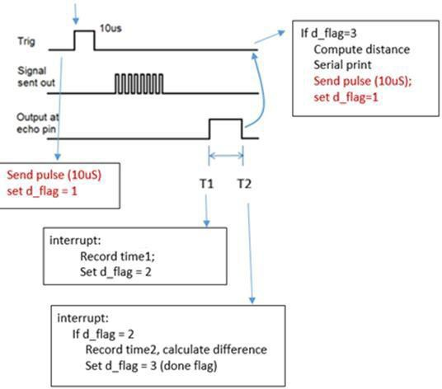
You are given the following design example. Use interrupt to redo Design Task 2.
CHECKPOINT: SHOW THE RESULT AND EXPLAIN THE PROGRAM TO TUTOR

Topic 2: Display texts and image on OLED by Arduino Components list:
  - Arduino: Mega 2560 / Micro
  - 0.96 inch passive OLED, part number SSD1306

Introduction of OLED and I2C:
OLED is based on organic materials that emit light when electric current is applied. Fig. 2.1 shows the OLED (Part number: SSD1306) used in the project. It has a resolution of 128 x 64 (dots), and its communication bus is Inter-Integrated Circuit (I2C).
An I2C bus consists of two signal wires, SCL (Serial clock) and SDA (Serial data). In I2C, the master unit controls the data communication, so that data can be transferred between the master and the slave. To drive an OLED, we can use an Arduino board as the master unit while the OLED is a slave. To specify a particular slave, a distinct address is needed. For the OLED, it is hard-wired in the module, for which by default, the address is 0x3C. Arduino can then send data to OLED via the bus, and then the OLED displays accordingly.
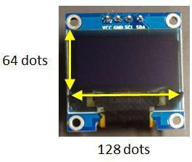
Fig. 2.1. Passive OLED: 0.96” in dimension and 128×64 in resolution

Note 1:  The I2C address is 7 bits. As shown at the back of the module (see the right figure), you can see a mark “0x78” or “0x7A”.  - The address 3C h which is 011 1100 b, then appending the R/W bit, one has 78?7B h (0111 1000 b).  - The address 3D h which is 011 1101b, then appending the R/W bit, one has 7A h (0111 1010 b). | 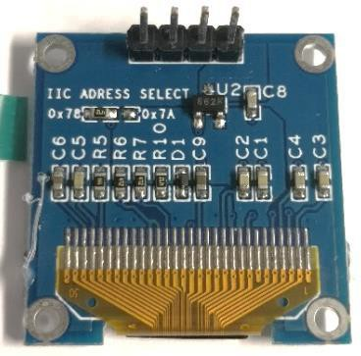

Self-Reading Materials
To understand more, read the following materials
- English version: https://randomnerdtutorials.com/guide-for-oled-display-with-arduino/

Hardware Connection
Arduino boards have dedicated SDA/SCL pins and a short summary is given in Table 2.1. (Self-reading: https://www.arduino.cc/en/reference/wire.h )
(Self-reading: https://www.arduino.cc/reference/en/language/functions/communication/wire/ )

Table 2.1 Pin assignment for SDA and SCL in Arduino boards

Board Type | Mega 2560 | Micro
SDA | 20 (marked as SDA) | D2
SCL | 21 (marked as SCL) | D3

Fig. 2.2 shows the connections between Arduino and OLED
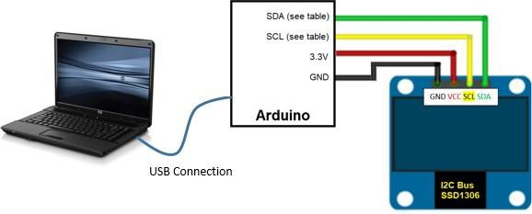
Fig. 2.2. Connecting OLED (SSD1306) to Arduino board. The USB connection to PC is for programming and providing power to Arduino.

Software Design and Library
  - Library
You’ll need the following library to program the OLED SSD1306
- Adafruit_SSD1306.h : It is a library to interface with the OLED SSD1306 Self-Reading: https://github.com/adafruit/Adafruit_SSD1306
The library <Adafruit_SSD1306.h> needs another library. You’ll need to install them if they were not included in your Arduino IDE:
- Adafruit_GFX.h : It is a library for drawing and display
Self-Reading https://github.com/adafruit/Adafruit-GFX-Library

Note: If an error message “Adafruit_I2CDevice.h> not found” appears in some IDE versions, installing additional library Adafruit_BUSIO.h would fix the problem.

Adafruit_SSD1306.h also uses another two libraries (we called this as dependency), which are bundled with the hardware packages. They are Wire.h and SPI.h. For students who like to know more, they may visit
- Wire.h: https://www.arduino.cc/en/reference/wire
- SPI.h: https://www.arduino.cc/en/Reference/SPI
Note: See Laboratory Manual (Arduino IDE and Programming) to learn how to add a library

Below shows the calling of the library and initialize the display (as an object in C++).
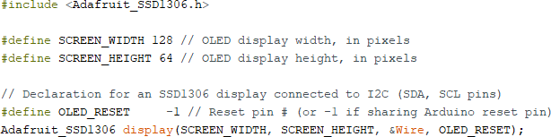

Program Example
You can open an example file to observe different functions (ssd1306_128x64_i2c.ino). Refer to Technical Training Manual I to review how to open an example file.
Below are some important notes:
- The address of the I2C should be 0x3C. [This is configured in the OLED board.]
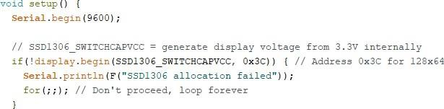
Should be set as 0x3C
- After calling any drawing functions, you need to call display.display to update the screen so as to make them show on-screen.
- Function delay() is added after display.display because it takes times for the screen to update.
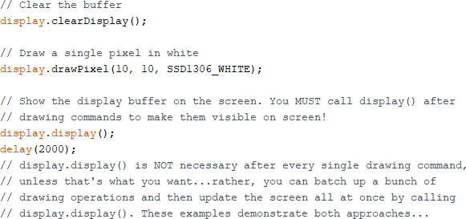

Brief Descriptions on Drawing Functions
A brief summary of drawing functions is given below. Details can be referred to the following link:
https://learn.adafruit.com/adafruit-gfx-graphics-library/graphics-primitives
Since the OLED is monochrome, color = SSD1306_WHITE to turn on the dot.
- drawPixel(x, y, color): (x,y) is pixel location
- drawLine(x1, y1, x2, y2, color): (x1,y1) and (x2,y2) are the starting and end points
- drawRect(x, y, w, h, color): (x,y) is top-left corner of the rectangle, w and h are its width and height, respectively.
- fillRect(x, y, w, h, color): same as drawRect but the rectangle is filled
- drawRoundRect(x, y, w, h, r, color): (x,y) is top-left corner of the rectangle, w and h are the width and height, r is the corner radius.
- fillRoundRect(x, y, w, h, r, color): same as drawRoundRect, except the rectangle is filled
- drawCircle(x, y, r, color): (x,y) is the center of the circle and r is its radius.
- fillCircle(x, y, r, color): same as drawCircle, except the circle is filled.
- drawTriangle(x1, y1, x2, y2, x3, y3, color): (x1,y1), (x2,y2), (x3,y3) are the corner locations of the triangle
- fillTriangle(x1, y1, x2, y2, x3, y3, color): same as drawTriangle, except the triangle is filled
- setTextSize(size): Set the text size, 1 is normal size
- setTextColor(color): Set the text color
- setCursor(x, y): move the cursor to (x,y)
- printlin(“…”) or println(F(“…”)): write the text in “” starting at current cursor location; with the symbol ‘F’, the string is stored in flash memory, not in SRAM
- drawBitmap(x, y, *bmpfile, w, h, color): (x,y) is the top-left corner, w and h are the width and height, bitmap data must be located in program memory using PROGMEM directive. The color can be inversed using SSD1360_INVERSE as color.
- clearDisplay(): clear the current screen

Basic Design:
- Design Task 1:
Understand the program example and successfully run the program according to your hardware configuration and settings. Also try at least 3 functions as given in Sect. A.4.3.

Design Task 2:
Draw a square with size 40 x 40 at the center of the OLED and write your name below

Design Task 3:
Create a logo using bitmap which represents yourself and display it onto the OLED.

Do the tasks with separated program or screens. Show the results to Tutor and explain how you do the design.

CHECKPOINT: SHOW THE RESULT AND EXPLAIN TO TUTOR FOR EACH TASK

Questions to be answered in report:
Q1. Explain the usage of 3 functions (that you tried in Design Task 1) and their outputs.
Q2. What are the x- and y-locations of the left-top corner and right-bottom corner (dots) of the square in Design Task 2?
Q3. How many memory has been used for different tasks? Which one occupies most and Why?

Advanced Design: You work on this only after finished tasks in Basic Design
a) Advanced Task 1:

In this task, Gravity SEN0291 is an I2C digital wattmeter that can measure the voltage, current and power of your electronic devices (Resistor of 5Ω 25W is used in this task) within the range of 26V 8A. The INA219 functions as a differential amplifier with a programmable gain and an ADC to convert the analog data of DC current and voltage into digital data. This digital data is temporarily stored in the memory of the INA219, waiting to be read by an external microcontroller (Arduino MEGA2560 in our case). The results are then printed on an OLED display.

Please refer to the following hyperlink for details of specification:
https://www.dfrobot.com/product-1827.html?srsltid=AfmBOoqsbqlmE44Cytd5txUdIi10BA2TMjTA_e_ervEVoGlMB1S3rZHY

Complete the wiring between individual components as shown in Figure 2.3. Develop a program to display the current, voltage and power data on the 0.96” OLED.

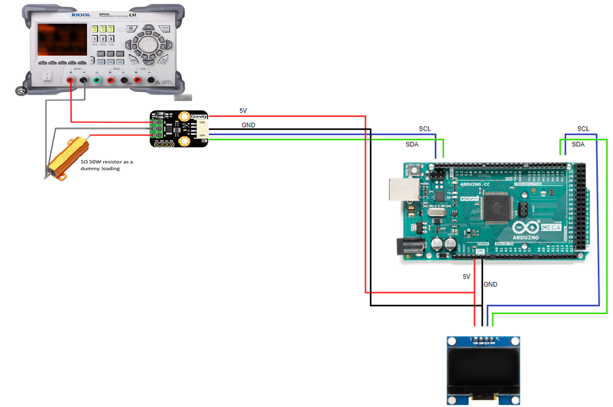

Fig. 2.3 shows the connections between INA219, Arduino and OLED

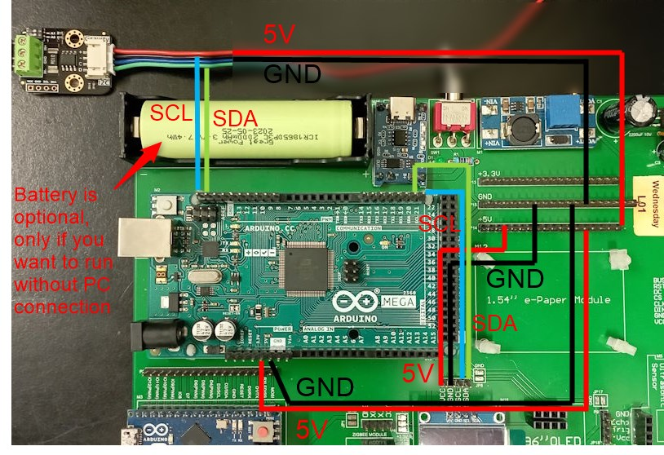

Fig 2.4 The connections between INA219 module and Arduino MEGA.

Installing the INA219 driver
Launch Arduino IDE, from the explorer bar:
 | select library icon,
 | input INA219 on the textbox,
 | locate DFRobot_INA219,
 | click install.
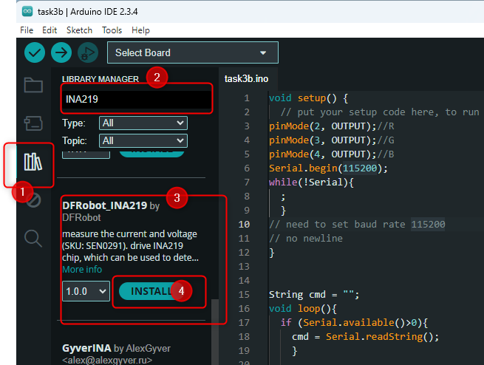
Now you will see a new example from File > Examples.

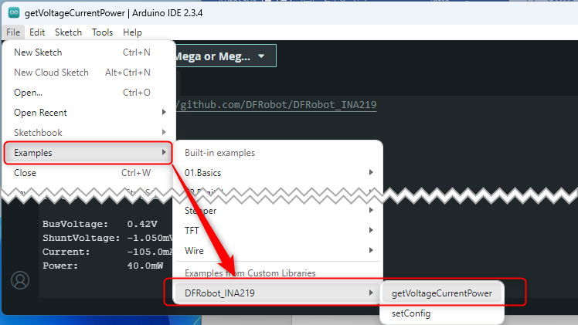

Select the demo program getVoltageCurrentPower.
Set Arduino MEGA2560 as your target system (Tools > Boards>Arduino AVR Boards>Arduino Mega or Mega 2560). Download the example sketch to your board by Sketch>Upload.

Now, enable the current output is 0.1A with a voltage of 0.50V on the DP832 power supply. Displays the results from INA219 on the 0.96” OLED.

Gradually increase the output current in 0.1A increments by adjusting the dial on the DP832 power supply, and record the results in the table below:

Readings on DP832 Power supply |  |  | Readings on 0.96” OLED |  |  | Power measurement error (assume DP832 is the true value)
Voltage/V | Current/A | Power/W | Voltage /V | Current/A | Power/W | %
 | 0.1
 | 0.2
 | 0.3
 | 0.4
 | 0.5
 | 0.6
 | 0.7
 | 0.8
 | 0.9
 | 1.0

CHECKPOINT: SHOW THE RESULT AND EXPLAIN THE PROGRAM TO TUTOR

Topic 3: Display texts and image on E-paper using Arduino Components list:
- Arduino: Mega 2560 / Micro
- 1.54-inch e-paper, part number GDEH0154D67 (Waveshare driver board)

Introduction of Epaper and SPI:
An e-paper contains many tiny capsules with black or white particles, which are negatively or positively charged, respectively. When positive charge is applied at the top, the black particles are drawn to the top and become visible. Similarly, if negative charge is applied to top, the screen turns to white. The particles would stay at their positions even removing the charge, meaning that the image can be kept even disconnecting the voltage supply.

An e-paper screen displays the patterns by reflecting the ambient light, so no background light is required. It also has high visibility with a wide viewing angle of 180 degrees.

Fig. 3.1 shows a photo of the e-paper and the driver board (manufacturer Waveshare). To communicate with the e-paper in this project, Serial Peripheral Interface (SPI) is used. SPI is an interface bus, using clock (SCK) and data lines (MOSI – Master-Output-Slave-Input, MISO - Master-Input-Slave-Output) for data communications. Additionally, a slave select line (SS) is used to choose the device that to be communicated with. Some devices use a half-duplex interface, having only a single data line. This kind of SPI is commonly referred as 3-wire SPI.
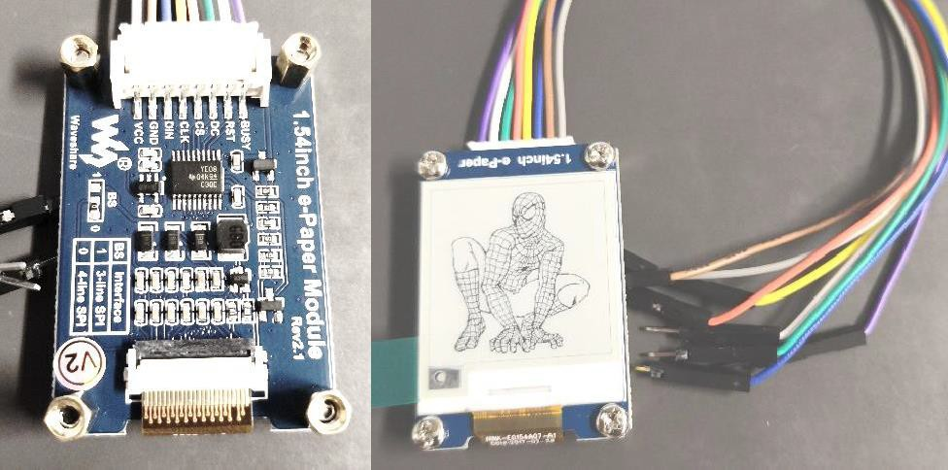
Fig. 3.1 (a) Back view: driver (b) Front view: Epaper panel

Self-Reading Materials:
To understand more, read the following materials
https://learn.sparkfun.com/tutorials/serial-peripheral-interface-spi/all

Hardware Connections
Some Arduino boards have dedicated SCK/MOSI/MISO/SS pins, and a short summary is given in the following table (Self-Reading: https://www.arduino.cc/en/reference/SPI )
Table 3.1 Pin assignment for SCK/MOSI/MISO/SS in Arduino boards

Board Type | MOSI | MISO | SCK | SS
Mega 2560 | 51 or ICSP-4 | 50 or ICSP-1 | 52 or ICSP-3 | 53
Micro | 16 or MOSI | 14 or MISO | 15 or SCK | 17 or SS

Note: ICSP refer to the socket on the Arduino boards. The pins are defined as follows. [Note: You’ll see a dot at pin 1 of the socket.]
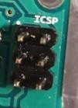
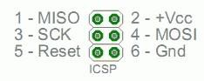
A dot indicates pin 1.
Fig. 3.2 ICSP socket on Arduino boards

Since we only write data from the master (Arduino) to the slave (epaper), only MOSI is needed. Also, to program an epaper, 3 more pins are needed. They are DC (Data/Command pin), RST (Reset pin) and BUSY (Busy detect pin). You can freely assign I/O pins to SS, DC, RST, and BUSY. An example of wiring is given in Table 3.2.

Table 3.2: Wiring connections between Epaper and Arduino board

GDEW0154T8 | Arduino Mega | Arduino Micro
VCC | 3.3V | 3.3V
GND | GND | GND
DIN=MOSI | MOSI(51) | MOSI
CLK=SCK | SCK(52) | SCK
CS=SS | 10 | SS
DC | 9 | 5
RST | 8 | 6
BUSY | 7 | 7
Note: Other pin numbers can be used for CS, DC, RST and BUSY, which is also defined in program.

Software Design
  - Library
You’ll need to install the following library to program the epaper:
- GxEPD2 : It is a library to interface with epaper manufactured by Waveshare.
To use this library, the following library needs to be pre-installed in the Arduino IDE.
- Adafruit_GFX.h : It is a library for drawing and graphics.
Note: See Technical Training I Manual to review how to add a library
GxEPD2 also use another library SPI.h (we called this as dependency), which is bundled with the hardware packages. For students who like to know more, they may visit
- SPI.h: https://www.arduino.cc/en/Reference/SPI

Self-Reading Materials:
About GxEPD2: https://github.com/ZinggJM/GxEPD2 About Adafruit_GFX:
https://github.com/adafruit/Adafruit-GFX-Library https://learn.adafruit.com/adafruit-gfx-graphics-library/graphics-primitives
About text fonts: https://learn.adafruit.com/adafruit-gfx-graphics-library/using-fonts

Use of Library and Initialization

Below shows the calling of the library and initialization of the display
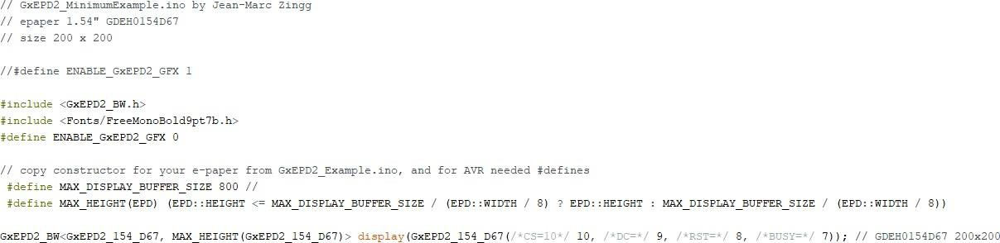

Explanation
2 header files are included
- GxEPD2_BW.h : use for the monochrome epaper
Remark: If you don’t use Paged
display, no need to add
- Fonts/FreeMonoBold9pt7b.h : A font type used in text
Define ENABLE_GxEPD2_GFX as 0 because we use Adafruit_GFX instead of this.
Define MAX_DISPLAY_BUFFER_SIZE and MAX_HEIGHT(EPD) which are for the Paged display, and it will be described in more details soon. The last line is to define the pins for CS, DC, RST and BUSY
Note: The pin assignment should match with your own wiring.

D.3. Brief descriptions on drawing functions
The followings are some drawing functions supported by Adafruit_GFX.h. You can observe their outcomes by insert them in the program example (as given in next page). Details can be referred to the following link:
https://learn.adafruit.com/adafruit-gfx-graphics-library/graphics-primitives
Also, since the epaper in-use is monochrome, color = GxEPD_WHITE or GxEPD_BLACK
- fillScreen(color): fill the whole defined screen with color
- setRotation(angle): angle is 0,1,2,3; rotate the display by 0, 90, 180, 270 degree in clockwise
- drawPixel(x, y, color): (x,y) is pixel location
- drawLine(x1, y1, x2, y2, color): (x1,y1) and (x2,y2) are the starting and end points
- drawRect(x, y, w, h, color): (x,y) is top-left corner, w and h are the width and height
- fillRect(x, y, w, h, color): same as drawRect but the rectangle is filled
- drawRoundRect(x, y, w, h, r, color): (x,y) is top-left corner, w and h are the width and height, r is the corner radius
- fillRoundRect(x, y, w, h, r, color): same as drawRoundRect, except the rectangle is filled
- drawCircle(x, y, r, color): (x,y) is the center and r is the radius.
- fillCircle(x, y, r, color): same as drawCircle, except the circle is filled.
- drawTriangle(x1, y1, x2, y2, x3, y3, color): (x1,y1), (x2,y2), (x3,y3) are the corner locations
- fillTriangle(x1, y1, x2, y2, x3, y3, color): same as drawTriangle, except the triangle is filled
- drawBitmap(x, y, *bmpfile, w, h, color): (x,y) is the top-left corner, w and h are the width and height, bitmap data must be located in program memory using PROGMEM directive.
- setCursor(x, y): move the cursor to (x,y)
- setTextColor(color): Set the text color
- setFont(*font): Set the text font, eg. display.setFont(&FreeMonoBold9pt7b);
- setTextSize(size): Set the text size, 1 is normal size
- print(“…”): write the text in “…”, starting at current cursor location

C.4 Paged Drawing
To reduce buffer size, we display something on an epaper using pages (i.e. page by page). The page size is specified by the buffer size, as defined in the program (see last page). A display is given in a picture loop, specified by firstPage() and nextPage() frames.
The standard procedures are as follows
- init(): Initialize the epaper
- firstPage: draw the first page (the buffer)
- nextPage: use a while loop to keep on drawing next Page
- powerOff(): Turn off generation of panel driving voltage. This is essential when finish your display.

A program example is given in next page.

// this part of code has been explained in Sec.D.2

#include <GxEPD2_BW.h> #define ENABLE_GxEPD2_GFX 0
#define MAX_DISPLAY_BUFFER_SIZE 800
#define MAX_HEIGHT(EPD) (EPD::HEIGHT <= MAX_DISPLAY_BUFFER_SIZE / (EPD::WIDTH / 8) ? EPD::HEIGHT : MAX_DISPLAY_BUFFER_SIZE / (EPD::WIDTH / 8)) GxEPD2_BW<GxEPD2_154_D67, MAX_HEIGHT(GxEPD2_154_D67)> display(GxEPD2_154_D67(/*CS=10*/ 10, /*DC=*/ 9, /*RST=*/ 8, /*BUSY=*/ 7)); // GDEH0154D67 200x200
//
void setup()
{
display.init(); delay(1000);

display.firstPage(); do {
// this part of code is executed multiple times, as many as needed, in case of full buffer it is executed once

// set the background to white (fill the buffer with value for white)
display.fillScreen(GxEPD_WHITE); delay(500);

display.fillCircle(20,60, 10, GxEPD_BLACK); // draw a circle
delay(500);
} while (display.nextPage());

// tell the graphics class to transfer the buffer content (page) to the controller buffer the graphics class will command the controller to refresh to the screen when the last page has been transferred
// returns true if more pages need be drawn and transferred; returns false if the last page has been transferred and the screen refreshed for panels without fast partial update

display.powerOff();
}
void loop()
{}

Basic Design:
  - Design Task 1:
Understand the program example and successfully run the program according to your hardware configuration and settings. Also try at least other 3 functions as in Sect. A.2.2.

Design Task 2:
Draw a rectangle with size 100 x 50 at the center of the epaper and then write your name inside; try to put your name at the center of the rectangle

Design Task 3:
Create a logo using bitmap which represents yourself and display it onto the epaper (attempt with and without paged drawing)

Do the tasks with separated screens. Show the results to Tutor and explain how you do the design.

CHECKPOINT: SHOW THE RESULT TO TUTOR FOR EACH TASK

Questions to be answered in report:
Q1. Explain the usage of 3 functions that you tried in Design Task 1 and their outputs.
Q2. What are the x- and y-locations of the left-top corner and right-bottom corner (dots) of your rectangle in Design Task 2?
Q3. How many memory has been used for different tasks? Which one occupies most and Why?

Advanced Design: You work on this only after finished tasks in Basic Design
- Advanced Task 1
It is possible to update a partial window of an epaper. You may explore it by checking the library. In this advanced design,
  - Draw a rectangle with size 100 x 50 dots at the center of the epaper, and then display your name and your members’ names alternatively inside the rectangle, without refreshing the whole screen
  - It can be further advanced: instead of displaying the members’ name, the texts to be displayed are changed according to the input from Serial monitor
CHECKPOINT: SHOW THE RESULT AND EXPLAIN THE PROGRAM TO TUTOR

Topic 4: Read / write RFID card using Arduino
Components list:
- Arduino: Mega 2560 / Micro
- MFRC522 package
  - PCD (Proximity Coupling Device), based on NXP MFRC522 Contactless Reader IC
  - PICC card (Proximity Integrated Circuit Card): MIFARE Card with 1K memory
  - PICC tag: MIFARE Tag with 1K memory

Introduction of RFID
RFID system divided into passive and active RFID. In this project, we focus on passive RFID, and the part number is MFRC522.
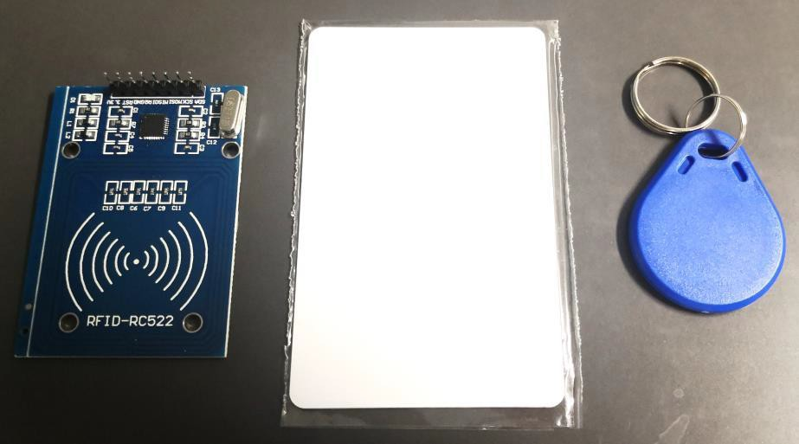
A passive RFID system has an antenna and circuitry that houses a unique code, but has no power source. A RFID reader (PCD) is needed to read/write the passive RFID card (PICC card ortag). MFRC522 is useful for contactless communication (with a very short range. A reader/writer antenna is used to communicate with the cards), by modulating signal of frequency 13.56MHz. The receiver module then demodulates and decodes the signals.
PCD
PICC card
PICC tag
Fig. 4.1. Photo of PCD, PICC card and tag in MFRC522 package

Communications between Arduino boards and the PCD are based on Serial Peripheral Interface (SPI). SPI is an interface bus, which uses clock (SCK) and data lines (MOSI – Master-Output- Slave-Input, MISO - Master-Input-Slave-Output) for data communications. Additionally, a slave select line (SS) is used to choose the device that to be communicated with. Some devices use a half-duplex interface, having only a single data line. This kind of SPI is commonly referred as 3-wire SPI.

Self-Reading Materials
Device datasheet: https://www.nxp.com/docs/en/data-sheet/MFRC522.pdf Introduction on hardware connection and program: https://medium.com/autonomous-robotics/an-introduction-to-rfid-dc6228767691

Hardware Connections
Some Arduino boards have dedicated SCK/MOSI/MISO/SS pins, and a short summary is given in the following table (Self-Reading: https://www.arduino.cc/en/reference/SPI )
Table 4.1 Pin assignment for SCK/MOSI/MISO/SS in Arduino boards

Board Type | MOSI | MISO | SCK | SS
Mega | 51 or ICSP-4 | 50 or ICSP-1 | 52 or ICSP-3 | 53
Micro | 16 or MOSI | 14 or MISO | 15 or SCK | 17 or SS
Note: ICSP refer to the socket on Arduino boards. The pins are defined as follows. [Note: You’ll see a dot at pin 1 of the socket.]
A dot indicates pin 1.
Fig. 4.2. ICSP on Arduino boards
To communicate between PCD and Arduino board, another pin, RST (Reset pin), is needed. You can freely choose an I/O pin for RST. Examples are given in the following table.

Table 4.2 Example of wiring between PCD and Arduino boards

PCD | Arduino Mega | Arduino Micro
SDA = SS | 53 | SS (17)
SCK | SCK (52) | SCK (15)
MOSI | MOSI (51) | MOSI (16)
MISO | MISO (50) | MISO (14)
IRQ | - | -
GND | GND | GND
RST | 5 | 5
3.3V | 3.3V | 3.3V

Software Design
  - Library
You’ll need to install the following library to program the RFID reader and cards:
    - MFRC522 : It is a library to interface with RFID reader using MFRC522.
To use this library, the following library needs to be pre-installed in the Arduino IDE.
    - Adafruit_GFX.h : It is a library for drawing and graphics
MFRC522 also use the library SPI,h. For students who like to know more, they may visit
- SPI.h: https://www.arduino.cc/en/Reference/SPI

Self-Reading Materials
About RFID: https://github.com/miguelbalboa/rfid
About MFRC522 library: https://www.arduino.cc/reference/en/libraries/mfrc522/

Brief descriptions on functions, enum and structures
Functions for setting up the Arduino
MFRC522(SSPin, resetPin); // set up the Arduino by defining the SS and RESET pins Functions for manipulating the MFRC522
PCD_Init() PCD_Reset()
Functions for communicating with PICCs
byte PICC_Select(Uid *uid, byte validBits = 0); byte PICC_HaltA();

Functions for communicating with MIFARE PICCs
byte PCD_Authenticate(byte command, byte blockAddr, MIFARE_Key *key, Uid *uid); void PCD_StopCrypto1();
byte MIFARE_Read(byte blockAddr, byte *buffer, byte *bufferSize); byte MIFARE_Write(byte blockAddr, byte *buffer, byte bufferSize);

Convenience functions - does not add extra functionality bool PICC_IsNewCardPresent();
bool PICC_ReadCardSerial();
Detailed documentation – enum and structures PICC types we can detect.
enum PICC_Type
Return codes from the functions in this class. enum StatusCode
A struct used for passing the UID of a PICC. typedef struct {
byte size; Number of bytes in the UID. 4, 7 or 10. byte uidByte[10];
byte sak; The SAK (Select acknowledge) byte returned from the PICC after successful selection.
} Uid
A struct used for passing a MIFARE Crypto1 key typedef struct {
byte keyByte[MF_KEY_SIZE];
} MIFARE_Key;
Member variables
Uid uid; Used by PICC_ReadCardSerial().

Example: ReadNUID in library
The following is an example program (ReadNUID)

#include <SPI.h> #include <MFRC522.h>

#define SS_PIN 10
#define RST_PIN 9

MFRC522 rfid(SS_PIN, RST_PIN); // Create object Instance

MFRC522::MIFARE_Key key; //create variable “key” with MIFARE_Key structure

// Init array that will store new NUID byte nuidPICC[4];

void setup() { Serial.begin(9600);
SPI.begin(); // Init SPI bus
rfid.PCD_Init(); // Init the MFRC522 chip

for (byte i = 0; i < 6; i++) { key.keyByte[i] = 0xFF;
}

Serial.println(F("This code scan the MIFARE Classsic NUID.")); Serial.print(F("Using the following key:")); printHex(key.keyByte, MFRC522::MF_KEY_SIZE);
}

void loop() {

// Reset the loop if no new card present on the sensor/reader. This saves the entire process when idle. if ( ! rfid.PICC_IsNewCardPresent()) // Check whether there is PICC card
return;

// Verify if the NUID has been read
if ( ! rfid.PICC_ReadCardSerial()) //Read the card, if true, then continue return;

Serial.print(F("PICC type: "));
MFRC522::PICC_Type piccType = rfid.PICC_GetType(rfid.uid.sak); Serial.println(rfid.PICC_GetTypeName(piccType));

// Check whether the card type is Classic MIFARE type or not if (piccType != MFRC522::PICC_TYPE_MIFARE_MINI &&
piccType != MFRC522::PICC_TYPE_MIFARE_1K && piccType != MFRC522::PICC_TYPE_MIFARE_4K) {
Serial.println(F("Your tag is not of type MIFARE Classic.")); return;
}
// check whether the UID of the card is the same as the stored one if (rfid.uid.uidByte[0] != nuidPICC[0] ||

rfid.uid.uidByte[1] != nuidPICC[1] || rfid.uid.uidByte[2] != nuidPICC[2] || rfid.uid.uidByte[3] != nuidPICC[3] ) { Serial.println(F("A new card has been detected."));

// Store NUID into nuidPICC array for (byte i = 0; i < 4; i++) {
nuidPICC[i] = rfid.uid.uidByte[i];
}

Serial.println(F("The NUID tag is:")); Serial.print(F("In hex: ")); printHex(rfid.uid.uidByte, rfid.uid.size); Serial.println();
Serial.print(F("In dec: ")); printDec(rfid.uid.uidByte, rfid.uid.size); Serial.println();
}
else Serial.println(F("Card read previously."));

// Halt PICC rfid.PICC_HaltA();

// Stop encryption on PCD rfid.PCD_StopCrypto1();
}

/**
* Helper routine to dump a byte array as hex values to Serial.
*/
void printHex(byte *buffer, byte bufferSize) { for (byte i = 0; i < bufferSize; i++) {
Serial.print(buffer[i] < 0x10 ? " 0" : " "); Serial.print(buffer[i], HEX);
}
}

/**
* Helper routine to dump a byte array as dec values to Serial.
*/
void printDec(byte *buffer, byte bufferSize) { for (byte i = 0; i < bufferSize; i++) {
Serial.print(buffer[i] < 0x10 ? " 0" : " "); Serial.print(buffer[i], DEC);
}
}

Basic Design:
- Design Task 1:
Understand the sample program and successfully run the program with the project platform (Note: Modify it to match with your hardware and configuration).

Design Task 2:
Write a program to output “Yes” in Serial monitor and light up a RGB-LED with green color if the ID is matched with a stored value; otherwise, display “No” and light up a RGB-LED with red color

Design Task 3:
Write a program to count how many times a particular card has been read. You have at least two cards. Output the counts to Serial monitor, and also, light up RGB-LED with different colors for different cards.

Show the results to Tutor and explain how you do the design.

CHECKPOINT: SHOW THE RESULT AND EXPLAIN TO TUTOR FOR EACH TASK

Questions to be answered in report:
Read the following material for MIFARE classic 1K smart card.
https://shop.sonmicro.com/Downloads/MIFARECLASSIC-UM.pdf

Q1. Where is the UID of a RFID tag stored in the memory?
Q2. In total, how many bytes can be used for storing data? [Remark: Byte 9 in sector trailer can also be used for general purpose 1 byte user data.]
Q3. What happens if the sector trailer is written with improper format?

Advanced Design: You work on this only after finished tasks in Basic Design
a) Advanced Task 1:
Write a program for the following task
Read a RFID tag and check its ID. If it matches with a pre-stored ID, MFincrement the byte 0 of 1st block of Sector 1 by one, and display “Increment xxx” in Serial monitor. Otherwise, display “Wrong RFID xxx” in Serial monitor.
“xxx” is the ID of the tag’s ID.

(Note: There is an example in the library about read/write a data block. The flow chart is given in Appendix 4A.)

CHECKPOINT: SHOW THE RESULT AND EXPLAIN THE PROGRAM TO TUTOR

Appendix 4A: Flow chart to Read/Write Block

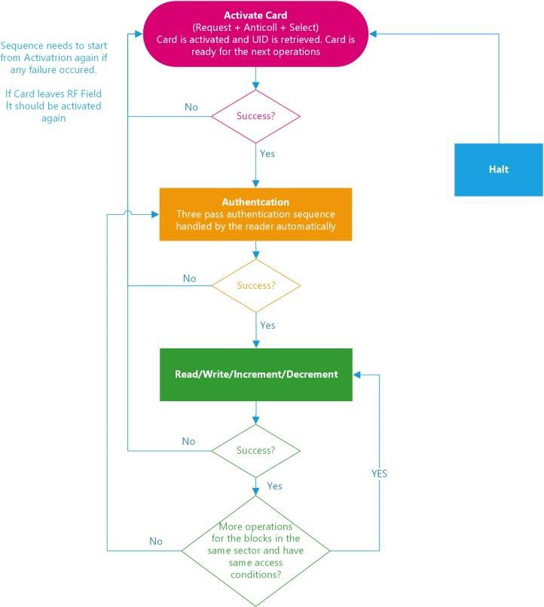

Fig. 4.4 Flow chart to read/write data block

Topic 5: Read/Write Cloud Data by Arduino
Components list:
- Arduino: Mega 2560
- Wireless transceiver ESP8266 module

Introduction of ThingSpeak
ThingSpeak is an IoT analytics platform service that allows you to aggregate, visualize, and analyze live data streams in the cloud. You can send data to ThingSpeak from your devices, create instant visualization of live data, and send alerts. Its website

ThingSpeak offers free data storage and analysis of time-stamped numeric or alphanumeric data. Users can access ThingSpeak by visiting http://thingspeak.com and creating a ThingSpeak user account. The user account is associated with the MathWorks account and students’ CityU email account has already been registered as MathWorks account. If not, students can register free accounts.

To register MathWorks, you can visit
  - https://www.cityu.edu.hk/csc/deptweb/facilities/central-sw-tah.htm

Documentation for ThingSpeak
- https://www.mathworks.com/help/thingspeak/index.html

Upload/Download Data
ThingSpeak stores data in channels. Channels support an unlimited number of timestamped observations (think of these as rows in a spreadsheet). Each channel has up to 8 fields and each field store one value. Fig. 5.1 shows an example of a channel with 3 fields. The channel ID is set by ThingSpeak system and the channel name and field names can be set by user.
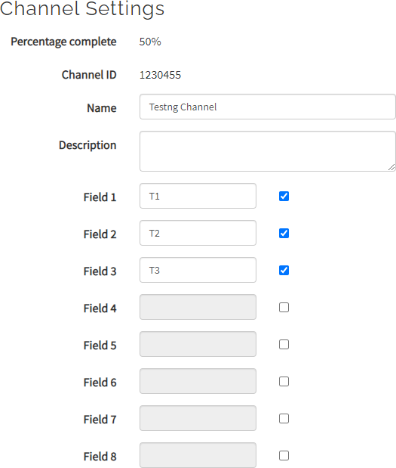
Fig.5.1: Example of Channel settings in ThingSpeak

Self-Reading Materials
Read the following materials to understand more about the channel settings. https://www.mathworks.com/help/thingspeak/collect-data-in-a-new-channel.html

To read/write the field, you’ll need to have the Read/Write API keys. For example.
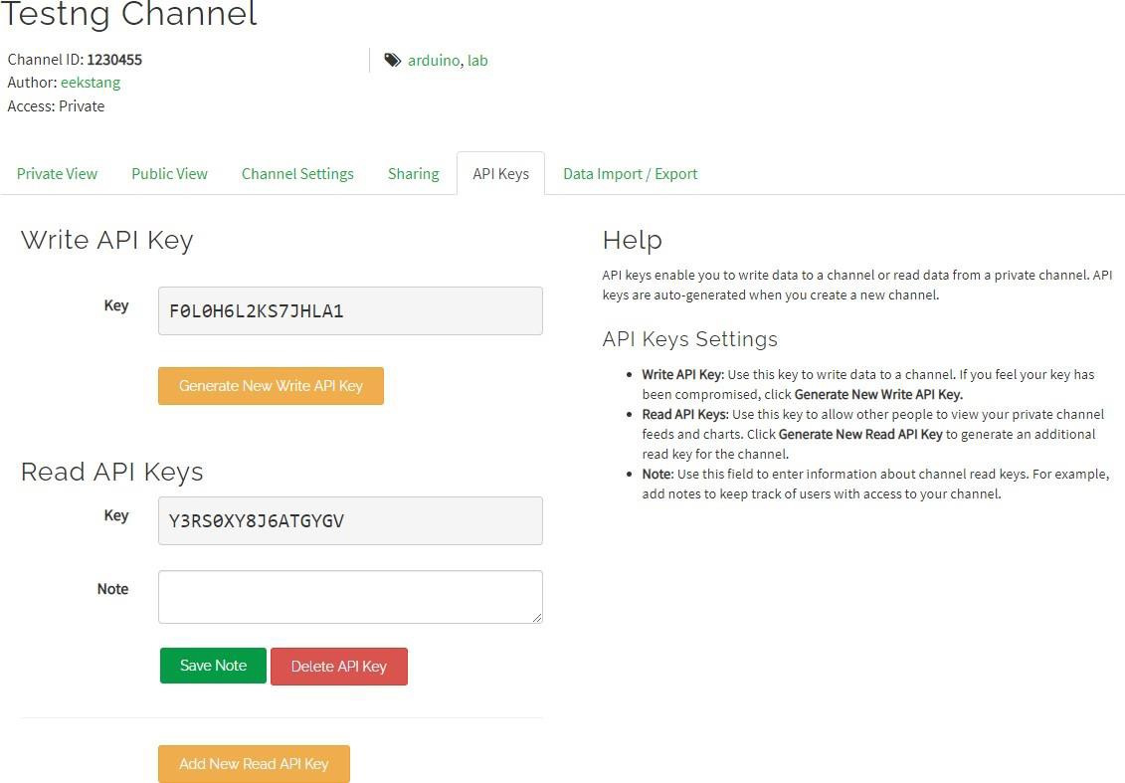
Fig.5.2: Example of the page shown at the API Keys submenu

In the cloud website, we can view and analysis those unlimited historic data. The channel can be set as private (API keys are needed to read/write) or public (everyone) or some specified ThingSpeak users.

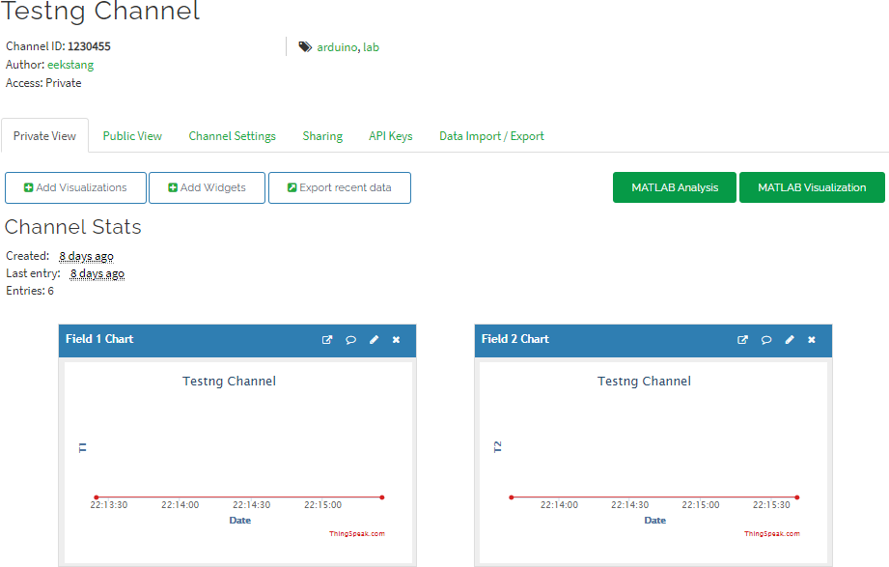

Fig.5.3: Channel statistics in ThingSpeak website

Limitation of Free Account
Read the license FAQ: https://thingspeak.com/pages/license_faq
Users with free account will be limited to sending no more than 3 million messages each year to the ThingSpeak service. They will also be limited to 4 channels, and the message update interval limit remains limited at 15 seconds.

Introduction on Wireless Communications
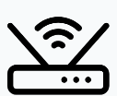

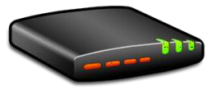
In order to access the ThingSpeak, we’ll need to access the Internet. That is done via the wifi. The basic idea is as follows.

Arduino board
Wifi module
Wifi router Modem to Internet

Fig. 5.4. Data flow for Internet access using Arduino
There is a Wifi router in each lab, which can access the Internet. The router is the access point (AP). It has a unique ID or the SSID, so that you can differentiate different AP and connect to a particular one. [Ask technician for SSID and password]
Once the Arduino accesses the Internet, it can read/write fields in the channel in ThingSpeak using the API-Key (with some functions in ThingSpeak.h library)

B.1. ESP8266 Wifi module
To have the wifi connection capability, a wifi module (part number ESP8266) is needed. Fig. shows the phot of ESP8266 and its pinout.
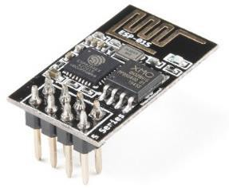
Top view

GND |  |  | RX
TX | CP | RST | VCC

Fig. 5.5. Wifi module ESP8266 and its pin layout

Hardware Connection
Arduino boards have built in support for serial communication on pins 0 (RX) and 1 (TX). However, it is reserved for the communication between Arduino and the COM port of your laptop. Therefore, if we want to use the Serial monitor, other Serial pins are to be used to connect the wifi module.

An example is given below.

Table 5.1 Example of wiring between ESP8266 and Serial 1 of Arduino Mega

ESP8266 | Arduino Mega
GND | GND
GPIO 2
GPIO 0
RX | TX1
TX | RX1
CH_PD | 3.3V
RST
Vcc | 3.3V
Note: The CH_PD has been connected to Vcc in the project platform board. TX1 and RX1 are the transmitter and receiver pins for Serial1.
- Note: Serial, Serial1, Serial2, Serial3 are predefined for Arduino Mega

Self-Reading Materials
To understand more, read the following materials https://create.arduino.cc/projecthub/user720003162/connecting-esp8266-01-to-arduino-uno-mega- and-blynk-194f17

Software Design

Library
You’ll need to install the following libraries to program the ESP8266 and access Cloud Service in ThingSpeak:
- ThingSpeak.h : for upload/read data from the cloud platform ThingSpeak
- WiFiEsp.h : allows the Arduino board to connect to the Internet via ESP8266 WIFI module Note: See Laboratory Manual (Arduino IDE and Programming) to learn how to add a library

Self-Reading Materials
To understand more, read the following materials
https://github.com/mathworks/thingspeak-arduino https://github.com/mathworks/thingspeak-arduino/blob/master/README.md https://github.com/bportaluri/WiFiEsp

Brief descriptions on functions, enum and structures
Some key functions for programming are given below (Note: The libraries in Sec. B.2.1 must be included.)
- Initialization the ESP8266 #define ESP_BAUDRATE 115200
// initialize Serial1 for ESP module. The default baud rate of the ESP is set as 115200 bps Serial1.begin(ESP_BAUDRATE);

// initialize ESP module

WiFi.init(&Serial1);

- Initialization the client for ThingSpeak

WiFiEspClient client; //create a wifi client ThingSpeak.begin(client); // Initialize ThingSpeak

- Reading/writing a field
  - If it is public, no API key is needed. ThingSpeak.readFloatField(weatherStationChannelNumber, temperatureFieldNumber);

  - If it is private, API key (read key or write key) is needed. ThingSpeak.readFloatField(myChannelNumber, i, myReadAPIKey); ThingSpeak.writeField(myChannelNumber, i+1, upload_number[i], myWriteAPIKey);

  - To check whether the read/write success. We can get the status value and, 200 implies success.
statusCode = ThingSpeak.getLastReadStatus(); // 200 is success

Program Example
The following is an example program to interface with a wifi module

#include "WiFiEsp.h"

#define ESP_BAUDRATE 115200
char ssid[] = "Twim"; // your network SSID (name) char pass[] = "12345678"; // your network password
int status = WL_IDLE_STATUS; // the Wifi radio's status

void setup() {
// initialize serial for debugging Serial.begin(115200); Serial1.begin(ESP_BAUDRATE);

// initialize ESP module WiFi.init(&Serial1);

// Connect or reconnect to WiFi if(WiFi.status() != WL_CONNECTED){
Serial.print("Attempting to connect to SSID: "); Serial.println(ssid);
while(WiFi.status() != WL_CONNECTED){
WiFi.begin(ssid, pass); // Connect to WPA/WPA2 network Serial.print(".");
delay(5000);
}
Serial.println("\nConnected");
}

void loop()
{
// check the network connection once every 10 seconds Serial.println();
printWifiData(); delay(10000);
}

void printWifiData()
{
// print your WiFi shield's IP address IPAddress ip = WiFi.localIP(); Serial.print("IP Address: "); Serial.println(ip);

}

Basic Design:
Before you start, you need to get familiar with the channel definition in ThingSpeak. Then, a private channel containing two fields, and work on the following design tasks.
You will need some other commands in the library. See
https://github.com/mathworks/thingspeak-arduino/blob/master/README.md

Design Task 1:
Write a program to download a value from a public channel (Note: You may refer to examples in ThingSpeak library, eg. ReadField)

Design Task 2:
Write a program to upload two random values to the fields (one value for one field) in your private channel in every minute. In total, upload 5 sets of values in 5 minutes.

Design Task 3:
Write a program to download the first field of the latest record and its created time, according to the level of an I/O pin (eg. It becomes high), then output the result (created time and the record) to Serial monitor.

CHECKPOINT: SHOW THE RESULT AND EXPLAIN TO TUTOR FOR EACH TASK

Questions to be answered in report:
Q1. If Serial2 is used, which pin (give pin number) of an Arduino Mega is to connect to RX of ESP8266? Which pin of Arduino Mega is to connect to TX of ESP8266?
Q2. Can we update two data to two different fields of a channel with a single upload? If yes, describe how.
Q3. What data type that we can store in the field of a channel?

Advanced Design: You work on this only after finished tasks in Basic Design
a) Advanced Task 1
It is also possible to use HTML to get data from ThingSpeak. You may refer to a simple example (refer to the below link).
http://matternett.blogspot.com/2016/09/fetching-data-from-thingspeak-iot-cloud.html
To use it, please notice
- The latest version of jquery is 3.6.0. You have to change the code in HTML accordingly
- The url should be updated. If it is a public channel, no password is needed. For example, we may have
url = 'https://api.thingspeak.com/channels/1293177/feeds.json?results=1';

Modify the html and get the results from your private channel

Advanced Task 2

You can also design a user interface (UI) in MATLAB using App Designer. You may refer to https://www.mathworks.com/products/matlab/app-designer.html
Design a simple interface such that
  - Button A: send a random data to the fields of your private channel
  - Button B: get results from your private channel and display it. An example of interface is shown below:

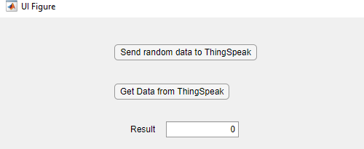





10/09/2023/AC

