City University of Hong Kong
Department of Electronic Engineering

EE3101 Communication Engineering

Laboratory Report

Experiment 2 - Eye Diagram

Tse Kwok Yip (54396093)

Abstract
This experiment is to study the effect of bandlimited channel like raised cosine filters on the transmission of binary data.

Aims & Objectives
Use Matlab to simulate binary data transmission over a bandwidth-limited channel. Then, an eye-diagram of the received waveform from the band-limited channel is plotted. And observe how the eye-pattern changes if you use different parameters.
Equipment Setup
A PC with software of Matlab

Introduction & Background Theory
In the field of telecommunications, the eye diagram (also known as eye diagram) is an oscilloscope display. The digital signal from the receiver is repeatedly sampled and applied to the vertical input. The data rate is used to trigger the horizontal scan. This is so-called because, for several types of encoding, the pattern looks like a series of eyes between a pair of rails. It is a tool to evaluate the combined effects of channel noise and intersymbol interference on the performance of baseband pulse transmission systems. It is a synchronous overlap of all possible realizations of the signal of interest observed during a particular signal interval.

Several system performance indicators can be derived by analyzing the display. If the signal is too long, too short, out of sync with the system clock, too high, too low, too noisy or too slow to change, or too much undershoot or overshoot, this can be observed from the eye diagram. The blink diagram corresponds to the minimum signal distortion. The signal distortion caused by inter-symbol interference and noise manifests itself as eye closure.

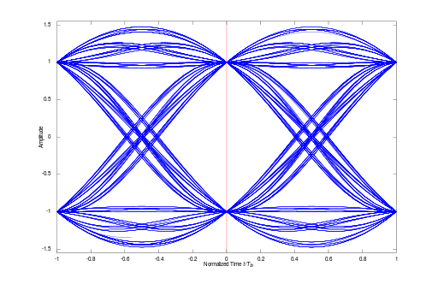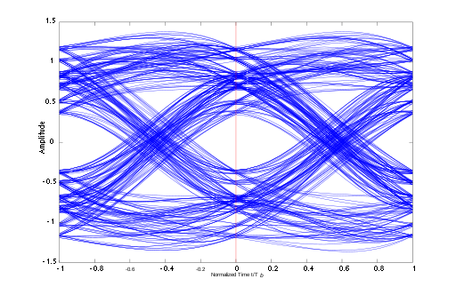

Procedures and Question
Step 1:

First of all, generate a sequence of 2000 random Bipolar-NRZ (i.e. NRZ-L) data D with amplitude ±1 (refer to Appendix of Experiment 1 for generating random data D). In each symbol interval, we sample at the rate of Ns samples per data, and create D_ext sequence. Let Ns equals 10. Assume that the data rate is 1b/s, (i.e. 1 symbol per sec) then the sampling rate is 10Hz. Refer to Appendix for Matlab code examples to oversample the data 10 times and gets D_ext. The parameters for designing the raised cosine impulse response are set as follows: the length of the impulse response N = 200 (i.e. the overall length is 200+1 samples); the cutoff frequency is optimum sampling time noise margin peak distortion sensitivity to timing error distortion of zero crossings Random NRZ-L Data generator Raised cosine filter h(t) received signal for eye-diagram plotting + noise Fc = 0.5 (the minimum Nyquist bandwidth is 1/2=0.5); the sampling frequency Fs = 10 (i.e. there are Fs/2Fc =10 samples per symbol); the excess bandwidth is α = 0.35. The length of the impulse response is ே N/( Fs/2Fc) symbols. After setting h=firrcos(200, 0.5, 0.35, 10, ‘rolloff’), the impulse response is from –10T to +10T with a total length of 20T (T is the symbol duration). The center (or maximum) of the impulse response is at position N/2+1=101, (i.e. h(101) has the maximum value), and the impulse response is zero at h(101 ± Fs/2Fc n) (i.e. zero ISI) where n is a non-zero integer. Check your impulse response. However, the convolution process also includes the transient responses at the beginning and at the end of tx data. Correct eye diagram plot can be obtained by using tx_mod in ‘eyediagram(tx_mod, Fs/Fc)’, where tx_mod is a modified version of tx such that the N samples at the beginning and N samples at the end of tx have been removed, Fs/Fc here means that each eye diagram trace consists of 2 symbols.
(1) What will happen if you choose eyediagram(tx_mod, Fs/Fc +1) in your eye-diagram plotting? Why?
(2) Is there any inter-symbol interference (ISI) at the optimum sampling point? How to reduce/eliminate it? (Hint: zero ISI for impulse response doesn’t imply zero ISI for pulse response.)

Step 2:

Explain the changes on eye-diagram if the following parameters are changed:
(a) Assume that the sampling rate remains the same but now the number of samples per data is reduced from 10 to 5. i.e. reduce Ns from 10 to 5 in D_ext simulation. The same impulse response is used.
(b) With Ns = 10, increase the cutoff frequency ( Fc ) from 0.5 to 1 in the impulse response of the filter. This implies the bandwidth of the raised cosine filter is doubled. (c) With Ns = 5 for the data and Fc = 1 for the impulse response.

Step 3:

Keep the cutoff frequency ( Fc ), the sampling frequency (ܨ௦) and Ns be the same as in Step 1 (i,e Fc = 0.5, ܨ௦= 10, Ns =10). Plot the eye-diagram with other filter parameters in ‘firrcos(N, Fc, α, Fs, ‘rolloff’)’ (Note: 2000 random data is used):
(a) excess bandwidth (α) = 0.03, length of the impulse response (N) = 60 & 200
(b) excess bandwidth (α) = 0.93, length of the impulse response (N) = 60 & 200 Comment on the eye-diagrams for N=60 & 200 in (a) and (b) [why is there basically no change on eye-diagrams for N=60 & 200 in (b)?].

Results

Step 1:
eyediagram(tx_mod, Fs/Fc)
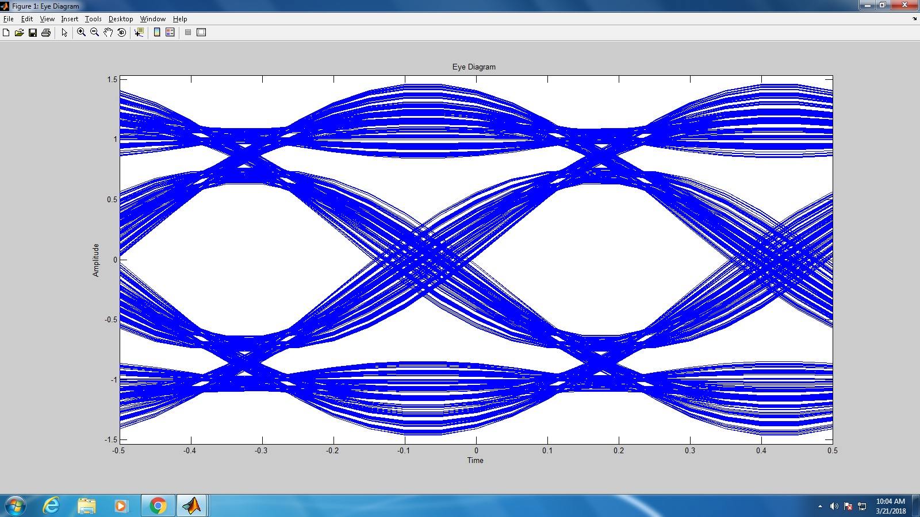

(1) When eyediagram(tx_mod, Fs/Fc + 1) is chosen, we cannot obtain a correct eye diagram. The eye-diagram cannot provide a clear +1 or -1. It is because the matlab code 'eyediagram(X,Y)' is plotting the X signal against Y, where Y is the number of sample per face. The optimum sampling instant is at (Fs/2Fc)n, where n is a non-zero integer. Therefore, Fs/Fc + 1 is not an optimum sampling instant, which produces large ISI.
(2) ISI still exists at the optimum sampling point. Because the input is not an impulse. In fact, this is a series of 10 impulses that can be considered as input pulses. However, it will cause ISI impulse response. In order to eliminate ISI, a modified impulse response Hm(f) should be found.

-Let Hd(f) be the transfer function of NRZ-L
-Let Hr(f) be the transfer function of raised cosine filter

Then, Hd(f) x Hm(f) = Hr(f) to achieve zero ISI.
=>Hm(f) = Hr(f) / Hd(f)

Step 2:
- The Ns affect the density of the graph. When the Ns is 5, there will have large ISI. This is because the sampling rate remains the same, that is, Fs = 10, so the sampling time is no longer the best sampling time. Therefore, the ISI is large.
Ns=5
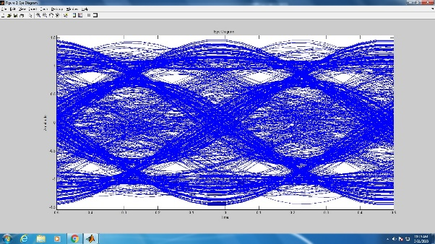
Ns=20
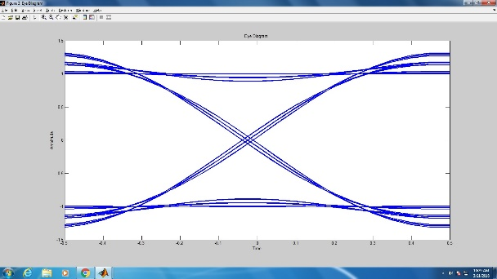
- With Ns = 10, increase the cutoff frequency (Fc) from 0.5 to 1
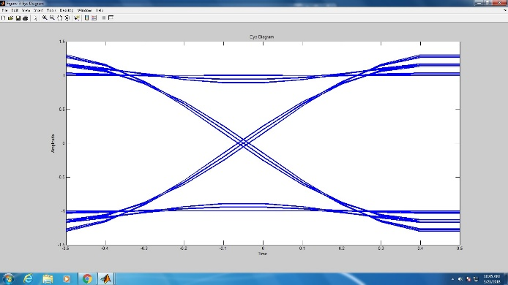

If Fc changes from 0.5 to 1, the bandwidth of the raised cosine filter is doubled. The eye diagram provides a clearer +1 or -1, which means less ISI.

- With Ns = 5 for the data and Fc = 1 for the impulse response
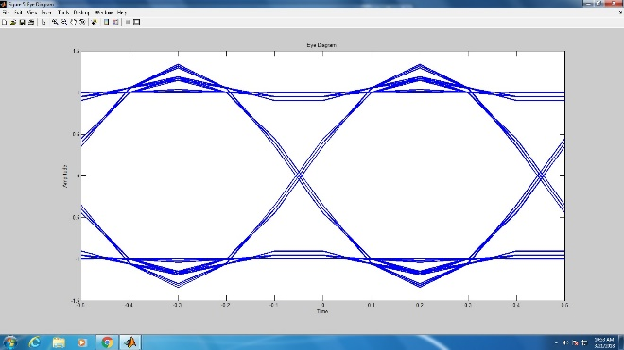
The duration of each eye-symbol become half and the top part and bottom part have form a triangle. It means that the numbers of samples per date is not enough and the cut off frequency is high.
Step 3:

- excess bandwidth (α) = 0.93, length of the impulse response (N) = 60
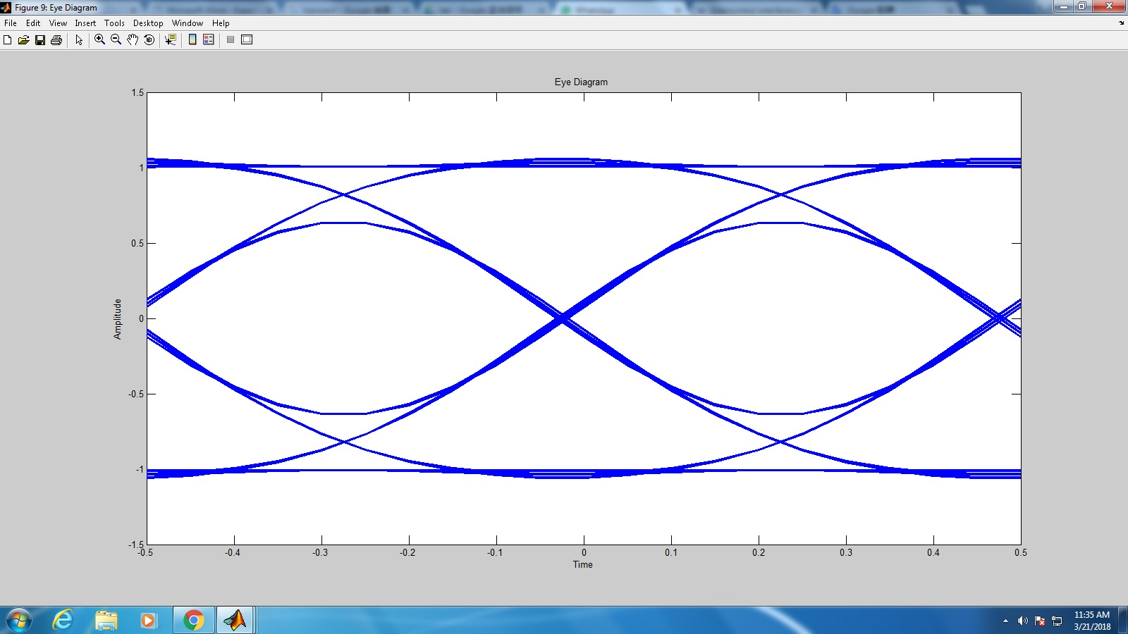

- excess bandwidth (α) = 0.93, length of the impulse response (N) = 200
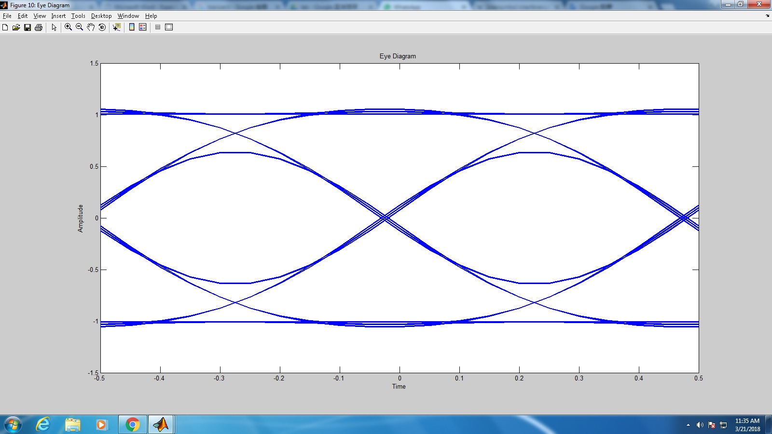
The reason why (b) the eye diagrams in N = 60 and 200 are basically unchanged is that the excess bandwidth (α) = 0.93 is very high, and the n-th largest point of the impulse response is also close to zero. Therefore, there is almost no difference between N = 60 and 200.
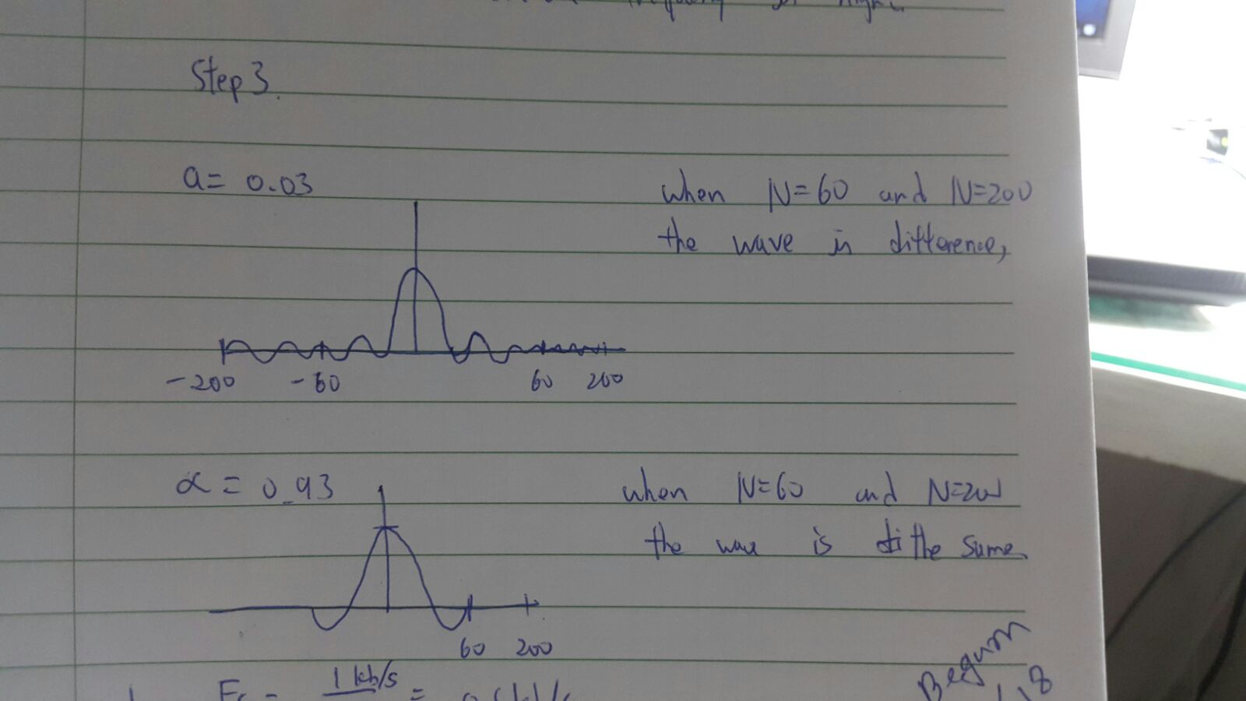
Discussion:
(1) The values of Fc and Fs in “firrcos(N, Fc,α, Fs, ‘rolloff’)” for 1kb/s NRZ-L data with 10 samples per data (bit) are:
Fc = 1k / 2 = 500Hz
Fs = 1k x 10 = 10kHz
There is no difference since the ratio did not change
(2) When the maximum value of a is 0.1,so 2% will be 0.02. the value of N will rough about 35.

Conclusions
In band-limited channels, there is Inter-Symbol Interference (ISI). Raised cosine filter parameter settings can affect ISI minimization performance. By observing the eye diagram, it is easy to determine whether the signal is good before sampling. The eye diagram can tell us the number of ISI at the best sampling position and the best sampling time.
Appendix
Program code for experiment 2

M=2000;
temp = rand(1,M);
for i=1:M
if temp(i) >0.5
D(i) = 1;
else
D(i) = -1;
end;
end;

Ns =10; % Ns=5 or Ns=10
for i =1:M
for j = 1:Ns
D_ext((i-1)*Ns + j) = D(i);
end;
end;

h = firrcos (200, 0.5, 0.22, 10, 'rolloff'); % modify the parameters in different steps

out = conv (h, D_ext);
out_leng = length (out);
out_stable = out(201+1:out_leng-201);
eyediagram (out_stable, 20)

