City University of Hong Kong
Department of Electronic Engineering

EE3004
Electronic Product Design
Final Report

Group : Group1 (L04)
Name : Tse Kwok Yip
Student ID : 5439 6093
Content
1. Summary P3
2. Introduction P3-P4
3 Background Theory P4-P7
4. Objectives P8
5. Hardware and Software Design P9-P13
6. Principle of Operation P13
7. Testing Procedure P14
8. Results P15
9. Analysis and Discussion P16
10. Conclusion P17
11. Appendix P18-P29

1. Summary
This project aims to design a line tracking car to finish some missions. To compare with last semester, the missions are much difficult and challenges such as turning 90 degrees, walking on the abrupt slope and catch the object.

The car will follow the black line and catch the plastic cube. Then walking back to the original place and put down the cube. The components of the car are including the gripper, the motor, the ultrasound sensor and the light sensor.
This report will include the design theory, hardware and software design of the car. The design experience, test methods, and issues already discussed and analyzed have been included in the report.

Finally, we will talk about the learning experience of the course process.

2. Introduction
This project is a line-tracking car design. As the mainstream of the future is automation, line tracking vehicles with robot cars are a good starting point for future development.
The aims of project is designing a car which is auto-tracking the black line and catching the plastic cube. In semester A, we have already learn the base Arduino program and made the line tracking car that can follow the simple black line. In this semester, we need to make the improvement base on what we have learned.

Initially, we designed a circuit prototype and tested it for success by using a breadboard test circuit. Next, PCB manufacturers will make schematics and PCB layouts. After welding and assembling components, some tests and optimizations were performed. For example, check the position of the component and the quality of the test PCB. For infrared sensors, the project selected RMB 70. Infrared sensors are the main component of this project. For servo motors, the installation position of the servo motor is also important. Because it will affect the balance of the car.

In the hardware, we design to use 6 light sensor and 1 ultrasound sensor to fulfill the condition of the road and 1 gripper to catch the plastic cube. We have change the design of PCB for many times because we need to minimize the size of the car and place the component to the suitable place.

In the 3D printing, we design use 3D printing to make the plastic component for holding the gripper on the PCB. The benefit is that plastic will not make the PCB short circuit.

From this project, we face different problem when we do the testing and producing. We find the importance of team work to share the work load and play our strength.

3 Background Theory
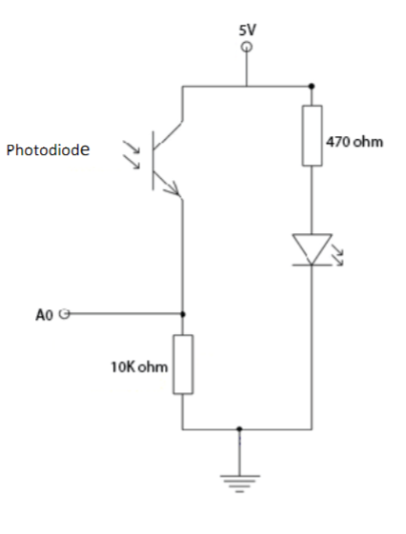
Figure 1: sensor circuit
As for the line-tracking car theory, the car relies on photodiodes and LEDs to create sensors to test the test leads and feed the received signals back to the Arduino to control the car's direction of travel.

As shown in Figure 1, the photodiode is connected to the LED as a sensor. The light-emitting diode is placed near the photodiode. When the LED is lit, the lamp will enter the black test lead. At the same time, depending on the black absorption, little or no light is reflected. And the photodiode can convert the optical power into current according to the received optical power into the photodiode. So the photodiode will detect some light and input the relative current into the Arduino because of the black color. Therefore, these data can be used to analyze the directional control of motor vehicles.
For the sensor circuit combination, we can use its three groups to create the circuit shown in Figure 2 to test the test line.
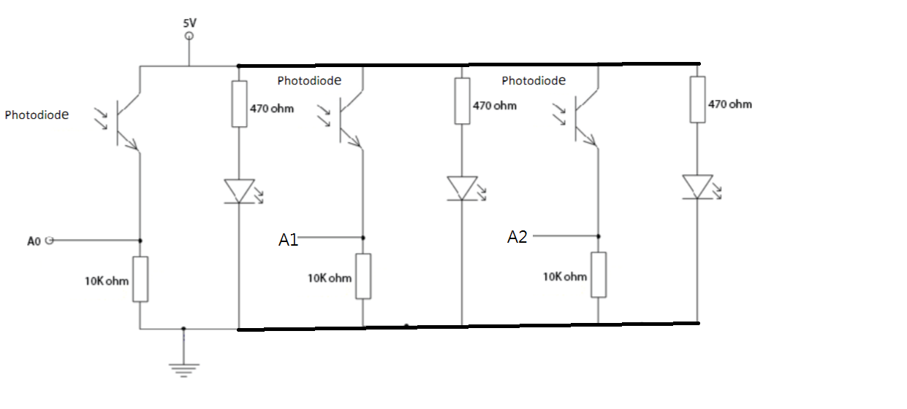
Figure 2: three sensor circuit
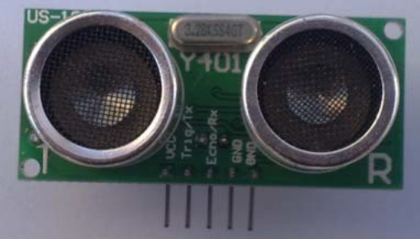 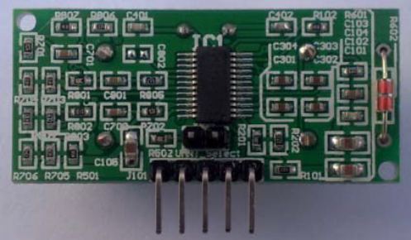Figure 3: front size of ultrasound sensor Figure 4: back size of ultrasound sensor

For the ultrasound, only need to input a high level above 10US on the Trig / TX pin, the system can send 8 40KHZ ultrasonic pulses and then detect the echo signal. When the echo signal is detected, the module must also measure the temperature value.
Then the distance measurement result is corrected according to the current temperature, and the corrected result is output through the Echo/RX pin.
In this mode, the module's distance value is converted to 2 times the time value at 340m / s, and a high level is output through the Echo terminal, according to the duration of this high level. Calculate the distance value that is the distance value: (high time *340m/s)/2.
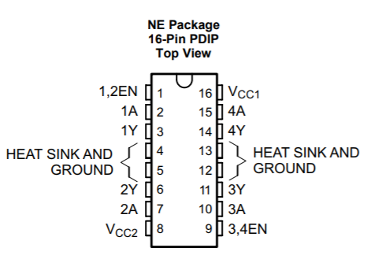
Figure 4: L293D 16-Pin Top View
For further improvement, Figure 4 of the L293D was used. L293D was selected in my design. The L293D is a push-pull four-channel driver that is a monolithic integrated high-voltage, high-current, four-channel driver. To make it user-friendly, the design comes with enable input. So it's easy to write in programming. The L293D is a 20-pin assembly with 8 pins connected for heat dissipation.

The L293D can provide up to 600mA of bidirectional current. In addition, in my design, there are two enable pins connected to the Arduino for PWM control. The L293D is an H-bridge motor driver, which has the advantages of lower cost and a full range of protection functions such as thermal shutdown and over-current protection.
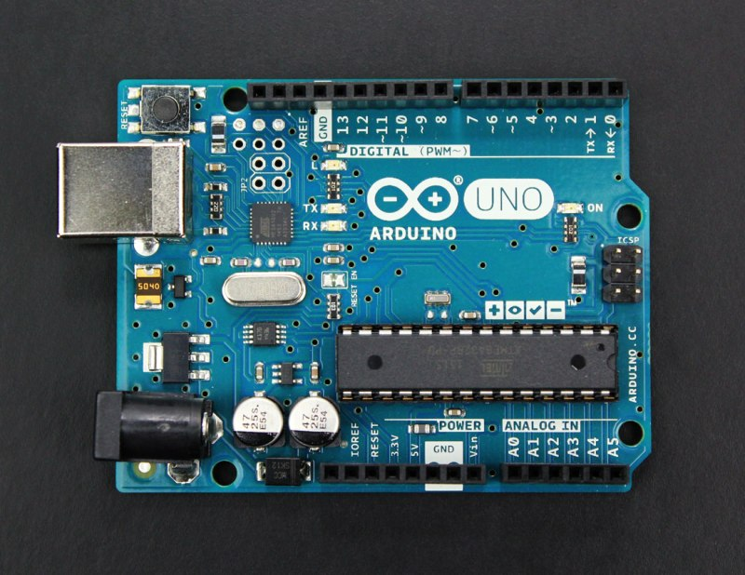
Figure 5: Ardunio board
Arduino is an open-source electronics platform based on easy-to-use hardware and software. Arduino boards are able to read inputs - light on a sensor, and turn it into an output - activating a motor, turning on the gripper. We can tell your board what to do by sending a set of instructions to the microcontroller on the board.

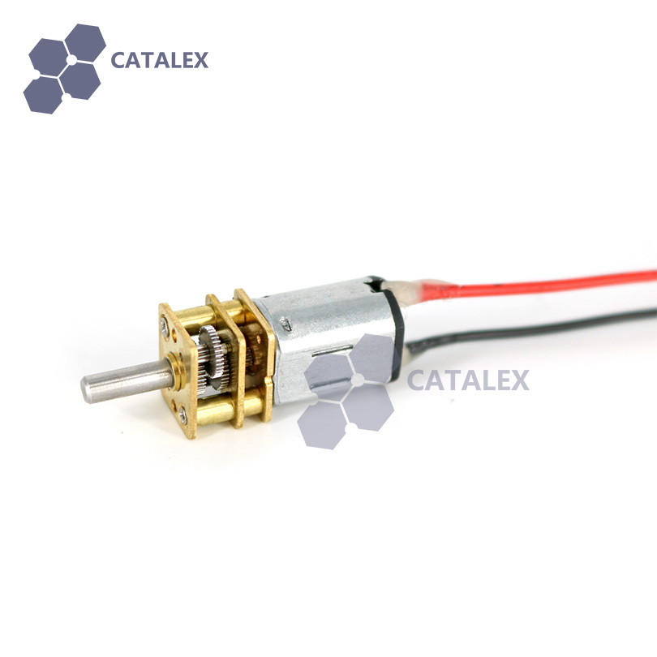
Figure 6: N20 deceleration motor
The 12V 1:150 speed ratio N20 deceleration motor has been chosen in the design. N20 deceleration motor is a DC motor which can provide a stable speed. Also, the quality of N20 is high. The feature of the 12V 1:150 speed ratio N20 deceleration motor is the torque is high. It can provided 250g.cm torque. Also 12V provided 300 rpm.
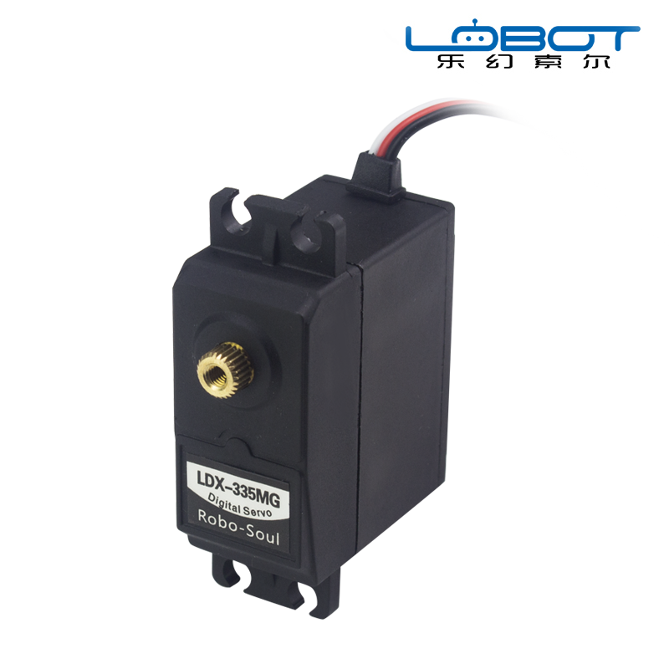
Figure 7: LDX-335MG
LDX-335MG was chosen in my design. The robotic arm was installed with LDX-335MG for pick up or pick down function. The servo motor includes of a DC motor, gear system, position sensor and control circuit. The DC motor gets powered from a battery and run at high and provides low torque. The gear system provides a higher torque. The position sensor senses the position of the shaft and feeds the data to the control circuit. The control circuit decodes the signal from position sensor and compares the actual position of the motor.

Servo motor is controlled by PWM. The width of the pulse determines the angle of the position of the servo motor.
4. Objectives
By completing the route tracking car project, we look forward to learning:
1. Understand the actual design issues of entry-level electronic devices.
2. Identify and approve the basic design and manufacturing procedures for electronic products.
3. Obtain practical experience in electronic product design and problem solving.
4. Learn about Arduino programming, PCB manufacturing and curing concepts.
5. Pulse width modulation theory and receiving sensor values.
6. Learn the working principle of the gripper and the ultrasound sensor.
7. Make the car that follow the black line of figure 6.
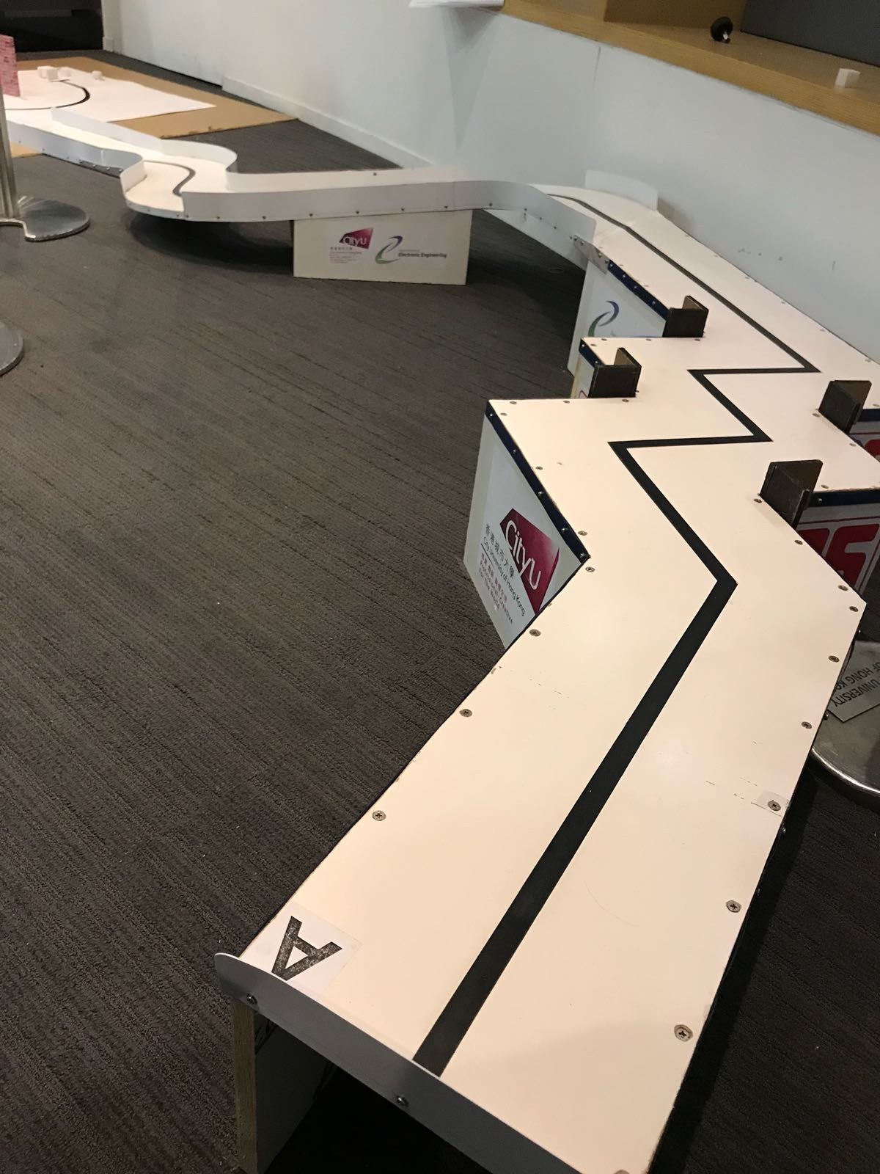
Figure 8: The road

5. Hardware and Software Design
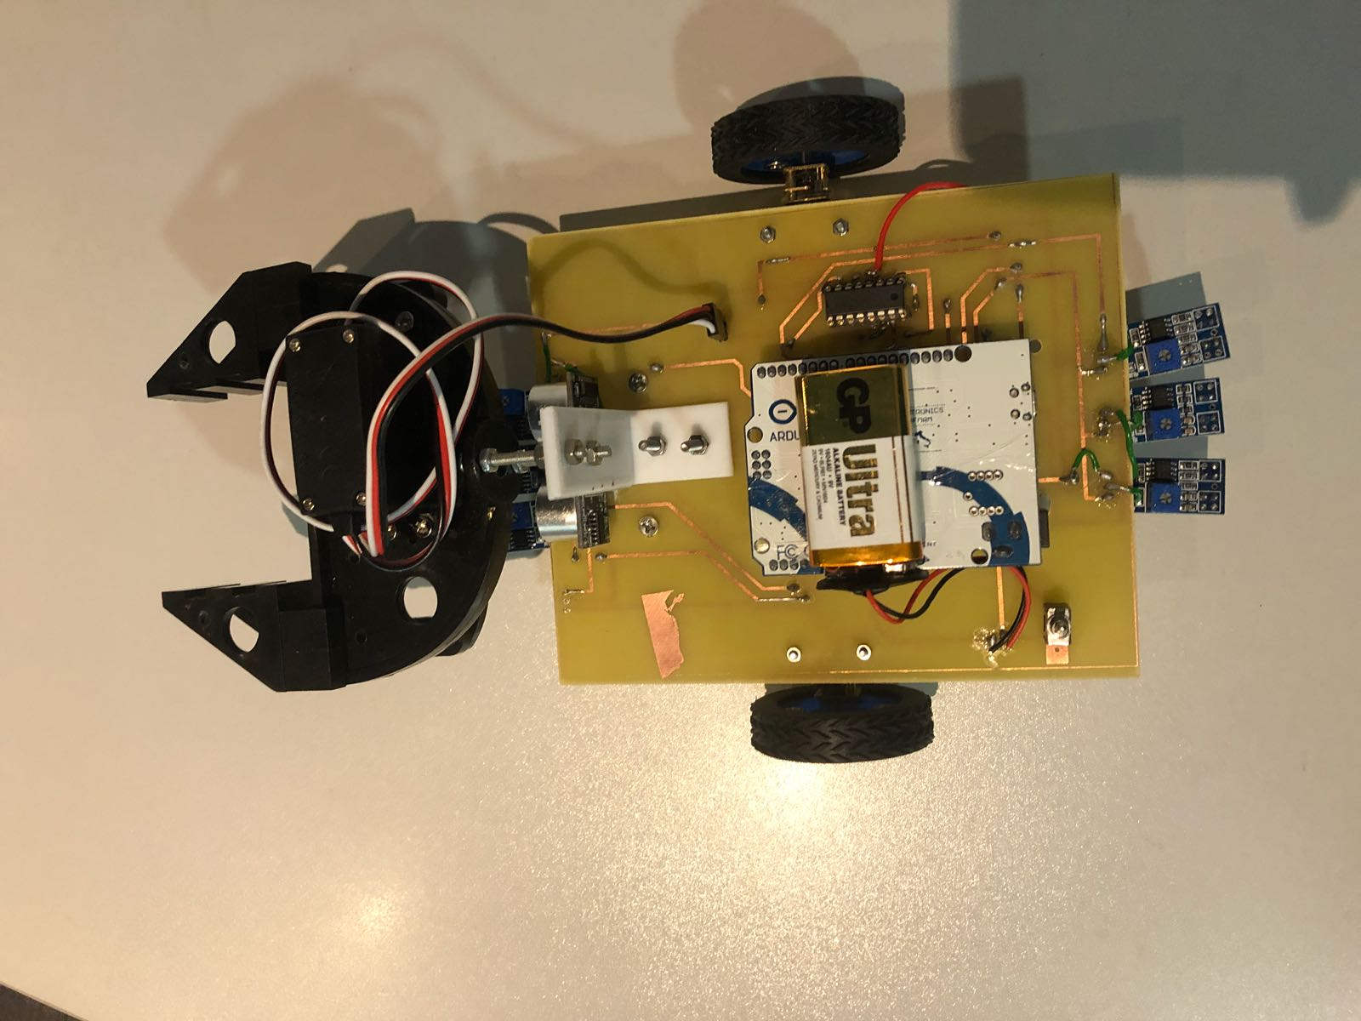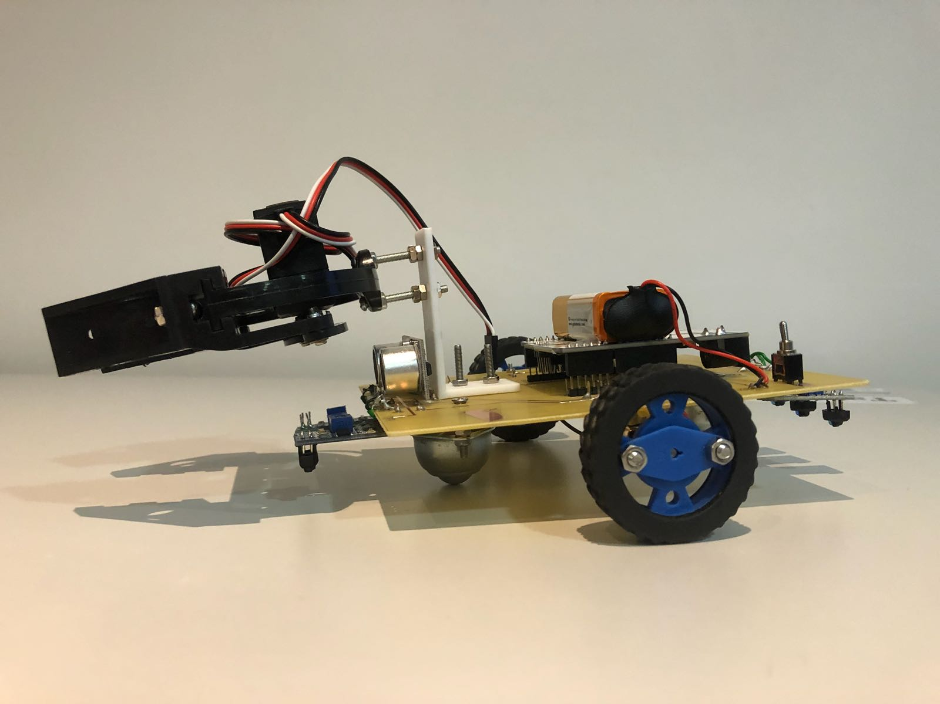
Figure 9: The top view of the car Figure 10: The side view of the car
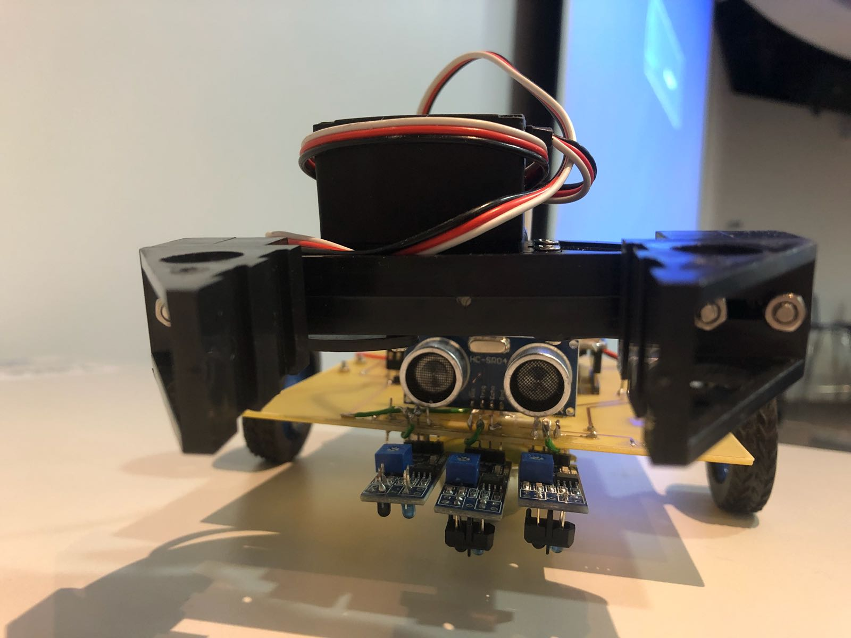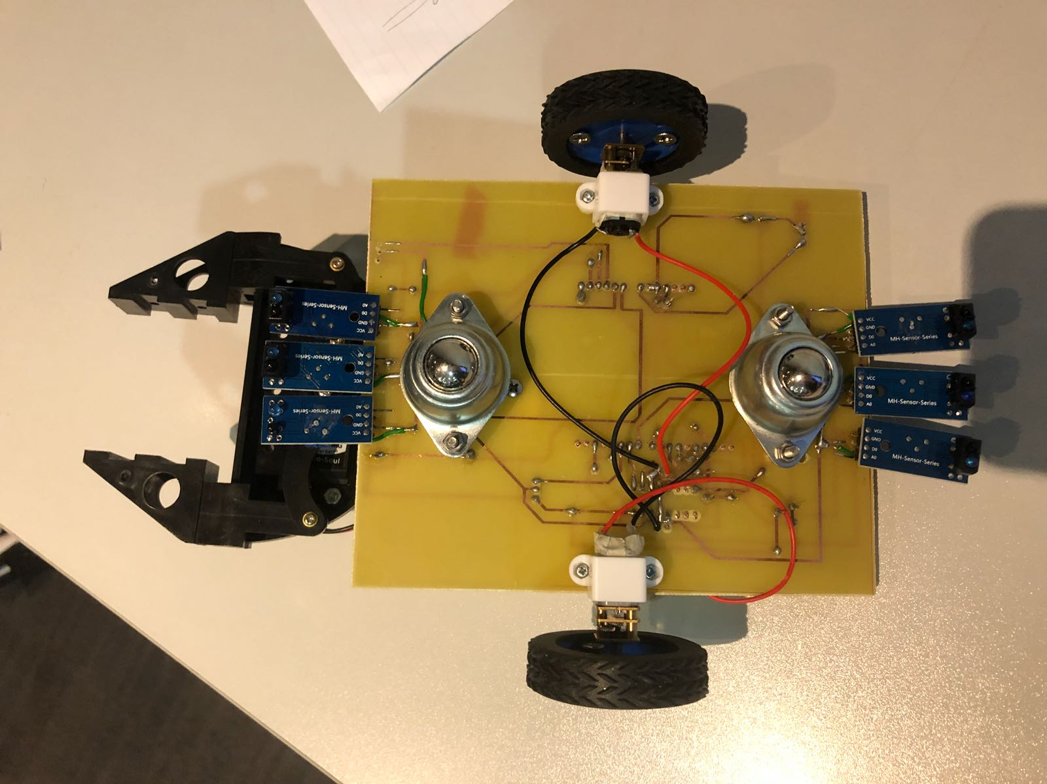
Figure 11: The front view of the car Figure 12: The bottom view of the car

For the figure 7, figure 8 and figure9, they are the Top view, Front view, Side view and bottom of the final product. We can clearly see that there are several part of the line tracking car including the motor system, sensor system, PCB, gripper, 3Dprinting, Arduino board and the power supply.

Figure 13: L293D 16-Pin Top View Figure 14: The motor with gear ratio (1:100)

For the motor system, it contains two part which is motor and L293D that show in figure 11 and figure 12. We decide to use the motor with gear ratio (1:100) because the weight of car was increase since the number or component is increase. Also, the car need to pass thought the abrupt slope. Therefore, we choose this motor. L293D can simplify the motor circuit and help us to give the value from Arduino to motor.
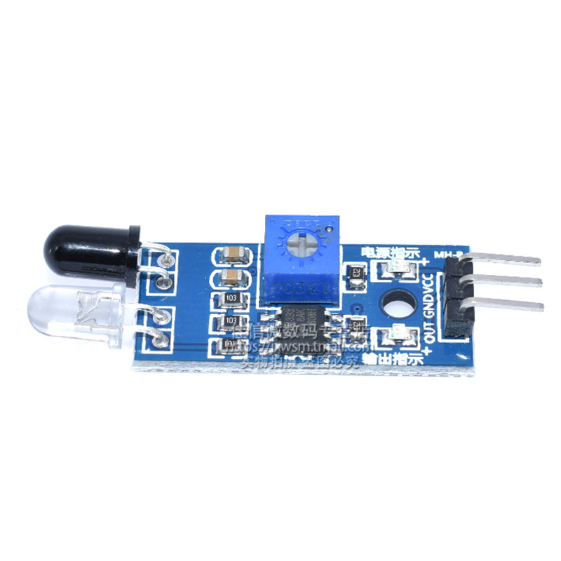
Figure 13: The light sensor Figure 14: The ultrasound sensor
For the sensor system, it contains two part which is the light sensor and the ultrasound sensor that show in figure 13 and figure 14. The function of light sensor is detecting the black line and send the signal to Arduino. The function of ultrasound sensor is detecting the distance between the plastic cube and the car. 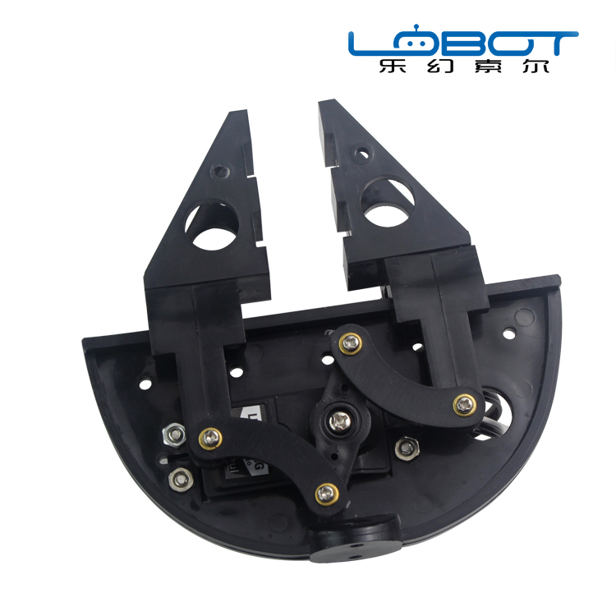
Figure 15: The gripper Figure 16: The servo motor
For the gripper, it contains two part which is the gripper and the servo motor that show in figure 15 and figure 16. The function of servo motor is control the close and open of the gripper.

Software:
In the program, we decide to use 5 stage to fulfill the all condition of the road.
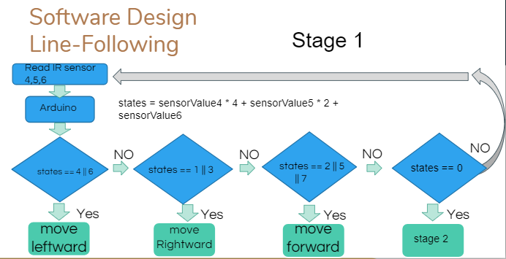
Figure 17: Stage1
For stage 1, it is from point A to point B. It will walk across the 90 degree and the detour. We will use the front sensor (4,5,6) to detect the black line.
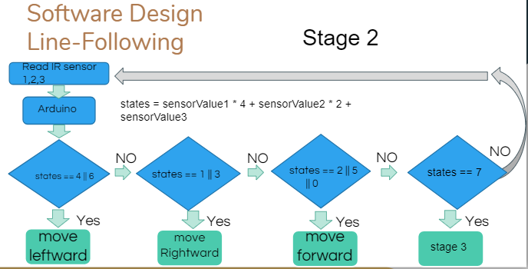 Figure 18: Stage2
For stage 2, it is from point B to point C. It will walk across the detour. We will change to use the backward sensor (1,2,3) to detect the black line.

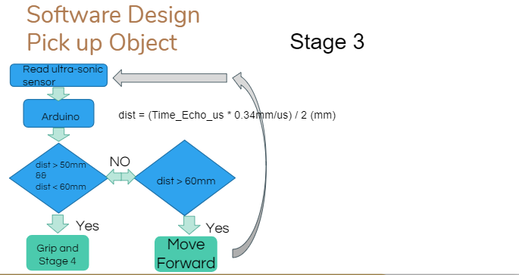
Figure 19: Stage3
For stage 3, it is from point C to point D. It will catch the plastic cube. We will change to use ultrasound sensor to detect the distance between the car and the cube.
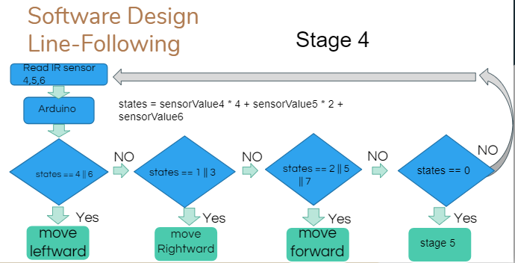
Figure 20: Stage4
For stage 4, it is from point C to point B. It will walk across the detour. We will change to use the backward sensor (4,5,6) to detect the black line.
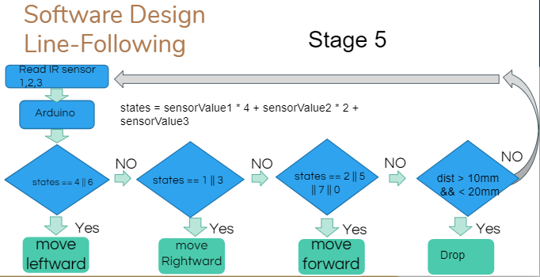
Figure 21: Stage5
For stage 5, it is from point B to point A. It will walk across the 90 degree and the detour. We will use the front sensor (1,2,3) to detect the black line.

6. Principle of Operation
The IR sensor circuit was required for tracking the black line. When the IR sensor was located on the black line, these rays will be absorbed by the surface.So there was no IR ray reflected to phototransistor. So lower value will be returned to Arduino. In contrast, when IR sensor is on the floor, these IR rays will be reflected. And the IR rays were reflected to phototransistor. There is less voltage drop across phototransistor. The higher value will be returned to Arduino. After that, the Arduino can detected the floor is black or not.

After the car runs from point A to point B, the car will change to use the backward sensors to detect the black line. Then the car runs from point B to point D . When the car faced to the object, the robotic arm is closed. After that, the car will change to use front sensors to move back to point B. And move to point A to release the object to basket.

Also, the car can pick up or pick down the object automatically by using the ultrasonic sensor. When the ultrasonic sensor sense the object at front, the robotic arm will close or open.
7. Testing Procedure
During the testing procedure of the project, we tested for several times until the smart car performs all the tasks successfully. The testing procedure costed us about three weeks.
The procedure of hardware and software testing are listed below:

For software testing:
Step 1: Coding or modifying the code through Arduino IDE.
Step 2: Upload the Arduino code from the computer to the Arduino Leonardo board.
Step 3: Place the smart car onto the testing path for testing.
Step 4: Observe the performance of the smart car. See if the car performs all the tasks successfully.
Step 5: If the smart car fails to perform all the tasks, then repeat step 1-4 again until the result is expected.

For hardware testing:
*After passing the software testing, we started the hardware testing.
Step 1: Place the smart car onto the testing path for testing.
Step 2: Observe the performance of the smart car. See if the hardware (e.g. the gripper, the motors, the green button) can work smoothly during the testing.
Step 3: If the component does not work smoothly as expected, then fix the problem of that component and repeat step 1-2 until the result is expected.

Also, the car can pick up or pick down the object automatically by using the ultrasonic sensor. When the ultrasonic sensor sense the object at front, the robotic arm will close or open.

8. Results
Before the car was fine-tuned, the car always deviated from black line. After the car value was fine-tuned, the car can track the black smoothly and move stably. Also, the car will not deviate from black line. Also, the balance of the car is essential. Since the robotic arm is heavy, so the balance of the car may affect the performance of the car.
On the other hand, the position of the sensor is also important. After resettling the position of component. The successful rate rises up to 90%.
After several testing, we finally completed the object-grasping smart car. The smart car that we built in this semester can perform all the tasks automatically. It can not only move through the black line (like the smart car we made in semester A) but also move up or down the slope, turn 90 degree clockwise or anti-clockwise, grasp the object that is located at a specific place, turn back and return to the starting point, release the object to a basket.

9. Analysis and Discussion
When doing this project, our team encountered many difficulties and problems. In the analysis and discussion section below, I will list the difficulties we encountered and how we overcome difficulties.

1. The opening and closing of the fixture are not smooth.During the testing phase, we found that the gripper's opening and closing were not smooth, making it difficult to grasp the grip. Therefore, our team decided to add the oil to make it smooth. After adding the oil, the fixture can work smoothly.

2. The position of the previously set fixture is too high
When we first built a smart car, we did not measure the height of the objects we had to accurately grasp. After fixing the fixture on the component holder, we found that the fixture we set was too high. It makes the grasper unable to catch the object at the end of the path. Finally, we solved the problem by connecting two small 4cm * 3cm circuit boards to both sides of the fixture.

3. Slippery
The wheels we used in the previous semester will make the smart car gliding easily when going downhill. We finally found that slipping is due to the material of the wheel. Therefore, we searched and purchased another set of better-quality wheels on the Internet. The wheels we purchased can create larger novels on the floor, which makes smart cars less slippery when going downhill.

4. Quickly run out of battery
In this project, we use a 9V battery to power the Arduino board, IR sensor, fixtures and buttons. Because smart cars are quite heavy, they need a lot of power to drive smart cars. As a result, the battery of the wet battery is quickly depleted.

5. Problems with the motor when changing directions
When the motor turns from clockwise to counterclockwise, it stops working due to insufficient voltage. However, if we adjust the PWM to a higher voltage, the motor will work at a higher rate, which will increase the speed of the smart car when it is driving. After discussion, our team decided to purchase another motor and replace the old one.

10. Conclusion
All in all, the line-tracking vehicle was successful. It can move and follow the black line. In addition, the car will not deviate from the black line. In this project, I learned some software such as DesignSpark, Eagle, and Arduino. Better understanding of PWM theory, Arduino programming, PCB layout and application software design.
However, because the reaction time is slower than the motor speed, the speed cannot be faster. In addition, faster motors may not have enough torque.
Finally, this project can enhance our practical skills and communication skills.

11. Appendix

#include <Servo.h>

// define pins for motors
int RightMotorSpeed = 13;
int RightMotorBackward = 10;
int RightMotorForward = 2;
int LeftMotorSpeed = 6;
int LeftMotorBackward = 9;
int LeftMotorForward = 11;

// define pins for sensors
int sensorPin1 = A2; //A5 //forward see rightest 19
int sensorPin2 = A3; //A4 18
int sensorPin3 = A4; //A3; 17
int sensorPin4 = A5; //A2;//leftest 16

int sensorPin5 = 3; //backward see left
int sensorPin6 = 4;
int sensorPin7 = 7; // right
int sensorPin8 = 8;

int sensorPin9 = 12;
// init sensor val
int sensorValue1 = 0;
int sensorValue2 = 0;
int sensorValue3 = 0;
int sensorValue4 = 0;

int sensorValue5 = 0;
int sensorValue6 = 0;
int sensorValue7 = 0;
int sensorValue8 = 0;
int sensorValue9 = 0;
// initialize the gripper
int clam = 5;
Servo myservo; // create servo object to control a servo
int angle_val = 175; // variable to read the value from program

int stage = 0;

// values for motor speed
int high = 200;
int mid = 170;
int low = 0;
int low2 = 50;

// values for dist meas
unsigned int EchoPin = A1; // connect Pin 2(Arduino digital io) to Echo/RX at US-100
unsigned int TrigPin = A0; // connect Pin 3(Arduino digital io) to Trig/TX at US-100
unsigned long Time_Echo_us = 0;
unsigned long Len_mm = 0;

void setup()
{
pinMode(LeftMotorSpeed, OUTPUT);
pinMode(LeftMotorBackward, OUTPUT);
pinMode(LeftMotorForward, OUTPUT);
pinMode(RightMotorSpeed, OUTPUT);
pinMode(RightMotorForward, OUTPUT);
pinMode(RightMotorBackward, OUTPUT);
pinMode(sensorPin1, INPUT);
pinMode(sensorPin2, INPUT);
pinMode(sensorPin3, INPUT);
pinMode(sensorPin4, INPUT);

pinMode(sensorPin5, INPUT);
pinMode(sensorPin6, INPUT);
pinMode(sensorPin7, INPUT);
pinMode(EchoPin, INPUT); //Set EchoPin as input, to receive measure result from US-100
pinMode(TrigPin, OUTPUT); //Set TrigPin as output, used to send high pusle to trig measurement (>10us)

Serial.begin(38400);

myservo.attach(5); // attaches the servo on pin 9 to the servo object
myservo.write(angle_val);
delay(1000);
}

void loop() {
// put your main code here, to run repeatedly:
ReverseRun(1);
/*
if (stage == 0)
{
ReverseRun(1);//
}
else if (stage == 1)
{
NormalRun(1);
}
else if (stage == 2)
{
Grip();

}
else if (stage == 3)
{
ReverseRun(1);
}
else if (stage == 4)
{
NormalRun(2);
}
else if (stage == 10)
{
Stop();
}
*/

}

void NormalRun(int foo) {
int state = ReadSensorValue(1);
int state2 = ReadSensorValue(3);
if (foo == 1)
{
if (state == 1) //
{
RightForward();
}
else
{
LeftForward();
}
}
else
{
if (state == 2)
{
LeftForward();
}

else if (state == 2)
{
LeftForward();
}
else if (state == 6)
{
LeftForward();
delay(150);
}
else if (state == 0 || state == 2 || state == 5)
{
GoForward();
}
else // state == 7
{
Stop();
delay(200);
stage = 4;
}
}
}

void ReverseRun(int bar) {
int state = ReadSensorValue(2);
int state2 = ReadSensorValue(4);
if (bar == 1)
{

if (state == 0)
{
Stop();
}
else if (state == 1)
{
RightBackward();
}
else if (state == 2)
{
LeftBackward();
}
else
{
if (state2 == 0)
{
GoBackward();
}
else if (state2 == 1)
{
//int sensorValue4 = digitalRead(sensorPin4);

while (state != 0)
{
GoBackward();
state = ReadSensorValue(2);
}

while (state == 0)
{
RightBackward();
state = ReadSensorValue(2);
}
}
else if (state2 == 2)
{
//int sensorValue4 = digitalRead(sensorPin4);
while (state != 0)
{
GoBackward();
state = ReadSensorValue(2);
}

while (state == 0)
{
LeftBackward();
state = ReadSensorValue(2);
}
}
}
}

/*
{
if (state == 1 || state == 2 || state == 3) //
{
RightBackward();
//delay(40);
}
else if (state == 7)//
{
RightBackwardRotate();
//delay(50);
}
else if (state == 4 || state == 8 || state == 12)//
{
LeftBackward();
//delay(40);
}
else if (state == 14)//
{
LeftBackwardRotate();
//delay(50);
}
else if (state == 6)
{
GoBackward();
}
else
{
Stop();
}
}
*/
else // bar == 2
{
if (state == 2) //
{
LeftBackward();
}
else
{
RightBackward();
}
}
}

void Stop()
{
analogWrite(LeftMotorSpeed, 0);
analogWrite(RightMotorSpeed, 0);
}

void GoForward()
{
ForwardMode();
analogWrite(LeftMotorSpeed, mid);
analogWrite(RightMotorSpeed, mid);
}

void GoBackward()
{
BackwardMode();
analogWrite(LeftMotorSpeed, mid);
analogWrite(RightMotorSpeed, mid);
}

void LeftForward()
{
ForwardMode();
analogWrite(LeftMotorSpeed, low);
analogWrite(RightMotorSpeed, high);
}

void RightForward()
{
ForwardMode();
analogWrite(LeftMotorSpeed, high);
analogWrite(RightMotorSpeed, low);
}

void LeftBackward()
{
BackwardMode();
analogWrite(LeftMotorSpeed, high);
analogWrite(RightMotorSpeed, low);
}

void RightBackward()
{
BackwardMode();
analogWrite(LeftMotorSpeed, low);
analogWrite(RightMotorSpeed, high);
}

int ReadSensorValue(int set)
{
if (set == 1)
{
sensorValue2 = digitalRead(sensorPin2);
sensorValue3 = digitalRead(sensorPin3);
return sensorValue2 * 2 + sensorValue3;
//return sensorValue1 * 4 + sensorValue2 * 2 + sensorValue3 * 1; // + sensorValue4;
}
else if (set == 2)
{
sensorValue6 = digitalRead(sensorPin6);
sensorValue7 = digitalRead(sensorPin7);
return sensorValue6 * 2 + sensorValue7;
//return sensorValue1 * 4 + sensorValue2 * 2 + sensorValue3 * 1; // + sensorValue4;
}
else if (set == 3)
{
sensorValue1 = digitalRead(sensorPin1);
sensorValue4 = digitalRead(sensorPin4);
return sensorValue1 * 2 + sensorValue4;
}
else
{
sensorValue5 = digitalRead(sensorPin5);
sensorValue8 = digitalRead(sensorPin8);
return sensorValue5 * 2 + sensorValue8;
}

}

void ForwardMode()
{
digitalWrite(LeftMotorBackward, LOW);
digitalWrite(LeftMotorForward, HIGH);
digitalWrite(RightMotorBackward, LOW);
digitalWrite(RightMotorForward, HIGH);
}

void BackwardMode()
{
digitalWrite(LeftMotorBackward, HIGH);
digitalWrite(LeftMotorForward, LOW);
digitalWrite(RightMotorBackward, HIGH);
digitalWrite(RightMotorForward, LOW);
}

void Grip()
{
//TunePos();
delay(1000);
angle_val = 95;
myservo.write(angle_val);
delay(1000);
stage = 3;
}

void TunePos()
{
int dist = MeasDist();
while (dist > 50)
{
GoForward();
Serial.print("Present Distance is: "); //output result to Serial monitor
Serial.print(dist, DEC); //output result to Serial monitor
Serial.println("mm"); //output result to Serial monitor
delay(100);
dist = MeasDist();
}
Stop();
}

long MeasDist()
{
digitalWrite(TrigPin, HIGH); //begin to send a high pulse, then US-100 begin to measure the distance
delayMicroseconds(50); //set this high pulse width as 50us (>10us)
digitalWrite(TrigPin, LOW); //end this high pulse

Time_Echo_us = pulseIn(EchoPin, HIGH); //calculate the pulse width at EchoPin,
Len_mm = (Time_Echo_us*34/100)/2-7; //calculate the distance by pulse width, Len_mm = (Time_Echo_us * 0.34mm/us) / 2 (mm)
return (Len_mm);
}

void LeftBackwardRotate()
{
digitalWrite(LeftMotorBackward, HIGH);
digitalWrite(LeftMotorForward, LOW);
digitalWrite(RightMotorBackward, LOW);
digitalWrite(RightMotorForward, HIGH);
analogWrite(LeftMotorSpeed, mid);
analogWrite(RightMotorSpeed, mid);
}

void RightBackwardRotate()
{
digitalWrite(LeftMotorBackward, LOW);
digitalWrite(LeftMotorForward, HIGH);
digitalWrite(RightMotorBackward, HIGH);
digitalWrite(RightMotorForward, LOW);
analogWrite(LeftMotorSpeed, mid);
analogWrite(RightMotorSpeed, mid);
}

void LeftForwardRotate()
{
digitalWrite(LeftMotorBackward, HIGH);
digitalWrite(LeftMotorForward, LOW);
digitalWrite(RightMotorBackward, LOW);
digitalWrite(RightMotorForward, HIGH);
analogWrite(LeftMotorSpeed, low2);
analogWrite(RightMotorSpeed, high);
}

void RightForwardRotate()
{
digitalWrite(LeftMotorBackward, LOW);
digitalWrite(LeftMotorForward, HIGH);
digitalWrite(RightMotorBackward, HIGH);
digitalWrite(RightMotorForward, LOW);
analogWrite(LeftMotorSpeed, high);
analogWrite(RightMotorSpeed, low2);
}

