CB2400 Tick & Learn
Theory of Consumer

Q.6

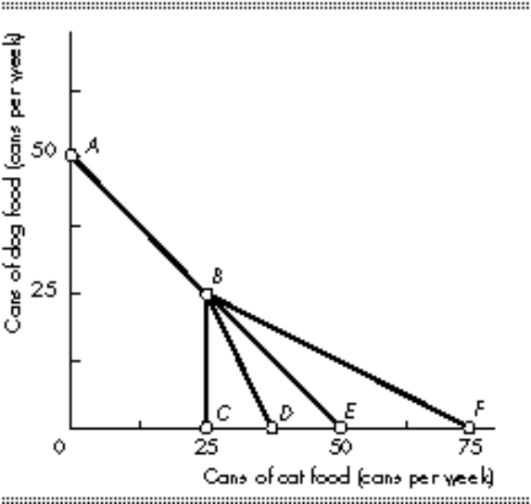

Morris has an income of $100 per week. The price of dog food is $2 per can and the price of cat food is $2 per can. However, there is a volume discount for cat food: If he buys more than 25 cans per week, the price of an additional can is only $1. In the above figure, Morris’s budget line runs through points
A) A, B, and C.
B) A, B, and D.
C) A, B, and E.
D) A, B, and F.

Ans: D
Budget Line refers to the bundles of goods that exhaust a consumer income. It can be represented by PXX + PYY = M, where PX and PY means the price of good X and Y, while M means the income.
Morris has an income of $100 per week. As 50x2 = $100, if he doesn’t buy any cat food, he can buy 50 cans of dog food, given that the price of dog food is $2 per can. If he doesn’t buy any dog food, he can buy 50 cans of cat food, given that the price of dog food is $2 per can.
Given that there is a discount that if he buys more than 25 cans per week, the price of an additional can is only $1. After he buys 25 cans of cat food, the money he spends is 25x2 = $50. The income remains is $50. He is able to buy 50 more cans of cat food. Therefore, the budget line will run through point F, which is a total of 75 cans of cat food if he doesn’t buy any dog food. Thus, the answer is D.
A, B and C should not be the answer. As provided discount lowers the price of cat food after buying 25 cans. It will rotates the budget line count-clockwise (to the right), which is not applicable to point F but not C, D, E.

