CB2400 Tick & Learn
Theory of Producer

Q.1

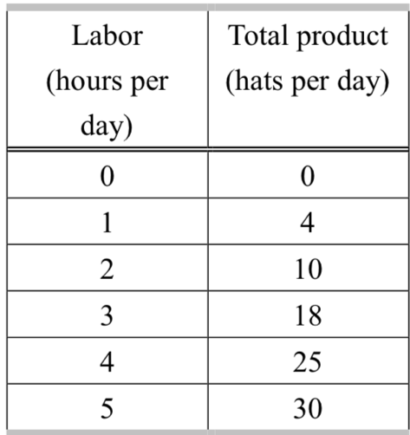

The above table shows the total product of producing baseball hats. If the firm increases the total labor (per day) from 3 to 4, the marginal product of labor is equal to
- 25 baseball hats.
- 21 baseball hats.
- 7 baseball hats.
- 6.25 baseball hats.
Ans: C
Marginal product of labor: change in total output by adding one additional unit of labor.
Let Q be the amount of total product and L be the amount of labor.
Marginal product (MPL) of 4th worker = dQ / dL (change in quantity / change in labor) = (25-18) / (4-3) = 7 baseball hats

Theory of Cost

Q.5
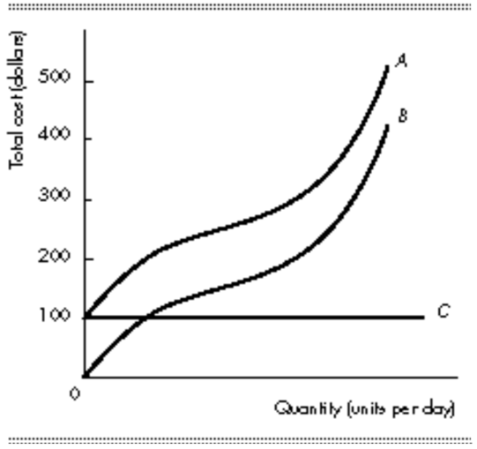
In the above figure, A and B represent the total cost and the total variable cost respectively. The relationship between costs indicates that the distance between curves
- A and B is equal to the fixed cost.
- A and B is equal to the variable cost.
- B and C is equal to the fixed cost.
- B and C is equal to the average total cost.
Ans: A
Total variable cost are costs that vary with output.
Total fixed cost are costs that do not vary with output, which means costs that do not change as output changes. Hence C represents the total fixed cost.
Total cost (A) = Total variable cost (B) + Total fixed cost (C)
As the difference between curve A & B is total cost – total variable cost = total fixed cost (C), the answer is A.

