EE3211 Modelling Techniques
Week 9 Assignment
Cardiovascular Disease: Sudden death is an important, lethal cardiovascular endpoint. Most previous studies of risk factors for sudden death have focused on men. Looking at this issue for women is important as well. For this purpose, data were used from the Framingham Heart Study. Several potential risk factors, such as age, blood pressure, and cigarette smoking, are of interest and need to be controlled for simultaneously. Therefore, a multiple logistic-regression model was fitted to these data, as shown in the following table.
Table. Multiple logistic-regression model relating 2-year incidence of sudden death in females without prior CHD (data taken from the Framingham Heart Study) to several risk factors.
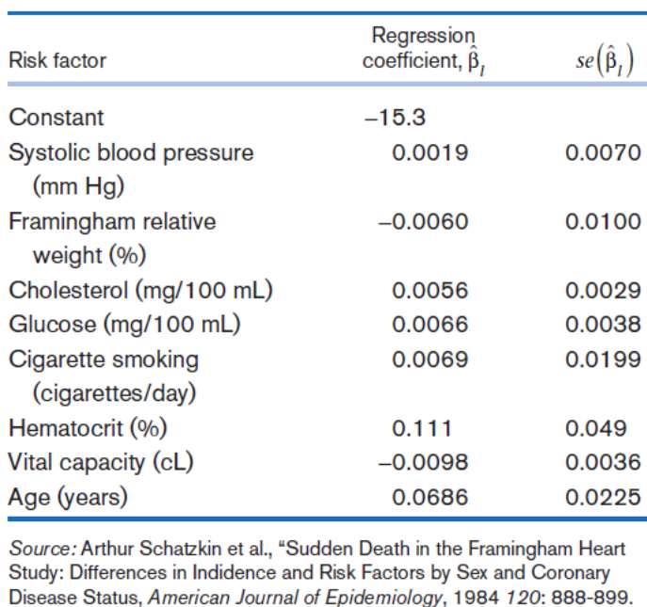
Q1. Assess the statistical significance of the individual risk factors. (3 points)
Q2. What do these statistical tests mean in this instance? (1 point)
Q3. Compute the OR relating the additional risk of sudden death per 100-centiliter (cL) decrease in vital capacity after adjustment for the other risk factors. (2 points)
Q4. Provide a 95% CI for the estimate in Q3. (2 points)
Q5. Provide R codes to run the mentioned multiple logistic regression test. (2 points)

EE3211 Modelling Techniques
Week 9 Assignment
Name:

