CB2400 Tick & Learn

Perfect Competition
Q6.
When the demand is P2 = $15, this producer will earn a _____of _______.
A. Loss, $60
B. Profit, $180
C. Loss, $300
D. Profit, $600
E. Loss, $900

Profit = (Price - Average Total Cost) x Quantity
= (P - ATC) x Q
=

Q.1
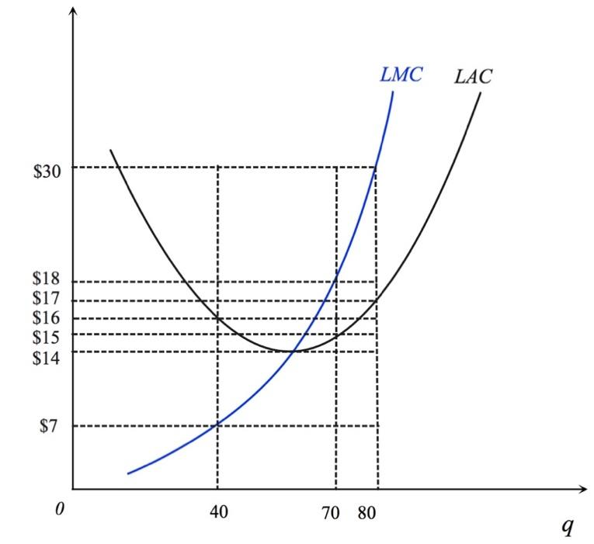

Consider a producer with cost functions in the above figure. Suppose this producer takes the market price and chooses its output level to maximize economic profit. When the market price is P = $30, this producer will earn

- A profit of $0
- A profit of $1040
- A profit of $1050
- A profit of $1120

Ans: B
Profit = (Price - Average Total Cost) x Quantity
= (P - ATC) x Q
= (30 - 17) x 80
= $ 1040

Market efficiency

Q.2

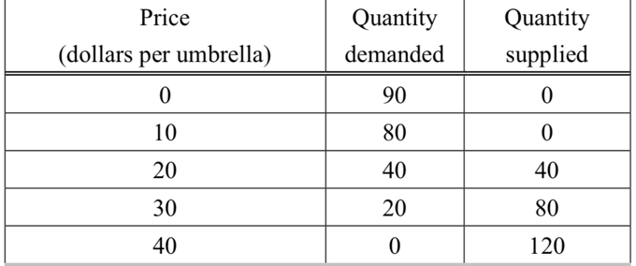

In the above table, if there are 80 umbrellas produced, the (marginal) deadweight loss from the 80th umbrella is

- $10
- $20
- $30
- $40

Ans: B

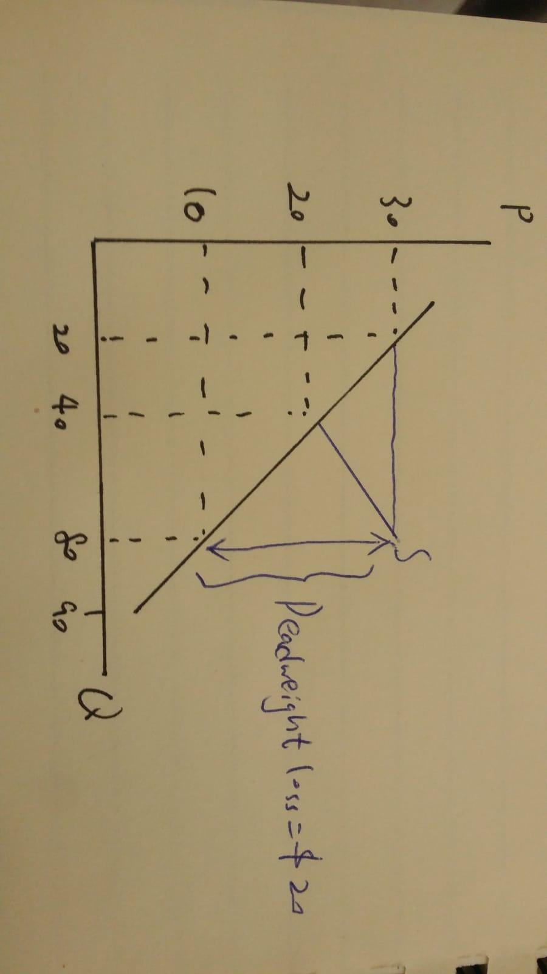

From the table, when the price per umbrella is $20, the quantity demand is equal to the quantity supplied. When 80 umbrellas are produced, it is over-produced of the market. As deadweight loss is the difference between the supply and demand, the distance between them is equal to $20. Thus, the deadweight loss is $20.

