EE 2000 Logic Circuit Design
Semester A 2021/22
Tutorial 6

- There are four judges for a debate of two persons – A and B. Each judge has an ON/OFF button, which is used to record his/her opinion of which one wins his/her vote. The scoreboard shows an A when the majority vote is in favour of person A and a B if it is person B. Provision is also made for a TIE.
(i) Derive the Truth Tables separately for A, B, and TIE.
(ii) Extract standard SOP and POS for each of the three outputs.
(iii) Simplify the three logic expressions in SOP form.

- Assume that: 0 is voting for B and 1 is voting for A; HIT is A won and MISS is B won.
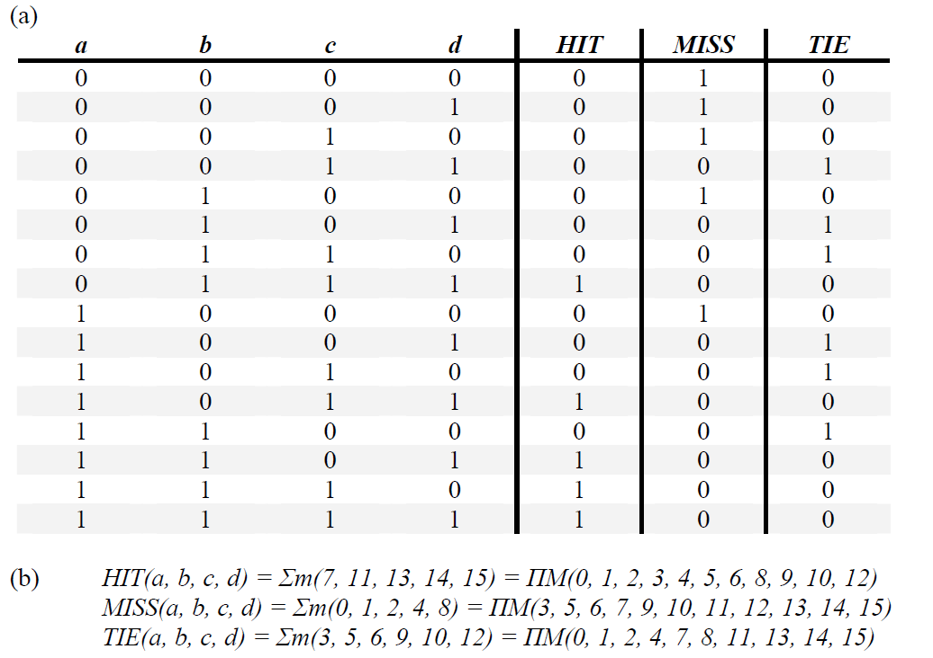
(ii)
(iii)
- Construct a 16×1 MUX with two 8×1 and one 2×1 MUXs.

Ans:

- Implement the following Boolean function with a 4×1 MUX and external gates. Connect inputs A and B to the selection lines and inputs C and D to the data input lines of the MUX.

F(A,B,C,D) = Σ m(1,3,4,11,12,13,14,15)

Ans:

From F(A,B,C,D) = Σ m(1,3,4,11,12,13,14,15), create a K-map without grouping.
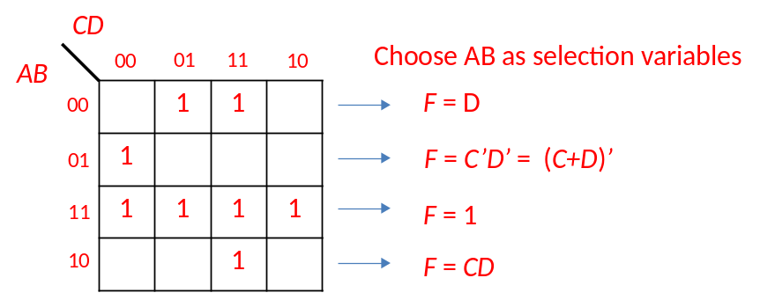
Therefore,

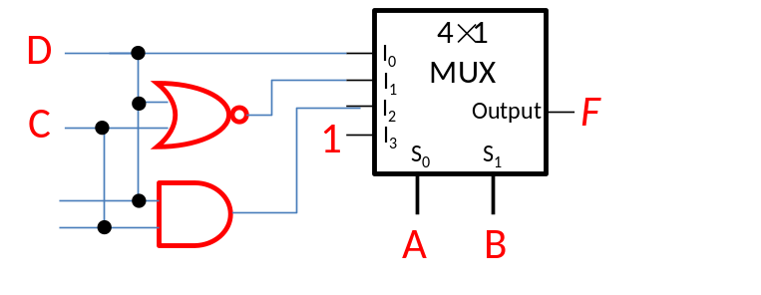

- Construct the PLA diagram with the minimum number of product terms for the following functions.
A(x,y,z) = Σ m(1,2,4,6)
B(x,y,z) = Σ m(0,1,6,7)
C(x,y,z) = Σ m(2,6)
D(x,y,z) = Σ m(1,2,3,5,7)

.
