EE3211 Modelling Techniques
Week 7 Assignment

Microbiology: A study sought to demonstrate that soy beans inoculated with nitrogen-fixing bacteria yield more and grow adequately without the use of expensive environmentally deleterious synthesized fertilizers. The trial was conducted under controlled conditions with uniform amounts of soil. The initial hypothesis was that inoculated plants would out-perform their uninoculated counterparts. This assumption was based on the fact that plants need nitrogen to manufacture vital proteins and amino acids and that nitrogen-fixing bacteria would make more of this substance available to plants, increasing their size and yield. There were eight inoculated plants (I) and eight unioculated plants (U). The plant yield as measured by pod weight for each plant is given in the following table:
Table. Pod weight (g) from inoculated (I) and uninoculated (U) plants.
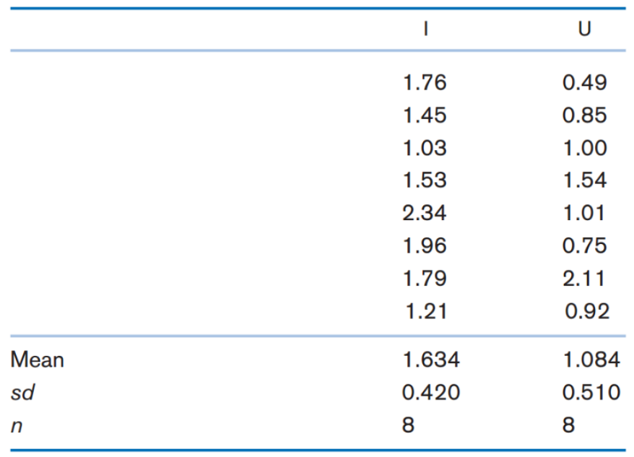
Q1. Is the data distribution parametric or nonparametric? Why? (2 points)
Q2. What test can be used to compare the distribution of pod weight for inoculated vs. uninoculated plants? (1 point)
Q3. Use hand-calculation to perform the test mentioned in Q2 and report a two-tailed p-value. (3 points)
Q4. Use R to perform the test mentioned in Q2 and report a two-tailed p-value. (3 points)
Q5. If the data distribution is parametric (e.g. with a much larger sample size), which parametric procedure can be applied to the data? (1 point)

EE3211 Modelling Techniques
Week 7 Assignment
Name:

Q1. Nonparametric, because we have no assumptions about the shape of the distribution.

Q2. Wilcoxon Rank Sum test.

Q3.
$$H_{0}:There is no difference between the ranks.$$
$$H_{1}:There is a difference between the ranks.$$

Total Sample (Ordered Smallest to Largest) |  |  |  | Ranks
I | U | I | U | I | U
1.76 | 0.49 |  | 0.49 |  | 1
1.45 | 0.85 |  | 0.75 |  | 2
1.03 | 1.00 |  | 0.85 |  | 3
1.53 | 1.54 |  | 0.92 |  | 4
2.34 | 1.01 |  | 1.00 |  | 5
1.96 | 0.75 |  | 1.01 |  | 6
1.79 | 2.11 | 1.03 |  | 7
1.21 | 0.92 | 1.21 |  | 8
 |  | 1.45 |  | 9
 |  | 1.53 |  | 10
 |  |  | 1.54 |  | 11
 |  | 1.76 |  | 12
 |  | 1.79 |  | 13
 |  | 1.96 |  | 14
 |  |  | 2.11 |  | 15
 |  | 2.34 |  | 16

As $n1, n2≤10$, critical value for the Wilcoxon Rank Sum test is 49 – 87.
$$R_{1}=7+8+9+10+12+13+14+16=89$$
As $89>87$, the p-value is smaller than 0.05.
Reject $H_{0}$, the ranks of the two groups are significantly different.

Q4.

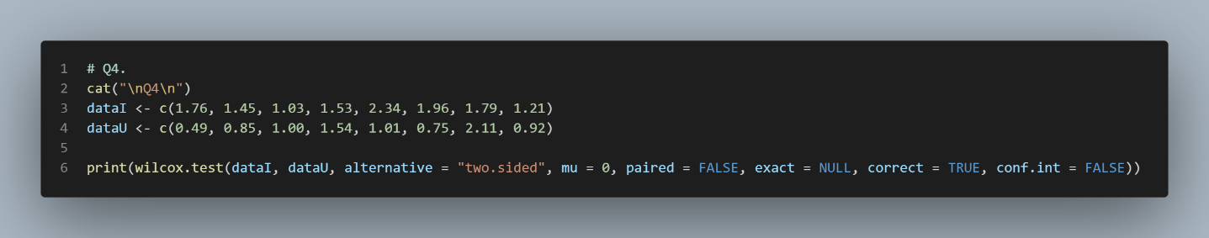

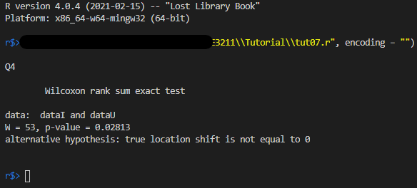

Q5. Two-sample t-test.

Q3.
By normal approximation:
$$R_{1}=7+8+9+10+12+13+14+16=89 \\ E\left(R_{1}\right)=\frac{8\left(8+8+1\right)}{2}=68 \\ sd\left(R_{1}\right)=\sqrt{\frac{8×8}{12}×\left(8+8+1\right)}=9.523 \\ Z=\frac{\left|89-68\right|-\frac{1}{2}}{9.523}=2.153 \\ p_{value}=2\left(1-Φ\left(2.153\right)\right)=0.03132<0.05$$
Reject $H_{0}$, the ranks of the two groups are significantly different.

