EE 2000 Logic Circuit Design
Semester A 2021/22A
Tutorial 3

- Use a truth table to present (A + B + C +D)’ = A’ B’ C’ D’

- Implement the following expression with 2-input NAND gates only:
- ABC + DE
- ABC + D’ + E

- Given a truth table:
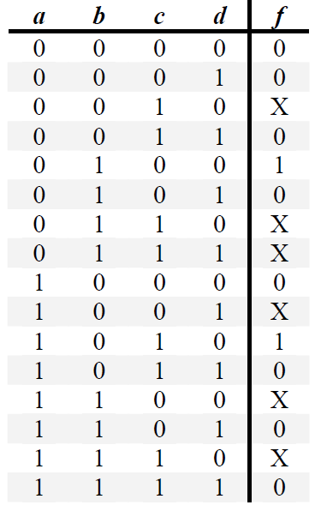 | - Express f as product of maxterms function in numeric form.  - Find its MPS form using K-map.  - From the answer of (b), please design a logic circuit by NAND gates only.

- Design a combinational circuit for a 3-bit Binary-to-Gray code converter.

- Joe, Jack, and Jim get together once a week to either go to a movie or go bowling. To decide what to do, they vote and a simple majority wins. Assuming a vote for the movie is represent as a 1, design a NAND gate circuit that automatically computes the decision.

