CB2400 Microeconomics

Tick & Learn

Basic Supply and Demand Model

1) If income decreases,
A) the demand curve for a normal good shifts leftward.
B) the demand curve for a normal good shifts rightward.
C) there is an upward movement along the demand curve for the good.
D) there is a downward movement along the demand curve for the good.

2) The quantity supplied of a good is
A) the same thing as the quantity demanded at each price.
B) the amount that the producers are planning to sell at a particular price during a given time period.
C) equal to the difference between the quantity available and the quantity desired by all consumers and producers.
D) the amount the firm would sell if it faced no resource constraints.

3) Which of the following is NOT held constant while moving along a supply curve?
A) Expected future prices.
B) The number of sellers.
C) The price of the good itself.
D) Prices of resources used in production.

4) Over the past decade technological improvements that have lowered the cost of producing an automobile have increased
A) both the supply and the demand for automobiles.
B) the supply but not the demand for automobiles.
C) the demand but not the supply of automobiles.
D) neither the supply nor the demand for automobiles.

5) Which of the following causes an increase in the quantity supplied of good X but NOT a shift of the supply curve of good X?
A) A reduction in the price of resources used to produce X.
B) An improvement in the technology for producing X.
C) An increase in the price of good Y, a complement in the production of X.
D) An increase in the price of X.

6) The price of a good will fall if
A) there is an excess supply at the current price.
B) the current price is less than the equilibrium price.
C) the quantity demanded exceeds the quantity supplied.
D) the price of a complement falls.

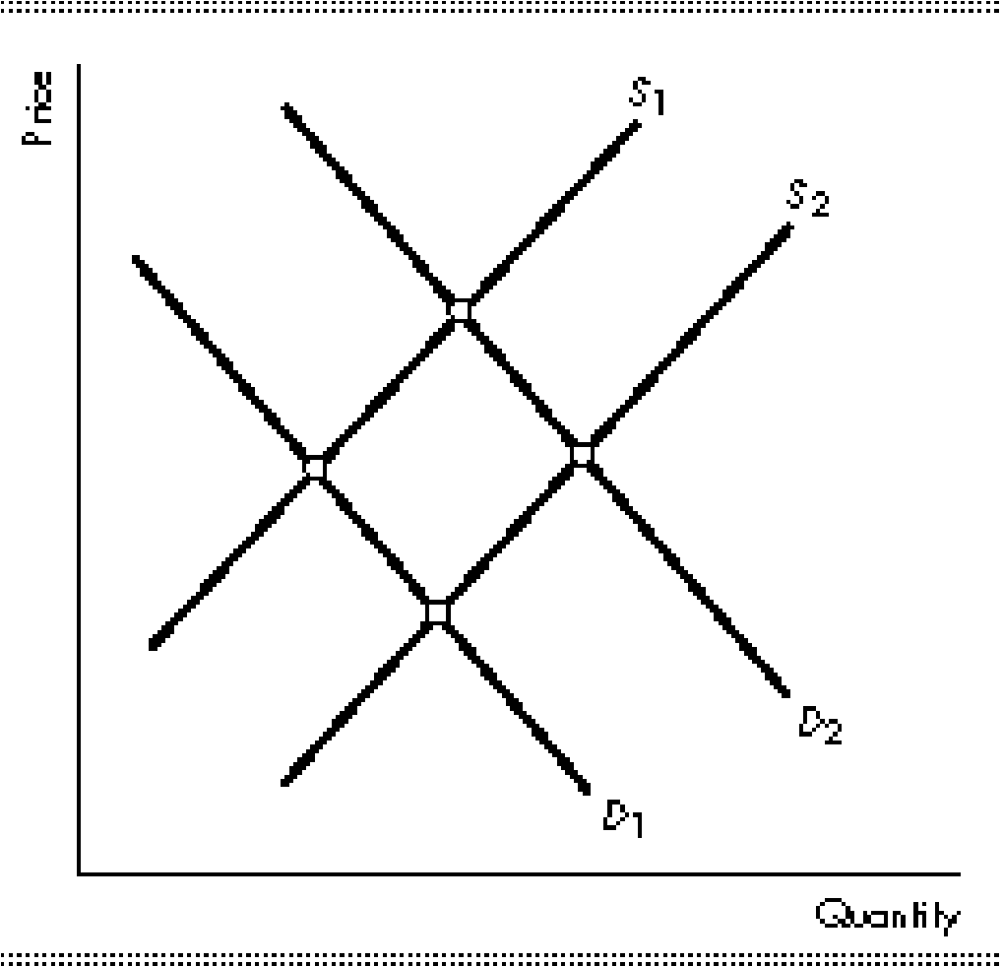
7) The above figure represents the market for oil. When terrorists blow up a major refinery the
A) demand curve for oil shifts from D₁ to D₂ and the supply curve for oil will not shift.
B) demand curve for oil shifts from D₁ to D₂ and the supply curve for oil shifts from S₂ to S₁.
C) demand curve for oil will not shift, and the supply curve for oil shifts from S₂ to S₁.
D) demand curve for oil will not shift, and the supply curve for oil shifts from S₁ to S₂.

8) Let Q _{d} stand for the quantity demanded, Q _{s} stand for the quantity supplied, and P stand for price. If Q _{d} = 20 – 2P and Q _{s} = 5 + 3P, then the equilibrium quantity is
A) 3.
B) 5.
C) 14.
D) 20.

Consider a (competitive) market with 200 consumers and 100 sellers. All the consumers have the same individual demand function
$Q^{d}=75-2P,$

and all the sellers have the same individual supply function

$Q^{s}=50+P.$

9) What is the market demand function?

A) $Q^{d}=15000-20P$
B) $Q^{d}=15000-40P$
C) $Q^{d}=15000-200P$
D) $Q^{d}=15000-400P$

10) (continued) What is the market supply function?

A) $Q^{s}=50+P$
B) $Q^{s}=50+100P$
C) $Q^{s}=5000+P$
D) $Q^{s}=5000+100P$

11) (continued) What is the equilibrium price?

A) $10$
B) $15$
C) $20$
D) $25$
12) (continued) What is the equilibrium quantity traded?

A) $6000$
B) $7000$
C) $8000$
D) $9000$

13) (continued) Now suppose the government imposes sales tax $\$5.00$ (per unit) on consumers. What is the new equilibrium quantity traded?

A) $6000$
B) $6200$
C) $6400$
D) $6600$

