EE 2000 Logic Circuit Design
Semester A 2021/22
Tutorial 7

- 2-to-4 Line Decoder (using 1-to-2 Line Decoder)

- Write the entity declaration for a 2-to-4 Line decoder module named LDecoder2_4 that has two input named A0 and A1, and four outputs named D0, D1, D2, D3.

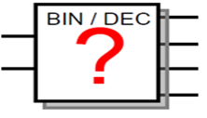
(LSB) A₀
(MSB) A₁
D₀
D₁
D₂
D₃

- Write the architecture declaration for the above 2-to-4 Line decoder named LDecoder2_4 with an architecture name “LDecoder1_2” using 2 1-to-2 Line decoders.

Inputs | Outputs
A₁ A₀ | D₀ D₁ D₂ D₃
0 0  0 1  1 0  1 1 | 1 0 0 0  0 1 0 0  0 0 1 0  0 0 0 1
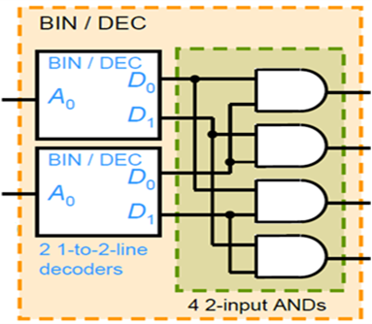
D₀ = A₁’A₀’
D₁ = A₁’A₀
D₂ = A₁A₀’
D₃ = A₁A₀
(LSB) A₀
(MSB) A₁

Solution:

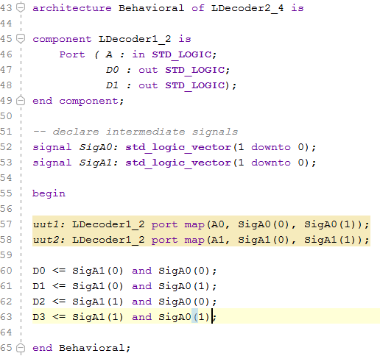

- 3-to-8 Decoder

- Write the entity and architecture declaration for a 3-to-8 decoder module named Decoder3_8 that has one 3-bit input named S and one 8-bit output named Q.

- Write the circuit named Q1 using VHDL with one 3-to-8 decoder and external gates.
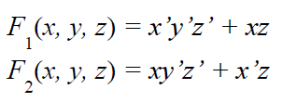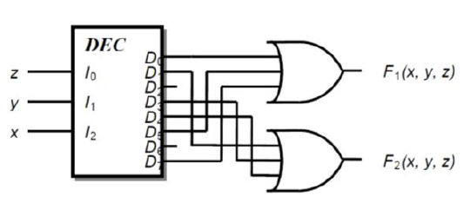
Solution:
