GE2410
English for Engineering


Unit 1

Performing Secondary Research

Students will need to bring their laptops or i-pads to class.

1.1 Aims and learning outcomes
This unit aims to develop your secondary research skills for study and work purposes. By applying what you learn in this unit, you should be able to achieve the following:
- differentiate between reliable and unreliable sources, and
- conduct searches of online databases
You are expected to apply what you learn in this unit when conducting the online searches for information needed in Assessed Task 2.

1.2 Reliable references
Task 1 What are reliable sources and what are unreliable sources? Provide some examples of each type in the table below. Which source types will you consult for the presentation you will deliver in Assessed Task 2?
Types of sources | Examples | Features
Reliable sources
Unreliable sources
Task 2 Study the materials provided in the Appendix of this unit. They are the front matters shown in four published sources. For each source, decide whether it is a monograph, an edited book chapter, a magazine article, a journal article or a document retrieved from a website.

1.3 Identifying and accessing academic references

1.3.1 Getting started
To facilitate your search for references, you could first identify the key sources that you need to consult. You may approach your subject lecturers for help. Ask them to suggest a few author names or a few specific sources that you may need to read first. Alternatively, you can consult course reading lists or references cited in materials that you have read in other contexts (e.g., course textbooks, journal articles, book chapters, final year project reports, etc.).
Read the references you obtain in these initial searches. Note the works that the sources frequently refer to. They may also be the ones that you need to read further. Also, pay attention to the key authors cited as well as the keywords (or phrases) that can be used to express specific aspects of your topic. These names and key phrases can help to build up further searches.

1.3.2 Conducting informed searches using CityU LibraryFind
CityU LibraryFind is a discovery tool to find online and print resources using just a single search engine. You can search almost everything using CityU LibraryFind, including books, journals, articles, dissertations, as well as media resources.
Task 3 Follow the steps below to use CityU LibraryFind to research on your topic.
- Go to the library homepage (http://www.cityu.edu.hk/lib/)
- In the middle of the page, find the “CityU LibraryFind” tab
- Enter your keyword in the search field
- Select “Article+”
- Click “Search”
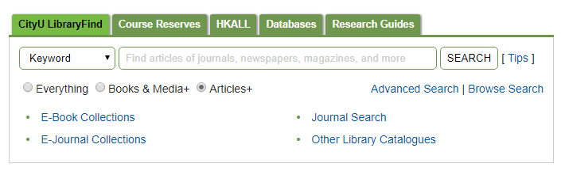
Figure 1 Screen capture of CityU LibraryFind

1.3.3 Conducting informed searches in online databases
Make use of the key authors, keywords and key phrases identified earlier to conduct more searches (i.e., searches informed by what you learned in your initial searches). You can conduct informed searches through an online database. An online database is one that indexes international publications (e.g., journal articles, book chapters, government publications and company reports) of various disciplines and industries. You have free access to a large number of online databases through the website of the University’s library.
Task 4 Follow the steps below to learn about the databases that can be accessed through the library website of the University.
- Click on the library homepage (http://www.cityu.edu.hk/lib/).
- Click E-Resources.
- On the E-Resources page, look for Databases and click List by Subject / Source Type.
- On the Subject List page, choose a relevant subject listed under Science and Engineering (e.g., Biology).
- Count the number of databases listed for the subject.
- Name some of the databases listed and see whether the list includes Science Direct Index Expanded, Scopus and IEEE Explorer.

1.4 Searching a database for sources: the case of Scopus
Since Scopus is one of the most frequently listed databases, it has been chosen to illustrate how you can use an online database.
Task 5 Follow the instructions below to access and perform searches in Scopus.

To access Scopus
- Enter the CityU Library Homepage.
- Click E-Resources.
- Click Title List (under Databases).
- Click S and then Scopus.

To perform searches in Scopus
- Type in the name of an author, a keyword or a key phrase (e.g., GPS & Hong Kong & Traffic).
- Specify the fields in which you want to perform the search by clicking the appropriate options provided in the boxes on the right (e.g., Abstract, Title, etc.)
- Click Search. Results of your search will be shown on the screen.
- Read the abstracts (summaries) of the references generated, and decide if they are what you are looking for. To access the abstract of a generated reference, click Abstract.

To download/access a reference generated
You can click on “Check@CityULib” to see if a full text is available. Follow the on-screen prompt to access the full-text document via different available services.

1.5 Recording bibliographic information of sources
Once you have obtained a source or its abstract, record its bibliographic details especially if you are going to use any part of the source in future public and formal communication (e.g., a presentation, a lab report, a final year project report, a work project report, etc.).
What you record for each source depends on its type. The table provided on the next page gives you some ideas of what to record for some common types of publication.
Task 6 Refer to the materials that you have studied in Task 2. For each of the sources, state where you can find the bibliographic details, e.g., author(s), editor(s), year of publication, publisher (for books only), volume/issue numbers (for journal articles), title, website, etc.

Source  Type  Details to  Note | A monograph | An edited book chapter | A journal article | A newspaper / magazine article | Online materials (except for online newspapers & magazines)
Author’s name(s) |  |  |  | (if available or else name of the newspaper / magazine) | (normally the website host or a particular unit of the organization of the host unless the source is a particular document written by an individual)
Year of publication |  |  |  | (full date needed for a newspaper; month needed for a magazine) | (date or year of release or updated)
Date of access | not applicable | not applicable | (possibly needed if the journal is published on line only) | (if the newspaper or the magazine is published online only)
Title of the article | not applicable |  |  |  | (title of the document if it is a file or else title/banner of the webpage)
Editor’s name(s) | not applicable |  | not applicable | not applicable | not applicable
Title of the book |  |  | not applicable | not applicable | not applicable
Title of the journal | not applicable | not applicable |  | (name of the newspaper or the magazine) | not applicable
Place of publication |  |  | not applicable | not applicable | not applicable
Publisher’s name |  |  | not applicable | not applicable | (host of website)
Volume / issue # | not applicable | not applicable – unless the book is part of a series |  | not applicable | not applicable
Page numbers | not applicable |  |  |  | not applicable
Website address | not applicable | not applicable | (if the journal is published online only) | (for online version of the newspaper or the magazine)

Unit 1 Appendix
Answer: A journal article

Source A
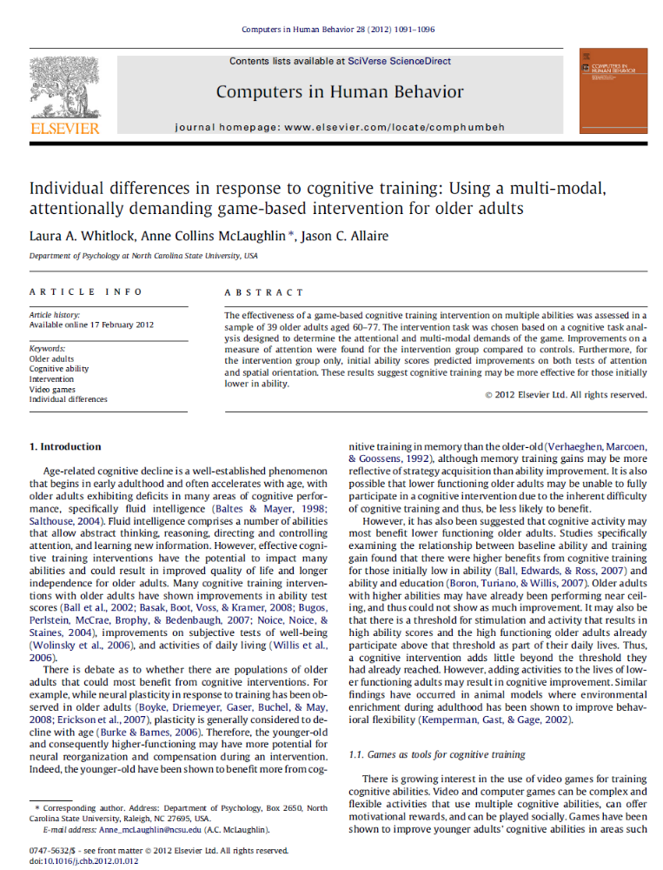

Source B
Answer: A coauthored monograph
Title page Fine-print page
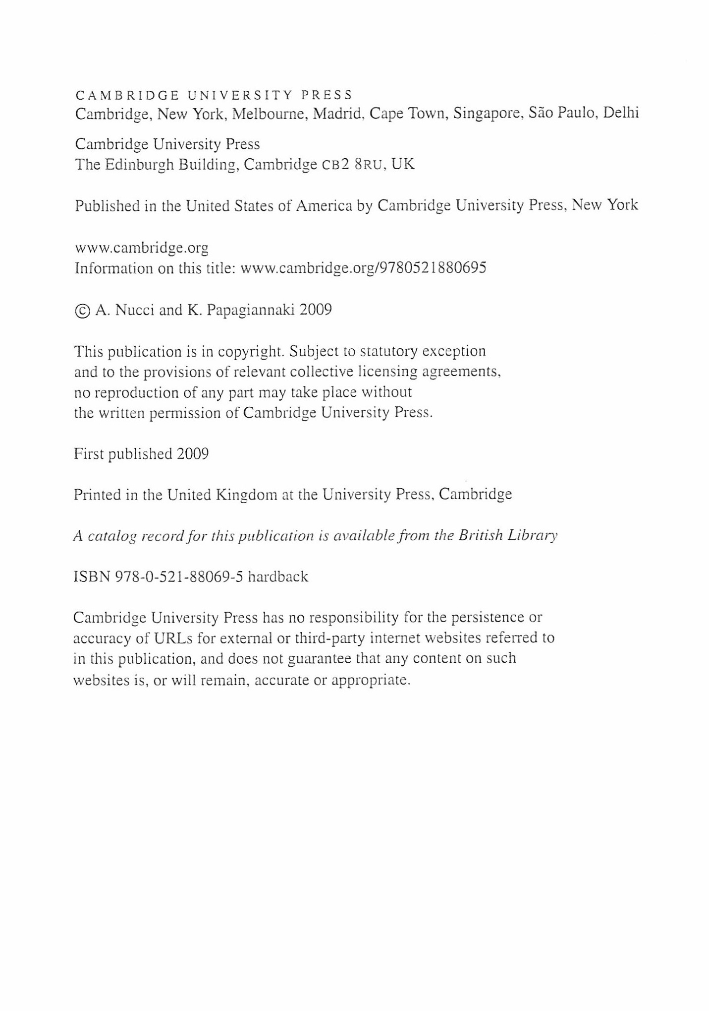

Contents page

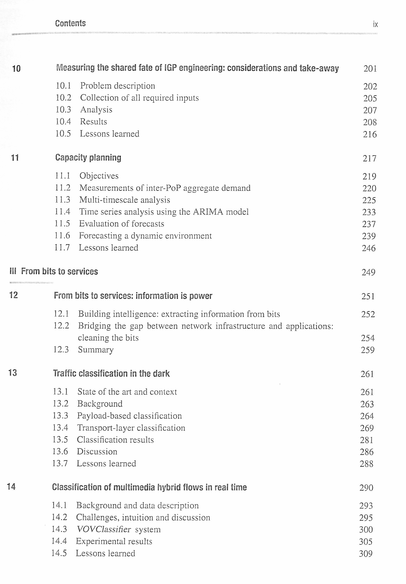
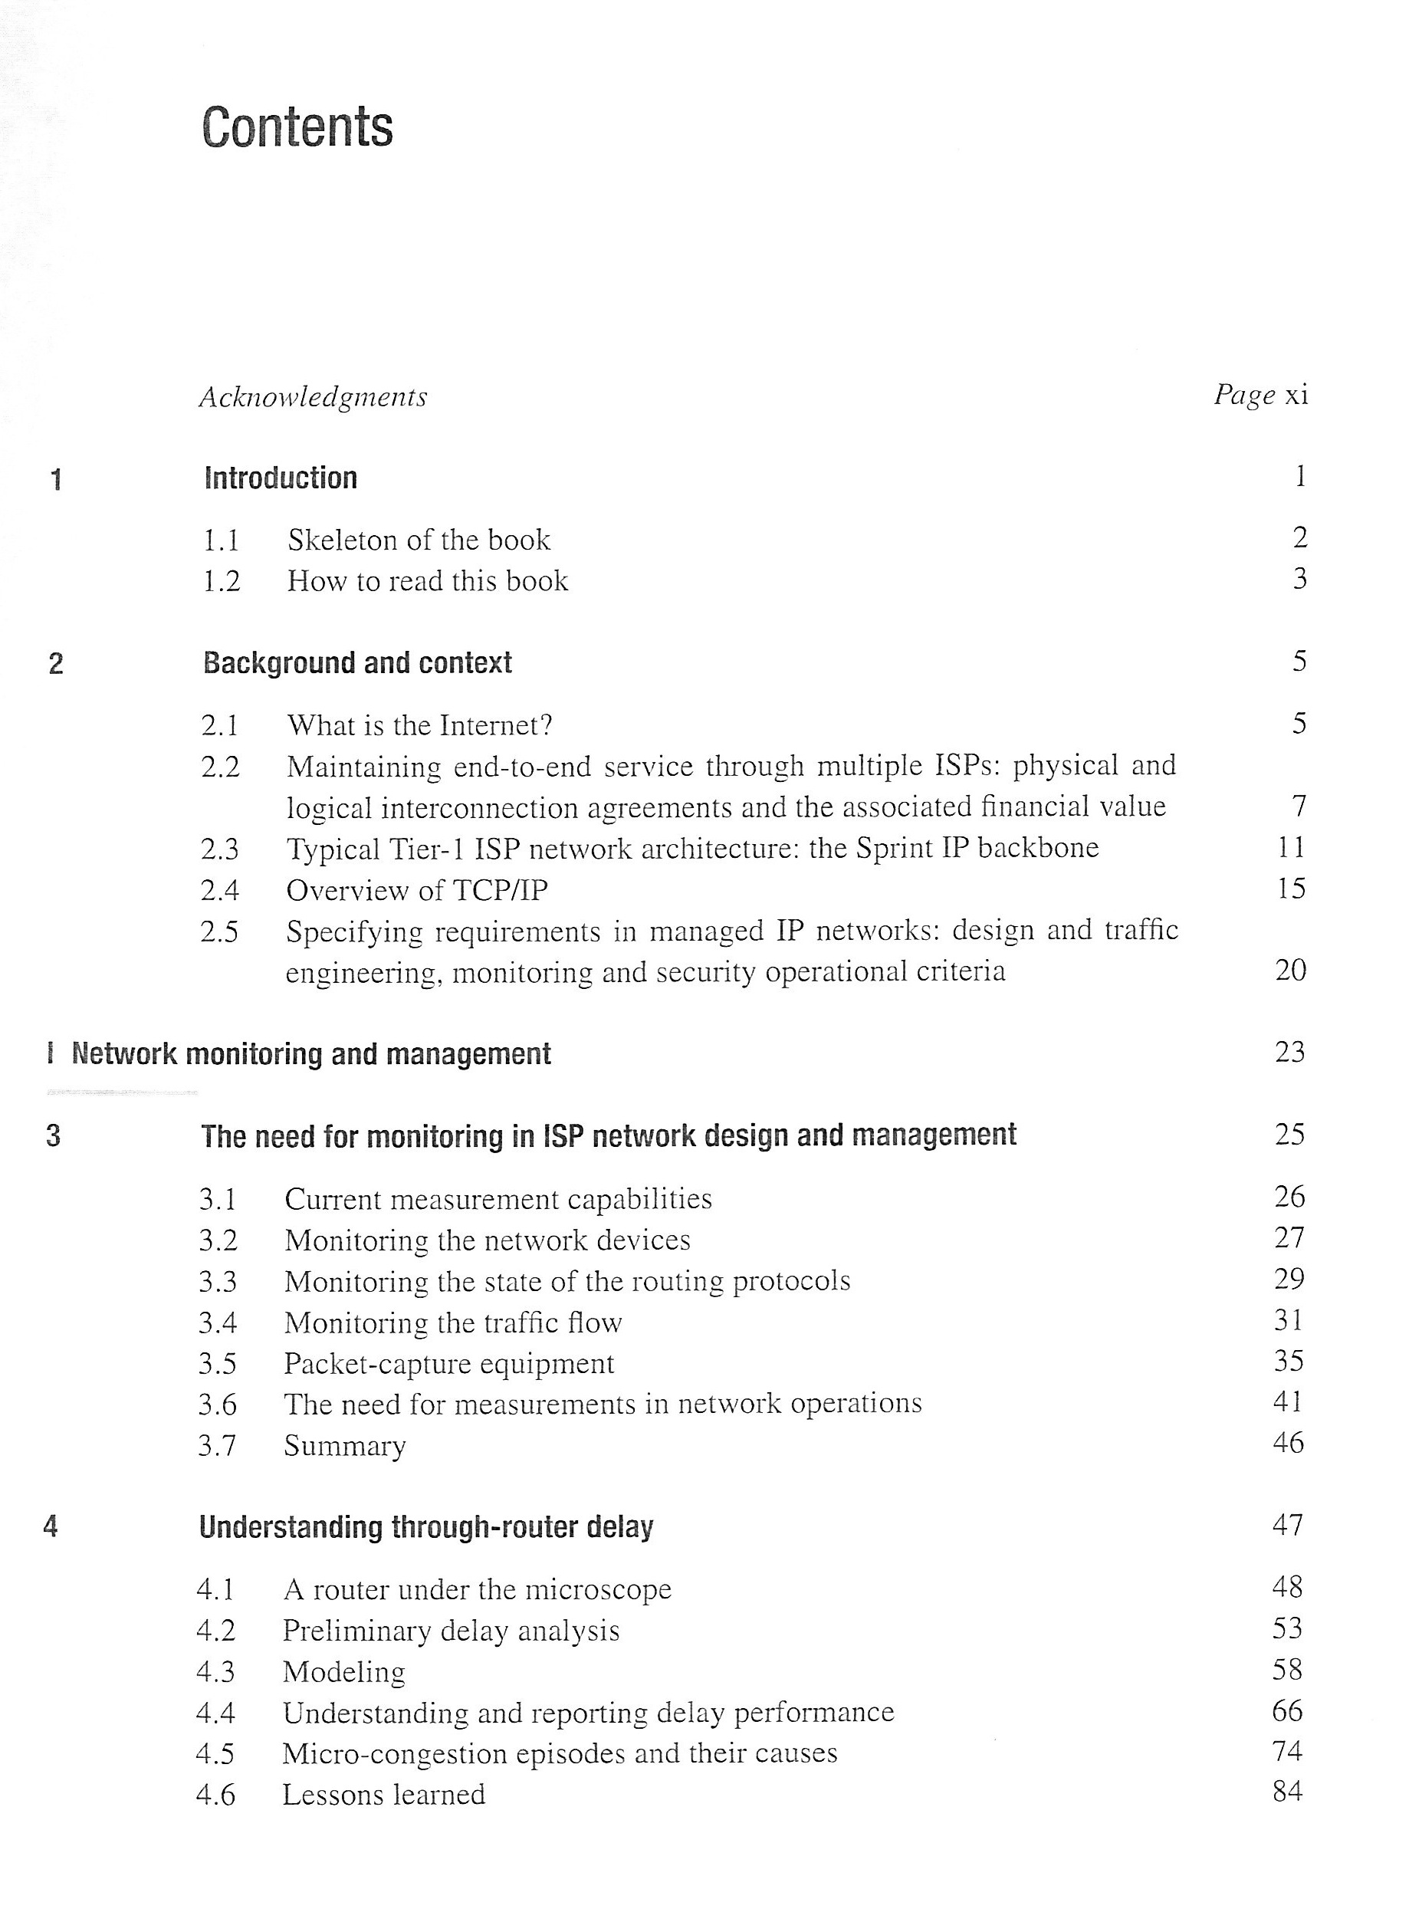
Source C
Answer: A book chapter in an edited book
Title page Fine-print page ( after the title page)
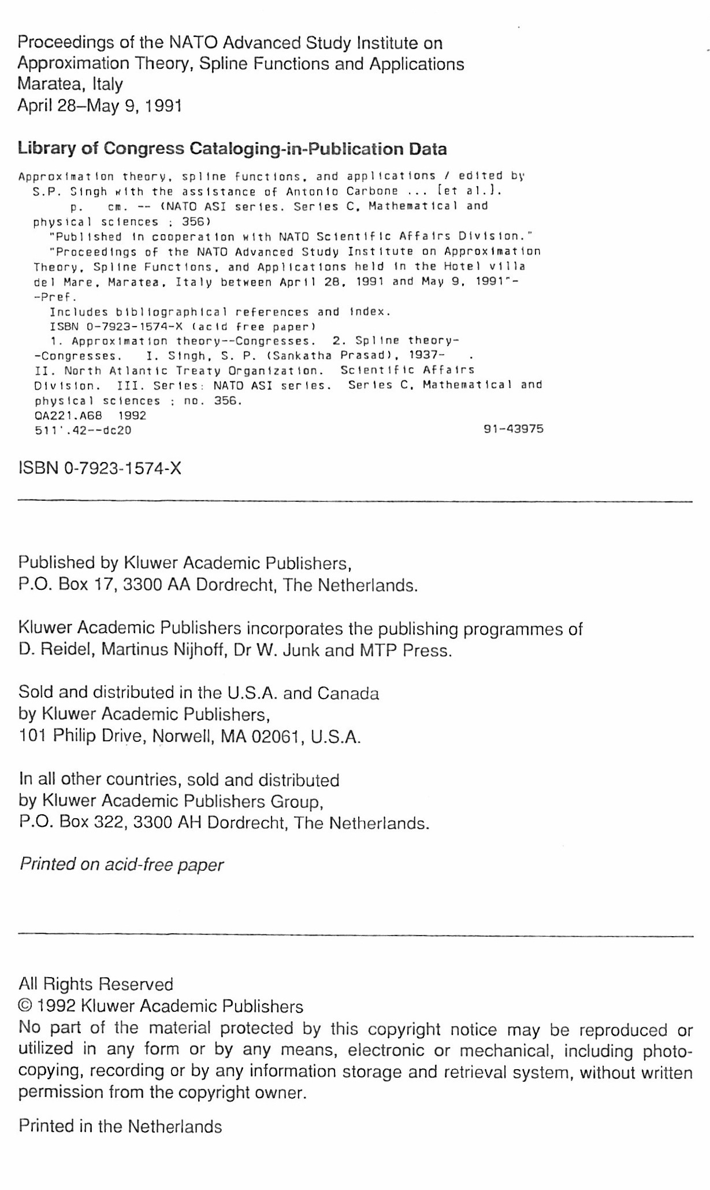
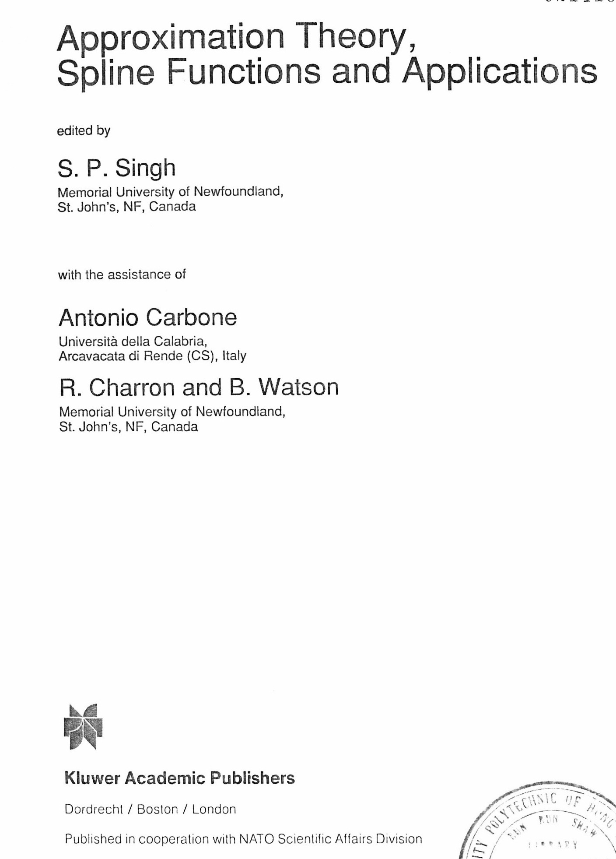
Contents page
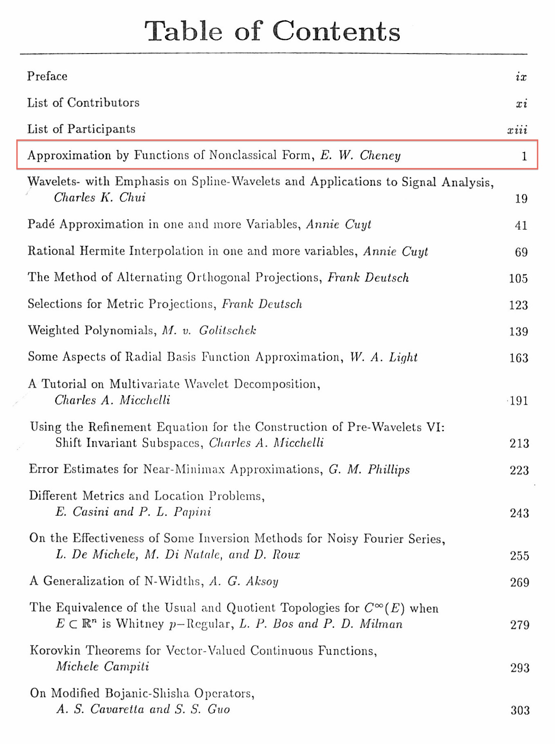
The chapter to use in a presentation

Source D
Answer: An article published in an online-magazine
