CS4335 Assignment 1 Deadline: 11:59 a.m., Thursday, 21st, Oct, 2021
（NOTE: Late submission will not be processed）

Question 1: (40 points) For the interval scheduling problem, given jobs (s, f) :
(0, 4), (2, 5), (5, 7), (4, 7), (6, 7), (4, 6), (6, 8), (9, 12), find a maximum subset of mutually compatible jobs.
Answer:
- sort the jobs by finished time:
(0, 4), (2, 5), (4, 6), (5, 7), (4, 7), (6, 7), (6, 8) (9, 12)
- plot the sketch (optional):
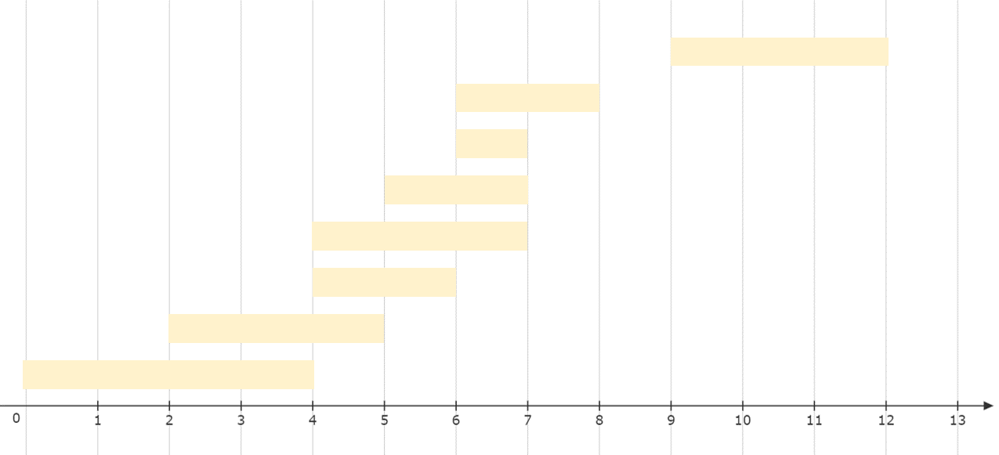
- choose the job series (optional):
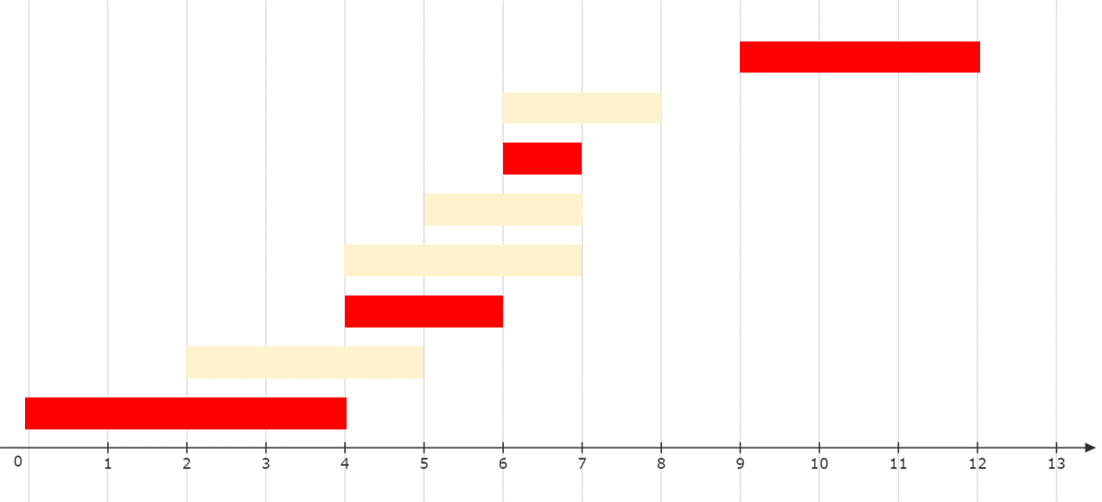
- the maximum answer is:
(0,4) (4,6) (6,7) (9,12) (full marks)

Question 2: (45 points) Consider the following graph.
1
5
6
2
10
9
7
11
3
4
8
12
5
4
6
5
9
4
2
5
4
2
4
8
2
1
3
8
1
3
2
7
1

Use Prim’s algorithm to compute a minimum spanning tree (40 marks).
How many minimum spanning trees are in the above graphs, draw all of them (No need to write the process for finding the trees) (5 marks)
Answer:
start from 1
The tree is empty. Q contains:
Node | 1 | 2 | 3 | 4 | 5 | 6 | 7 | 8 | 9 | 10 | 11 | 12
Key | 0 | inf | inf | inf | inf | inf | inf | inf | inf | inf | inf | inf
Parent | NIL | NIL | NIL | NIL | NIL | NIL | NIL | NIL | NIL | NIL | NIL | NIL
The tree has one node 1. Q contains:
Node | 2 | 3 | 4 | 5 | 6 | 7 | 8 | 9 | 10 | 11 | 12
Key | 5 | inf | inf | 5 | inf | inf | inf | inf | inf | inf | inf
Parent | 1 | NIL | NIL | 1 | NIL | NIL | NIL | NIL | NIL | NIL | NIL
Step 1: select edge(1, 2)
The tree has nodes 1, 2. Q contains:
Node | 3 | 4 | 5 | 6 | 7 | 8 | 9 | 10 | 11 | 12
Key | 2 | inf | 4 | inf | 7 | inf | inf | inf | inf | inf
Parent | 2 | NIL | 2 | NIL | 2 | NIL | NIL | NIL | NIL | NIL
Step 2: select edge(2, 3)
The tree has nodes 1, 2, 3. Q contains:
Node | 4 | 5 | 6 | 7 | 8 | 9 | 10 | 11 | 12
Key | 4 | 4 | inf | 1 | inf | inf | inf | inf | inf
Parent | 3 | 2 | NIL | 3 | NIL | NIL | NIL | NIL | NIL
Step 3: select edge(3, 7)
The tree has nodes 1, 2, 3, 7. Q contains:
Node | 4 | 5 | 6 | 8 | 9 | 10 | 11 | 12
Key | 3 | 4 | 2 | 8 | inf | 9 | 1 | inf
Parent | 7 | 2 | 7 | 7 | NIL | 7 | 7 | NIL
Step 4: select edge(7, 11)
The tree has nodes 1, 2, 3, 7, 11. Q contains:
Node | 4 | 5 | 6 | 8 | 9 | 10 | 12
Key | 3 | 4 | 2 | 3 | inf | 2 | 8
Parent | 7 | 2 | 7 | 11 | NIL | 11 | 11
Step 5: select edge(7, 6)
The tree has nodes 1, 2, 3, 7, 11, 6. Q contains:
Node | 4 | 5 | 8 | 9 | 10 | 12
Key | 3 | 4 | 3 | inf | 1 | 8
Parent | 7 | 2 | 11 | NIL | 6 | 11
Step 6: select edge(6, 10)
The tree has nodes 1, 2, 3, 7, 11, 6,10. Q contains:
Node | 4 | 5 | 8 | 9 | 12
Key | 3 | 4 | 3 | 5 | 8
Parent | 7 | 2 | 11 | 10 | 11
Step 7: select edge(7, 4)
The tree has nodes 1, 2, 3, 7, 11, 6, 10,4. Q contains:
Node | 5 | 8 | 9 | 12
Key | 4 | 3 | 5 | 8
Parent | 2 | 11 | 10 | 11
Step 8: select edge(11, 8)
The tree has nodes 1, 2, 3, 7, 11, 6, 10, 4,8. Q contains:
Node | 5 | 9 | 12
Key | 4 | 5 | 4
Parent | 2 | 10 | 8
Step 9: select edge(2, 5)
The tree has nodes 1, 2, 3, 7, 11, 6, 10, 4, 8,5. Q contains:
Node | 9 | 12
Key | 2 | 4
Parent | 5 | 8
Step 10: select edge(5, 9)
The tree has nodes 1, 2, 3, 7, 11, 6, 10, 4, 8,5, 9. Q contains:
Node | 12
Key | 4
Parent | 8
Step 11: select edge(8, 12)
The tree has nodes 1, 2, 3, 7, 11, 6, 10, 4, 8,5, 9, 12. Q contains no nodes.

Based on the start node and the decision on the situation that more than one edges have the same weight, for specific cases, edge (1, 2) can be replaced by (1, 5), edge (2, 5) can be replaced by (5, 6), and edge (6, 7) can be replaced by (10, 11) in the final minimum spanning tree. Meanwhile, the selection order has to be correct.
There are 8 minimum spanning trees in the given graphs.
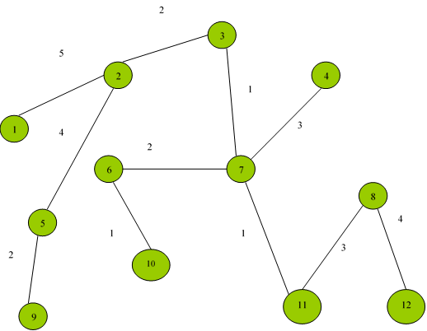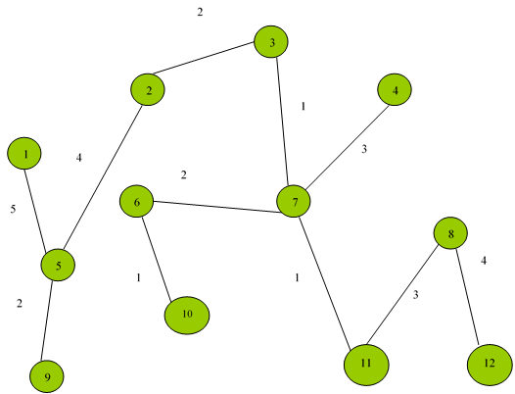

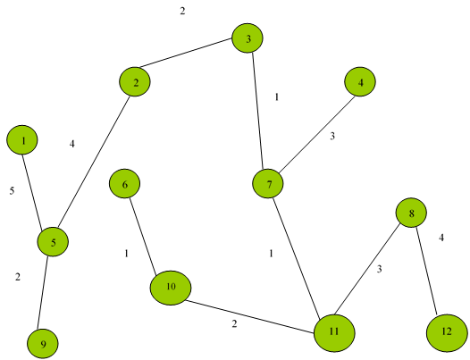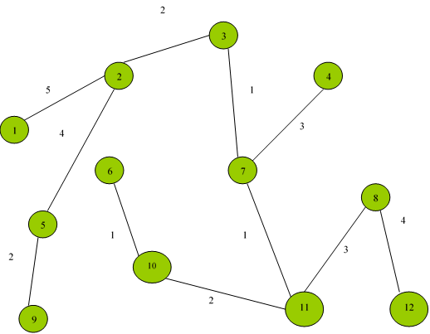

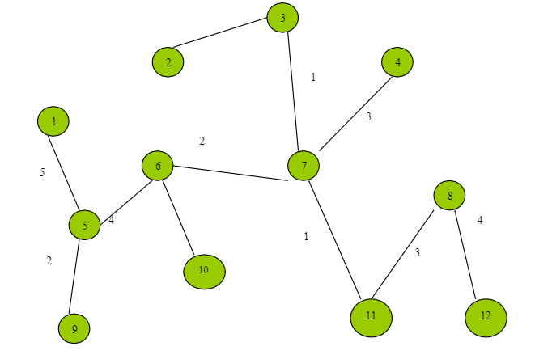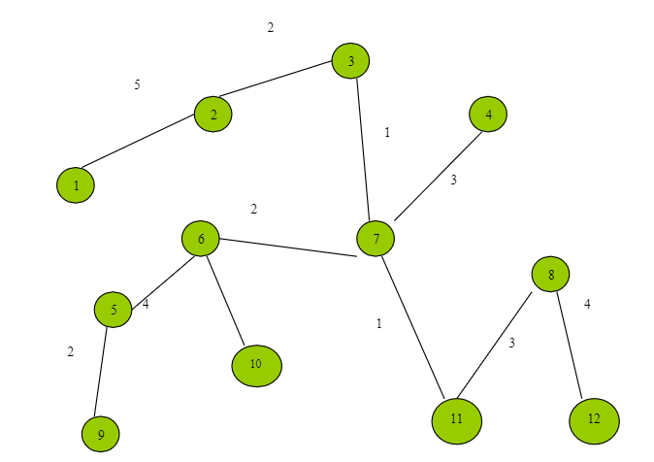
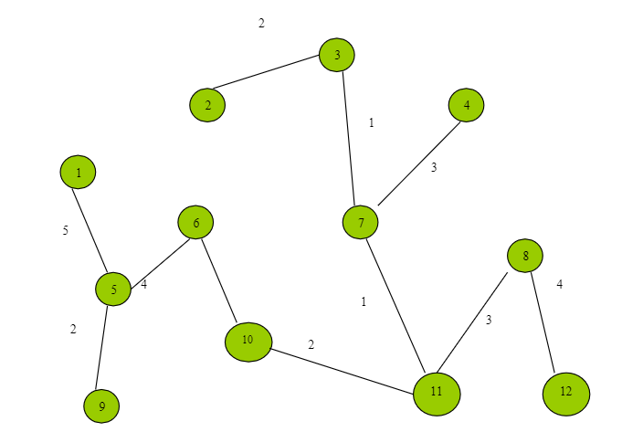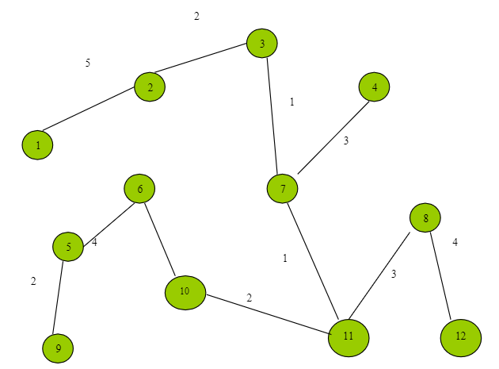

Question 3: (15 points) Words in a tree.
Given a tree of n nodes, each node in the tree has a depth. The root has depth 0. Now consider n words, each word i has a count f_{i.} We want to store the words into the tree, one word per node such that the total distance will be minimized. The total distance of a storage is calculated as
f₁d₁+f₂d₂+…+f_{n}d_{n,}
where d_{i} is the node depth for word i

Design an algorithm to solve the problem (5 points). Prove that your algorithm is correct. (10 points)

e.g.

Given a tree with six nodes (figure 1) and we want store 6 words, I am a primary school student, with counts shown as below,

I: 30, am: 26, a: 22, primary: 16, school: 13, student: 6

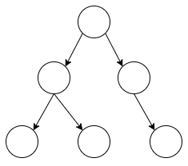
figure 1

There are several ways to store these words. The following are two storage methods with the corresponding distances.
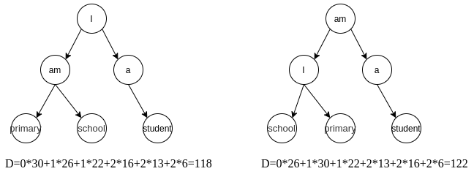
Answer:

Algorithm:
Sort the words with descending order of count, Iterate the given tree with BFS and fill the node with ordered words one by one.

Proof:
Words count with descending order: c₀ c₁ … c_{n} , for each 0<= i < n, c_{i} <= c_{i+1}
Distance as the algorithm describes,
D_{opt} = c₀d₀ + c₁d₁ + …+c_{n}d_{n}, where d_{i} is the depth of ith node in the tree, d₀ = 0 for the root node.
If we change the insertion order of any two words, i and i+1, the distance is,
D₁ = c₀d₀ ... + c_{i+1}d_{i} + c_{i}d_{i+1}+ …+c_{n}d_{n}
We can get that,
D_{opt} - D₁ = (c₀d₀ + c₁d₁ + …+c_{n}d_{n}) - (c₀d₀ ... + c_{i+1}d_{i} + c_{i}d_{i+1}+ …+c_{n}d_{n})
= (c_{i}d_{i} + c_{i}d_{i}) - (c_{i+1}d_{i} + c_{i}d_{i+1}) <= 0
For other insertion situations, we can easily get D_{opt} - D_{other} <= 0 always holds.

