EE3114 Homework # 9 2021-11-16 Assignment

9-1 Design a negative state-feedback controller $u=-Kx$ such that the controlled system

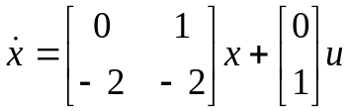

has two desired stable poles : $-3 ±j3$

9-2 Given a state-space system as follows:

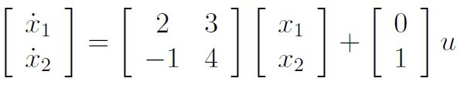
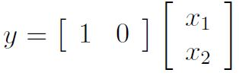

(a) Is this system observable?

(b) Design a state-feedback observer such that it has desired poles to be the roots of the following characteristic equation:

$s^{2}+2ζω_{n}s+ω_{n}^{2}=0$

This is to find the observer gain $L= \left[\begin{matrix}L_{1} \\ L_{2}\end{matrix}\right]$ in terms of $ζ$ and $ω_{n}$

(c) Find numerically the observer gain $L$ if $ζ=1$ and $ω_{n}=6$.

9-3 