City University of Hong Kong

EE 4101 – Industrial Electronics

Case Report

Case # : _____1____ Group #: ___________ Date: _____21st Dec, 2015____

Leader: ______Tam Chu-kwong______

A) Individual assessment: (The leader is required to put the names of your members into the following table.)

Student name & ID | Comments | Rating (1 – 5)
Tam Chu-kwong
53219921
MA Wai-wai
53649005
Ling Tsz-YAN
53789259

B) Group assessment:
Comment | Rating (1 – 5)

Content
Description | Page
Problem identification | 3
Mind map | 4
Objective of the case | 4
Object 1 | 5-6
Object 2 | 7-8
Object 3 | 9-11
Conclusion | 12

Problem
We are asked to design a 3kW Grid-tried Solar Inverter.
In this case, the supply voltage of the solar panel is between 100V and 300V. The output frequency of the inverter can be both 50Hz and 60Hz. Rated power is 3kW with maximum power point tracking. The minimum output power factor is 0.98.
The supply voltage can be from 200V to 700V. The system is capaturable form emergency output for critical loads. The capacitor in the DC link is samll.

Mind map

Objective of the case
- DC /AC inverter, high output power factor with power factor correction function.
- DC/DC inverter with maximum power point tracking.
- Grid-tied Solar inverter

2. Report
- Objective 1 AC/DC convertor with low harmonics, high efficient
Name (ID): _Tam Chu-kwong___ ( 53219921 )
In this part, 3-phase H-bridge DC/AC inverter is used. There are there major reasons to adopt the circuit.
  - Suitable for low frequency application.
  - Controllable output frequency
  - Faction as power factor corrector.
Since there is a low frequency, H-bridge is better than resonant inverter. Otherwise, the inductor and capacitor is so larger than not practical in real case. Moreover, the output frequency of resonant inverter is determined by inductor and capacitor. Thus, this cannot fulfil the requirement, output two frequency, 50Hz or 60Hz.
Since the inverter is connected to the grid, 3-phase DC/AC inverter is used. Otherwise, unbalanced may occur. This may be lower the power quality.
Connection
There are six switch, MOSFETs and a capacitor to form a DC/AC inverter.  The lower switch and the upper switch work as a pair.  Since there is no active power in P.F. corrector, a small capacitor is enough.  In power inverter mode, the energy will come from the battery and the inverter will produce a 50Hz or 60Hz sine wave. | 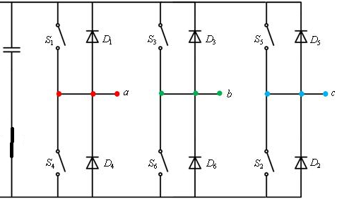

Phase Lock Loop
PLL is for feedback the line instantaneously voltage level. This is essential for the inverter to product power to the grid or work as power factor corrector.
Emergency power  When there is a fault in the power line such than affect the power quality transfer from the power source , the breaker will separate the system from the power source and make the system as island. | 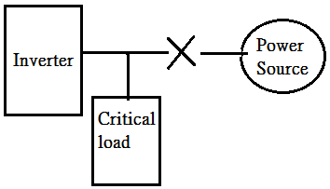
Operation Algorithms
Inverter model:  The DC/AC is using a space-vector modulator technique. This can allow a microprocessor to control six switches in the same time. The switches are turned on and off according to different time.  As shown in the diagram, the voltage level of three line are different.  The upper switch and the lower switch in the same line cannot be turn on or off in the same time. | 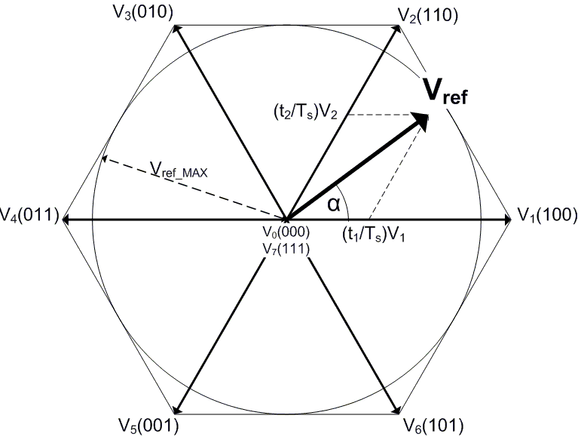
When the switch is on, the switch is operation in PWM model. The signal is a sawtooth and take a sine wave a reference.  When the sawtooth is higher than the sine wave, the signal is high, whereas, the signal is low vice verse. This can product a changing pulse wave.  The switching frequency is higher than the line frequency. It can be considered than a period of switching time is a delta of the line time.  DC = 0.5+0.5 sin(wt)  Thus, the Duty cycle is changing a little time by time. The output voltage is a sine wave. | 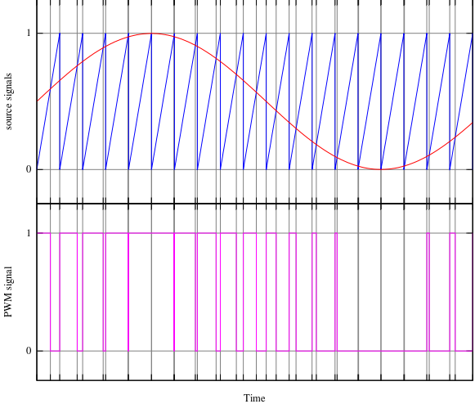

Active Filter Model:  In the design, this is a shunt active filter, with Hysteresis control technique used.  The method is the hysteresis band by summing two different signals, PLL phase comparator and the band estimation circuit.  The current is detected. If the current with in the band gap, no action.  If not, the filter will action and force current to opposite direction. This can reduce the THD. | 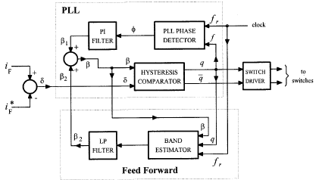

a) Objective 2 - Maximum power control and save energy to battery
Name (ID): ___MA Wai Wai__ ( 523649005 )

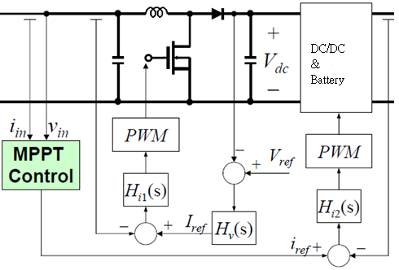

Boost Converter:
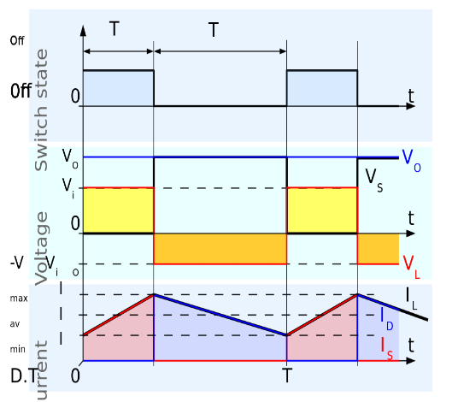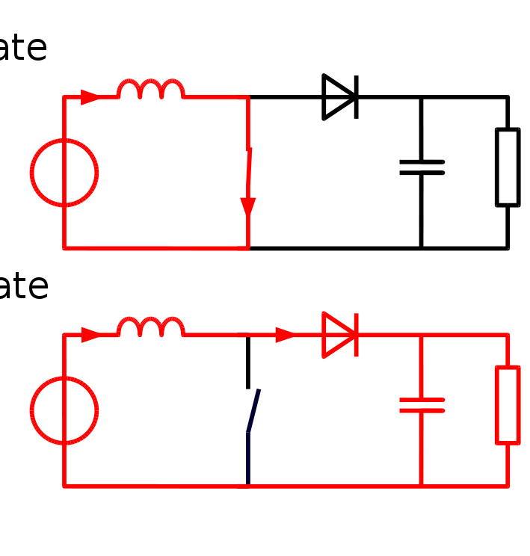

Continuous mode
In on-state, the switch is closed, current flow through the inductor and the inductor store the energy, resulting in an increase in the inductor current.

In the off-state, the switch is open and the only path offered to inductor current is through the flyback diode D, the capacitor C and the load R. This results in transferring the energy accumulated during the On-state into the capacitor.

The current through the inductor (IL) never falls to zero in continuous mode and formula is follow:
On-state: 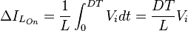

Off-state: 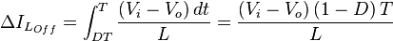

D is the duty cycle if the on-off time.
PWM:
In the first DC/DC part, the boost converter boost up the input voltage to the required voltage level (DC link voltage).The DC link voltage is regulated by controlling the output current of the panel. After comparing the DC link voltage with Vref, a current reference Iref is generated by processing the error through the block Hv(s). The panel current is thus regulated by changing the duty cycle (D) of the switch by PWM.
Battery
DC
DC
DC
AC
MPPT
Charge control

MPPT:
In the second DC/DC part, it is used to satisfy the voltage to the battery load and control the charging of battery. The MPP control gives the necessary output current command for the battery. If the output current is too large, the solar panel cannot sustain the power delivery. Thus, the control Hi2 will give the necessary to reduce the output current by changing the duty cycle of the switches of the switch by PWM.
Charge control:
At night, an off-grid PV system may use batteries to supply loads. Although the fully charged battery pack voltage may be close to the PV panel's maximum power point voltage, this is unlikely to be true at sunrise when the battery has been partially discharged. Charging may begin at a voltage considerably below the PV panel maximum power point voltage, and an MPPT can resolve this mismatch.
When the batteries in an off-grid system are fully charged and PV production exceeds local loads, an MPPT can no longer operate the panel at its maximum power point as the excess power has no load to absorb it. The MPPT must then shift the PV panel operating point away from the peak power point until production exactly matches demand.
In a grid connected photovoltaic system, all delivered power from solar modules will be sent to the grid. Therefore, the MPPT in a grid connected PV system will always attempt to operate the PV modules at its maximum power point.

Objective 3 : Grid-tied Solar inverter
Name (ID): ____ Ling Tsz-YAN ( 53789259 )

Mechanism
Grid tie photovoltaics (PV) systems consist of solar panels and a grid-tie inverter, with no batteries. The solar panels feed a special inverter which converts the DC voltage coming from the solar panels directly into AC power to match the grid.

A solar panel electricity systems, also known as solar PV, capture the sun's energy using photovoltaic cells. These cells do not need direct sunlight to work. They can still generate some electricity on a cloudy day. The cells convert the sunlight into electricity, which can be used to run household appliances and lighting.
How do solar panels (PV) cells work?
The PV cells are made from layers of semi-conducting material, usually silicon. When light shines on the cell it creates an electric field across the layers. The stronger the sunshine, the more electricity is produced. Groups of cells are mounted together in panels or modules that can either be mounted on the roof or on the ground.The power of a PV cell is measured in kilowatts peak. That is the rate at which it can generates energy at utmost performance in no shading sunlight during the day time.

A grid-tie inverter is an electrical device that allows solar power users to complement the grid power with solar power. It works by regulating the amount of voltage and current that is received from the D.C. solar panels (or other D.C. energy source) and converting this into A.C.. The main difference between a normal inverter and a grid-tie inverter is that the latter also ensures that the power supplied will be in phase with the grid power. This allows individuals with surplus power (wind, solar, and so forth) to sell the power back to the utility.
How is a grid tie inverter different from other inverters?
Firstly the 60Hz has to be matched in phase to the grid. This means the local oscillator has to be in synchronise with the grid. Secondly the voltage of the inverter output needs to be variable to allow it to be slightly higher than the grid voltage to enabling current to flow out to the grid. This is done by sensing current flow and raising the voltage on the output (or duty cycle of the transformer input) until the current flow results in the resulting output power matching the input power from the DC supply.

Figure 1 Grid-Tied Without Battery
Configuration  PV modules use semiconductor materials to generate dc electricity from sunlight. The certain area is needed to collect as much sunlight as possible, so the semiconductor is either made into thin, flat, as a very thin continuous layer onto a support material. Those cells are wired together and sealed into a water resistance module, with electrical connectors added. For grid connection, it have between over a hundred cells and produce 100 to 350 dc voltages , with a rated output of between 3000 Watt peak(Wp).  In order to supply electricity into a mains electricity system, the dc output from the module must be converted to ac at the correct voltage and frequency. An electronic inverter is used to do this. Generally a number of PV modules are connected in cascade to provide a higher dc voltage to the inverter input, and sometimes several of these ‘series strings’ are connected in parallel, so that a single inverter can be used for 50 or more modules. Modern inverters are very efficient (typically 97%), and use electronic control systems to ensure that the PV array keeps working at its optimum voltage. They also incorporate safety systems as required in the country of use. | 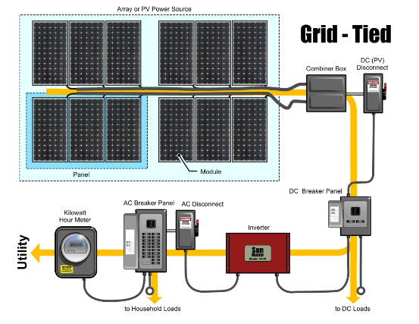
 | 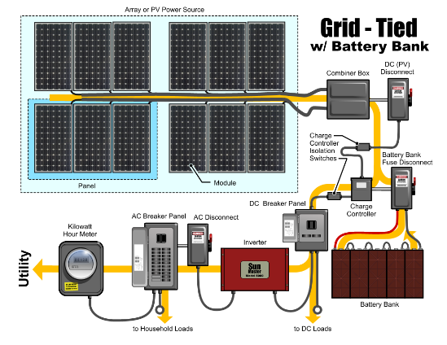

Maximum Power Point Tracking
There are several types of strategies to optimize the power output of the grid-tied solar inverter. Maximum power point trackers may implement different algorithms and switch between them based on the operating conditions of the array.
Method | Perturb and Observe | Incremental conductance
Type | Online-Digital | Online-Digital
Principle | Periodically perturb the panel and observe the rate of change of the output power | Continuous monitoring of the change in the panel conductance
Complexity | Medium | Medium
Speed | Fast | Depends
Sensed Parameters | Voltage & Current | Voltage & Current
Efficiency | High (~96%) | High
Advantages | -Ease of implementation  -Top-level efficiency | -Calculate the direction, for which the array’s point changed in order to reach the MPP  -Determine precisely  when the MPP is reached
Disadvantages | Unsuitable for fast changing operating conditions. | Expensive

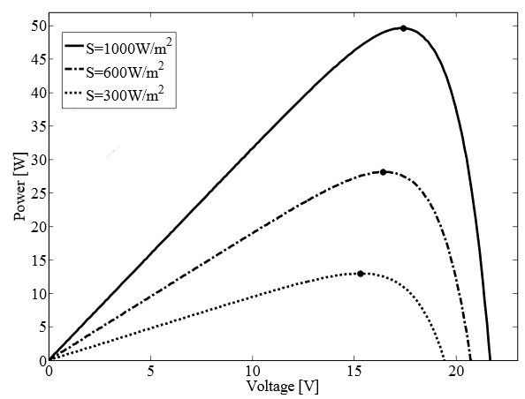 | 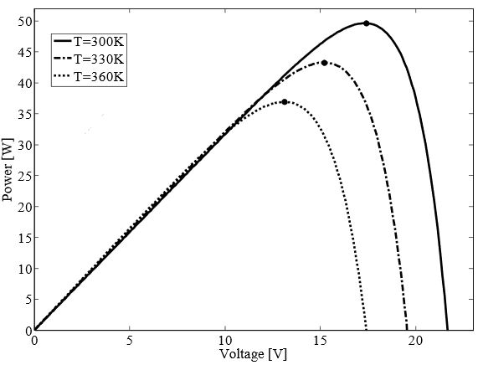
Fig.3 V-P panel characteristics for three different irradiance levels. Each point represents the MPP of related curve. | Fig.4 V-P panel characteristics for three different temperature levels. Each point represents the MPP of related curve.

Conclusion
By using the switch, we can achieve the task requirement.
By using a inverter, the output frequency of 50Hz or 60Hz can be achieve. Moreover, if the H-bridge and PWM technique are used, the output power factor can be very high. If there is no need power transfer from the solar panel, the DC/AC inverter can be worked as active power corrector.
By using the MPPT and PWM, we can control the DC/DC converter to get the require value of our output. Otherwise, MPPT can control the charge and discharge of the battery at an on/off grid.
By reducing the demand for fossil-fuel generation on electricity use, the grid-connected PV may the better approach to cuts greenhouse gas emissions, because no emissions are produced during PV operation. PV is the easiest renewable electricity source to apply into buildings. The electricity is supplied at the point of use, thus avoiding the losses which occur in electricity distribution. It can be used at different scale, such from less than a kWp on an individual home up to MWp scale systems on large public buildings, which is simple and reliable. In view of this, it is a valuable way to raise awareness of electricity supply and use, and helps highlight the potential for renewable energy.

