EE3211 Modelling Techniques
Week 3 Assignment Answer
Q1.
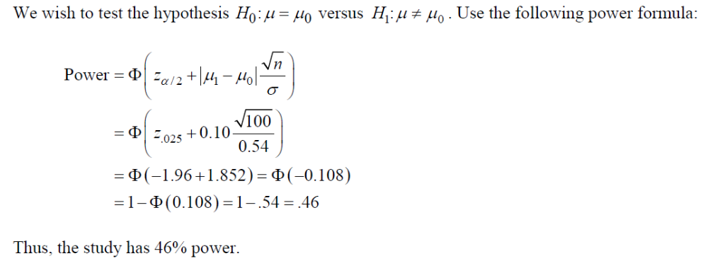

Q2.
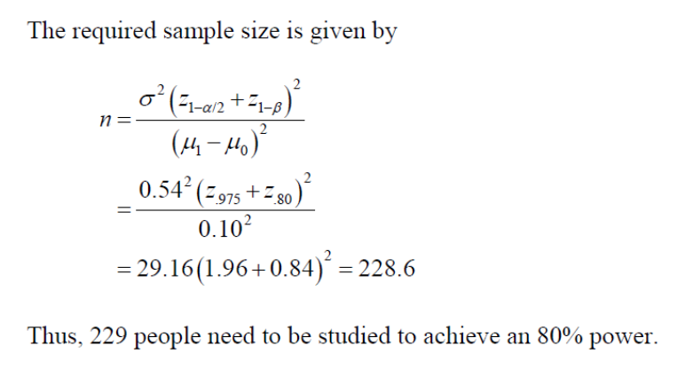

Q3.
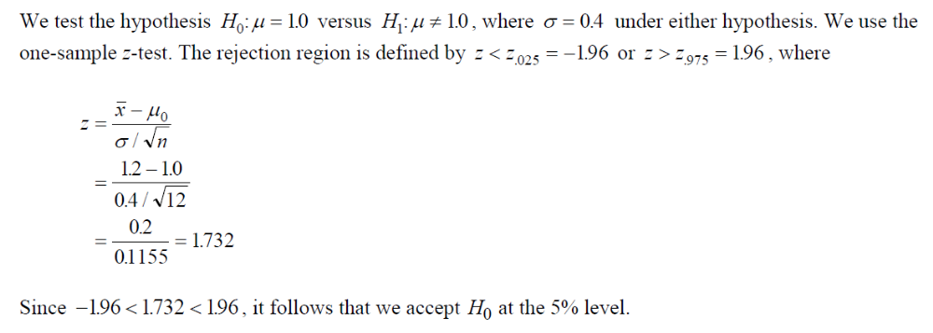

Q4.
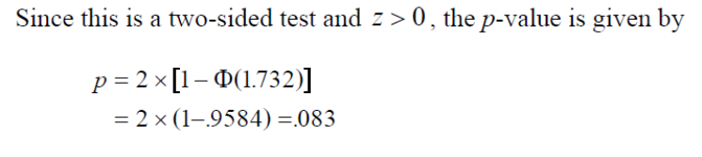
Q5.
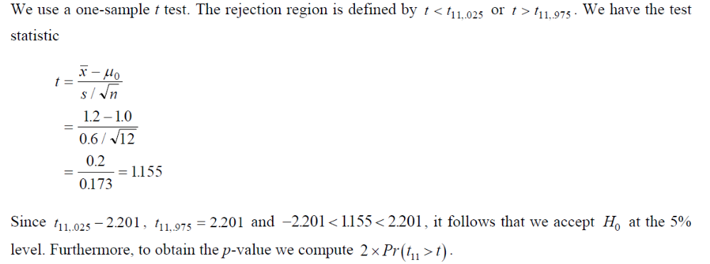
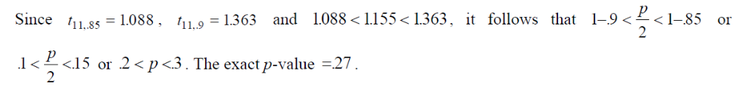
Q6.
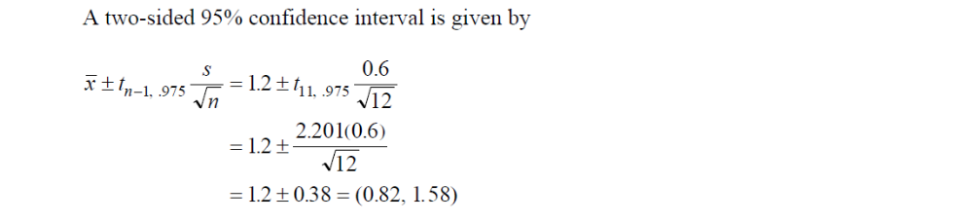
Q7. This interval contains 1.0 = the mean for the general population. This is consistent with the result in Q5 where we accepted H₀ using a two-sided test at the 5% level.

Q8.
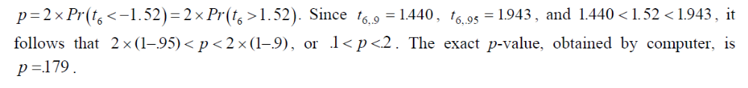
> 2*(1-pt(1.52,6))
[1] 0.179322

Q9.
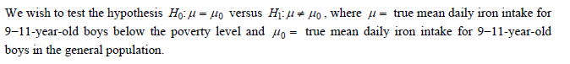

Q10.
