Market efficiency

Q.2

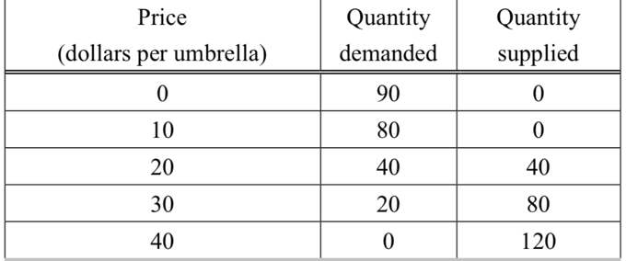

In the above table, if there are 80 umbrellas produced, the deadweight loss from the 80th umbrella is

$10
$20
$30
$40

Ans: B

when the price per umbrella is $20, where Qd=Qs. When 80 umbrellas are produced, it is the over-production the market. As deadweight loss is the difference between the supply and demand, the distance between them is equal to $20. Thus, the deadweight loss is $20.

CB2400 Tick & Learn

Monopoly

Q.1
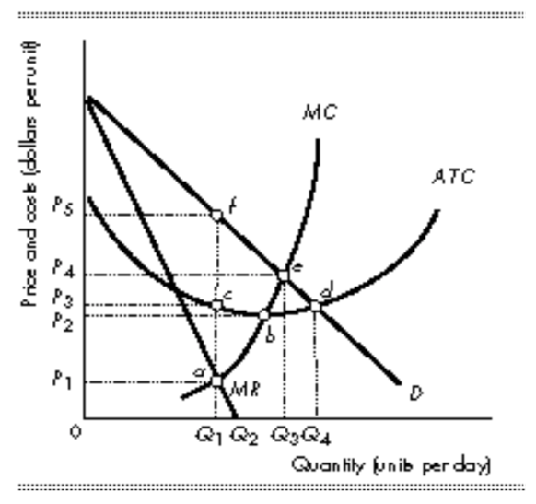

P1; Q1
P2; Q2
P4; Q3
P5; Q1

Ans: D
In single-price monopolist, the firm will produce an amount of quantity where marginal revenue equal to marginal cost (MR=MC), which is Q1.
The firm will set the price based on the quantity on the demand curve, and that is point F.

Comparison of Perfect Competition & Monopoly

Q.3
Which of the following would be considered a form of price discrimination?

Setting separate rates for residential and commercial users of electricity
A restaurant offering a kid’s menu at lower prices
An express delivery service charging different prices for overnight and two-day delivery of a package
Selling delivered copies of the New York Times to consumers nearer to New York City at a lower price because transportation costs are lower

Ans: A
price discrimination is the practice of charging different prices of the same product when there is no cost different in selling those units.

Option A is correct because it charges residential users and commercial users at different prices based on the same product

While other options are incorrect. For option B, comparing to normal menu, the food products served in kid’s menu are different from that of normal menu and thus not the same product. For option C, the provided service is different in the delivery time. For option D, the cost in selling the products is different indicating that the factor behind is the transportation cost,

Monopolistic Competition

Q.4
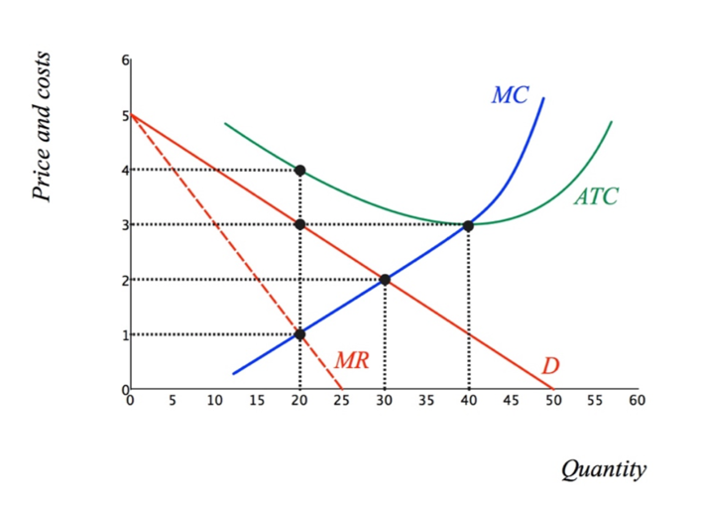
In the figure above (cost curves and demand curve for a firm in monopolistic competition), the firm’s economic

loss will be greater than $30 per day.
loss will be $30 or less per day.
profit will be between $0 and $30 per day.
profit will be greater than $30.01 per day.

Ans: B

(P - ATC) Q = (3 - 4) x 20 = -20, indicating that the firm has no profit and a loss of $20 per day. Therefore, the answer is B.

