EE2000 Logic Circuit Design Lam Kit Mai 53091299
Experiment 3: Implementation of a sequence generator and recognizer
(2 weeks)

Objectives: (i) To design and implement a sequential logic circuit to generate a pre-defined 4-bit repeated sequence (1st week), and (ii) to design and implement a sequential logic circuit for recognizing the sequence pattern generated by the circuit in part (i).
Components:
5V USB transformer 1
USB power cable 1
Breadboard 1
Timer IC NE555 1
D-FF 74LS74 1
LEDs 3
1 k Ω resistor 1
220 k Ω resistor 2
2.2 µF capacitor 1
Other logic gates (subject to different design
(See Appendix 2) – obtained from the component trays in the laboratory)

Design details (Sequence of 1010) (Sequence generator):
State table:
Present state | Next state / Output
S0 | S1 / 1
S1 | S2 / 0
S2 | S3 / 1
S3 | S0 / 0
Binary state assignment: S0 = 00, S1 = 01, S2 = 10, S3 = 11
Design table:
PS | NS | D-FF Input | Output
Q_{A}Q_{B} | Q_{A}Q_{B} | D_{A}D_{B} | Z
00 | 01 | 01 | 1
01 | 10 | 10 | 0
10 | 11 | 11 | 1
11 | 00 | 00 | 0
D-FF excitation table:
Q_{n} | Q_{n+1} | D
0 | 0 | 0
0 | 1 | 1
1 | 0 | 0
1 | 1 | 1
No external input is required as it is a free running circuit. The sequence generator design is based on D-FF, data of D-FF equals data of next state.
FF input logic function:
D_{A} = Q_{A}’Q_{B} + Q_{A}Q_{B}’ = Q_{A}Q_{B,} D_{B} = Q_{B}’, Z = Q_{B}’
Circuit diagram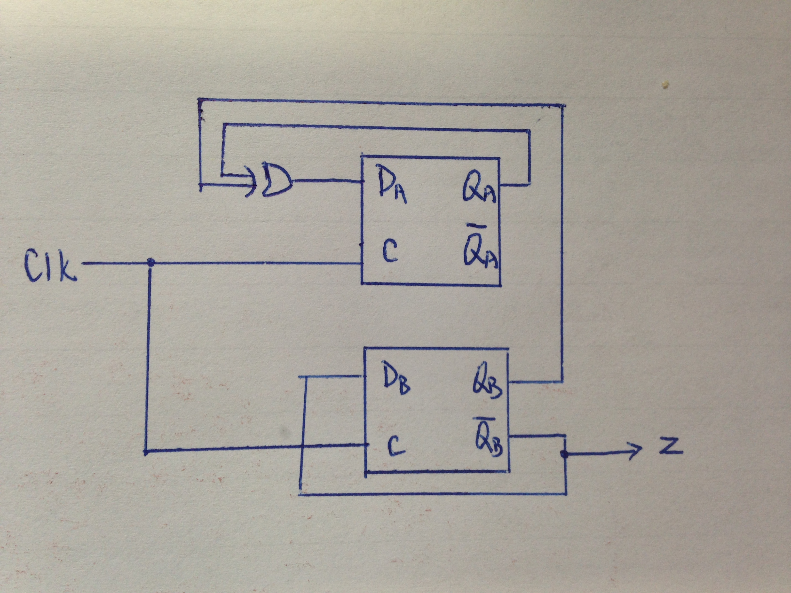
Results (including waveforms to justify your claims)
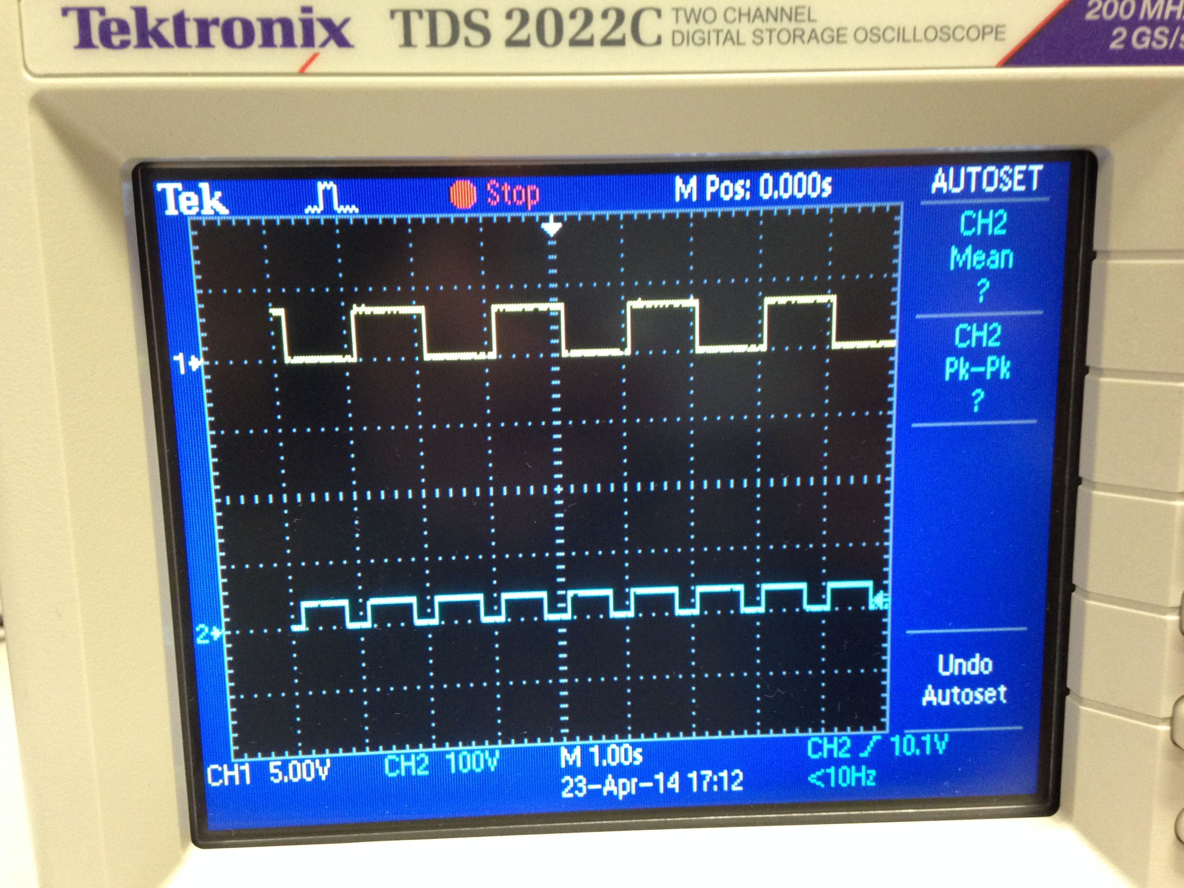
( Channel 1 : sequence generator, Channel 2 : clock signal )
A repeated sequence of 1010 is generated, the output state (generator) changes for each clock period. By observation, the LED connected to the sequence generator output is “on”, “off”, “on” and “off” for 4 clock periods.

Design details (Sequence of 1010) (Sequence recognizer):
State table:
PS | NS (Input = 0) / Output | NS (Input = 1) / Output
S0 | S0 / 0 | S1 / 0
S1 | S2 / 0 | S1 / 0
S2 | S0 / 0 | S3 / 0
S3 | S0 / 1 | S1 / 0
Binary state assignment: S0 = 00, S1 = 01, S2 = 10, S3 = 1
Design table:
PS  Q_{A}Q_{B} | Input  X | NS  Q_{A}Q_{B} | D-FF Input  D_{A}D_{A} | Output  Z
00 | 0 | 00 | 00 | 0
00 | 1 | 01 | 01 | 0
01 | 0 | 10 | 10 | 0
01 | 1 | 01 | 01 | 0
10 | 0 | 00 | 00 | 0
10 | 1 | 11 | 11 | 0
11 | 0 | 00 | 00 | 1
11 | 1 | 01 | 01 | 0

FF input logic function:
D_{A} = Q_{A}’Q_{B}X’ +Q_{A}Q_{B}’X, D_{B} = X, Z = Q_{A}Q_{B}X’
Circuit diagram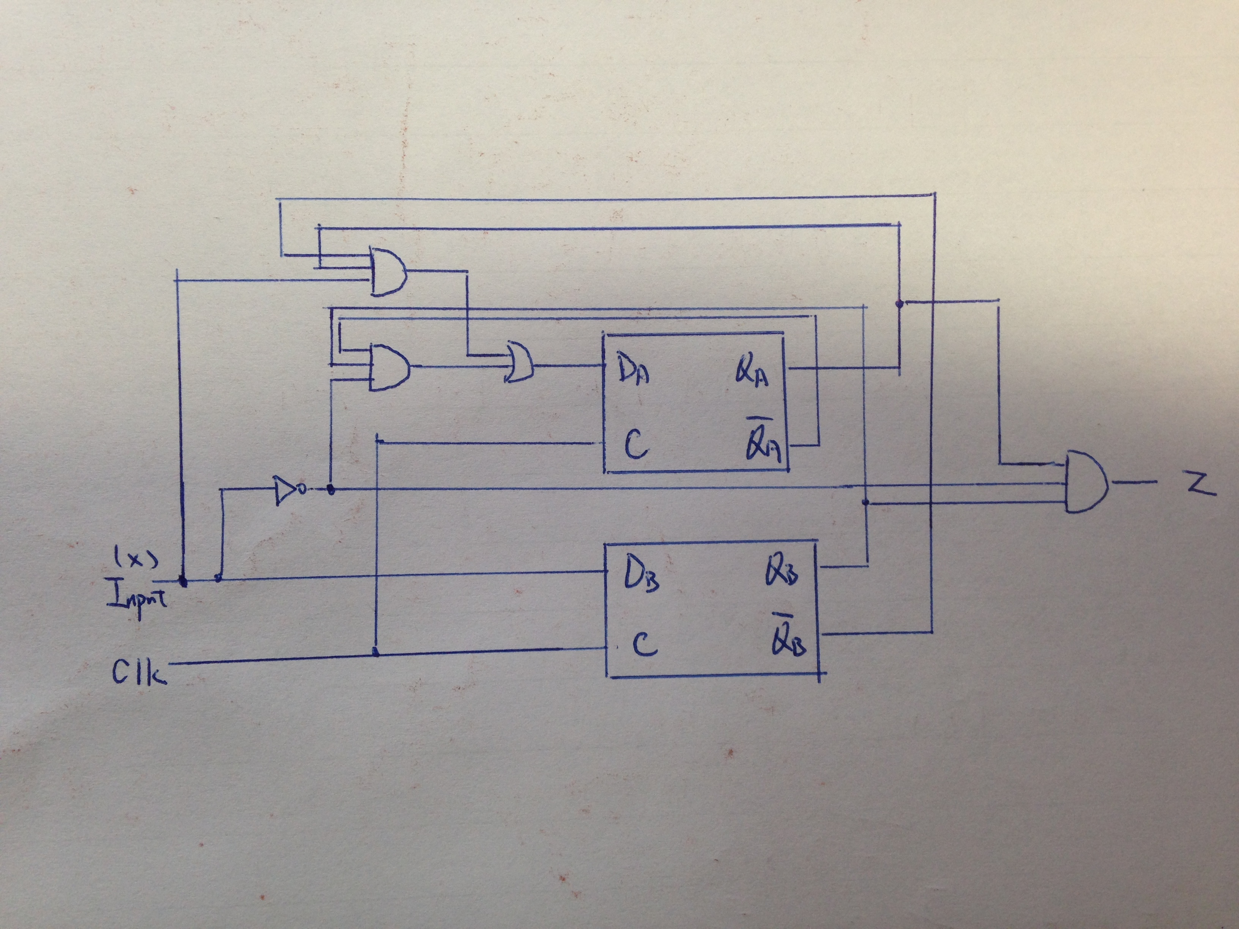
Results (including waveforms to justify your claims)
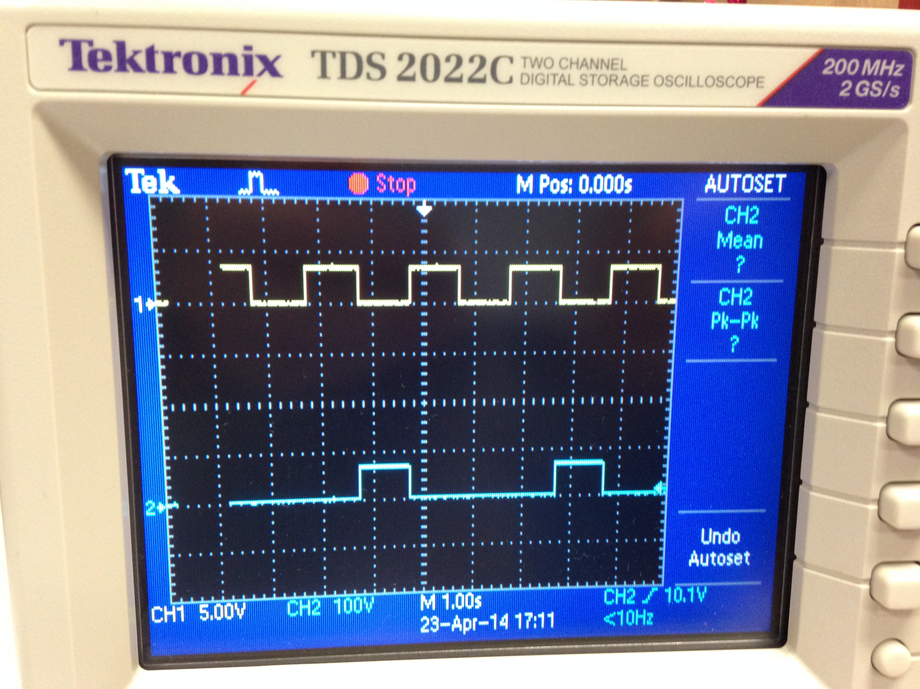
( Channel 1 : sequence generator, Channel 2 : sequence recognizer )

A repeated sequence of 1010 is generated in part 1. When 4-bit sequence is displayed, the sequence recognizer turns from logic ”low” to logic “high” for one clock period(LED connected to the recognizer is “on”) when the fourth bit is displayed, which means a specific sequence pattern is recognized. By observation, the LED connected to the sequence generator output is “off”, “off”, “off” and “on” for 4 clock periods
Discussions
There are specific FF input logic functions for different sequences, which can be done by implementing circuit by specific logic gates. After a logic function for generating sequence 1010 (Z) is determined, the circuit output the signal shown by turning on and off a LED. Similarly, after determining the FF input logic function for the recognizer design, circuit for sequence recognizer is implemented by specific logic gates combination. The sequence generator output is connected to the sequence recognizer input. The sequence recognizer giving out logic “high” in the fourth bit of a cycle means an completed sequence recognition. D-FFs in both generator and recognizer must connect to the same clock. Both of them synchronize with a clock signal, which is produced by a timer IC NE555. Since FF input logic function for each sequence is different, the recognizer cannot recognize other sequence (logic “high” cannot be generated).

Conclusion
A sequence logic circuit based on D-FF is implemented to generate a 4-bit repeated sequence (1010) and a sequential logic circuit for recognizing the sequence pattern generated by the circuit in part (i). A LED connected to the generator and recognizer output can show the logic change of the output, “ON” for logic “high” and “OFF” for logic “low”. When the recognizer detects expected sequence, LED will be “ON” representing logic “high” in the fourth bit of the sequence.

