City University of Hong Kong
Department of Electronic Engineering

EE3101 Communication Engineering

Laboratory Report

Experiment 2 - Eye Diagram

WONG Chun Wai (54010871)

Abstract
This experiment is to study the effect of bandlimited channel like raised cosine filters on the transmission of binary data.

Aims & Objectives
Use Matlab to simulate the binary data transmission through bandlimited channel. Then, plot the eye-diagram of a received waveform from a bandlimited channel. And observe how the eye-pattern will change if different parameters are used.

Equipment Setup
A PC with software of Matlab

Introduction & Background Theory
The required bandwidth of flat-top pulses is infinity. For a practical communication system, the bandwidth is limited by the overall equivalent system transfer function of He(f). In a bandlimited environment, the pulse will spread in time, and the pulse for each symbol may be smeared into adjacent time slot and cause inter-symbol interference (ISI). Nyquist minimum bandwidth is an ideal brick wall filter with cutoff frequency fo, which is equal to half of symbol rate. Zero ISI can be achieved with optimum sampling at t=0, T, 2T,... One frequently used system transfer function, called raised cosine filter, achieves zero ISI with small excess bandwidth and can be practically realized. Since the filter design is not perfect and there may be distortions at the channel. It is not an easy task to identify whether the signal is good or not before the sampling. One of the simple ways to check the waveform is by using eye-diagram. It can be obtained by overlapping the signal waveform from (n–x)T to (n+x)T {where x is normally 0.5 or 1 and T is the symbol duration} for n=1, 2, ….
After overlapping a number of curves, we can get the eye-diagram. The eye-diagrams for waveform A and B are shown as below:
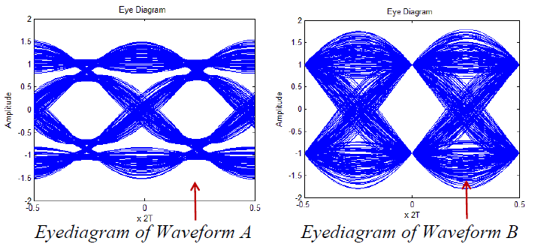

It is obvious that waveform B is better because it can provide a clear +1 or ‒1 when samples at t = 0, i.e. no ISI at sampling instant. Eye-diagram can tell the position of optimum sampling and the amount of ISI at optimum sampling instant.

Procedures
Step 1:

Generate a sequence of 2000 random Bipolar-NRZ (i.e. NRZ-L) data D with amplitude +-1. In each symbol interval, we sample at the rate of Ns samples per data, and create D_ext sequence. Let Ns equals 10. Assume that the data rate is 1b/s, (i.e. 1 symbol per sec) then the sampling rate is 10Hz. The parameters for the raised cosine impulse response are set as follows: the length of the impulse response N = 200 (i.e. the overall length is 200+1 samples); the cutoff frequency is Fc = 0.5 (the minimum Nyquist bandwidth is 1/2=0.5); the sampling frequency Fs = 10 (i.e. there are Fs/(2Fc)=10 samples per symbol); the excess bandwidth is α = 0.22. The length of the impulse response is N/(Fs/2Fc) symbols. After setting h=firrcos(200, 0.5, 0.22, 10, ‘rolloff’), the impulse response is from –10T to +10T with a total length of 20T (T is the symbol duration). The center (or maximum) of the impulse response is at position N/2+1=101, (i.e. h(101) has the maximum value), and the impulse response is zero at h(101+- Fs/(2Fc)n) (i.e. zero ISI) where n is a non-zero integer. Correct eye diagram plot can be obtained by using tx_mod in “eyediagram(tx_mod, Fs/Fc)”, where tx_mod is a modified version of tx such that the N samples at the beginning and N samples at the end of tx have been removed, Fs/Fc here means that each eye diagram trace consists of 2 symbols. Also, plot eyediagram(tx_mod, Fs/Fc + 1) and see the result.

Step 2:

Modify the following parameters and see how the results are changed.
(a) Assume that the sampling rate remains the same but now the number of samples per data is reduced from 10 to 5. i.e. reduce Ns from 10 to 5 in D_ext simulation. The same impulse response is used.
(b) With Ns = 10, increase the cutoff frequency (Fc) from 0.5 to 1 in the impulse response of the filter. This implies the bandwidth of the raised cosine filter is doubled.
(c) With Ns = 5 for the data and Fc = 1 for the impulse response.

Step 3:

Keep the cutoff frequency (Fc), the sampling frequency (Fs) and Ns be the same as in Step 1 (i.e. Fs = 0.5, Fs= 10, Ns =10). Plot the eye-diagram with other filter parameters in “firrcos(N, Fc,α, Fs, ‘rolloff’)” (Note: 2000 random data is used):
(a) excess bandwidth (α) = 0.05, length of the impulse response (N) = 60 & 200
(b) excess bandwidth (α) = 0.95, length of the impulse response (N) = 60 & 200

Results

Step 1:
eyediagram(tx_mod, Fs/Fc)
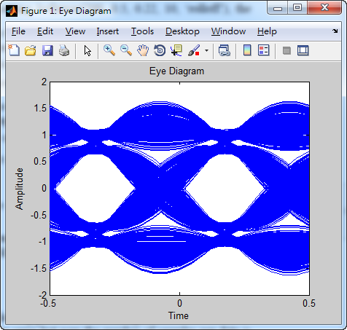

eyediagram(tx_mod, Fs/Fc + 1)
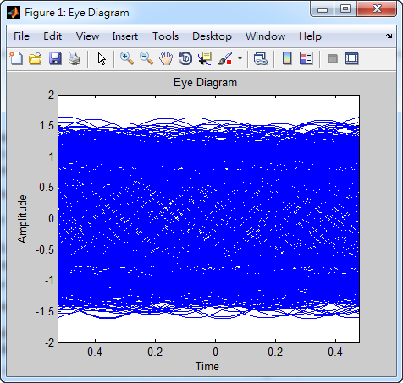

- If eyediagram(tx_mod, Fs/Fc + 1) is chosen, the eye-diagram cannot provide a clear +1 or -1, i.e. there is large ISI exist at Fs/Fc + 1 sampling instant. It is because the optimum sampling instant is at (Fs/2Fc)n, where n is a non-zero integer. Therefore, Fs/Fc + 1 is not an optimum sampling instant, which produce large ISI.
- There are still existing ISI at the optimum sampling point. Since the input is not a one impulse. In fact, it is a series of 10 times impulses which can be treated as a pulse at the input. However, there will cause ISI for pulse response. In order to eliminate ISI, an modified impulse response Hm(f) should be found out.

-Let Hd(f) be the transfer function of NRZ-L
-Let Hr(f) be the transfer function of raised cosine filter

Then, Hd(f) x Hm(f) = Hr(f) to achieve zero ISI.
=>Hm(f) = Hr(f) / Hd(f)

Step 2:
- reduce s N from 10 to 5
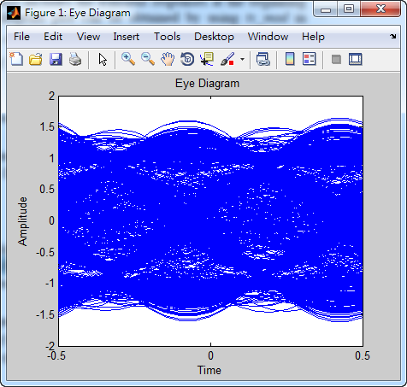

If the number of samples per data is reduced from 10 to 5, i.e. Ns from 10 to 5, then there will have large ISI. It is because the sampling rate remain unchanged, i.e. Fs=10 so, the sampling instant become no longer an optimum sampling instant. Thus, there are large ISI.

- With Ns = 10, increase the cutoff frequency (Fc) from 0.5 to 1
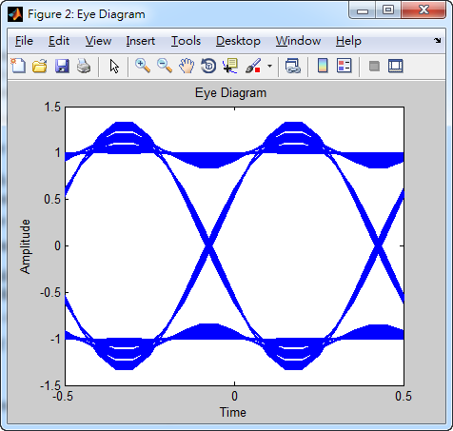

If Fc is changed from 0.5 to 1, then the Bandwidth of raised cosine filter is doubled. The eye-diagram provides clearer +1 or -1, that means less ISI.

- With Ns = 5 for the data and Fc = 1 for the impulse response
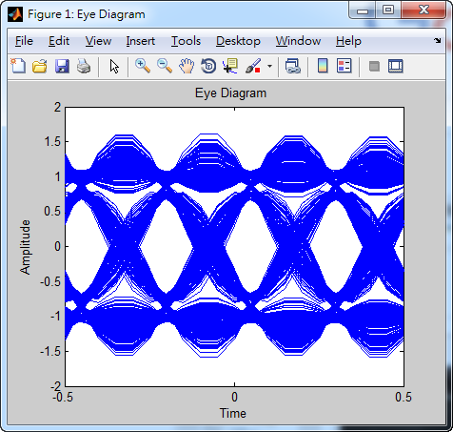

If Ns=5 and Fc=1, the duration of each eye-symbol become half.

Step 3:
- excess bandwidth (α) = 0.05, length of the impulse response (N) = 60
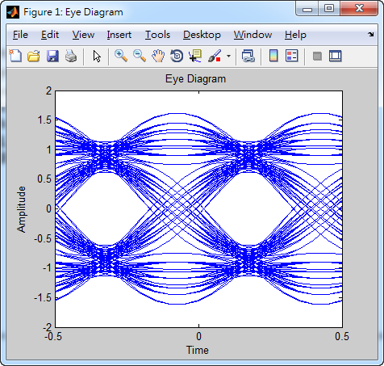

excess bandwidth (α) = 0.05, length of the impulse response (N) = 200
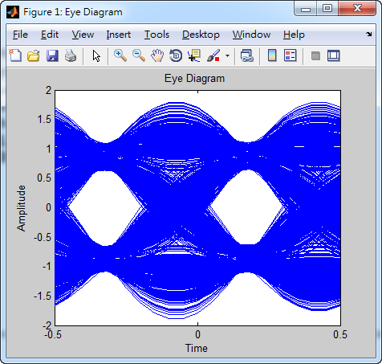
- excess bandwidth (α) = 0.95, length of the impulse response (N) = 60
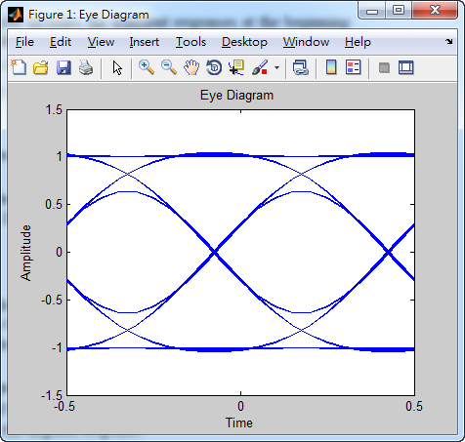

- excess bandwidth (α) = 0.95, length of the impulse response (N) = 200
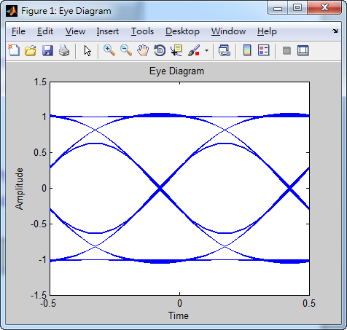

The reason why there is basically no change on eye-diagrams for N=60 & 200 in (b) is that the excess bandwidth (α) = 0.95 is very high, the nth maximum point of impulse response are also close to zero. Therefore, it is almost no different between N=60 & 200.

Discussion:
- The values of Fc and Fs in “firrcos(N, Fc,α, Fs, ‘rolloff’)” for 1kb/s NRZ-L data with 10 samples per data (bit) are:
Fc = 1k / 2 = 500Hz
Fs = 1k x 10 = 10kHz

The length of the impulse response is infinity, but in this experiment we use finite length (N) impulse response as an approximation. Assume α = 0.22, Fc = 0.5 and Fs = 10 are used, the minimum N value in “firrcos(N, Fc,α, Fs, ‘rolloff’)” such that the magnitude of the impulse response outside N is less than 2% of its maximum value is that:

Maximum magnitude of impulse response is h(101) = 0.1
Less than 2% of Max. = Less than 0.1 x 2% = Less than 0.002
By observation on Matlab, N=100

If α=1, Fc=0.5 and Fs=10 is used, then the minimum N value is that:
By observation on Matlab, N=45

Conclusions
In the bandlimited channel, there have inter-symbol interference (ISI). The parameters setting of raised cosine filter can affect the performance of minimizing ISI. By observing eye-diagram, it is easy to determine whether the signal is good or not before the sampling. Eye-diagram can tell us the position of optimum sampling and the amount of ISI at optimum sampling instant.

Appendix
Program code for experiment 2

M=2000;
temp = rand(1,M);
for i=1:M
if temp(i) >0.5
D(i) = 1;
else
D(i) = -1;
end;
end;

Ns =10; % Ns=5 or Ns=10
for i =1:M
for j = 1:Ns
D_ext((i-1)*Ns + j) = D(i);
end;
end;

h = firrcos (200, 0.5, 0.22, 10, 'rolloff'); % modify the parameters in different steps

out = conv (h, D_ext);
out_leng = length (out);
out_stable = out(201+1:out_leng-201);
eyediagram (out_stable, 20)

