GE2410 Unit 4 Delivering Effective Presentations – Embodied Communication (worksheet)
Brian Cox: What went wrong at the Large Hadron Collider
(https://www.youtube.com/watch?v=YnAVjkuQz-Y&t=25s)

The image below (Fig. 1) shows a piece of machinery (a magnet) from the Large Hadron Collider, which is the world’s largest science experiment and impressive feat of engineering. Imagine the presenter has this image on the slide and is explaining to the audience that a manufacturing defect occurred with the language next to the image below.
I. How do you think the speaker might gesture when says this? Do you think any kind of gestures could help? Discuss with a partner and/or make some notes.
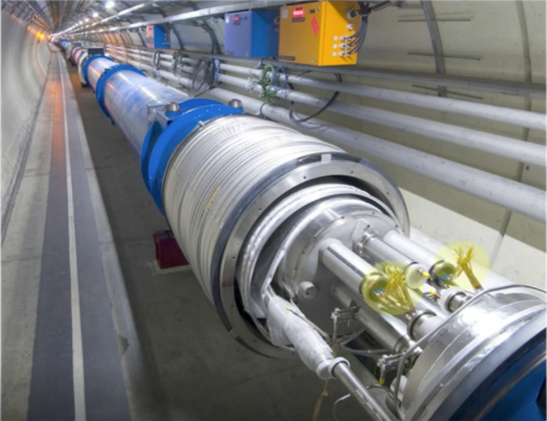
“In one of the joins between over 9,000 magnets in the LHC there was a manufacturing defect so the wire heated up slightly and its 13000 amps suddenly encountered electrical resistance”

Fig. 1 Slide behind Brian Cox illustrating the magnets at LHC

II. Now watch the segment of the talk What went wrong at the Large Hadron Collider where Brian Cox is showing this picture of machinery (1.28 to 2.09). Does the speaker gesture in the way you imagined? Discuss how he gestured and why you think he gestured in this way.

III. Compare these four images that are taken as the speaker says “In one of the joins” (image 1) “between over 9,000 magnets in the LHC” (image 2) “there was a manufacturing defect” (image 3) “so the wire heated up slightly” (image 4). What differences might there be in the way he is gesturing about the image and for his audience? Write a description of Cox’s embodied communication below. Keep in mind the image that is on the slide behind him (Fig. 1 on previous page).
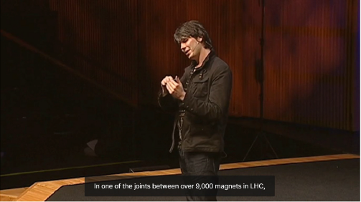
(1) (c) As he introduces the idea of “joins”, his hands come together like a join and he looks at his hands.
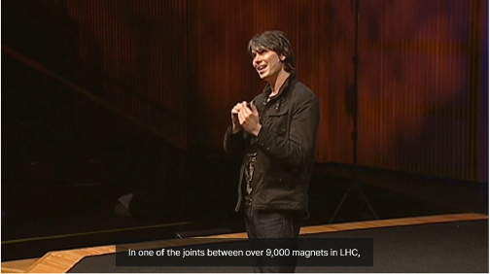
(2)
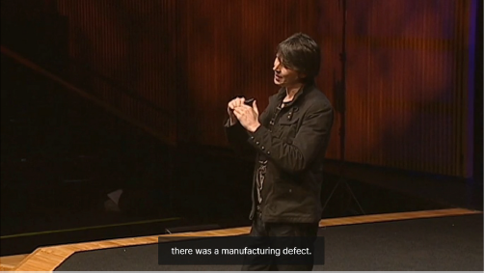
(3)
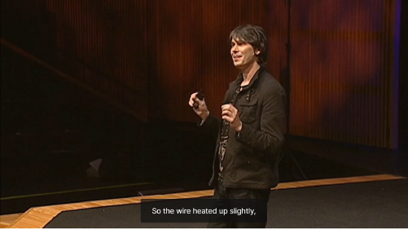
(4)

