EE3211 Modelling Techniques
Week 6 Assignment

Sexually transmitted disease: Suppose a study examines the relative efficacy of penicillin and spectinomycin in treating gonorrhea. Three treatments are considered:
- penicillin
- spectinomycin, low dose
- spectinomycin, high dose
Three possible responses are recorded:
- positive smear
- negative smear, positive culture
- negative smear, negative culture
The data is presented below:
Table. Efficacy of different treatments for gonorrhea.
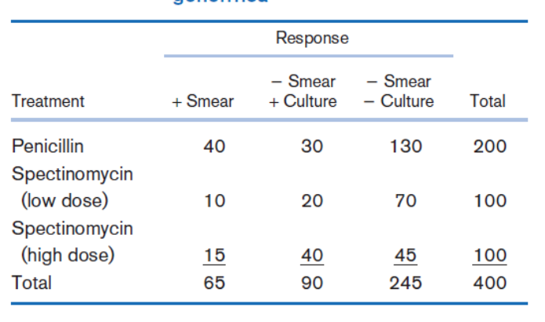
Q1. Is there any relationship between the type of treatment and the response? (5 points)
Q2. Suppose either a positive smear or a positive culture is regarded as a positive response and distinguished from the negative smear, negative culture response. Is there an association between the type of treatment and this measure of response? (5 points)

