CB2400 Micro-Economics

Tick & Learn

Theory of Consumer

1) Which of the following occur when a person maximizes utility?
I. the marginal utility of each good bought is equal
II. the highest level of utility is attained
III. all of a person’s budget is spent
A) I and II.
B) I and III.
C) II and III.
D) I, II and III.

2) The supply of wheat decreases (i.e., the supply curve shifts to the left), so that the quantity of wheat consumed decreases. Thus
A) both the marginal utility and the total utility from wheat increase.
B) the marginal utility from wheat increases and the total utility decreases.
C) the marginal utility from wheat decreases and the total utility increases.
D) both the marginal utility and the total utility from wheat decrease.

3) A convex indifference curve diagram has movies on the vertical axis and sodas on the horizontal. As the consumption of sodas increases and movies decreases (moving southeast along an indifference curve) the marginal rate of substitution of sodas for movies
A) rises.
B) falls.
C) does not change.
D) probably changes, but more information is needed to determine if it rises or falls.

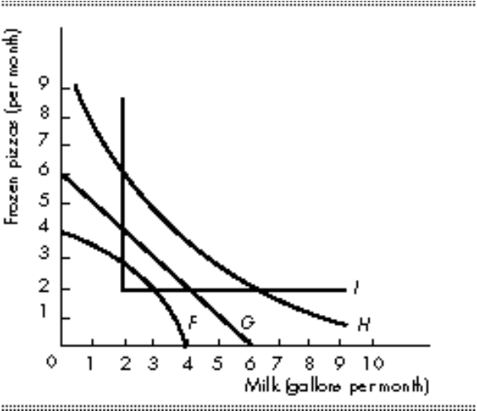

4) In the above figure, which curve is an indifference curve for someone who views frozen pizzas and milk as perfect complement?
A) Indifference curve F
B) Indifference curve G
C) Indifference curve H
D) Indifference curve I

5) Suppose Sam plans to buy only popcorn and soda. He has $40 to spend per week. A change in which of the following variables will change Sam’s budget line?
I. price of popcorn.
II. income.
III. preferences.
IV. utility.
A) II only.
B) I and II.
C) I, II and III.
D) III and IV.

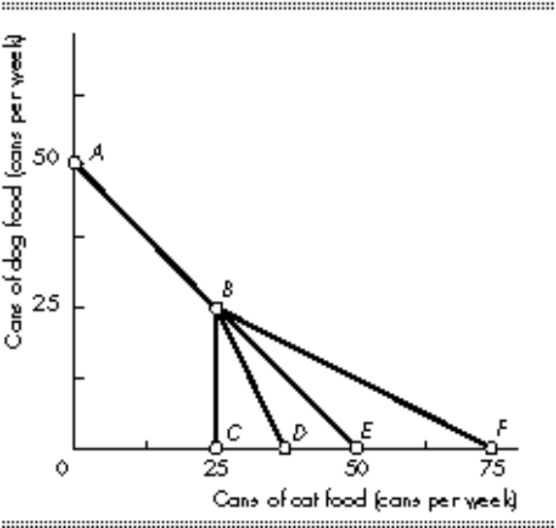
6) Morris has an income of $100 per week. The price of dog food is $2 per can and the price of cat food is $2 per can. However, there is a volume discount for cat food: If he buys more than 25 cans per week, the price of an additional can is only $1. In the above figure, Morriss’s budget line runs through points
A) A, B, and C.
B) A, B, and D.
C) A, B, and E.
D) A, B, and F.

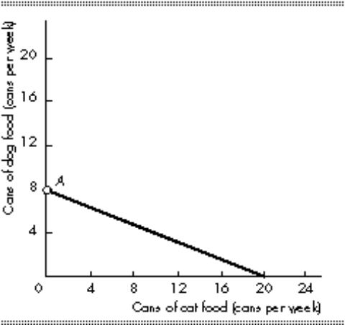
7) The figure above shows Ilene’s budget line. The price of a can of cat food is $2. If the price of a can of cat food rises, her budget line will
A) rotate inward toward the origin.
B) rotate outward away from the origin.
C) shift leftward in a parallel manner.
D) shift rightward in a parallel manner.

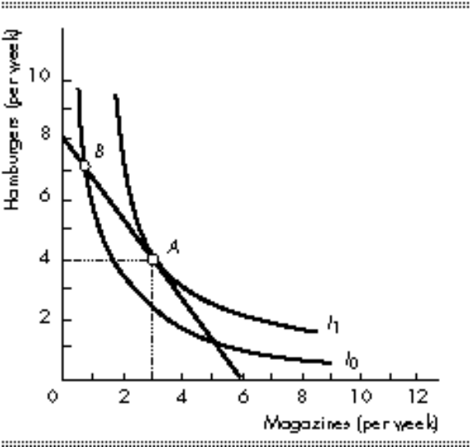
8) In the above figure, point B
A) is superior to point A.
B) is inferior to point A.
C) is as good as point A.
D) could be superior to, inferior to, or as good as point A but there is no way of telling which.

