EE3211 Modelling Techniques
Week 1 Assignment

Cardiovascular disease: The data, shown below and is given as a separate file named Chostesterol.csv on Canvas, is a sample of cholesterol levels taken from 24 hospital employees who were on a standard American diet and who agreed to adopt a vegetarian diet for 1 month. Serum-cholesterol measurements were made before adopting the diet and one month after.
Table. Serum-cholesterol levels (mg/dL) before and after adopting a vegetarian diet
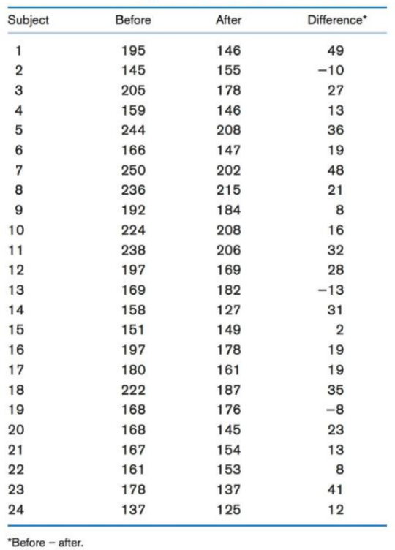
Q1. Calculate the mean change in cholesterol. (1 point)
Q2. Calculate the standard deviation of the change in cholesterol levels. (1 point)
Q3. Construct a stem-and-leaf plot of the cholesterol changes. (1 point)
Q4. Calculate the median change in cholesterol. (1 point)
Q5. Construct a box plot of the cholesterol changes to the right of the stem-and-leaf plot and comment on the distribution e.g. symmetry [Hint: Identify any outlying value by finding the upper and lower quartiles] (3 points)
Q6. Some investigators believe that the effects of diet on cholesterol are more evident in people with high rather than low cholesterol levels. If you split the data in Table 2.15 according to whether baseline cholesterol is above or below the median, can you comment descriptively on this issue? (3 points)

EE3211 Modelling Techniques
Week 1 Assignment

Name:

Q1. 19.54167

Q2. 16.80574

Q4. 19

Q3.
Stem | Leaf
-0 | 308
0 | 2882336999
2 | 13781256
4 | 189
Key: 4 | 1 = 41

Q5.
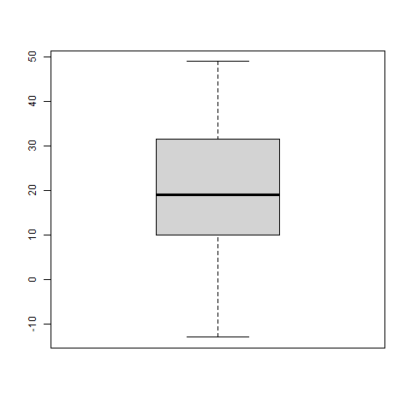

Q5. As the lower quartile is farther from median than upper quartile, it is a negative skewed distribution.

Q6. The effects of the diet on cholesterol are more evident in people with high cholesterol levels.
As number of people having cholesterol levels before the diet who are above the median, with the difference of cholesterol levels who are above median, is larger than the number of people having cholesterol levels before the diet who are below the median, with the difference of cholesterol levels who are above median.

